Testimonials
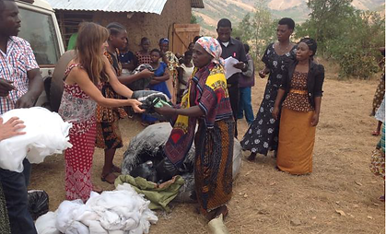
“The ultra-sound equipment has been so important for my work with pregnant women. I can perform scans now and I have been able to identify a number ante-natal problems that otherwise may have led to miscarriage or still birth. I would like to thank the Guernsey Doctors at MSG and the Tumaini Fund for sending this valuable equipment.”

-Dr. Matson, Kayanga health center, talking to Mandy Austin, Guernsey Community Nurse.
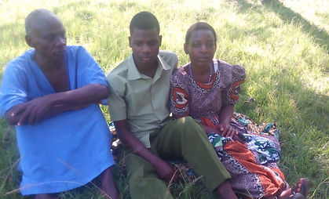
“The shallow well in Kanyinya has reduced the distance we have to carry water. The health of our children is much better and so our medical bills have reduced. The children have better attendance at school. Our clothes are cleaner. The well has so many benefits for the village. There are 84 families using the well so we hope it does not run dry. God willing, we will get another well.”

-Committee members , Kanyinya Parish
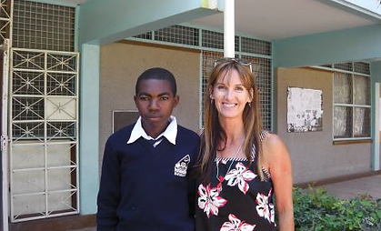
“I had no hope to progress but now I have a career. I started being sponsored by Tumaini at the beginning of secondary school. I would not be a teacher now if it wasn’t for the support I have been given. God bless you”
​
“Before I was supported by the Tumaini Fund, I thought I would have to leave secondary school. I have no parents so I have no one to help me with my education. I have just completed the first year of nursing training and I came top of my class of 100 students. I am very happy. I want to become a Dispenser”
​
-Jackson Samweli and Jumanne Sospeter

​
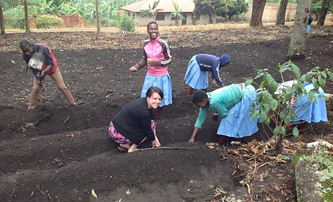
“This is the second carpenter’s workshop I have started for the Tumaini Fund. The first one is in Murgwanza and here in Kayanga the students are working very hard to learn. I am very happy that you have bought more tools for the students to learn woodworking skills”

-Wilbrod
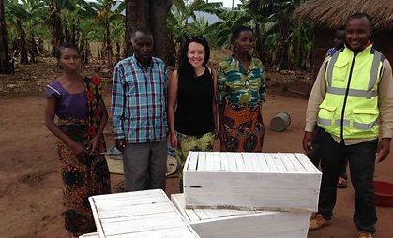
“This is an excellent community project. We have been able to divert some of the water from the spring to make this fish pond. We will be able to grow Tilapia fish so that the people will have a source of protein food. The fish grow quickly so within 6-9 months we should have the first cull. We will test the water to make sure the fish are healthy and safe to eat.”

-Mike Kiondo (Tumaini Area Coordinator - Chato)
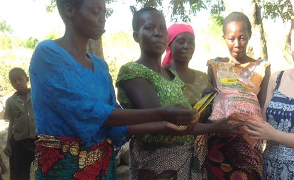
“My name is Elia Ethan and I have been supported by the Tumaini Fund through secondary school. I am now a first year medical student and I am very happy to be able to go to University in Dar Es Salaam. Without support I would have to stay in my village and work on the land. I want to become a Psychiatrist.”
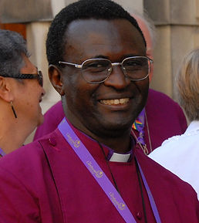
Reginard Ibrahim is the son of a witch-doctor. Reginard became a Christian at secondary school. His Father then converted to Islam, but Reginald refused, so his Father put him out of the home and refused to pay his secondary school needs. Tumaini took over Reginard's fees and he became Headboy of his school, then he successfully trained to certificate level as a nurse. Now he has just started doing his nursing diploma and then plans to take his degree in nursing.
“I am so grateful for the mosquito nets, three of my children have Malaria and it costs a lot of money for their treatment. I have two other children and I hope the net will prevent them getting sick.”

-Mariamu
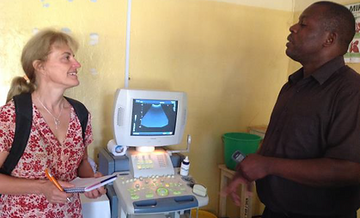
“My name is Levocatus. I feel blessed that I am being sponsored by Guernsey Water through the Tumaini Fund, to train to be a water quality technician. I will work very hard to pass my exams so that I can work in a water testing laboratory. This is so important because the wells need to be tested regularly.”
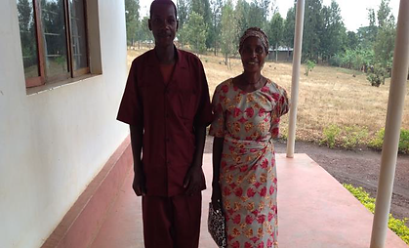
“I am glad the Tumaini Fund is helping me. I am in the 5th year at secondary school and I want to go to University. I want to be a leader of my country. I like geography, history and politics.”

-Ivan Nyamkara with Sarah Jane Allen
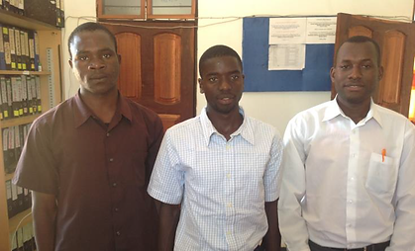
“I am sad that I did not pass the exam to go to secondary school. But I thank God that I came to the tailoring school to learn to sew. I want to have my own sewing machine. Today I was very happy to plant seeds. I like digging the soil and want to see the plants grow. We will have carrots and tomatoes as well as maize for flour. We had a good time and laughed a lot.”

-Maria
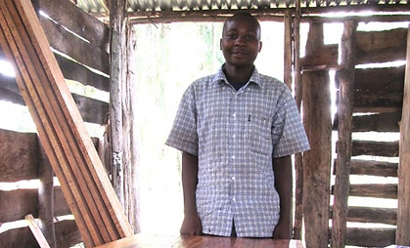
“I am working with the Lusahunga widows group to develop a sustainable agricultural model. We have planted maize to make flour, sunflowers to make oil as a cash crop, and a range of nutritious vegetables such as cabbages, tomatoes, okra, beans and ground nuts. The beehives will attract bees to improve pollination and hopefully the honey can be eaten or sold to supplement the income.”

-Ruth Kinniburgh, Horticulturalist
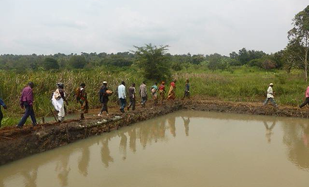
This is the Upendo (Love) widows group. They started a micro finance batik project. They have been printing beautiful fabrics and also making liquid soap. With 2 acres of land, they now have seeds to plant.
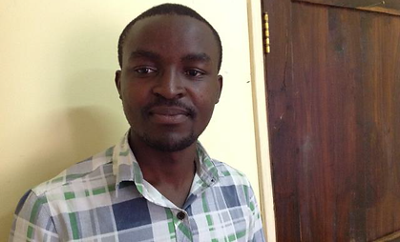
“The Tumaini Fund has made a huge difference to the lives of the people in my Diocese. I am so pleased that, through the love of Jesus, we can work in partnership for the benefit of the people of Lweru.”

-Bishop Jackton, with Josiah, Sarah-Jane Allen
