**Issues with Na cha**:

**Batch starts running around 7:00 PM. By 8:30 PM if the batch has not been confirmed, then something is wrong and need to be fixed.**

**To fix, follow the instructions below:**

1. Go to Transaction Tracker/View Batch Transmittal. You will see that in the Confirmed Number column is blank.

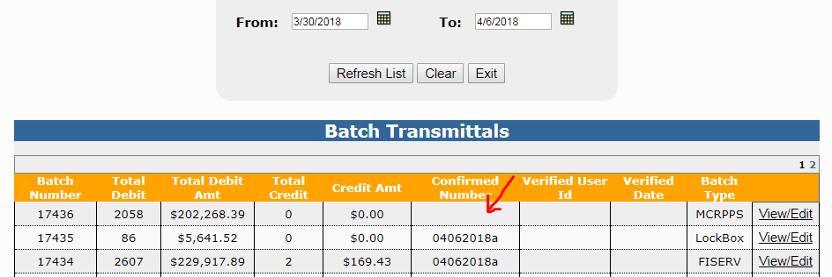

1. VPN to the 107.10 server.
2. Navigate to the PSNBatch\Wells Fargo\Inbound folder and open the NWCNOT file.

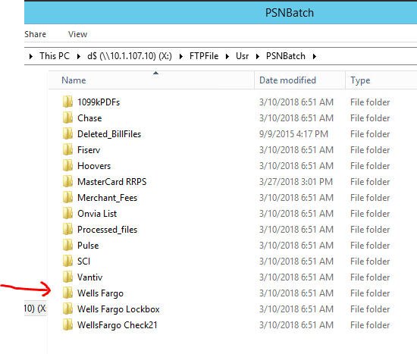

1. Scroll to bottom of the file and compare the Total Debit and Total Debit Amount to the one on the View Batch Transmittal page. Sometimes, it’s the Total Debit that is off and sometimes it’s the Total Debit Amount.
2. Find out the different between the total on the View Batch Transmittals and the total in the file.
3. Use Payment Tracker/View Payment Transactions to locate the transaction that's off so you can get the receipt number. For example, the difference amount is $25.25.

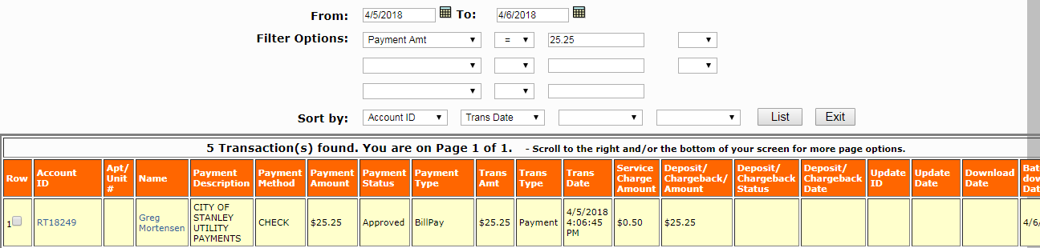

1. Select the check box and click the Process Transaction button.

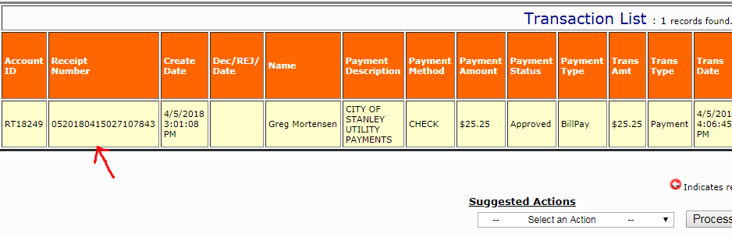

1. Copy the receipt number and run one of the scripts below accordingly to fix the issue.

* **Run_ACH_BAtch_Settlement_Debit.vbs** = Run this script if the TOTAL AMOUNT is different, answer "YES" to remove the $$ amount from the batch debit and "YES" to reconcile the batch.

* **Force_ACH_BAtch_Settlement_Debit.vbs** = Run this script if the TOTAL COUNT is different, answer "YES" to remove the count and "YES" to reconcile the batch.

**\*If the total count/amount of the credit is off, then just let Norman know because there’s no script that can fix it at the moment.**