**PCS**:

When you get calls regarding PCS:

1. Log into PSN as Manager, hover over Support and select View/Edit Queue Items.

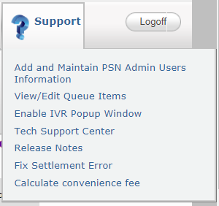

1. Click the drop down next to Queue Description then select PSN Batch File Load and Downloads.

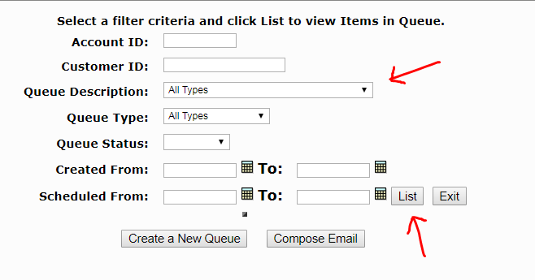

1. Click List to view the status of the queue.
2. Update Date must be up-to-date. You’ll start getting calls once the Update Date is 10 minutes behind. Update Date column shows the last time PCS gets updated.

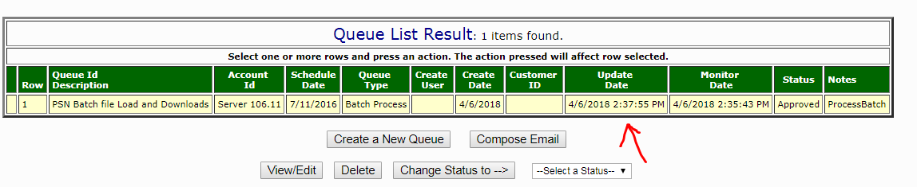

**\*Because there are multiple false alerts in the past, make sure you receive both the emails and calls stating that PCS payments have not been posted before restarting the Scheduler.**

**To restart the Scheduler to fix PCS issues:**

1. **VPN into 106.11 server.**
2. **Open up Task Manager, click Services tab.**

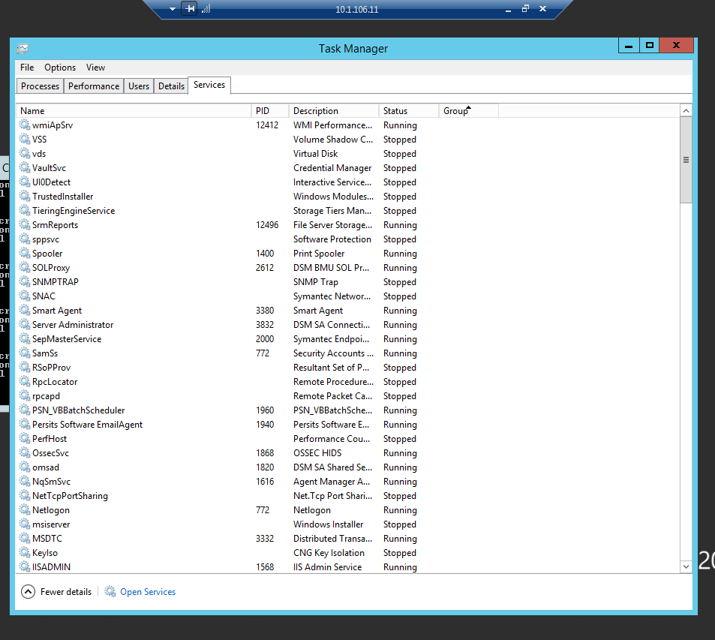

1. **Click Open Services at the bottom of your screen**
2. **Search for PSN_VBBatchScheduler**

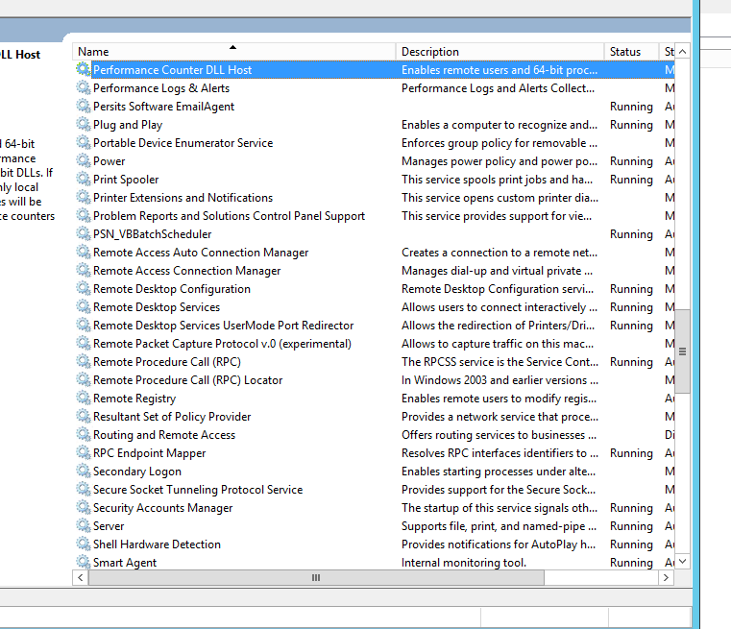

1. **Stop it for 5 seconds and restart it.**