Welcome to horbac identity provider documentation! — horbac idp 0.1 documentation

horbac idp

* Welcome to horbac identity provider documentation!
* Indices and tables
* Introduction
* This is a heading

horbac idp

* »
* Welcome to horbac identity provider documentation!
* [View page source](_sources/index.rst.txt)

# Welcome to horbac identity provider documentation!¶

# Indices and tables¶

* [Index](genindex.html)
* [Module Index](py-modindex.html)
* [Search Page](search.html)

# Introduction¶

* This is a bulleted list.
* It has two items, the second item uses two lines.

1. This is a numbered list.
2. It has two items too.
3. This is a numbered list.
4. It has two items too.

* this is
* a list
  + with a nested list
  + and some subitems
* and here the parent list continues

term (up to a line of text)

Definition of the term, which must be indented

and can even consist of multiple paragraphs

next term

Description.

These lines are

broken exactly like in

the source file.

This is a normal text paragraph again.

|  |  |  |  |
| --- | --- | --- | --- |
| Header row, column 1 (header rows optional) | Header 2 | Header 3 | Header 4 |
| body row 1, column 1 | column 2 | column 3 | column 4 |
| body row 2 | … | … |  |

This is a paragraph that contains [a link](https://domain.invalid/).

# This is a heading¶

fieldname

Field content

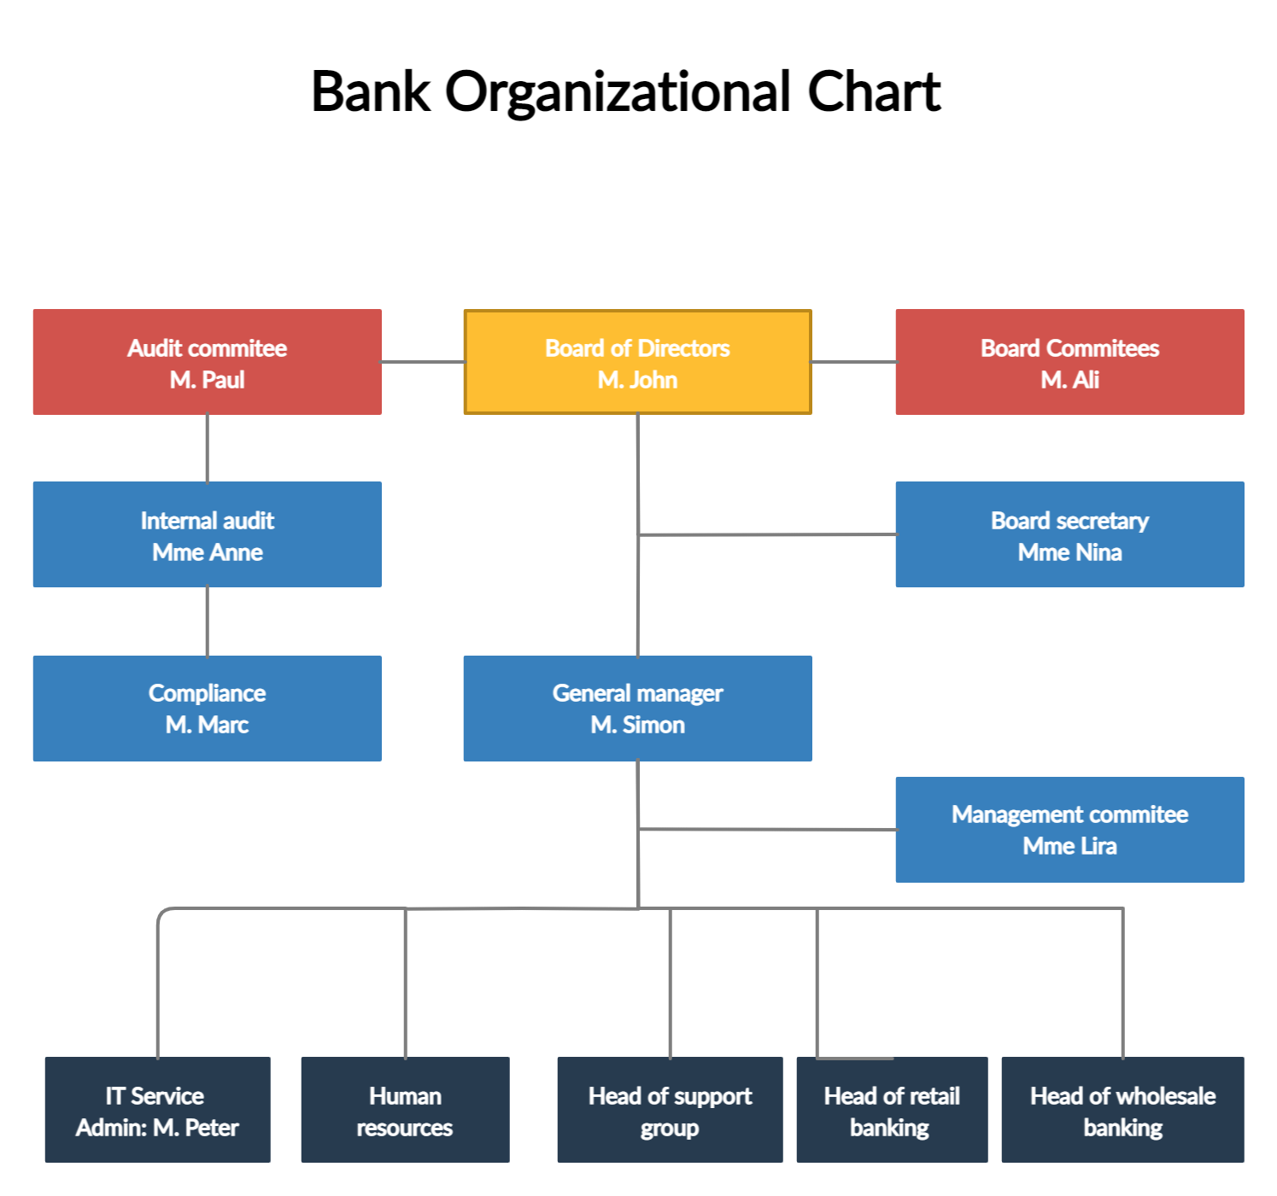

Lorem ipsum 1 dolor sit amet … 2

Footnotes

1

Text of the first footnote.

2

Text of the second footnote.

Lorem ipsum [Ref] dolor sit amet.

Ref

Book or article reference, URL or whatever.

This is a normal text paragraph. The next paragraph is a code sample:

It is not processed in any way, except  
that the indentation is removed.  
  
It can span multiple lines.

This is a normal text paragraph again.

© Copyright 2021, Tsognong Fidèle.

Built with [Sphinx](https://www.sphinx-doc.org/) using a [theme](https://github.com/readthedocs/sphinx_rtd_theme) provided by [Read the Docs](https://readthedocs.org).