P SOMA SHANKA REDDY
192465066
CSA5801- DevSecOps Engineering and Application Security
SLOT-A
LAB PROGRAM
CODES WITH THEIR OUTPUT ;
# ============================================================
# CSA58 DevSecOps Engineering and Application Security
# 40 R PROGRAMS
# Rule:
# Static / workflow / design / modelling -> DiagrammeR
# Dynamic / simulation / analysis / results -> dygraphs
# ============================================================

# Install once:
# install.packages("DiagrammeR")
# install.packages("dygraphs")
# install.packages("xts")

library(DiagrammeR)
library(dygraphs)
library(xts)

# ============================================================
# EXPERIMENT 1
# Installation and Configuration of Git, GitHub, RStudio
# and Required DevSecOps Tools
# ============================================================

library(DiagrammeR)

grViz("
digraph DevSecOpsSetup {

graph [
rankdir = TB,
bgcolor = white,
labelloc = t,
label = 'DevSecOps Tool Installation and Configuration',
fontsize = 20
]

node [
shape = box,
style = 'rounded,filled',
fontname = Helvetica,
fontsize = 14
]

Git [
label = '1. Install Git',
fillcolor = lightblue
]

GitHub [
label = '2. Create / Configure GitHub',
fillcolor = lightgreen
]

RStudio [
label = '3. Install RStudio',
fillcolor = lightyellow
]

R [
label = '4. Configure R Environment',
fillcolor = lightpink
]

Tools [
label = '5. Configure DevSecOps Tools',
fillcolor = lightcyan
]

Verify [
label = '6. Verify Installation',
shape = diamond,
fillcolor = lightgray
]

Ready [
label = 'DevSecOps Environment Ready',
shape = oval,
fillcolor = lightgreen
]

Git -> GitHub
GitHub -> RStudio
RStudio -> R
R -> Tools
Tools -> Verify
Verify -> Ready [label = 'Success']
}
")
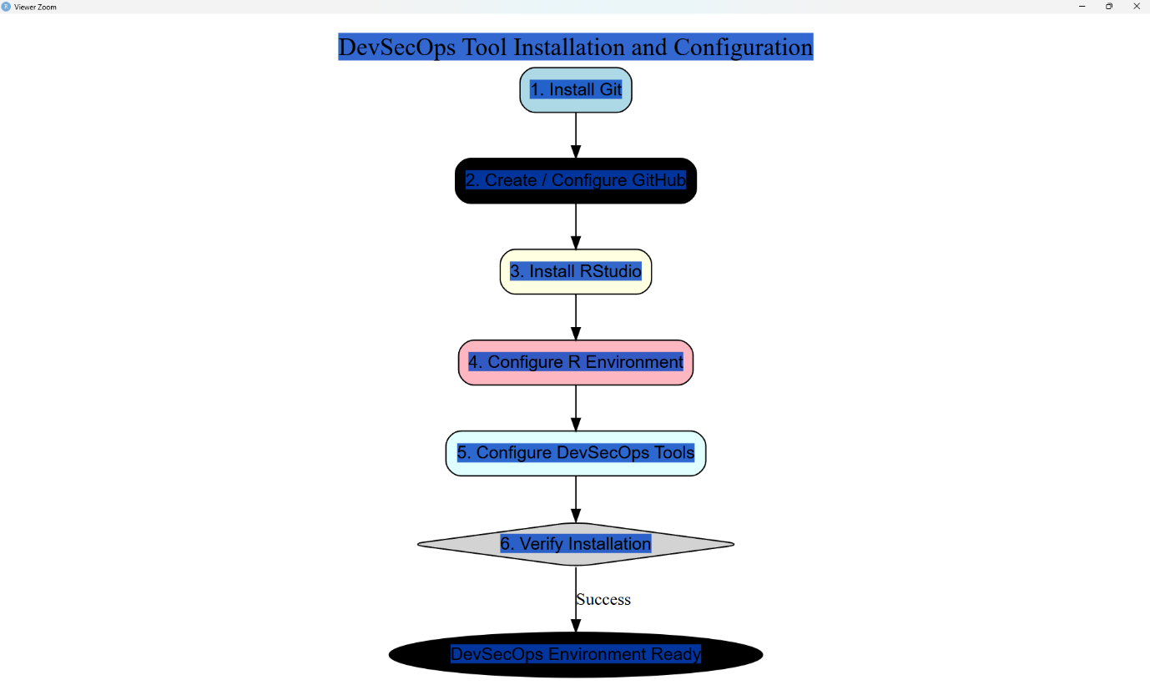

# ============================================================
# EXPERIMENT 2
# Visualization of the DevSecOps Lifecycle using Workflow Modelling
# ============================================================

# Run this once if DiagrammeR is not installed
install.packages("DiagrammeR")

# Load package
library(DiagrammeR)

# DevSecOps lifecycle workflow
grViz("
digraph DevSecOps {

graph [
rankdir=LR,
bgcolor=white,
label='DevSecOps Lifecycle Workflow',
labelloc=t,
fontsize=20
]

node [
shape=box,
style='rounded,filled',
fontname=Helvetica,
fontsize=13
]

Plan [
label='PLAN\\nRequirements & Security Planning',
fillcolor=lightblue
]

Code [
label='CODE\\nSecure Coding',
fillcolor=lightgreen
]

Build [
label='BUILD\\nCompile & Package',
fillcolor=lightyellow
]

Test [
label='TEST\\nFunctional & Security Testing',
fillcolor=lightpink
]

Security [
label='SECURITY\\nSAST / DAST / SCA',
fillcolor=lightcyan
]

Deploy [
label='DEPLOY\\nSecure Deployment',
fillcolor=lavender
]

Monitor [
label='MONITOR\\nSecurity Monitoring',
fillcolor=wheat
]

Feedback [
label='FEEDBACK\\nRisk & Improvement',
shape=diamond,
fillcolor=lightgray
]

Plan -> Code
Code -> Build
Build -> Test
Test -> Security
Security -> Deploy
Deploy -> Monitor
Monitor -> Feedback
Feedback -> Plan [label='Continuous Improvement']
}
")

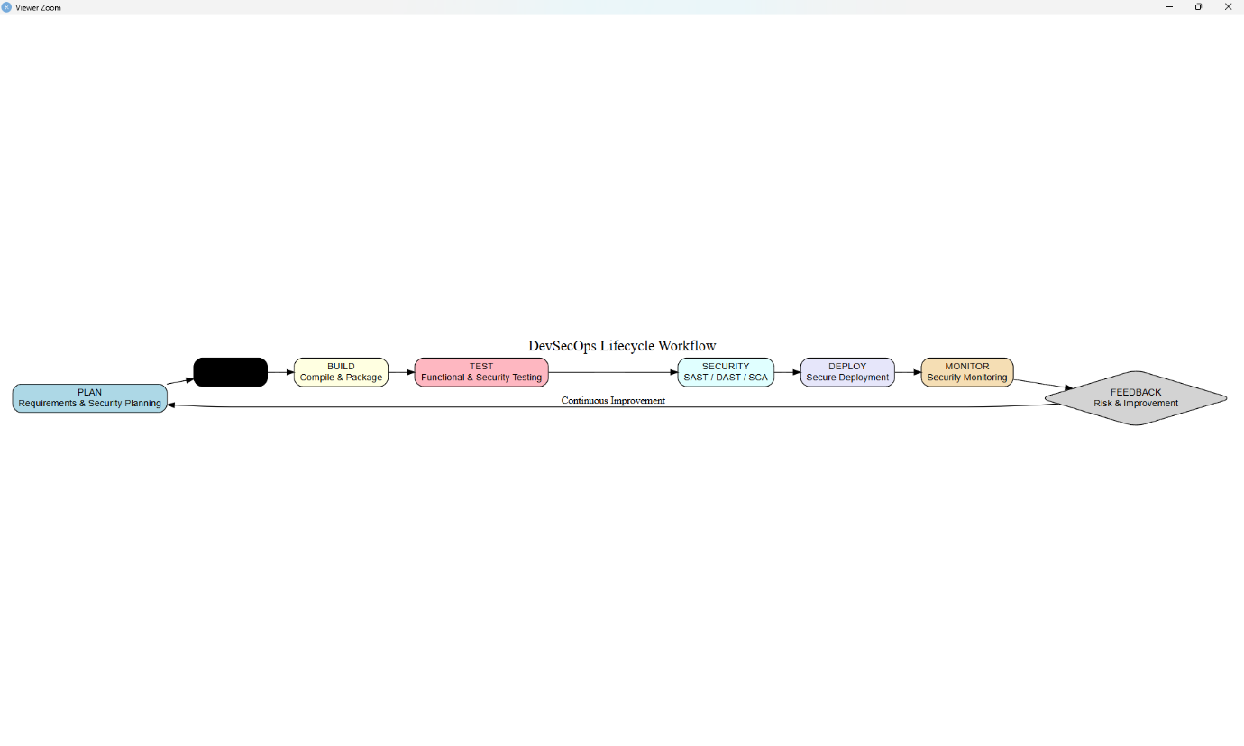

# ============================================================
# EXPERIMENT 3
# Comparative Analysis of DevOps and DevSecOps using Synthetic Data
# ============================================================

# Run once if required
install.packages("dygraphs")
install.packages("xts")

# Load packages
library(dygraphs)
library(xts)

# Synthetic performance data
days <- as.Date("2026-07-20") + 0:9

data <- xts(
cbind(
DevOps = c(62, 64, 66, 65, 68, 70, 71, 72, 74, 75),
DevSecOps = c(60, 64, 69, 72, 75, 78, 81, 84, 87, 90)
),
order.by = days
)

# Interactive comparison graph
dygraph(
data,
main = "DevOps vs DevSecOps Performance Comparison",
xlab = "Date",
ylab = "Performance Score"
) %>%
dyRangeSelector()
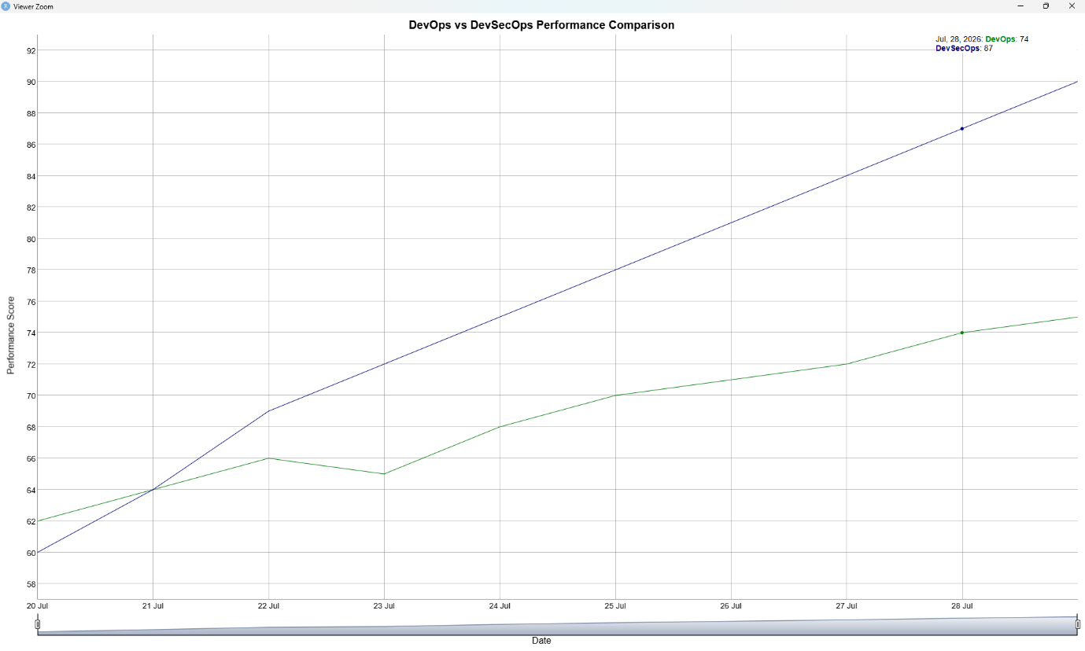

# ============================================================
# EXPERIMENT 4
# Security Risk Assessment and Risk Matrix Simulation
# ============================================================

# Run once if required
install.packages("dygraphs")
install.packages("xts")

library(dygraphs)
library(xts)

# Synthetic security risk data
days <- as.Date("2026-07-27") + 0:9

risk_data <- xts(
cbind(
ThreatLikelihood = c(3, 4, 5, 6, 7, 6, 5, 4, 3, 2),
Impact = c(2, 3, 4, 5, 6, 7, 6, 5, 4, 3),
RiskScore = c(6, 12, 20, 30, 42, 42, 30, 20, 12, 6)
),
order.by = days
)

# Interactive security risk simulation
dygraph(
risk_data,
main = "Security Risk Assessment and Risk Matrix Simulation",
xlab = "Date",
ylab = "Risk Value"
) %>%
dyRangeSelector()
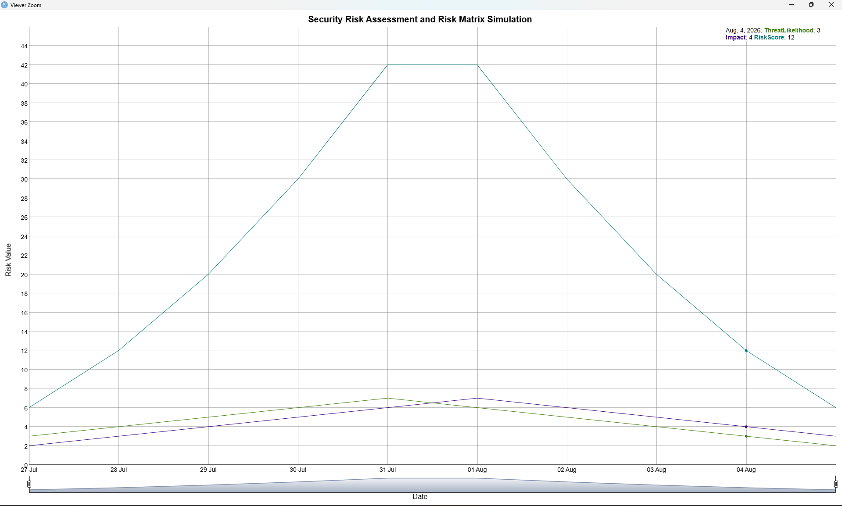
# ============================================================
# EXPERIMENT 5
# Threat Propagation Simulation and Attack Surface Analysis
# ============================================================

# Run once if required
install.packages("dygraphs")
install.packages("xts")

library(dygraphs)
library(xts)

# Synthetic threat propagation data
days <- as.Date("2026-08-03") + 0:9

threat_data <- xts(
cbind(
ThreatLevel = c(2, 4, 7, 11, 16, 14, 11, 8, 5, 3),
AttackSurface = c(10, 14, 19, 26, 34, 31, 27, 22, 17, 13),
ExposedAssets = c(3, 5, 8, 12, 16, 14, 11, 8, 5, 4)
),
order.by = days
)

# Interactive threat propagation analysis
dygraph(
threat_data,
main = "Threat Propagation and Attack Surface Analysis",
xlab = "Date",
ylab = "Security Level"
) %>%
dyRangeSelector()
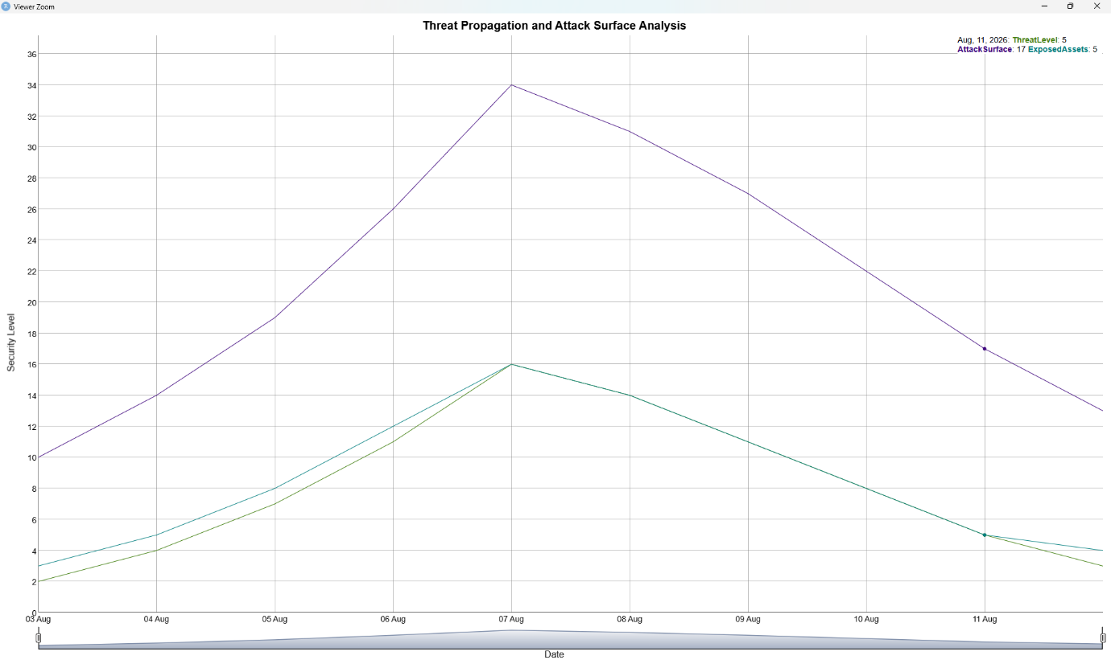
# ============================================================
# EXPERIMENT 6
# Design and Simulation of Shift-Left Security Workflow
# ============================================================

# Run once if required
install.packages("DiagrammeR")

library(DiagrammeR)

grViz("
digraph ShiftLeftSecurity {

graph [
rankdir=LR,
bgcolor=white,
label='Shift-Left Security Workflow',
labelloc=t,
fontsize=20
]

node [
shape=box,
style='rounded,filled',
fontname=Helvetica,
fontsize=13
]

Plan [
label='Security Planning',
fillcolor=lightblue
]

Code [
label='Developer Writes Code',
fillcolor=lightgreen
]

SAST [
label='Early Security Check\\n(SAST)',
fillcolor=lightyellow
]

Fix [
label='Fix Security Issues',
fillcolor=lightpink
]

Test [
label='Security Testing',
fillcolor=lightcyan
]

Build [
label='Secure Build',
fillcolor=lavender
]

Deploy [
label='Deploy',
fillcolor=wheat
]

Plan -> Code
Code -> SAST
SAST -> Fix [label='Issues Found']
Fix -> SAST [label='Recheck']
SAST -> Test [label='No Critical Issues']
Test -> Build
Build -> Deploy
}
")
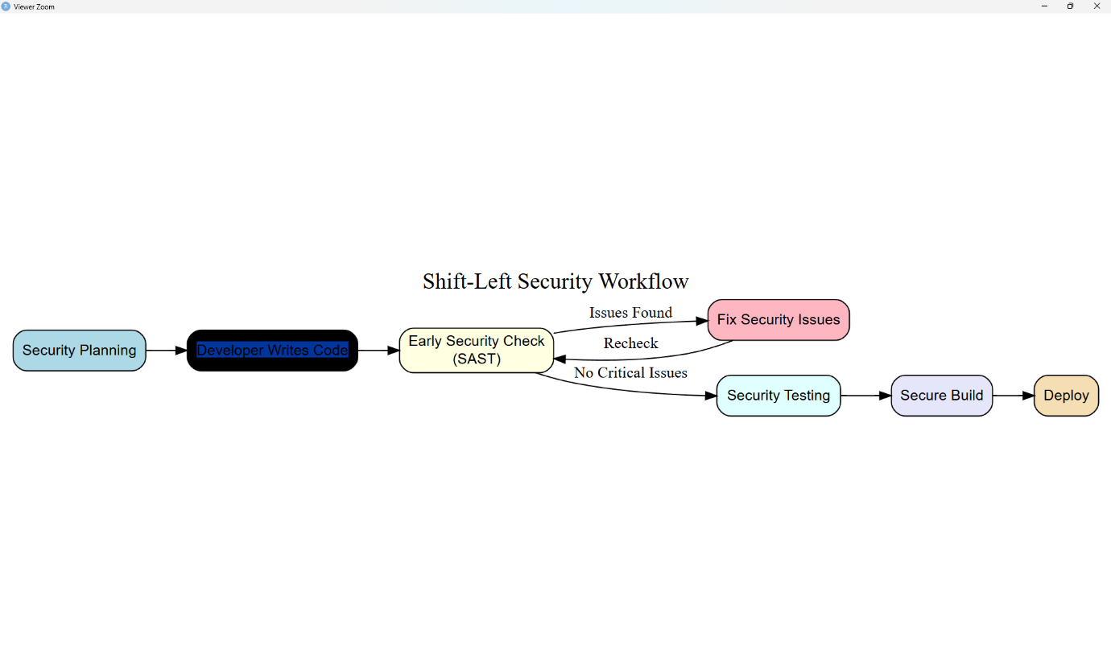

# ============================================================
# EXPERIMENT 7
# Static Application Security Testing (SAST)
# and Security Verification
# ============================================================

# Run once if required
install.packages("dygraphs")
install.packages("xts")

library(dygraphs)
library(xts)

# Synthetic SAST scan results
days <- as.Date("2026-08-10") + 0:9

sast_data <- xts(
cbind(
Critical = c(4, 4, 3, 3, 2, 2, 1, 1, 0, 0),
High = c(8, 7, 7, 6, 5, 4, 3, 2, 2, 1),
Medium = c(12, 11, 10, 9, 8, 7, 6, 5, 4, 3),
Low = c(15, 14, 13, 12, 11, 10, 9, 8, 7, 6)
),
order.by = days
)

# Interactive SAST vulnerability trend
dygraph(
sast_data,
main = "SAST Vulnerability Detection and Security Verification",
xlab = "Scan Date",
ylab = "Number of Vulnerabilities"
) %>%
dyRangeSelector()
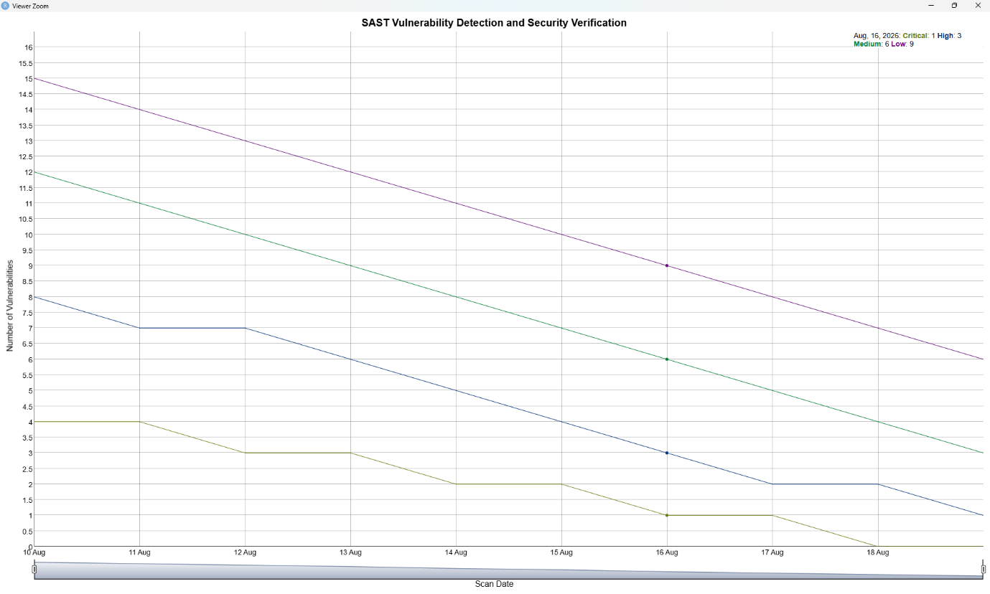

# ============================================================
# EXPERIMENT 8
# Dynamic Application Security Testing (DAST)
# ============================================================

# Run once if required
install.packages("dygraphs")
install.packages("xts")

library(dygraphs)
library(xts)

# Synthetic DAST scan results
days <- as.Date("2026-08-17") + 0:9

dast_data <- xts(
cbind(
Critical = c(5, 5, 4, 4, 3, 2, 2, 1, 1, 0),
High = c(9, 8, 8, 7, 6, 5, 4, 3, 2, 1),
Medium = c(14, 13, 12, 11, 10, 9, 7, 6, 4, 3)
),
order.by = days
)

dygraph(
dast_data,
main = "DAST Security Scan and Vulnerability Analysis",
xlab = "Scan Date",
ylab = "Detected Vulnerabilities"
) %>%
dyRangeSelector()
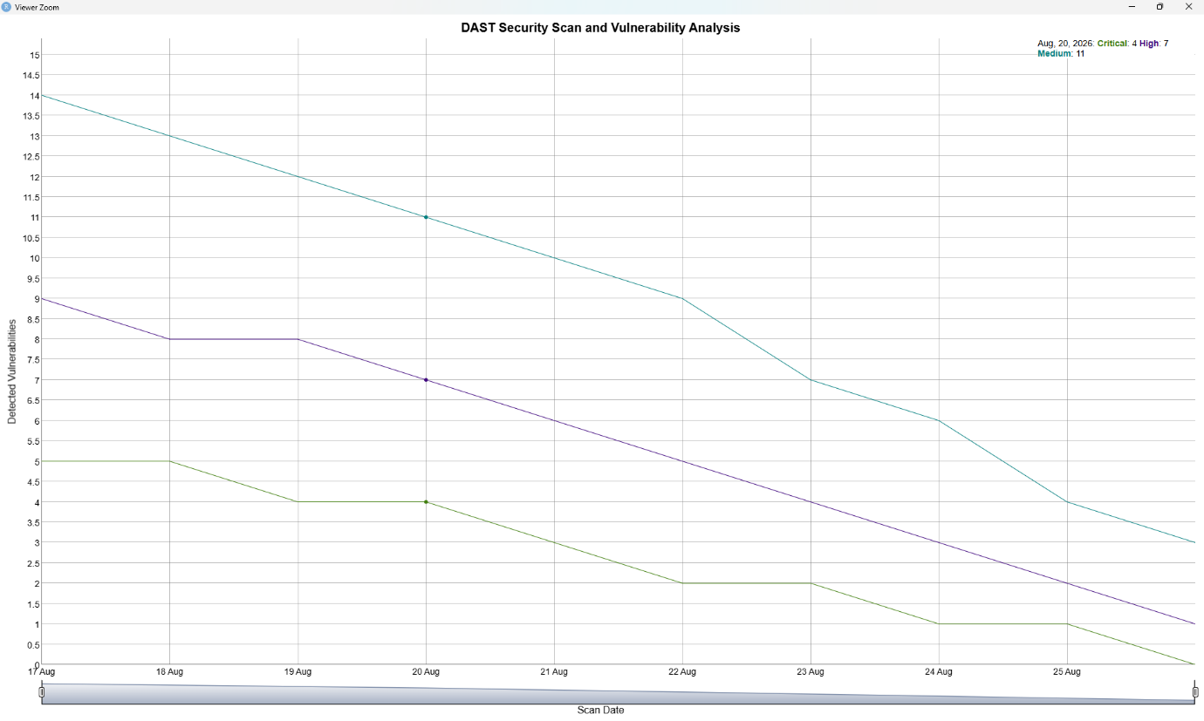
# ============================================================
# EXPERIMENT 9
# Software Composition Analysis (SCA)
# ============================================================

# Run once if required
install.packages("dygraphs")
install.packages("xts")

library(dygraphs)
library(xts)

# Synthetic dependency vulnerability data
days <- as.Date("2026-08-24") + 0:9

sca_data <- xts(
cbind(
VulnerableDependencies = c(12, 11, 10, 9, 8, 7, 5, 4, 2, 1),
OutdatedDependencies = c(8, 8, 7, 6, 6, 5, 4, 3, 2, 2),
SecureDependencies = c(20, 21, 23, 25, 26, 28, 31, 33, 36, 38)
),
order.by = days
)

dygraph(
sca_data,
main = "Software Composition Analysis (SCA)",
xlab = "Scan Date",
ylab = "Number of Dependencies"
) %>%
dyRangeSelector()
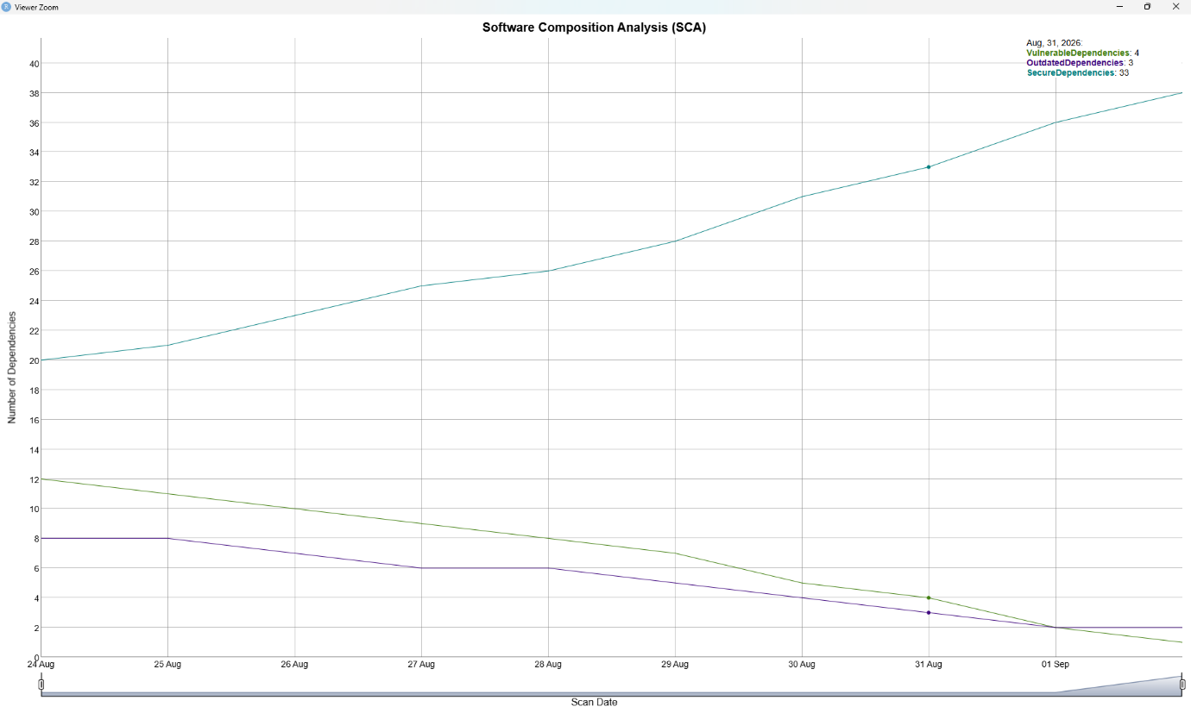

# ============================================================
# EXPERIMENT 10
# Vulnerability Trend Analysis and Security Reporting
# ============================================================

# Run once if required
install.packages("dygraphs")
install.packages("xts")

library(dygraphs)
library(xts)

# Synthetic vulnerability trend data
days <- as.Date("2026-08-31") + 0:9

vulnerability_data <- xts(
cbind(
Critical = c(8, 7, 6, 5, 4, 3, 3, 2, 1, 1),
High = c(14, 13, 12, 11, 10, 8, 7, 6, 4, 3),
Medium = c(20, 19, 18, 16, 15, 14, 12, 10, 8, 6)
),
order.by = days
)

# Interactive vulnerability trend report
dygraph(
vulnerability_data,
main = "Vulnerability Trend Analysis and Security Reporting",
xlab = "Date",
ylab = "Number of Vulnerabilities"
) %>%
dyRangeSelector()
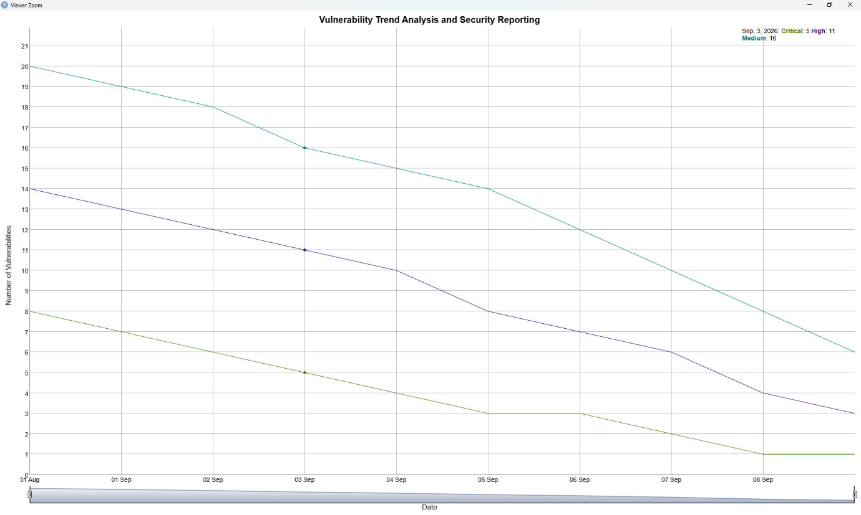

# ============================================================
# EXPERIMENT 11
# Secure Infrastructure Architecture Design using IaC Concepts
# ============================================================

# Run once if required
install.packages("DiagrammeR")

library(DiagrammeR)

grViz("
digraph IaC {

graph [
rankdir=LR,
bgcolor=white,
label='Secure Infrastructure Architecture using IaC',
labelloc=t,
fontsize=20
]

node [
shape=box,
style='rounded,filled',
fontname=Helvetica,
fontsize=13
]
Developer [
label='Developer',
fillcolor=lightblue
]
Git [
label='Git Repository',
fillcolor=lightgreen
]
IaC [
label='Infrastructure as Code\\n(Terraform / IaC)',
fillcolor=lightyellow
]
Security [
label='Security Validation',
fillcolor=lightpink
]
Cloud [
label='Cloud Infrastructure',
fillcolor=lightcyan
]
Network [
label='Secure Network',
fillcolor=lavender
]
Application [
label='Secure Application',
fillcolor=wheat
]
Monitor [
label='Security Monitoring',
fillcolor=lightgray
]
Developer -> Git
Git -> IaC
IaC -> Security
Security -> Cloud [label='PASS']
Cloud -> Network
Network -> Application
Application -> Monitor
Monitor -> Git [label='Feedback']
}
")
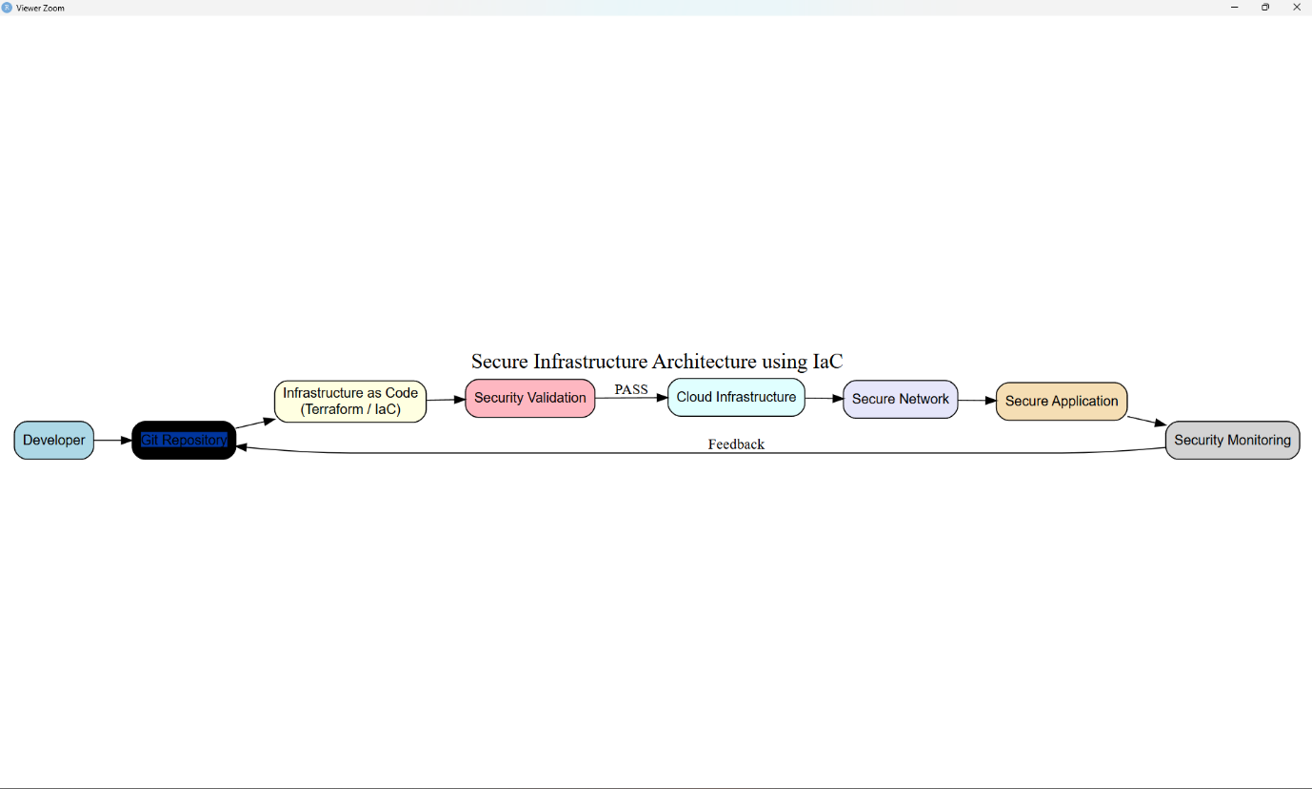

# ============================================================
# EXPERIMENT 12
# Identity and Access Management (IAM) Relationship Modelling
# ============================================================

# Run once if required
install.packages("DiagrammeR")

library(DiagrammeR)

grViz("
digraph IAM {

graph [
rankdir=LR,
bgcolor=white,
label='Identity and Access Management (IAM) Model',
labelloc=t,
fontsize=20
]

node [
shape=box,
style='rounded,filled',
fontname=Helvetica,
fontsize=13
]

User [
label='Users',
fillcolor=lightblue
]

Admin [
label='Administrator',
fillcolor=lightgreen
]

Developer [
label='Developer',
fillcolor=lightyellow
]

Role [
label='Roles',
fillcolor=lightpink
]

Permission [
label='Permissions',
fillcolor=lightcyan
]

Resource [
label='Resources',
fillcolor=lavender
]

Audit [
label='Access Audit\\n& Monitoring',
fillcolor=wheat
]

User -> Admin [label='assigned']
User -> Developer [label='assigned']

Admin -> Role [label='has role']
Developer -> Role [label='has role']
Role -> Permission [label='grants']
Permission -> Resource [label='accesses']
Resource -> Audit [label='logged']
}
")
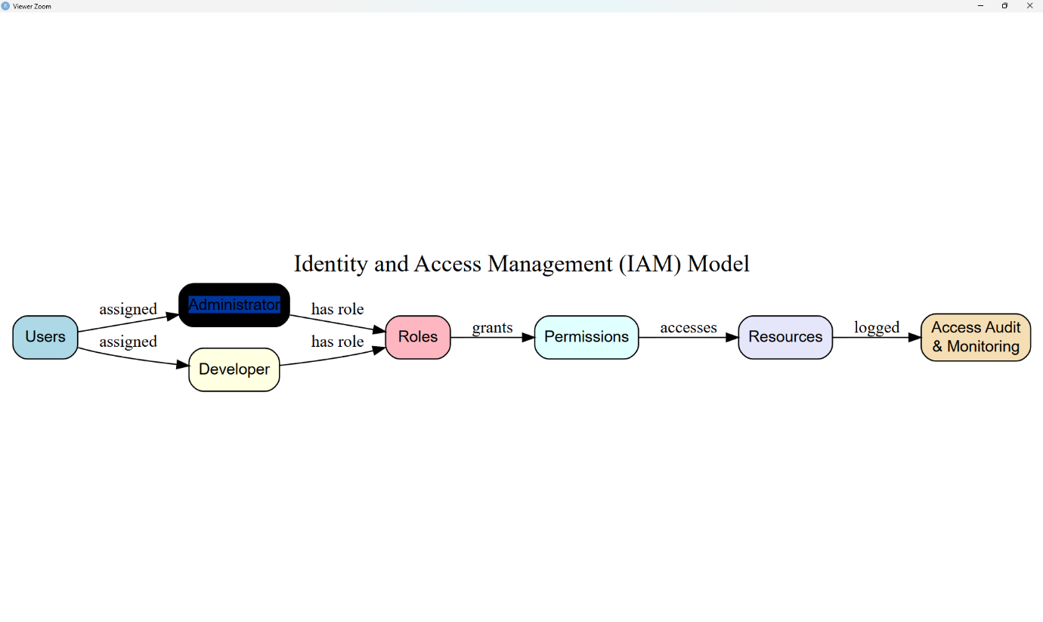
# ============================================================
# EXPERIMENT 13
# GitOps Workflow Design and Secure Deployment Simulation
# ============================================================

# Run once if required
install.packages("DiagrammeR")

library(DiagrammeR)

grViz("
digraph GitOps {

graph [
rankdir=LR,
bgcolor=white,
label='GitOps Secure Deployment Workflow',
labelloc=t,
fontsize=20
]

node [
shape=box,
style='rounded,filled',
fontname=Helvetica,
fontsize=13
]

Developer [
label='Developer\\nCode Changes',
fillcolor=lightblue
]

Git [
label='Git Repository\\nVersion Control',
fillcolor=lightgreen
]

CI [
label='CI Pipeline\\nBuild & Test',
fillcolor=lightyellow
]

Security [
label='Security Checks\\nSAST / SCA',
fillcolor=lightpink
]

CD [
label='CD Pipeline\\nDeployment',
fillcolor=lightcyan
]

Kubernetes [
label='Kubernetes\\nCluster',
fillcolor=lavender
]

Monitor [
label='Monitoring\\n& Security Verification',
fillcolor=wheat
]

Developer -> Git
Git -> CI
CI -> Security
Security -> CD [label='PASS']
Security -> Git [label='FAIL']
CD -> Kubernetes
Kubernetes -> Monitor
Monitor -> Git [label='Feedback']
}
")
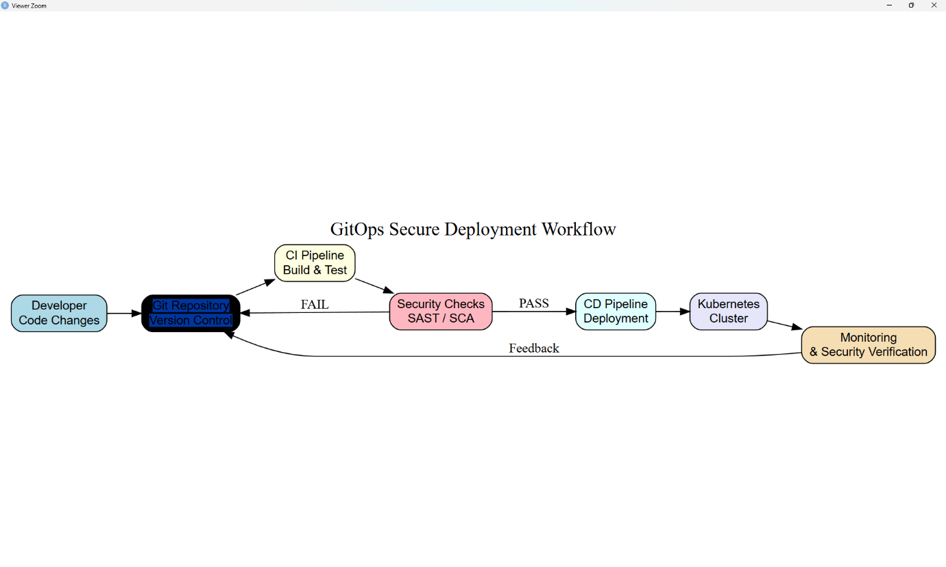
# ============================================================
# EXPERIMENT 14
# Container Security and Vulnerability Assessment
# ============================================================

# Run once if required
install.packages("dygraphs")
install.packages("xts")

library(dygraphs)
library(xts)

# Synthetic container security scan data
days <- as.Date("2026-09-07") + 0:9

container_data <- xts(
cbind(
Critical = c(4, 4, 3, 3, 2, 2, 1, 1, 0, 0),
High = c(8, 7, 7, 6, 5, 4, 4, 3, 2, 1),
Medium = c(12, 11, 10, 9, 8, 7, 6, 5, 4, 3)
),
order.by = days
)

dygraph(
container_data,
main = "Container Security and Vulnerability Assessment",
xlab = "Scan Date",
ylab = "Number of Vulnerabilities"
) %>%
dyRangeSelector()

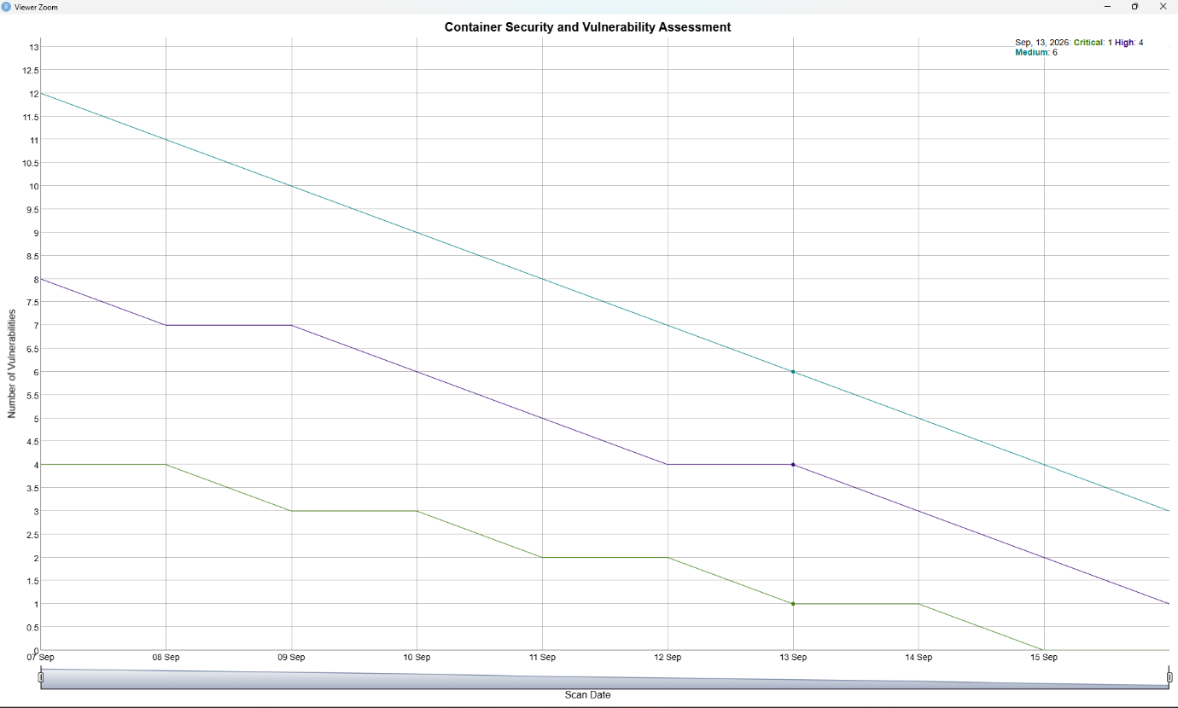

# ============================================================
# EXPERIMENT 15
# Security Log Generation, Incident Timeline Analysis
# and Anomaly Detection
# ============================================================

# Run once if required
install.packages("dygraphs")
install.packages("xts")

library(dygraphs)
library(xts)

# Synthetic security log data
time <- as.POSIXct("2026-09-12 09:00:00") + (0:9) * 3600

log_data <- xts(
cbind(
NormalEvents = c(8, 10, 9, 11, 10, 9, 12, 10, 9, 11),
FailedLogins = c(2, 3, 2, 4, 3, 2, 3, 2, 3, 2),
SuspiciousEvents = c(0, 1, 0, 1, 2, 12, 1, 0, 10, 1)
),
order.by = time
)

# Interactive security log and anomaly analysis
dygraph(
log_data,
main = "Security Log Timeline and Anomaly Detection",
xlab = "Time",
ylab = "Number of Security Events"
) %>%
dyRangeSelector()

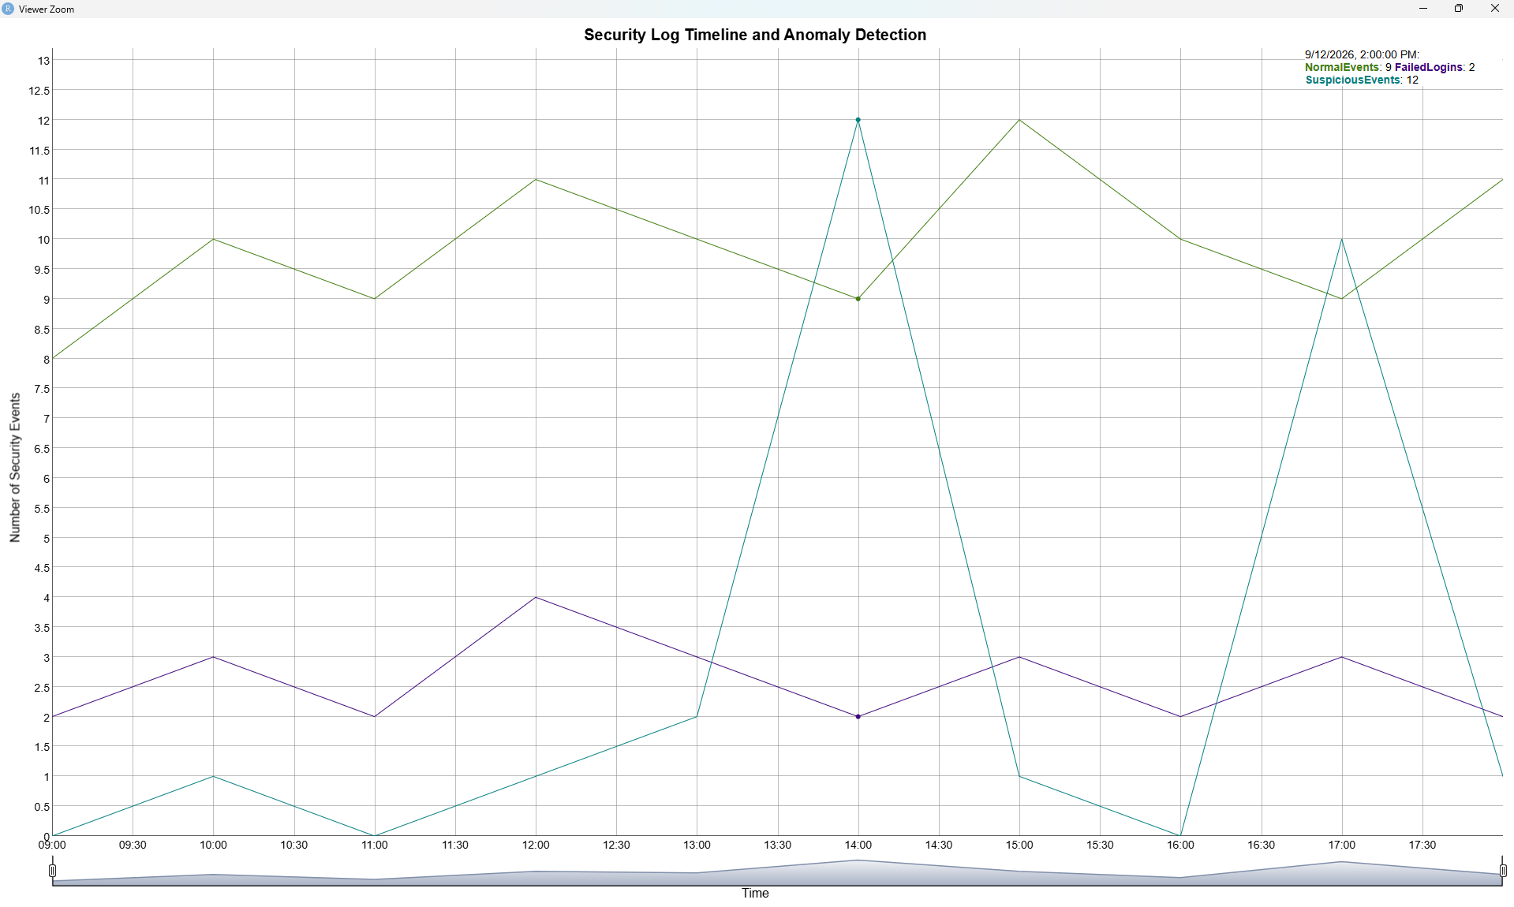

# ============================================================
# EXPERIMENT 16
# Development of a DevSecOps Security Monitoring Dashboard
# ============================================================

# Run once if required
install.packages("dygraphs")
install.packages("xts")

library(dygraphs)
library(xts)

# Synthetic security monitoring data
days <- as.Date("2026-09-17") + 0:9

dashboard_data <- xts(
cbind(
SecurityScore = c(62, 66, 69, 71, 74, 77, 79, 82, 85, 88),
Vulnerabilities = c(22, 20, 18, 17, 15, 13, 11, 9, 7, 5),
SecurityAlerts = c(10, 9, 8, 9, 7, 6, 5, 4, 3, 2)
),
order.by = days
)

dygraph(
dashboard_data,
main = "DevSecOps Security Monitoring Dashboard",
xlab = "Date",
ylab = "Security Metrics"
) %>%
dyRangeSelector()

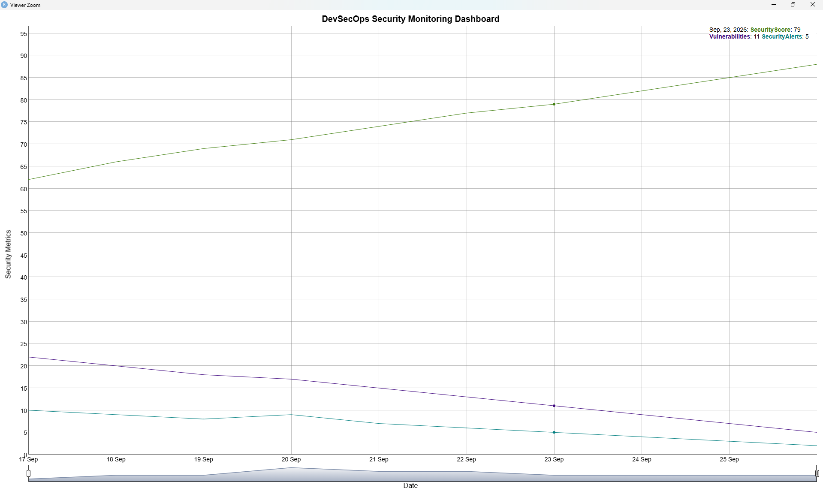

# ============================================================
# EXPERIMENT 17
# Secure Coding Practices and Vulnerability Detection Simulation
# ============================================================

# Run once if required
install.packages("dygraphs")
install.packages("xts")

library(dygraphs)
library(xts)

# Synthetic secure coding scan data
days <- as.Date("2026-09-19") + 0:9

coding_data <- xts(
cbind(
InsecureFindings = c(18, 16, 15, 13, 11, 9, 7, 5, 3, 2),
FixedFindings = c(2, 4, 6, 8, 10, 12, 14, 16, 18, 20),
SecureChecks = c(5, 7, 9, 11, 13, 15, 17, 19, 21, 23)
),
order.by = days
)

dygraph(
coding_data,
main = "Secure Coding Practices and Vulnerability Detection",
xlab = "Scan Date",
ylab = "Number of Findings / Checks"
) %>%
dyRangeSelector()

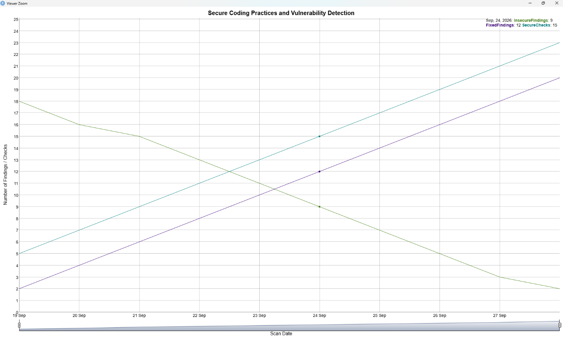

# ============================================================
# EXPERIMENT 18
# OWASP Top 10 Vulnerability Identification and Risk Classification
# ============================================================

# Run once if required
install.packages("DiagrammeR")

library(DiagrammeR)

grViz("
digraph OWASP {

graph [
rankdir=LR,
bgcolor=white,
label='OWASP Top 10 Vulnerability Identification and Risk Classification',
labelloc=t,
fontsize=20
]

node [
shape=box,
style='rounded,filled',
fontname=Helvetica,
fontsize=12
]

App [
label='Web Application',
fillcolor=lightblue
]

A01 [
label='A01 Broken Access Control',
fillcolor=lightpink
]

A02 [
label='A02 Cryptographic Failures',
fillcolor=lightyellow
]

A03 [
label='A03 Injection',
fillcolor=lightcyan
]

A04 [
label='A04 Insecure Design',
fillcolor=lavender
]

A05 [
label='A05 Security Misconfiguration',
fillcolor=wheat
]

A06 [
label='A06 Vulnerable Components',
fillcolor=lightgreen
]

Risk [
label='Risk Classification\\nCritical / High / Medium / Low',
shape=diamond,
fillcolor=lightgray
]

App -> A01
App -> A02
App -> A03
App -> A04
App -> A05
App -> A06

A01 -> Risk
A02 -> Risk
A03 -> Risk
A04 -> Risk
A05 -> Risk
A06 -> Risk
}
")

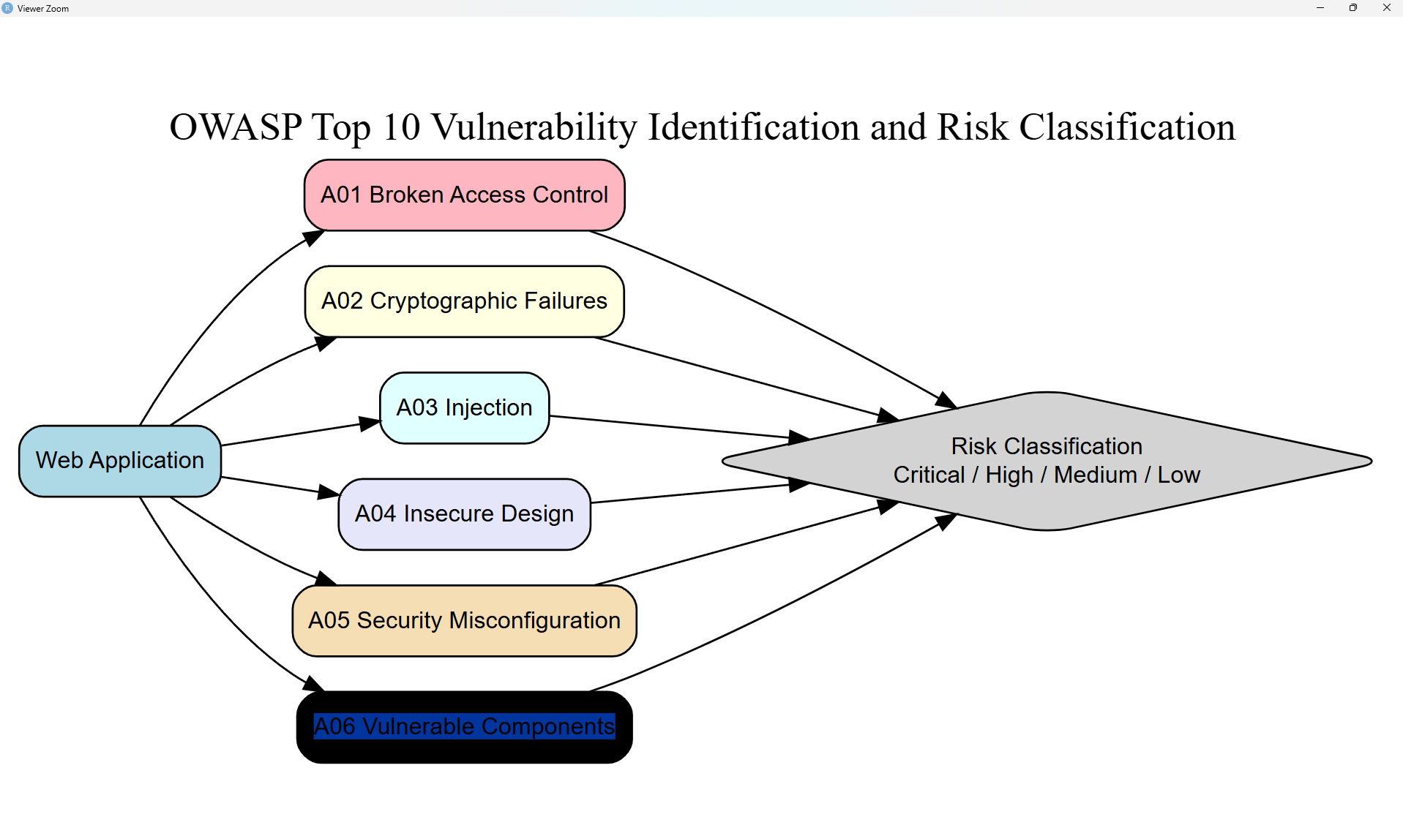

# ============================================================
# EXPERIMENT 19
# Security Test Case Design and Automated Verification Simulation
# ============================================================

# Run once if required
install.packages("dygraphs")
install.packages("xts")

library(dygraphs)
library(xts)

# Synthetic automated security test results
days <- as.Date("2026-09-26") + 0:9

test_data <- xts(
cbind(
Passed = c(5, 6, 7, 7, 8, 9, 9, 10, 10, 10),
Failed = c(5, 4, 3, 3, 2, 1, 1, 0, 0, 0),
TotalTests = c(10, 10, 10, 10, 10, 10, 10, 10, 10, 10)
),
order.by = days
)

dygraph(
test_data,
main = "Security Test Case Design and Automated Verification",
xlab = "Test Date",
ylab = "Number of Tests"
) %>%
dyRangeSelector()

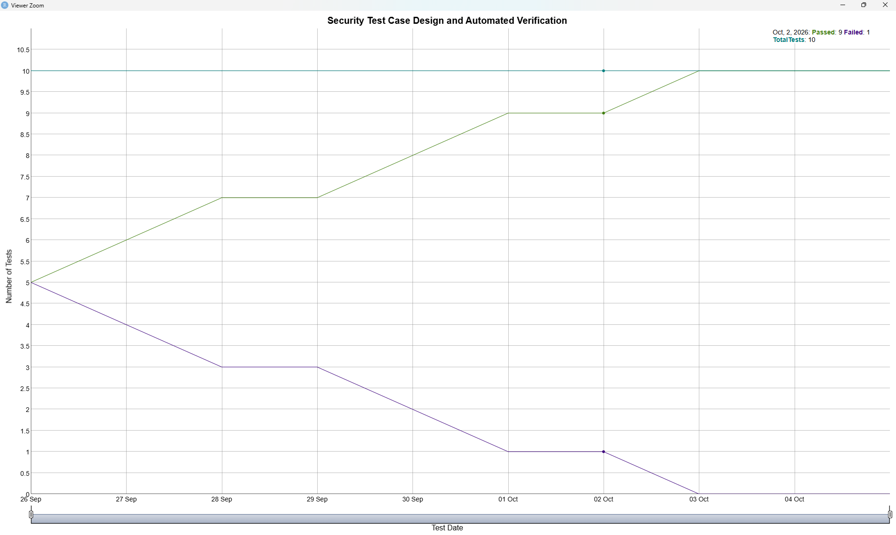

# ============================================================
# EXPERIMENT 20
# CI/CD Pipeline Security Verification and Quality Gate Simulation
# ============================================================

# Run once if required
install.packages("dygraphs")
install.packages("xts")

library(dygraphs)
library(xts)

# Synthetic CI/CD security verification data
days <- as.Date("2026-09-28") + 0:9

pipeline_data <- xts(
cbind(
Passed = c(3, 4, 5, 6, 7, 7, 8, 9, 9, 10),
Failed = c(7, 6, 5, 4, 3, 3, 2, 1, 1, 0),
SecurityGate = c(0, 0, 0, 1, 1, 1, 1, 1, 1, 1)
),
order.by = days
)

dygraph(
pipeline_data,
main = "CI/CD Pipeline Security Verification and Quality Gate",
xlab = "Pipeline Date",
ylab = "Test / Gate Results"
) %>%
dyRangeSelector()

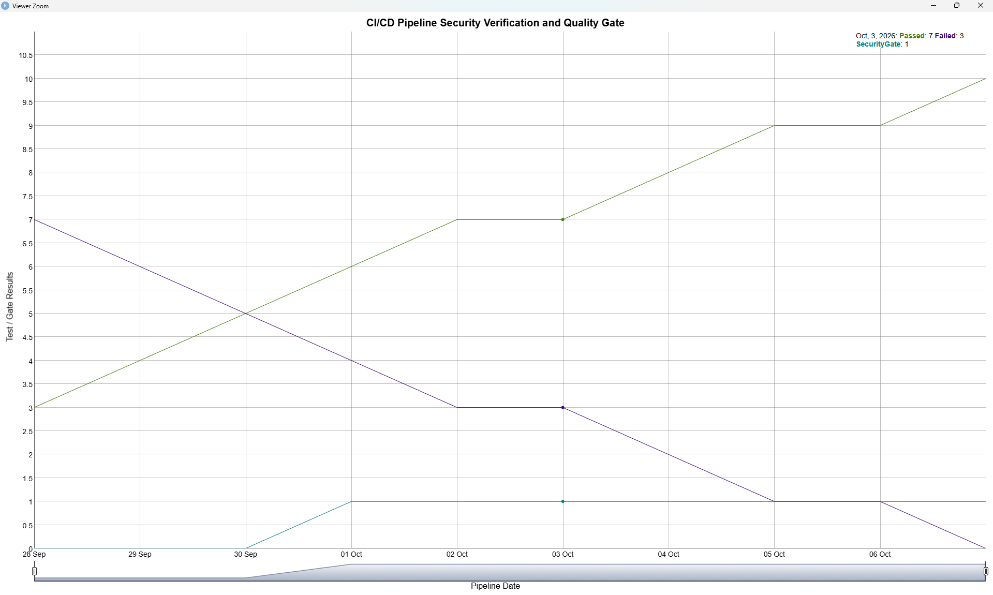

# ============================================================
# EXPERIMENT 21
# Security Vulnerability Prioritization using CVSS-Based Scoring
# ============================================================

# Run once if required
install.packages("dygraphs")
install.packages("xts")

library(dygraphs)
library(xts)

# Synthetic CVSS vulnerability scores
days <- as.Date("2026-10-01") + 0:9

cvss_data <- xts(
cbind(
CVSS = c(3.2, 5.1, 6.4, 7.2, 8.1, 9.0, 6.8, 4.5, 8.7, 7.5),
Priority = c(1, 2, 2, 3, 3, 4, 3, 2, 4, 3)
),
order.by = days
)

dygraph(
cvss_data,
main = "CVSS-Based Vulnerability Prioritization",
xlab = "Assessment Date",
ylab = "CVSS Score / Priority"
) %>%
dyRangeSelector()

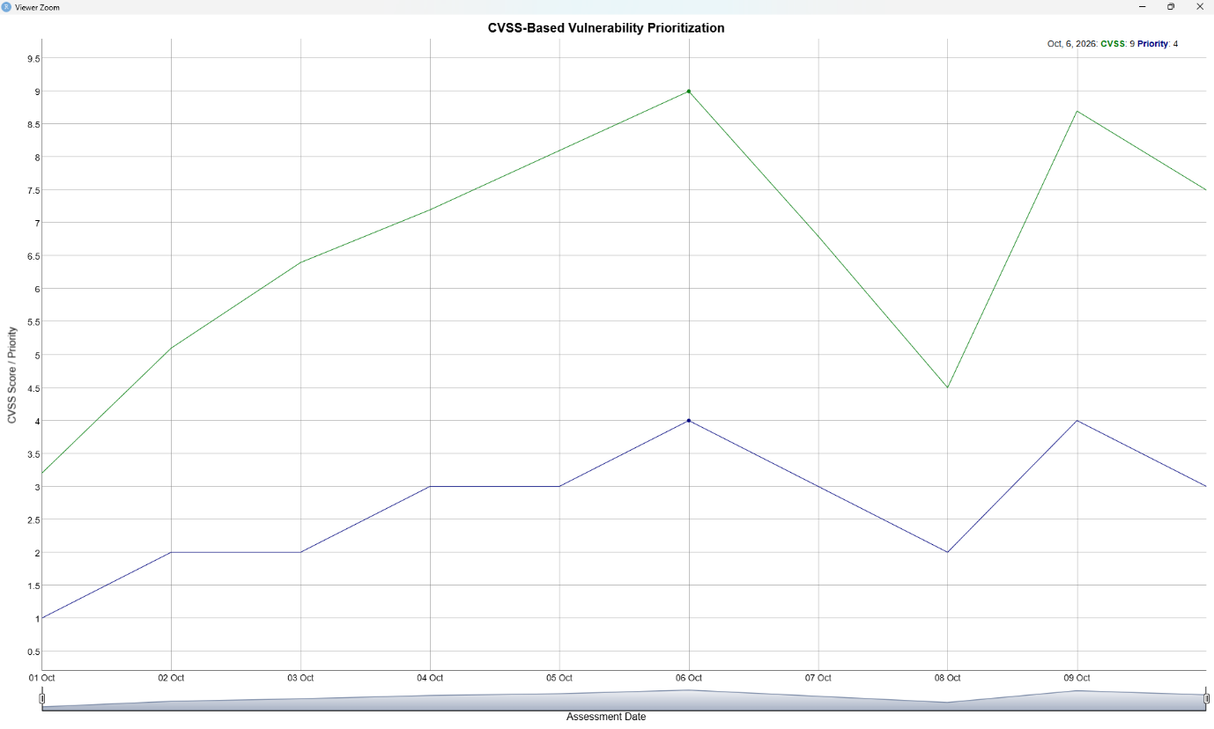

# ============================================================
# EXPERIMENT 22
# Secrets Detection and Secure Secrets Management Simulation
# ============================================================

# Run once if required
install.packages("dygraphs")
install.packages("xts")

library(dygraphs)
library(xts)

# Synthetic secrets detection data
days <- as.Date("2026-10-05") + 0:9

secrets_data <- xts(
cbind(
SecretsFound = c(12, 10, 9, 8, 6, 5, 4, 3, 2, 1),
SecretsRemoved = c(2, 3, 4, 5, 6, 7, 8, 9, 10, 11),
SecureSecrets = c(3, 5, 7, 9, 12, 14, 16, 18, 20, 22)
),
order.by = days
)

dygraph(
secrets_data,
main = "Secrets Detection and Secure Secrets Management",
xlab = "Scan Date",
ylab = "Number of Secrets"
) %>%
dyRangeSelector()

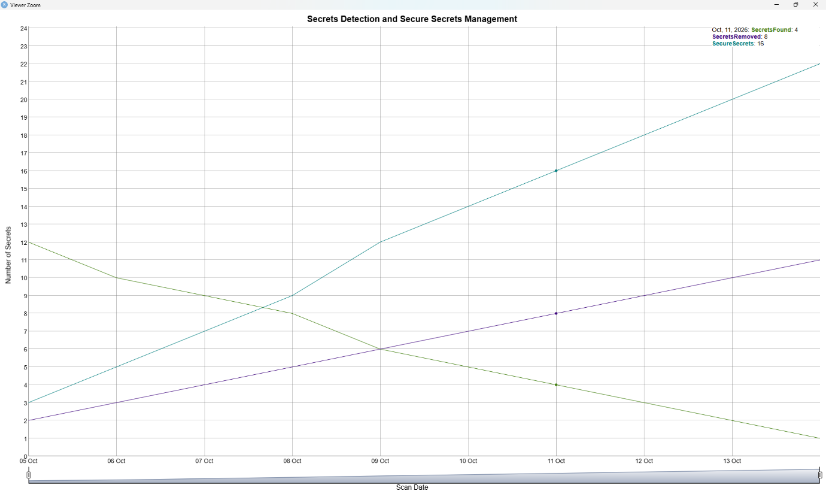

# ============================================================
# EXPERIMENT 23
# API Security Testing and Vulnerability Analysis
# ============================================================

# Run once if required
install.packages("dygraphs")
install.packages("xts")

library(dygraphs)
library(xts)

# Synthetic API security testing data
days <- as.Date("2026-10-07") + 0:9

api_data <- xts(
cbind(
Critical = c(3, 3, 2, 2, 1, 1, 1, 0, 0, 0),
High = c(7, 6, 6, 5, 4, 4, 3, 2, 1, 1),
Medium = c(10, 9, 8, 8, 7, 6, 5, 4, 3, 2),
SecurityTests = c(20, 22, 24, 25, 27, 29, 31, 33, 35, 37)
),
order.by = days
)

dygraph(
api_data,
main = "API Security Testing and Vulnerability Analysis",
xlab = "Test Date",
ylab = "Security Results"
) %>%
dyRangeSelector()

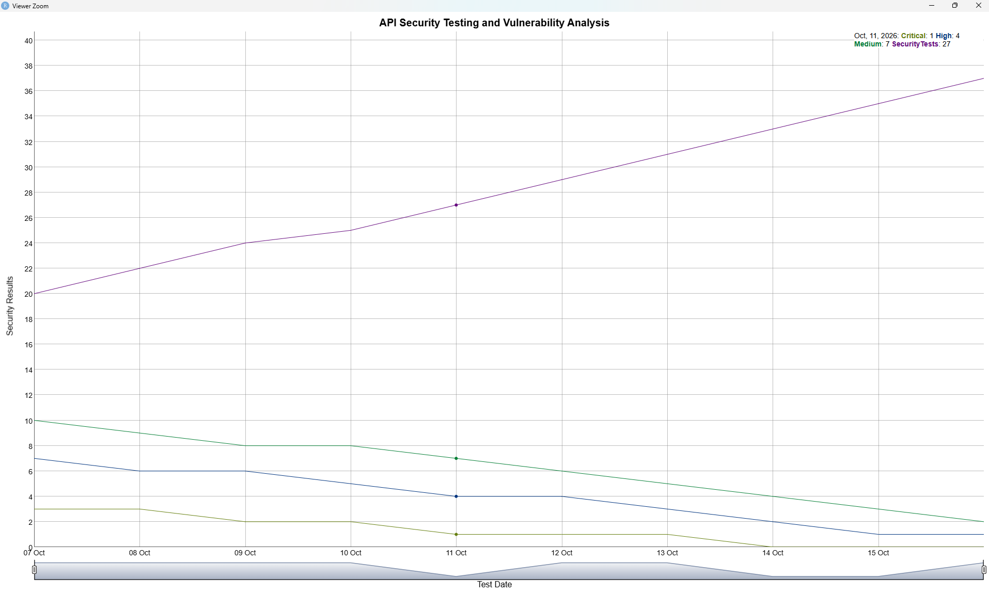

# ============================================================
# EXPERIMENT 24
# Web Application Security Vulnerability Simulation
# ============================================================

# Run once if required
install.packages("dygraphs")
install.packages("xts")

library(dygraphs)
library(xts)

# Synthetic web application vulnerability data
days <- as.Date("2026-10-09") + 0:9

web_data <- xts(
cbind(
Critical = c(4, 4, 3, 3, 2, 2, 1, 1, 0, 0),
High = c(8, 8, 7, 6, 5, 5, 4, 3, 2, 1),
Medium = c(14, 13, 12, 11, 10, 9, 8, 6, 5, 3),
Low = c(10, 10, 9, 8, 8, 7, 6, 5, 4, 3)
),
order.by = days
)

dygraph(
web_data,
main = "Web Application Security Vulnerability Simulation",
xlab = "Test Date",
ylab = "Number of Vulnerabilities"
) %>%
dyRangeSelector()

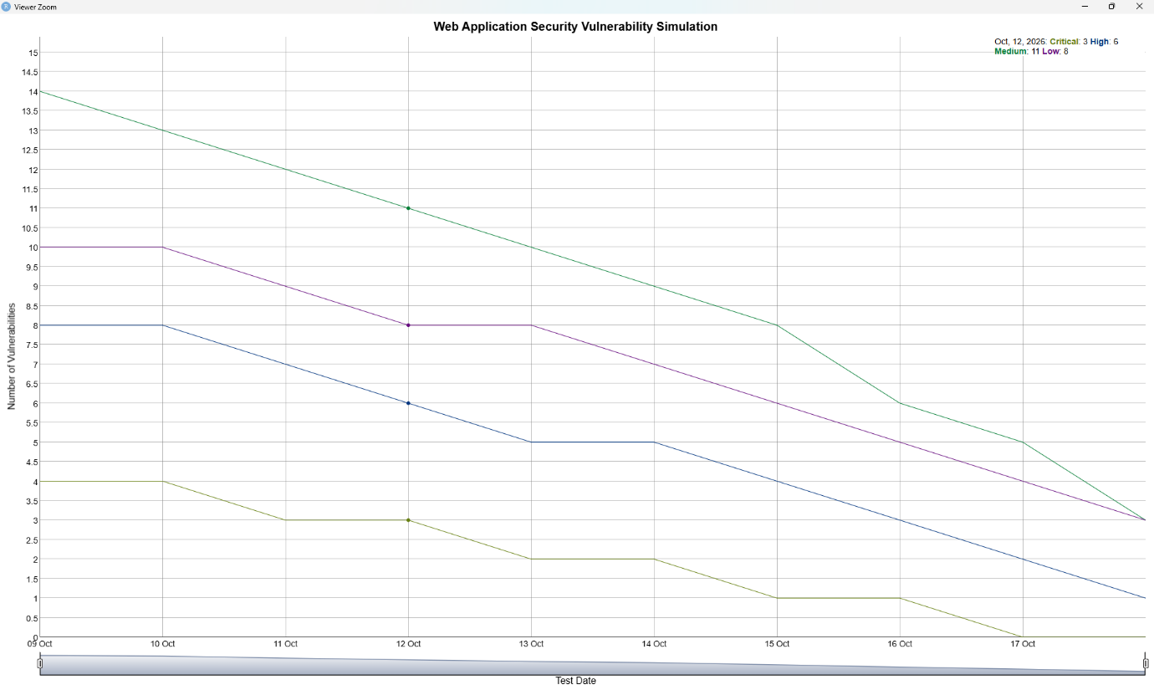

# ============================================================
# EXPERIMENT 25
# Security Policy Enforcement using Rule-Based Simulation
# ============================================================

# Run once if required
install.packages("dygraphs")
install.packages("xts")

library(dygraphs)
library(xts)

# Synthetic security policy enforcement data
days <- as.Date("2026-10-12") + 0:9

policy_data <- xts(
cbind(
Allowed = c(8, 9, 10, 11, 12, 13, 14, 15, 16, 17),
Blocked = c(7, 6, 6, 5, 4, 4, 3, 2, 2, 1),
PolicyViolations = c(6, 5, 5, 4, 3, 3, 2, 2, 1, 1)
),
order.by = days
)

dygraph(
policy_data,
main = "Rule-Based Security Policy Enforcement",
xlab = "Date",
ylab = "Number of Requests / Events"
) %>%
dyRangeSelector()

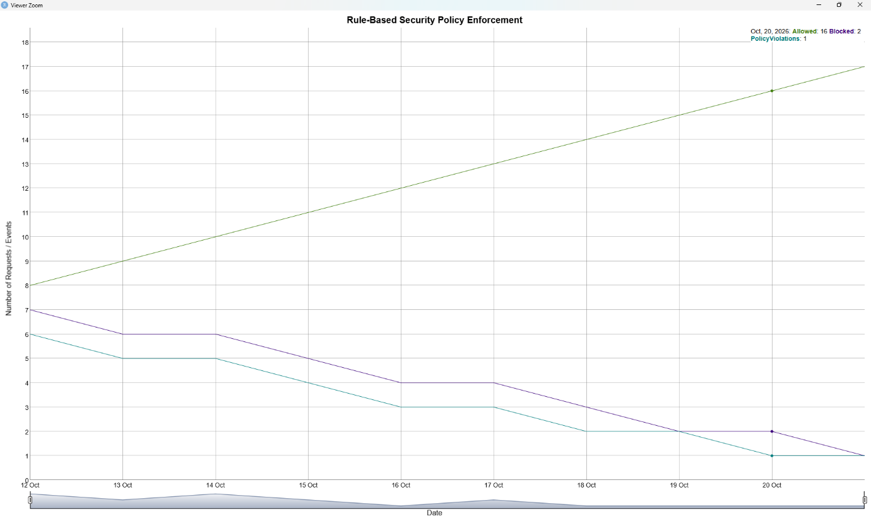

# ============================================================
# EXPERIMENT 26
# DevSecOps Security Gate Modelling and Decision Simulation
# ============================================================

# Run once if required
install.packages("DiagrammeR")

library(DiagrammeR)

grViz("
digraph SecurityGate {

graph [
rankdir=LR,
bgcolor=white,
label='DevSecOps Security Gate Decision Workflow',
labelloc=t,
fontsize=20
]

node [
shape=box,
style='rounded,filled',
fontname=Helvetica,
fontsize=13
]

Start [
label='Start',
fillcolor=lightblue
]

Build [
label='Application Build',
fillcolor=lightgreen
]

SecurityScan [
label='Security Scan',
fillcolor=lightyellow
]

Gate [
label='Security Gate\\nDecision',
shape=diamond,
fillcolor=lightpink
]

Deploy [
label='Deploy Application',
fillcolor=lightcyan
]

Reject [
label='Reject Build\\n& Fix Issues',
fillcolor=wheat
]

Start -> Build
Build -> SecurityScan
SecurityScan -> Gate

Gate -> Deploy [label='PASS']
Gate -> Reject [label='FAIL']

Reject -> Build [label='Rebuild']
}
")

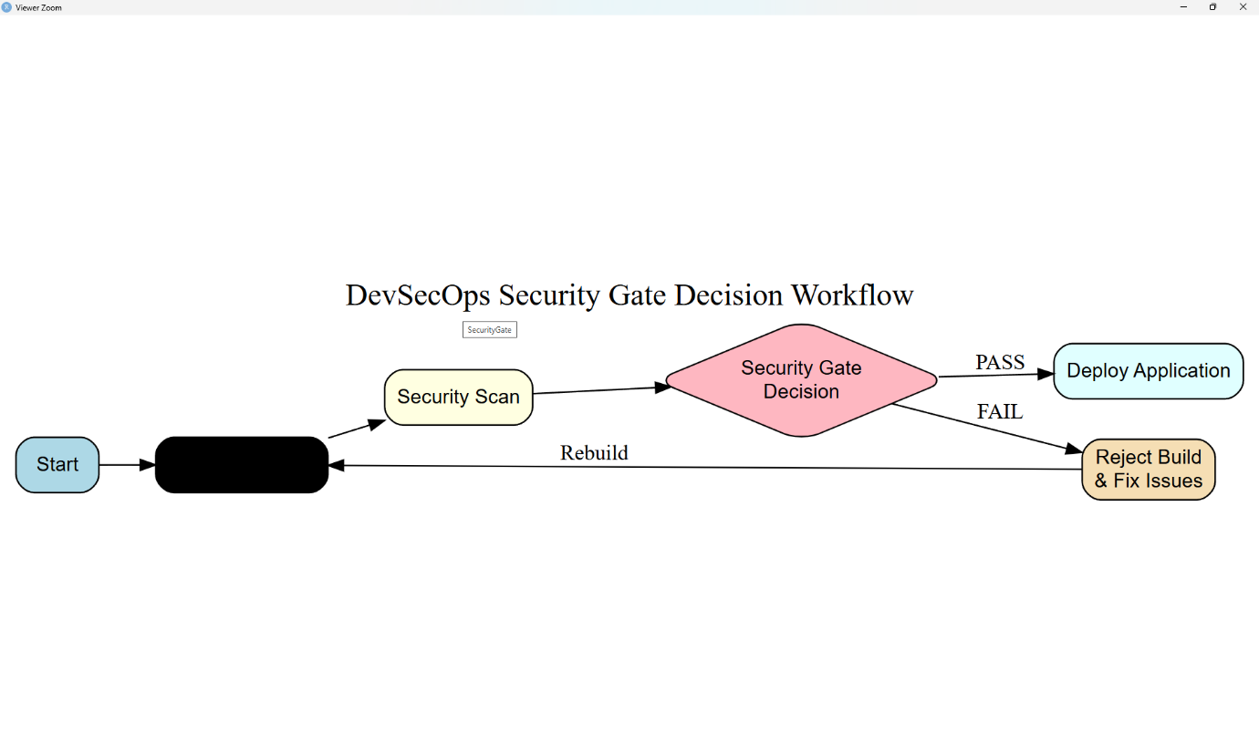

# ============================================================
# EXPERIMENT 27
# Security Metrics Generation and KPI Analysis
# ============================================================

# Run once if required
install.packages("dygraphs")
install.packages("xts")

library(dygraphs)
library(xts)

# Synthetic security KPI data
days <- as.Date("2026-10-14") + 0:9

kpi_data <- xts(
cbind(
SecurityKPI = c(60, 63, 66, 68, 71, 74, 76, 79, 82, 85),
SecurityScore = c(65, 67, 69, 72, 74, 76, 79, 81, 84, 87),
ComplianceKPI = c(70, 71, 73, 75, 77, 80, 82, 85, 88, 90)
),
order.by = days
)

dygraph(
kpi_data,
main = "Security Metrics and KPI Analysis",
xlab = "Date",
ylab = "KPI Score"
) %>%
dyRangeSelector()

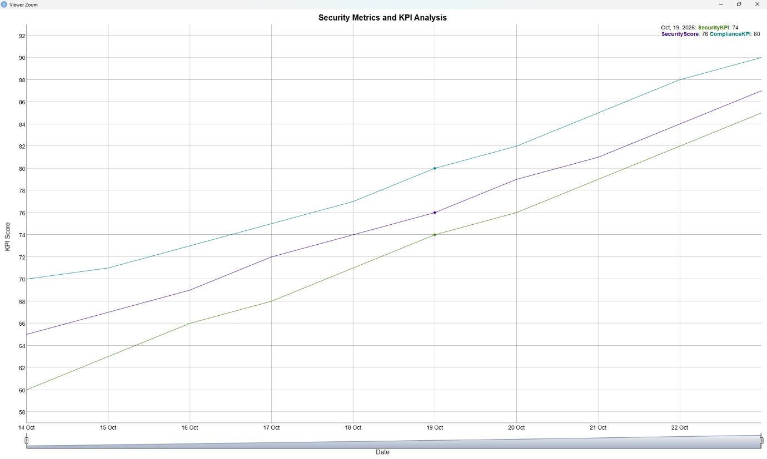

# ============================================================
# EXPERIMENT 28
# Continuous Security Monitoring and Vulnerability Detection Simulation
# ============================================================

# Run once if required
install.packages("dygraphs")
install.packages("xts")

library(dygraphs)
library(xts)

# Synthetic continuous security monitoring data
days <- as.Date("2026-10-19") + 0:9

monitoring_data <- xts(
cbind(
DetectedVulnerabilities = c(4, 6, 5, 8, 10, 7, 6, 5, 3, 2),
SecurityAlerts = c(3, 5, 4, 7, 9, 6, 5, 4, 3, 2),
ResolvedVulnerabilities = c(1, 2, 2, 3, 4, 4, 5, 5, 4, 3)
),
order.by = days
)

dygraph(
monitoring_data,
main = "Continuous Security Monitoring and Vulnerability Detection",
xlab = "Monitoring Date",
ylab = "Security Events"
) %>%
dyRangeSelector()

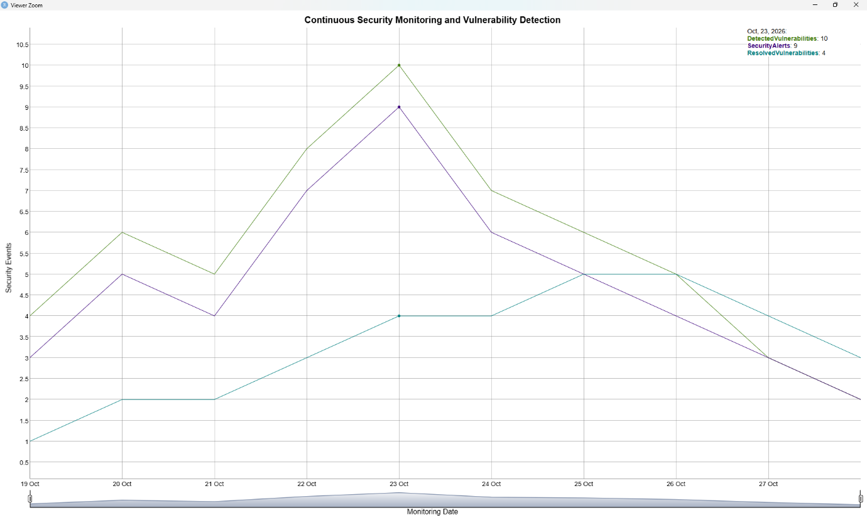

# ============================================================
# EXPERIMENT 29
# Security Event Correlation and Attack Pattern Analysis
# ============================================================

# Run once if required
install.packages("dygraphs")
install.packages("xts")

library(dygraphs)
library(xts)

# Synthetic security event correlation data
days <- as.Date("2026-10-21") + 0:9

event_data <- xts(
cbind(
SecurityEvents = c(4, 5, 6, 15, 7, 6, 18, 8, 5, 4),
CorrelatedEvents = c(1, 2, 2, 8, 3, 3, 10, 4, 2, 1),
AttackPatterns = c(0, 1, 1, 5, 2, 1, 7, 2, 1, 0)
),
order.by = days
)

dygraph(
event_data,
main = "Security Event Correlation and Attack Pattern Analysis",
xlab = "Date",
ylab = "Number of Security Events"
) %>%
dyRangeSelector()

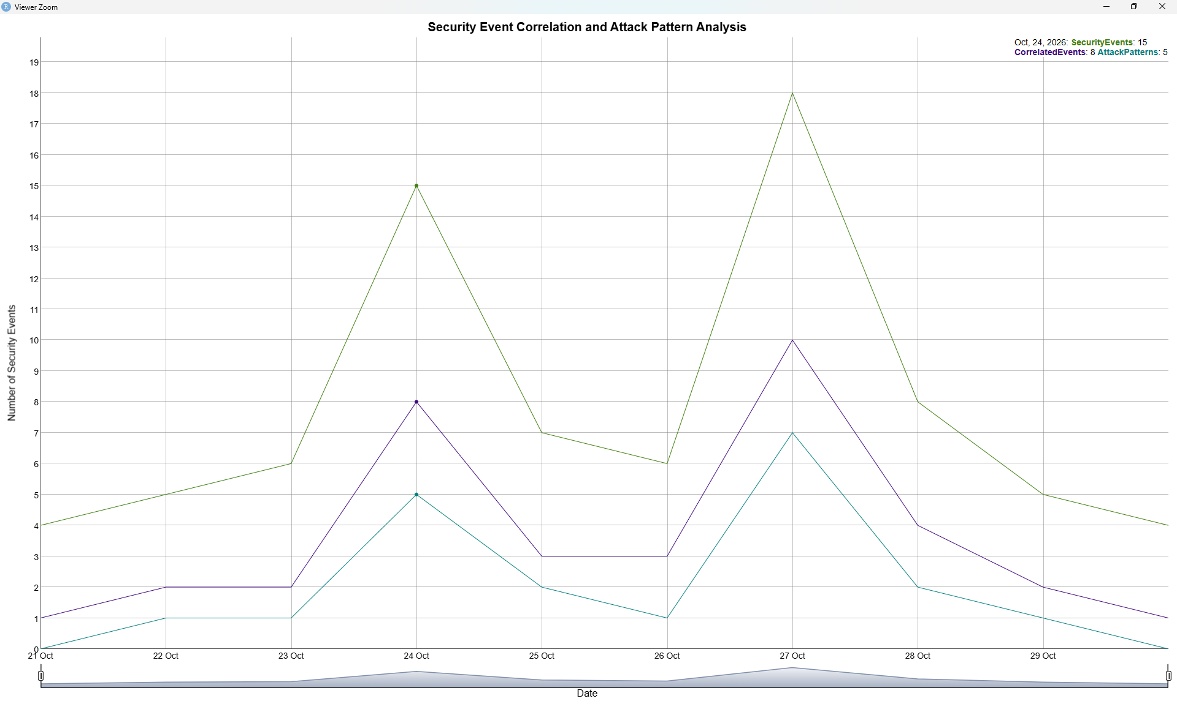

# ============================================================
# EXPERIMENT 30
# Intrusion Detection and Anomaly Detection Simulation
# ============================================================

# Run once if required
install.packages("dygraphs")
install.packages("xts")

library(dygraphs)
library(xts)

# Synthetic intrusion detection data
days <- as.Date("2026-10-23") + 0:9

intrusion_data <- xts(
cbind(
NormalTraffic = c(20, 22, 21, 23, 22, 21, 24, 23, 22, 21),
Anomalies = c(1, 2, 1, 3, 10, 2, 1, 8, 2, 1),
IntrusionAlerts = c(0, 1, 0, 1, 7, 1, 0, 6, 1, 0)
),
order.by = days
)

dygraph(
intrusion_data,
main = "Intrusion Detection and Anomaly Detection Simulation",
xlab = "Date",
ylab = "Number of Events"
) %>%
dyRangeSelector()

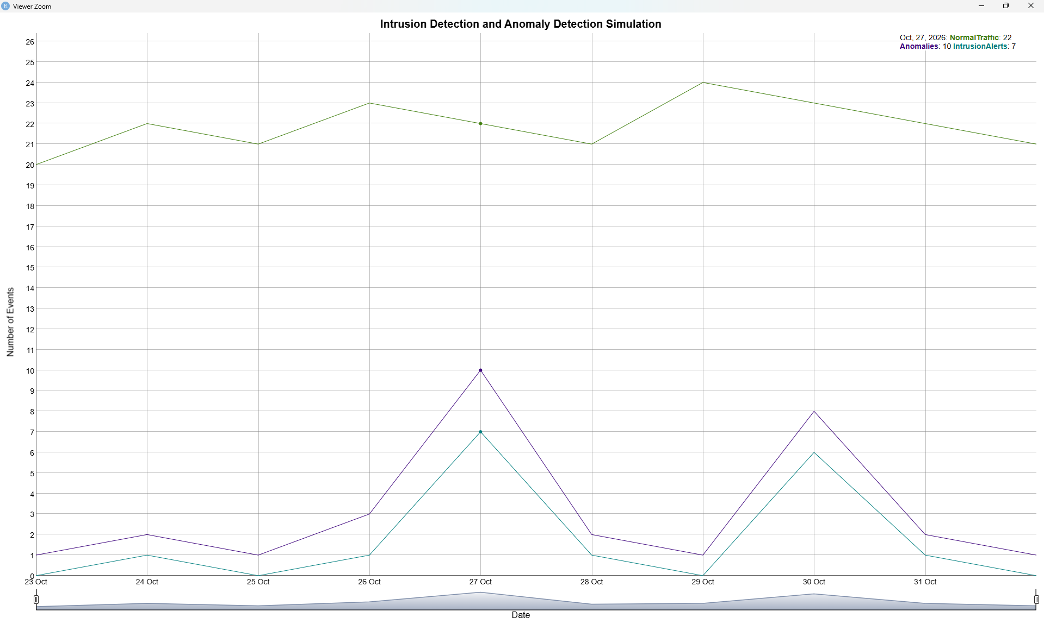

# ============================================================
# EXPERIMENT 31
# Security Incident Classification and Severity Analysis
# ============================================================

# Run once if required
install.packages("dygraphs")
install.packages("xts")

library(dygraphs)
library(xts)

# Synthetic incident severity data
days <- as.Date("2026-10-26") + 0:9

incident_data <- xts(
cbind(
Low = c(8, 9, 10, 11, 12, 13, 14, 15, 16, 17),
High = c(6, 6, 5, 5, 4, 4, 3, 3, 2, 2),
Critical = c(2, 2, 3, 2, 2, 1, 2, 1, 1, 1)
),
order.by = days
)

dygraph(
incident_data,
main = "Security Incident Classification and Severity Analysis",
xlab = "Date",
ylab = "Number of Incidents"
) %>%
dyRangeSelector()

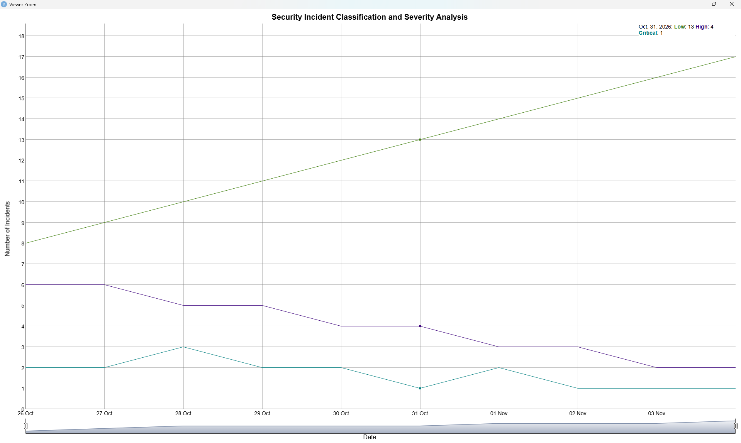

# ============================================================
# EXPERIMENT 32
# Incident Response Workflow Modelling and Simulation
# ============================================================

# Run once if required
install.packages("DiagrammeR")

library(DiagrammeR)

grViz("
digraph IncidentResponse {

graph [
rankdir=LR,
bgcolor=white,
label='Incident Response Workflow',
labelloc=t,
fontsize=20
]

node [
shape=box,
style='rounded,filled',
fontname=Helvetica,
fontsize=13
]

Detect [
label='Detect\\nSecurity Incident',
fillcolor=lightblue
]

Classify [
label='Classify\\nIncident',
fillcolor=lightyellow
]

Contain [
label='Contain\\nThreat',
fillcolor=lightpink
]

Eradicate [
label='Eradicate\\nRoot Cause',
fillcolor=lightgreen
]

Recover [
label='Recover\\nSystem',
fillcolor=lightcyan
]

Monitor [
label='Monitor\\n& Verify',
fillcolor=lavender
]

Report [
label='Incident Report\\n& Lessons Learned',
fillcolor=wheat
]

Detect -> Classify
Classify -> Contain
Contain -> Eradicate
Eradicate -> Recover
Recover -> Monitor
Monitor -> Report
}
")

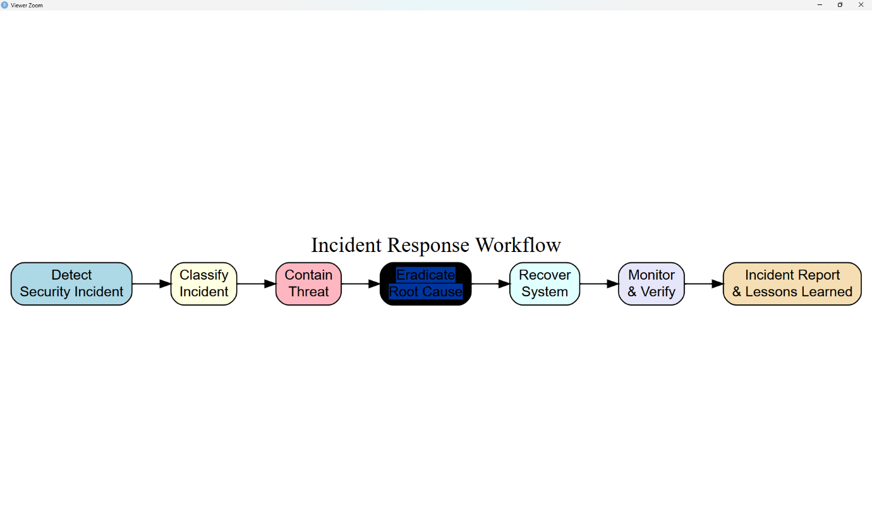

# ============================================================
# EXPERIMENT 33
# Security Incident Timeline Reconstruction and Root Cause Analysis
# ============================================================

# Run once if required
install.packages("dygraphs")
install.packages("xts")

library(dygraphs)
library(xts)

# Synthetic incident timeline data
days <- as.Date("2026-10-29") + 0:9

incident_data <- xts(
cbind(
IncidentEvents = c(1, 2, 4, 8, 12, 9, 5, 3, 2, 1),
SuspiciousEvents = c(0, 1, 2, 5, 9, 6, 3, 2, 1, 0),
ResolvedEvents = c(0, 0, 1, 2, 3, 5, 6, 7, 8, 9)
),
order.by = days
)

dygraph(
incident_data,
main = "Security Incident Timeline and Root Cause Analysis",
xlab = "Date",
ylab = "Number of Events"
) %>%
dyRangeSelector()

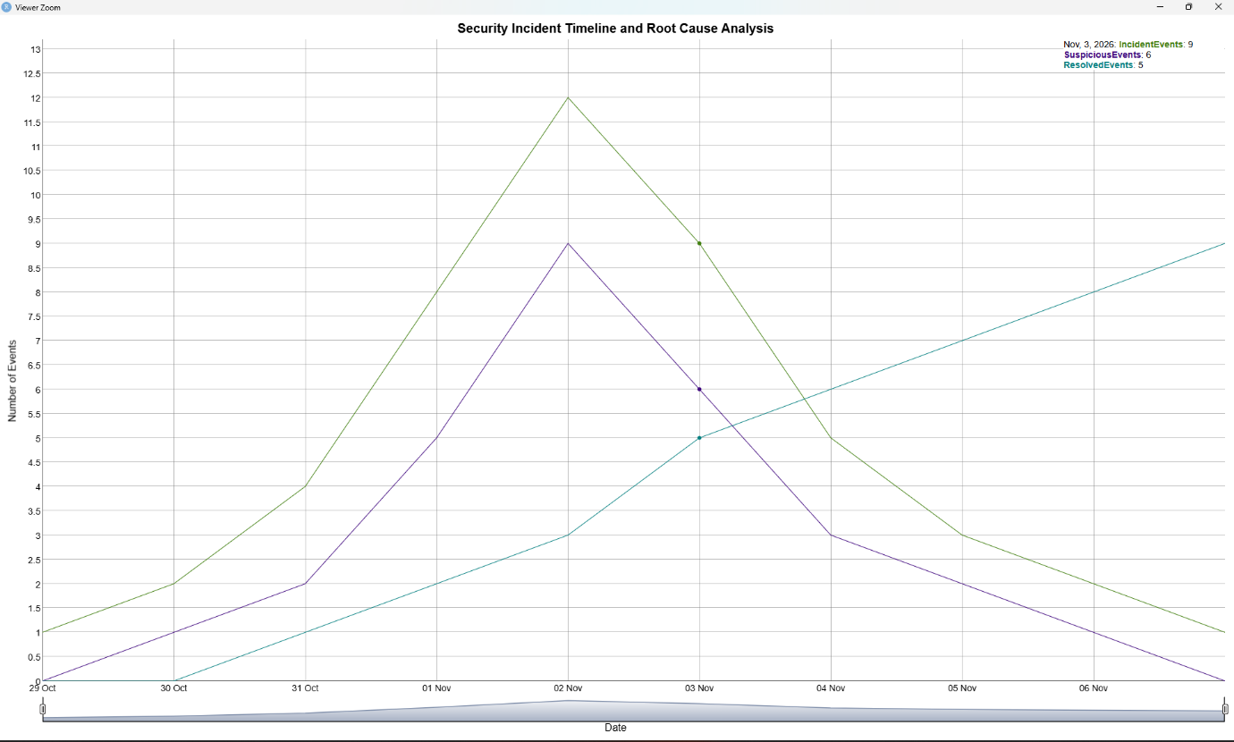
# ============================================================
# EXPERIMENT 34
# MTTD and MTTR Analysis
# ============================================================

# Run once if required
install.packages("dygraphs")
install.packages("xts")

library(dygraphs)
library(xts)

# Synthetic MTTD and MTTR data
days <- as.Date("2026-11-02") + 0:9

incident_data <- xts(
cbind(
MTTD = c(20, 18, 17, 15, 14, 12, 11, 10, 9, 8),
MTTR = c(40, 38, 35, 33, 30, 28, 25, 22, 20, 18)
),
order.by = days
)

dygraph(
incident_data,
main = "MTTD and MTTR Analysis",
xlab = "Date",
ylab = "Time (Minutes)"
) %>%
dyRangeSelector()

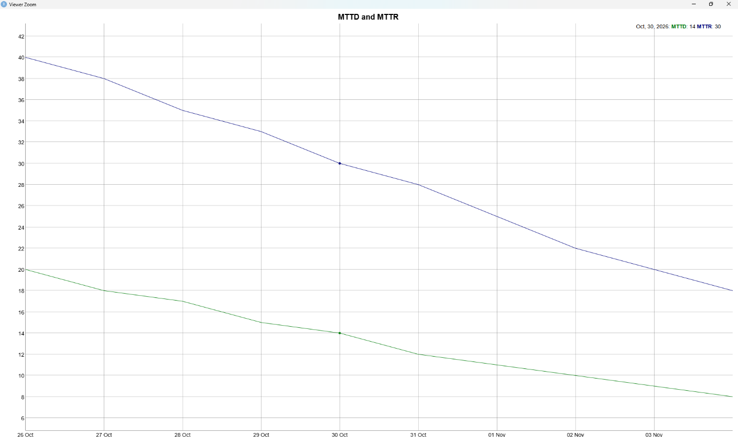

# ============================================================
# EXPERIMENT 35
# Security Compliance Monitoring and Governance Simulation
# ============================================================

# Run once if required
install.packages("dygraphs")
install.packages("xts")

library(dygraphs)
library(xts)

# Synthetic security compliance data
days <- as.Date("2026-11-05") + 0:9

compliance_data <- xts(
cbind(
ComplianceScore = c(70, 72, 75, 77, 80, 82, 84, 87, 90, 92),
PoliciesSatisfied = c(65, 68, 70, 73, 76, 79, 82, 85, 88, 91),
AuditFindings = c(15, 13, 12, 10, 9, 8, 6, 5, 3, 2)
),
order.by = days
)

dygraph(
compliance_data,
main = "Security Compliance Monitoring and Governance",
xlab = "Date",
ylab = "Compliance Metrics"
) %>%
dyRangeSelector()

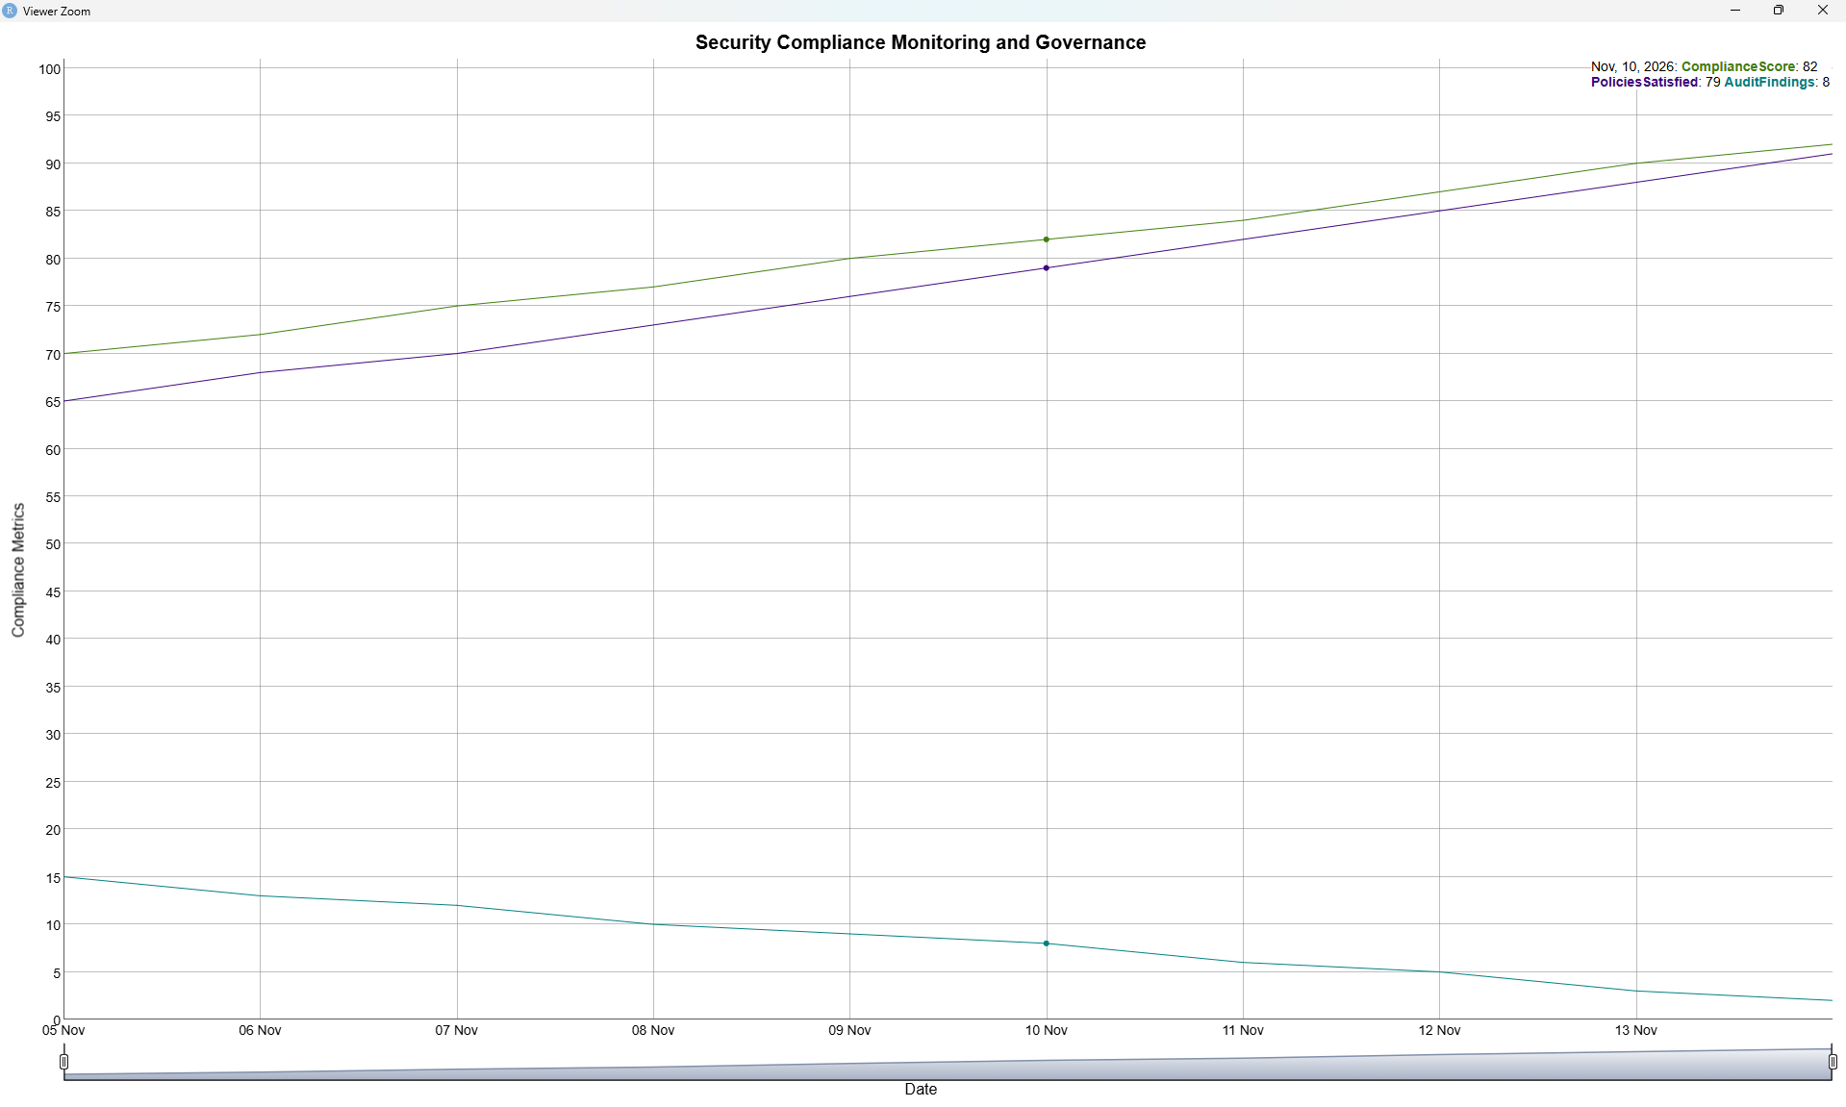

# ============================================================
# EXPERIMENT 36
# DevSecOps Risk-Based Decision Making using Synthetic Data
# ============================================================

# Run once if required
install.packages("dygraphs")
install.packages("xts")

library(dygraphs)
library(xts)

# Synthetic risk-based decision data
days <- as.Date("2026-11-07") + 0:9

risk_data <- xts(
cbind(
RiskScore = c(80, 75, 70, 65, 60, 55, 50, 45, 40, 35),
SecurityScore = c(55, 58, 61, 65, 68, 72, 75, 79, 82, 85),
DecisionScore = c(40, 45, 50, 55, 60, 65, 70, 75, 80, 85)
),
order.by = days
)

dygraph(
risk_data,
main = "DevSecOps Risk-Based Decision Making",
xlab = "Date",
ylab = "Risk / Security Score"
) %>%
dyRangeSelector()

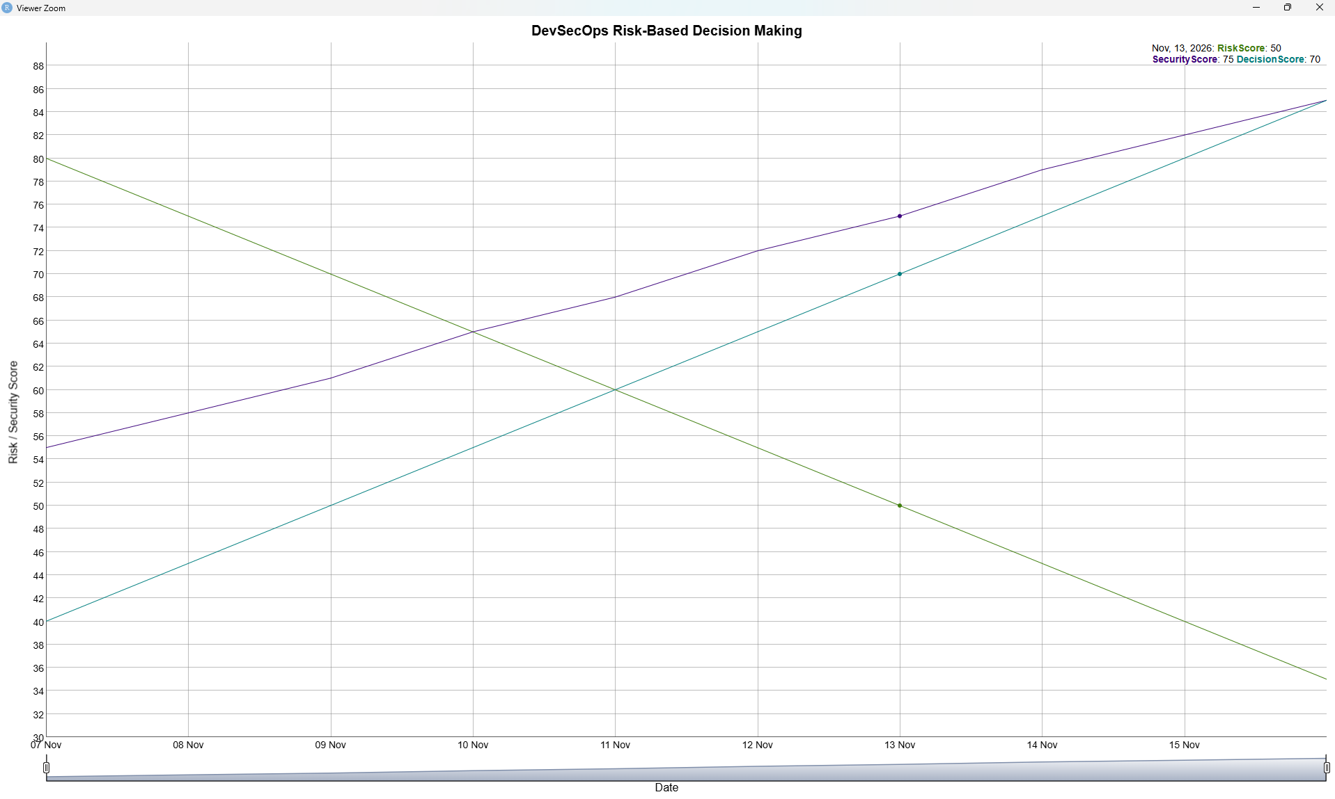

# ============================================================
# EXPERIMENT 37
# Monte Carlo Simulation for DevSecOps Security Risk Analysis
# ============================================================

# Run once if required
install.packages("dygraphs")
install.packages("xts")

library(dygraphs)
library(xts)

# Generate Monte Carlo risk simulation data
set.seed(1)

simulations <- 100
risk <- rnorm(simulations, mean = 50, sd = 10)

# Keep risk values within a practical range
risk <- pmax(0, pmin(100, risk))

# Sort risk values for clear visualization
risk <- sort(risk)

days <- as.Date("2026-11-10") + 0:(simulations - 1)

risk_data <- xts(
cbind(
RiskScore = risk
),
order.by = days
)

dygraph(
risk_data,
main = "Monte Carlo DevSecOps Security Risk Simulation",
xlab = "Simulation",
ylab = "Risk Score"
) %>%
dyRangeSelector()

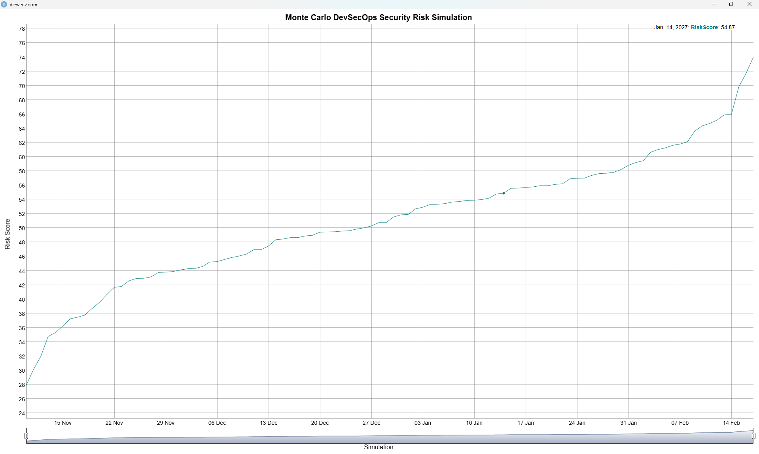

# ============================================================
# EXPERIMENT 38
# Comparative Evaluation of Secure and Insecure CI/CD Pipelines
# ============================================================

# Run once if required
install.packages("dygraphs")
install.packages("xts")

library(dygraphs)
library(xts)

# Synthetic CI/CD pipeline comparison data
days <- as.Date("2026-11-12") + 0:9

pipeline_data <- xts(
cbind(
SecurePipeline = c(90, 91, 92, 93, 94, 95, 96, 97, 98, 99),
InsecurePipeline = c(70, 68, 72, 65, 67, 64, 62, 60, 58, 55),
SecurityChecks = c(8, 9, 9, 10, 10, 11, 11, 12, 12, 13)
),
order.by = days
)

dygraph(
pipeline_data,
main = "Secure vs Insecure CI/CD Pipeline",
xlab = "Date",
ylab = "Pipeline Security Score"
) %>%
dyRangeSelector()

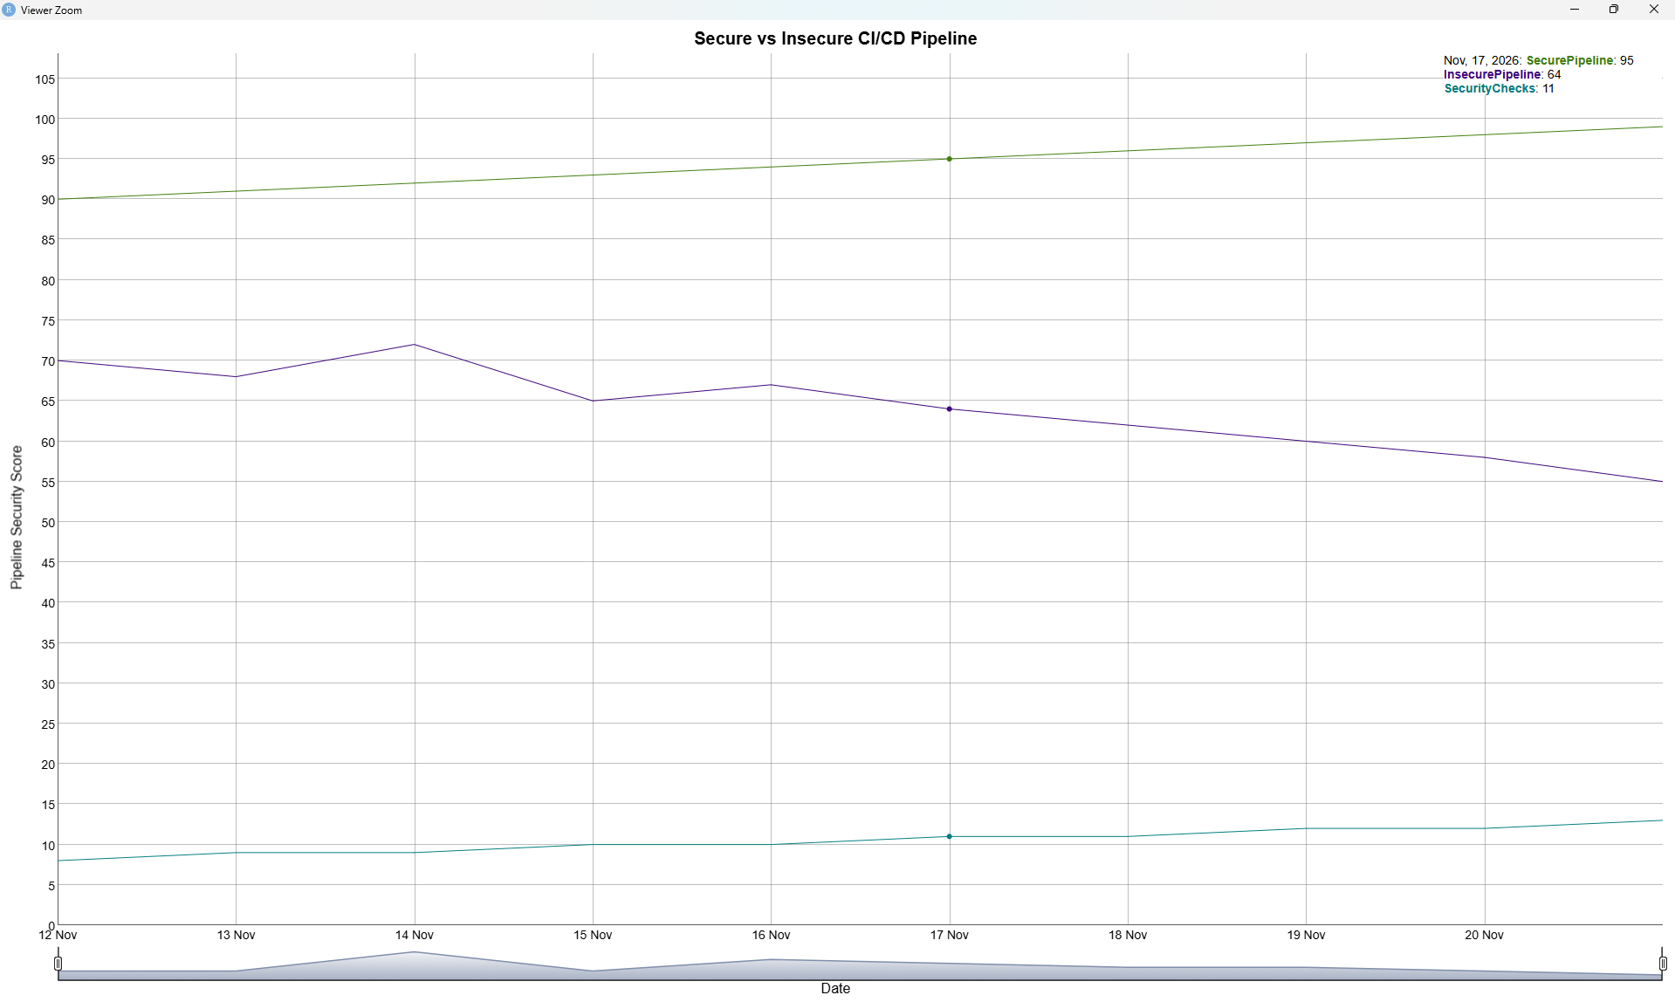

# ============================================================
# EXPERIMENT 39
# Integrated DevSecOps Security Analytics and Reporting
# ============================================================

# Run once if required
install.packages("dygraphs")
install.packages("xts")

library(dygraphs)
library(xts)

# Synthetic integrated security analytics data
days <- as.Date("2026-11-14") + 0:9

security_data <- xts(
cbind(
SecurityScore = c(60, 64, 68, 70, 73, 76, 79, 82, 85, 88),
Vulnerabilities = c(20, 18, 17, 15, 13, 11, 9, 7, 5, 4),
SecurityAlerts = c(15, 14, 12, 11, 9, 8, 6, 5, 3, 2)
),
order.by = days
)

dygraph(
security_data,
main = "Integrated DevSecOps Security Analytics and Reporting",
xlab = "Date",
ylab = "Security Metrics"
) %>%
dyRangeSelector()

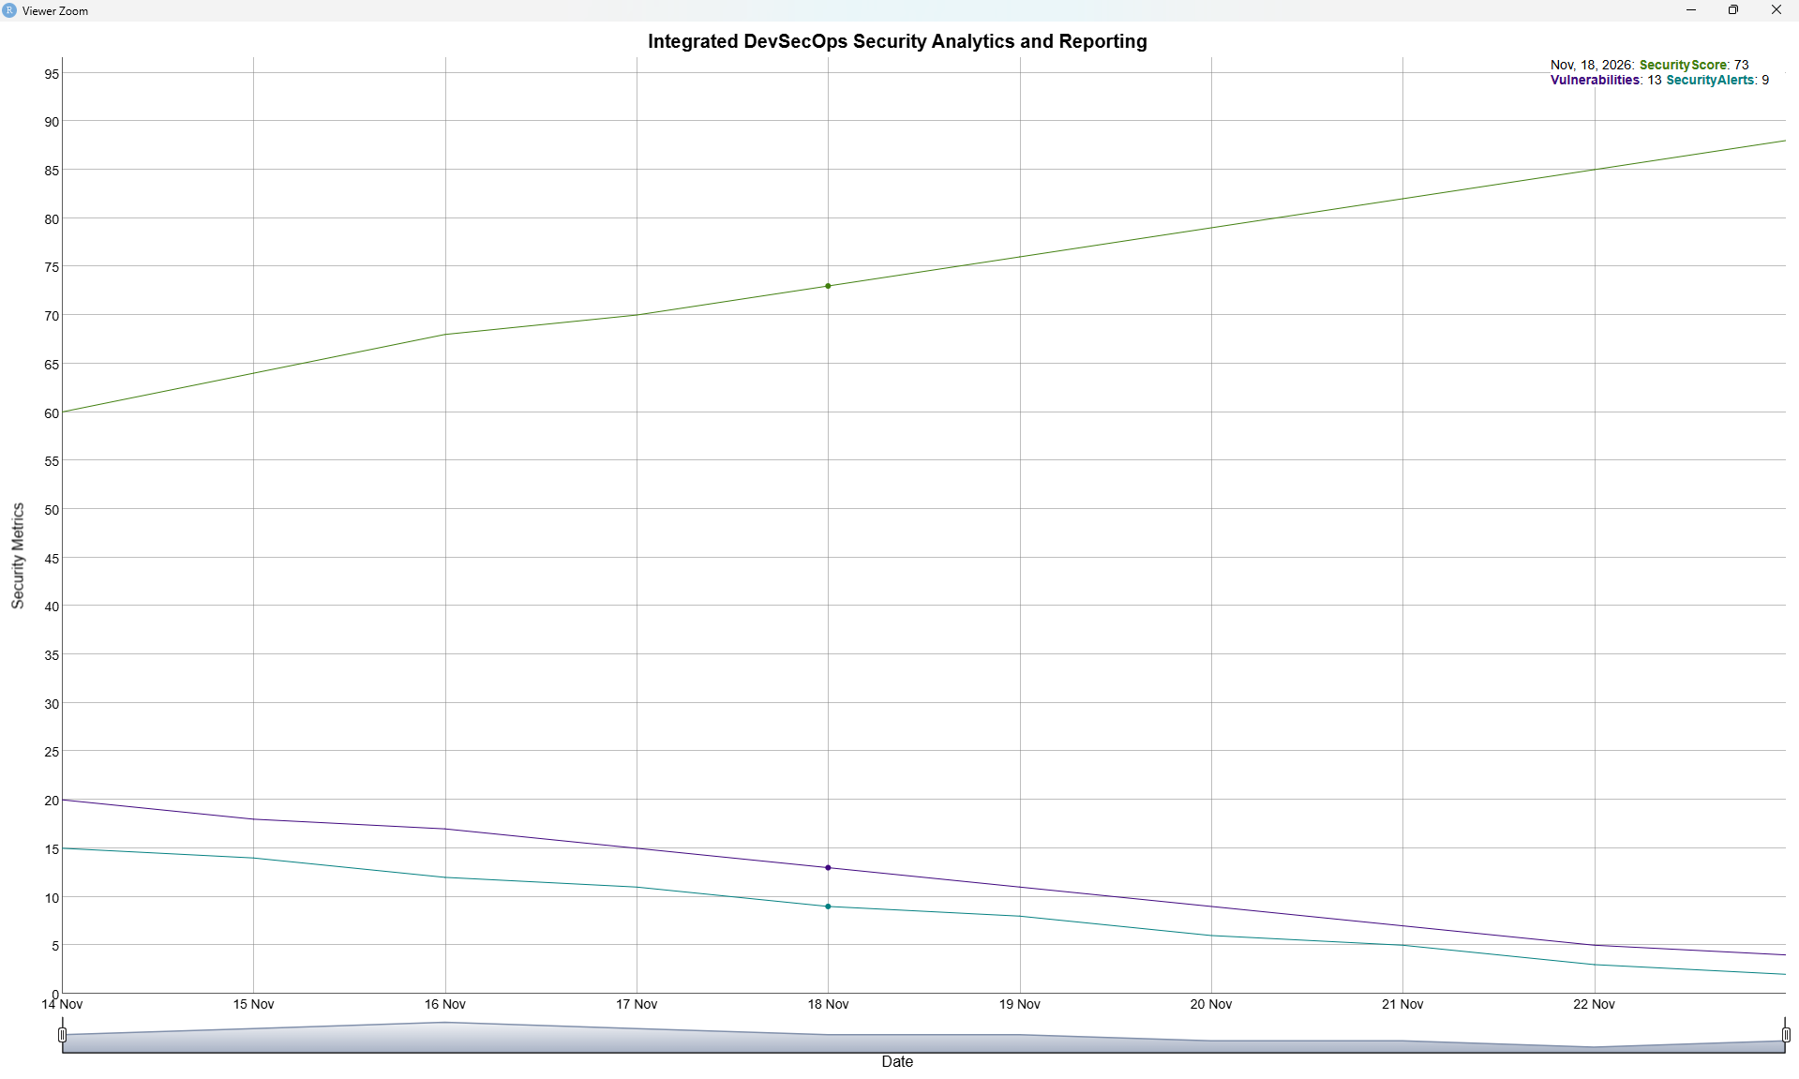

# ============================================================
# EXPERIMENT 40
# End-to-End DevSecOps Pipeline Security Simulation and Evaluation
# ============================================================

# Run once if required
install.packages("dygraphs")
install.packages("xts")

library(dygraphs)
library(xts)

# Synthetic end-to-end DevSecOps pipeline data
days <- as.Date("2026-11-16") + 0:9

pipeline_data <- xts(
cbind(
Build = c(70, 72, 75, 78, 80, 82, 84, 86, 88, 90),
Security = c(60, 64, 68, 72, 75, 78, 81, 84, 87, 90),
Deployment = c(55, 60, 65, 68, 72, 76, 80, 84, 87, 91)
),
order.by = days
)

dygraph(
pipeline_data,
main = "End-to-End DevSecOps Pipeline Security Simulation",
xlab = "Date",
ylab = "Pipeline Score"
) %>%
dyRangeSelector()

