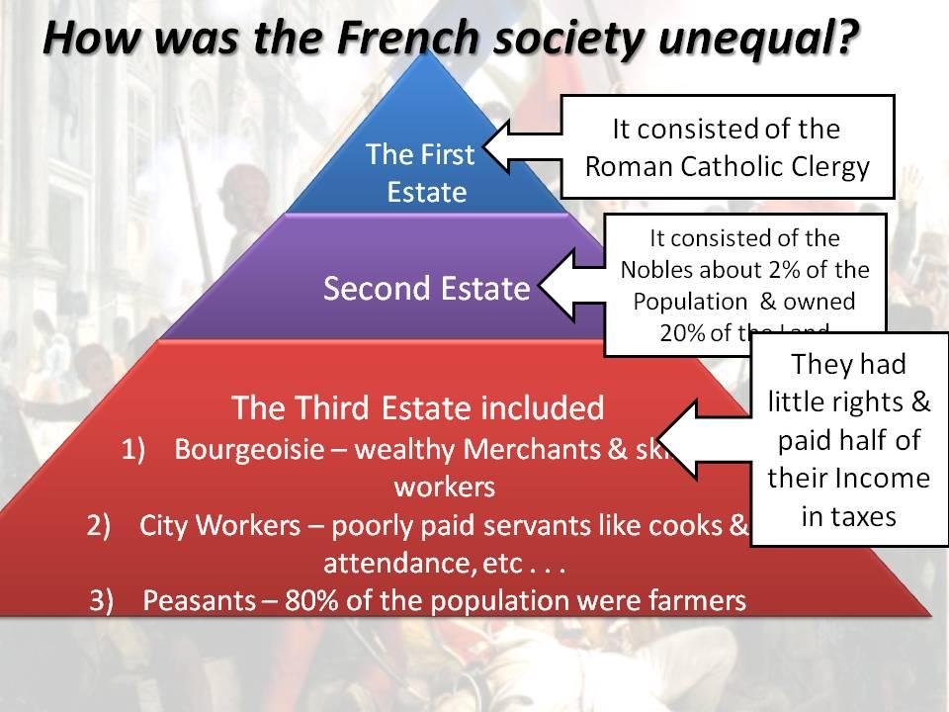

The following chart represents economic inequality because

1. The third estate paid 50% of their income in taxes
2. The bourgeoisie had many more opportunities than peasants and the second estate

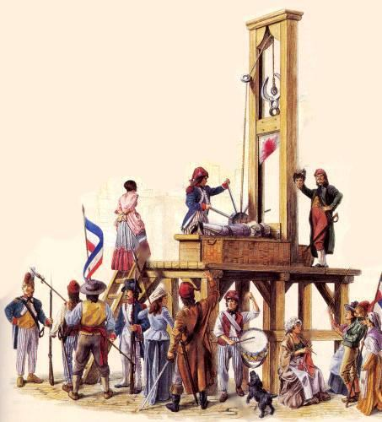

The picture of the guillotine most clearly represents

1. The massive revolts of peasants, merchants, and member of the second estate against the clergy
2. The ruthless (brutal) form of punishment used frequently by Robespierre against “enemies of the revolution”
3. The main punishment used by King Louis XVI against criminals before the revolution