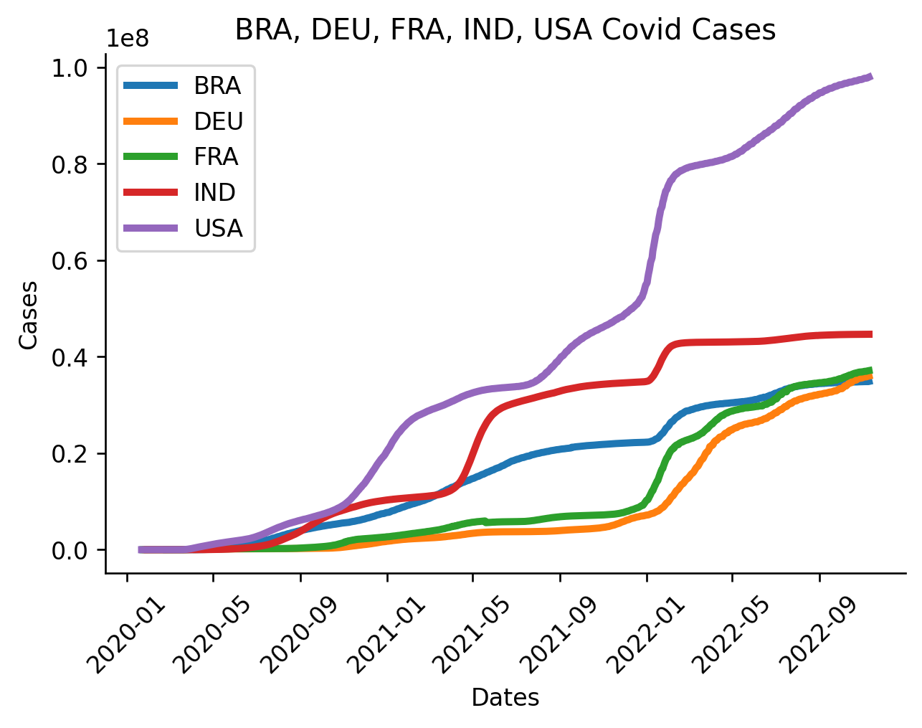

**The line plot evidenced the number of COVID-19 cases by time from 2020-2022. A Line plot is a good way to compare time trends.**

**The plot reveals that the USA is the leading country in the number of COVID-19 cases followed by India and Brazil.**

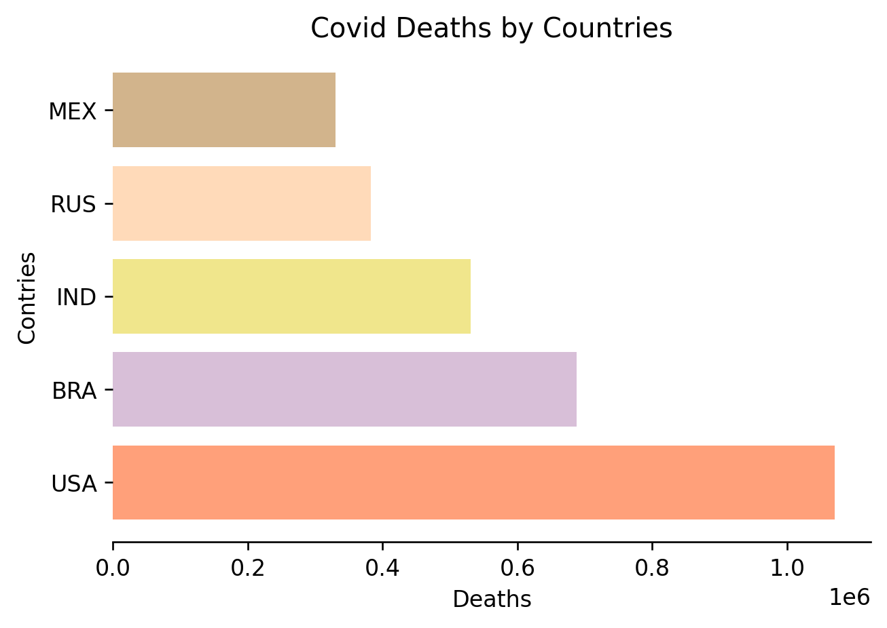

**The bar plot shows the number of COVID-19 deaths by country. I chose a bar chart because it is a good way to compare the distribution by country.**

**The chart allows us to see that the USA has the largest number of covid deaths, followed by Brazil and India.**

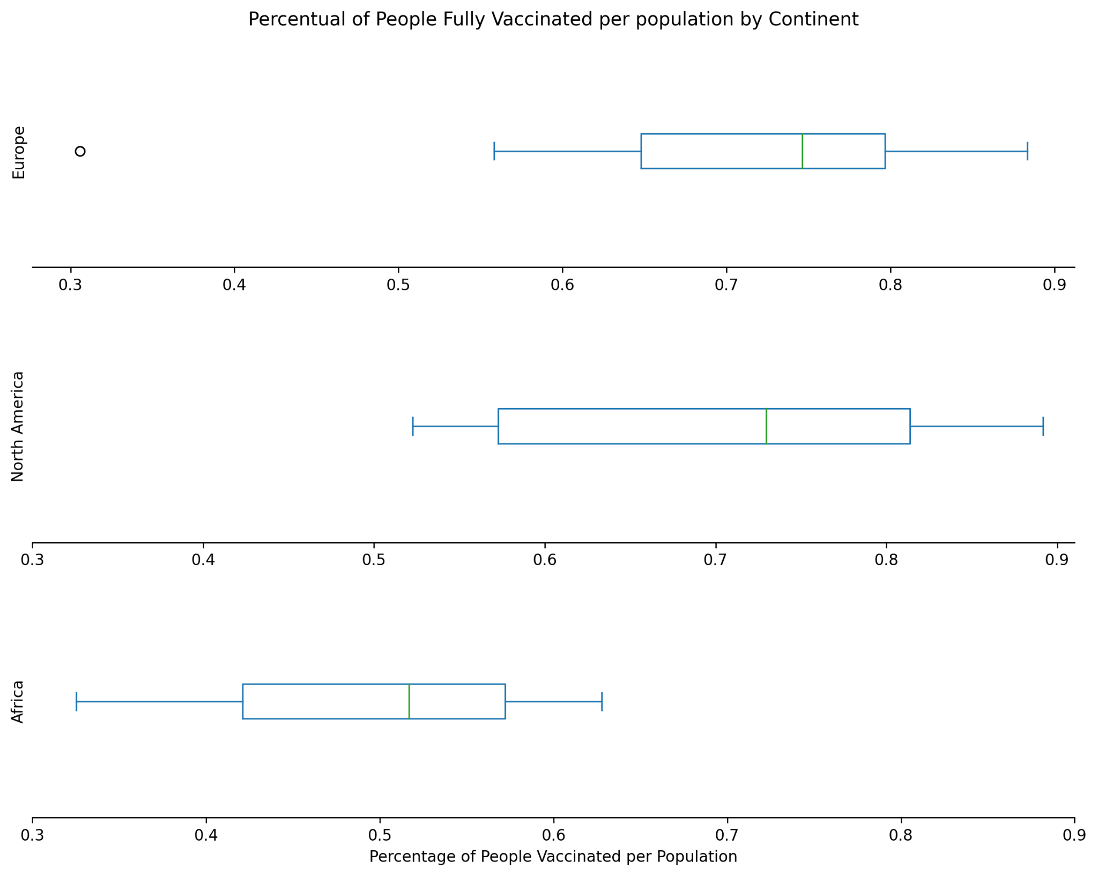

**The box plot shows the percentage of people fully vaccinated in three continents. I chose a box plot chart because it is a good way to compare median. The chart enables us to see that Europe and North America countries have a median percentage of fully vaccinated population around 75% while Africa has a median about 50%.**