Deliverable #2

Component Design

**Project 1: Mobile Testing as a Service**

**Component: Crowd-sourced tester management**

CMPE281 – Cloud Technology

**Rachit Saxena**

**012469626**

* Section 1: Component overview

**Purpose:**

Project requires us to develop a mobile service platform MobileTaas, which is a SaaS based testing platform, which allows user to provide cloud based mobile testing for mobile apps.

It has basically three kinds of user groups:

1. Freelanced testers
2. Mobile App Project Managers
3. Operation Service Staff.

**Objective:**

With Cloud market growing at exponential rate more and more services and platforms are getting introduced in cloud market to match the ever-growing demands of users. Such in the need for testing portal to make application more bug free and efficient.

With MTaas application user gets an online portal for testing through which he/she can access all the services of freelance testers who are registered on this platform. Which provides various advantages to users over conventional testing platform like:

* Reduced cost over conventional mobile testing platforms.
* Fewer changes and upgrades on mobile applications.
* Multi tenancy of mobile web applications.

**Function Scope & Usage**:

One of the components of MTaas application is Crowd Sourced tester management, this functionality allows users with experience in freelance testing to get access to this platform by creating an account with their id, profile, contact, resume, project information etc. After creating account user gets access to portal using its id and password through which testers can provide its services to other users who wants to tests their application.

The scope and usage of cloud based mobile based cloud testing services are:

Sharing of mobile resources over shared cross platform.

On demand mobile testing service.

Multi-tenant and customization support.

* Section 2: Component application interface design and analysis

**API DOCUMENTATION: Documentation below shows all the API related to**

**Crowd sourced tester management component in MTass application.**

**Allowed HTTPs requests:**

PUT: To create resource

POST: Update resource

GET: Get a resource or list of resources

DELETE: To delete resource

**Description of Usual Server Responses:**

* 200 OK - the request was successful (some API calls may return 201 instead).
* 201 Created - the request was successful, and a resource was created.
* 204 No Content - the request was successful but there is no representation to return (i.e. the response is empty).
* 400 Bad Request - the request could not be understood or was missing required parameters.
* 401 Unauthorized - authentication failed or user doesn't have permissions for requested operation.
* 403 Forbidden - access denied.
* 404 Not Found - resource was not found.
* 405 Method Not Allowed - requested method is not supported for resource.

The scope of cloud-based mobile testing-as-a-service

(mobile TaaS) primarily includes eight types of testing

activities

The scope of cloud-based mobile testing-as-a-service

(mobile TaaS) primarily includes eight types of testing

activities

|  |
| --- |
| 1. Sign Up New User |
| POST <http://localhost:3001/signup> |
| **Details of this API:**  Creates a new user account. |
| **Attributes:**   * name | String | Name * email | String | Unique id of the user * password | String | Password of the user * type |String | Type of User – Manager or Tester |
| **Response Type :** Response Code |

|  |
| --- |
| 2. Sign In User |
| GET [http://localhost:3001/](http://localhost:3001/createuser)signin |
| **Details of this API:**  Sign In user into his account |
| **Attributes:**   * email | String | Unique Id of the user * password | String | Password of the user |
| **Response Type :** JSON | Response Code |

|  |
| --- |
| 3. Create User Profile |
| GET <http://localhost:3001/createuser>profile |
| **Details of this API:**  Creates user profile. |
| **User attributes:**   * name | String | Name * id | String | Id of the user * description | String | Description of the project * skillset | String | Set of skill. * Resume | file | resume format. |
| **Response Type :** JSON | Response Code |

|  |
| --- |
| 4. Update User Profile |
| GET <http://localhost:3001/updateuser>profile |
| **Details of this API:**  Update user profile. |
| **User attributes:**   * name | String | Name * id | String | Id of the user * description | String | Description of the project * skillset | String | Set of skill. * Resume | file | resume format. |
| **Response Type :** JSON | Response Code |

|  |
| --- |
| 5. Delete User Profile |
| GET <http://localhost:3001/deleteuser>profile |
| **Details of this API:**  Deletes user profile. |
| **User attributes:**   * name | String | Name * id | String | Id of the user |
| **Response Type:** Event | Response Code |

* Section 3: Component function design, data and DB design, and behavior analysis

**Class Diagram**: Class diagram of MTaas contains 5 classes with multiple parameters and methods as shown below. It presents better visual perspective of logic design.

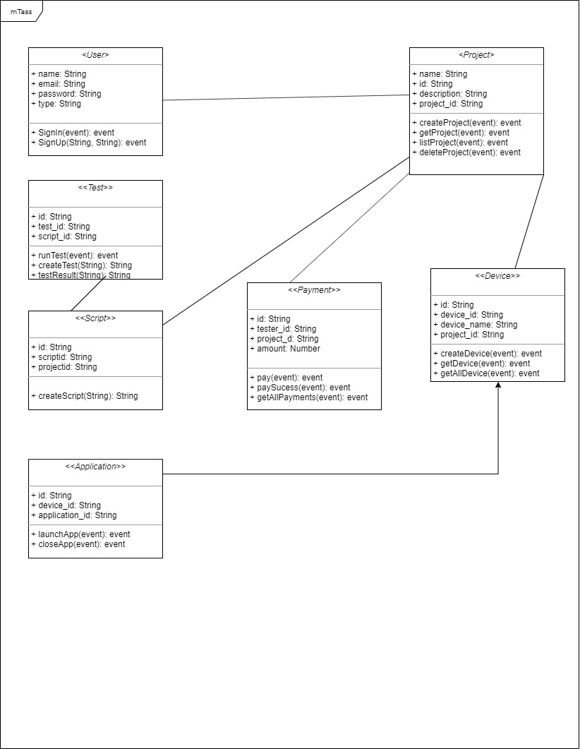

**Sequence Diagram:** Sequence diagram below depicts interaction between multiple objects in sequential order, starting from checking credentials to last payment checkout and sign out.

First four objects Actor, web Portal, Database, Dashboard depicts the step by step sequence of how user gets th

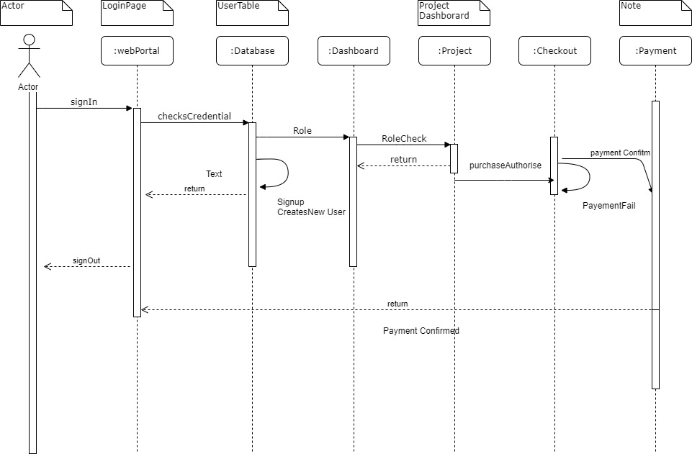

**Figure2.1 Application sequence diagram**

**Database Diagram:** Database in MTass is used to capture and store entries from various user profiles, project details, scripts from project their result.

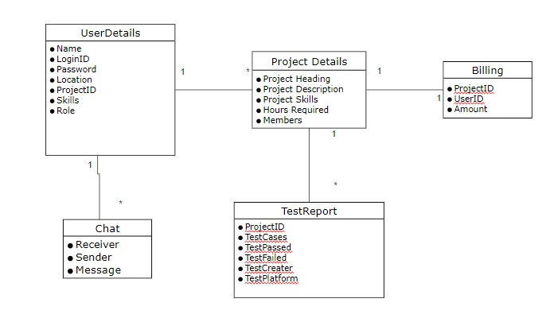

**Figure2.2 Database Architecture Diagram**

* Section 4: Component Business Logic

Decision table for login screen for crowd sources tester management component.

The condition is simple if the user provides correct username and password the user will be redirected to the homepage. If any of the input is wrong, an error message will be displayed.

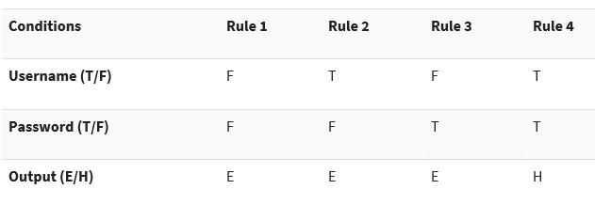

**Figure2.3 Decision Table**

Legend:

* T – Correct username/password
* F – Wrong username/password
* E – Error message is displayed
* H – Home screen is displayed
* Section 5: Component graphic user interface design

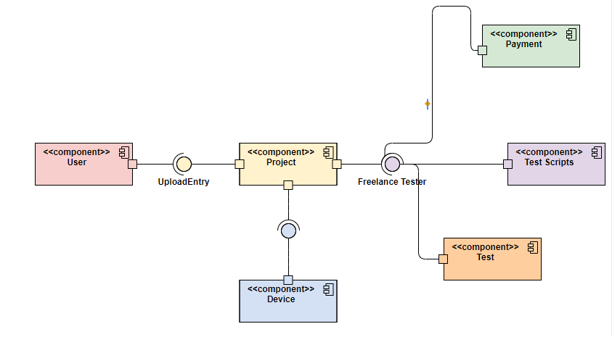

**Figure2.4 Component Diagram of MTass Application**

User Interface mockups for component crowd sourced tester management are shown below for three web-pages.

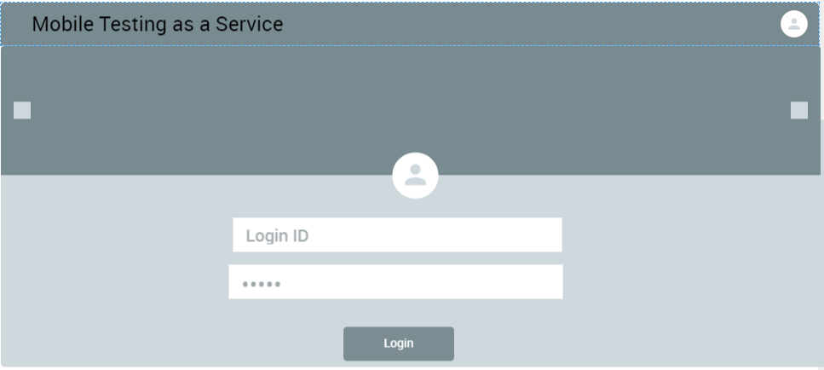

**Figure2.5 Login Page UI Mockup**

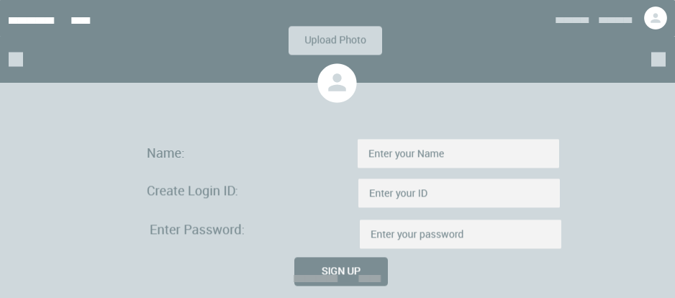

**Figure2.6 SignUp Page UI Mockup**

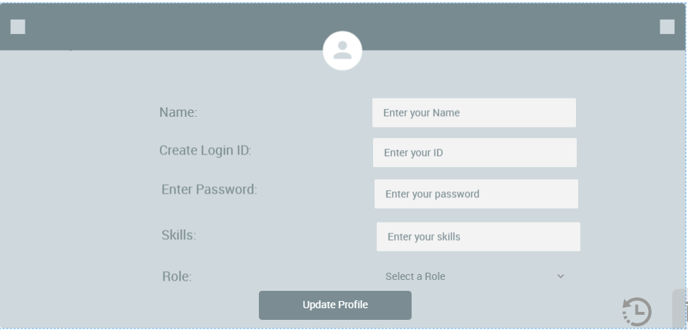

**Figure2.7 Update Page UI Mockup**