GIS
and
Remote Sensing

Volume 2




An introduction to using open source GIS software with remote sensed images

Robert Catherman
Director of Safe Water Development - MEDRIX™

April 2018
Edition E.6.6



GIS and
Remote Sensing

Volume 2

An introduction to using
open source GIS software
with remote sensed images

Robert Catherman
Director of Safe Water Development - MEDRIX™

April 2018
Edition E.6.6

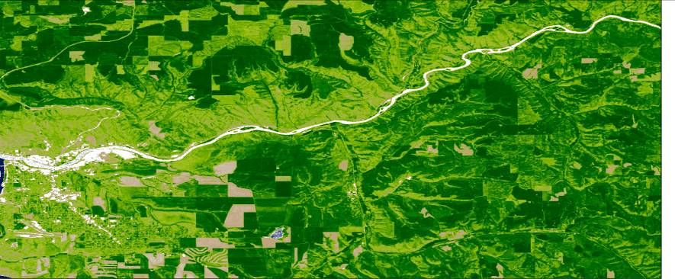

Acknowledgments

Dr. Joe Hannah, of faculty of Geography Department at University of Washington, my instructor in GEOG 360 who taught me principles of map making and how to effectively use GIS technology as well as shared frequent consultations over coffee during the development of this project.

Dr. Miles G. Logsdon, Senior Lecturer, School of Oceanography, College of Ocean and Fishery Sciences, University of Washington, Seattle, WA introduced me to the use of remote sensed images in OCN 452.

Dr. L. Monika Moskal, Associate Professor of Remote Sensing, College of the Environment, School of Environmental and Forest Sciences, University of Washington, Seattle, WA, added to my skills in analyzing remote sensed images in ESRM 430.
nternational (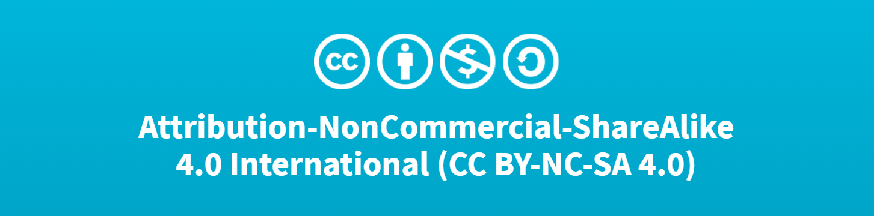CC BY-NC 4.0)
This is a human-readable summary of (and not a substitute for) the license. Disclaimer.
You are free to:
- Share — copy and redistribute the material in any medium or format
- Adapt — remix, transform, and build upon the material
- The licensor cannot revoke these freedoms as long as you follow the license terms.
Under the following terms:
- Attribution — You must give appropriate credit, provide a link to the license, and indicate if changes were made. You may do so in any reasonable manner, but not in any way that suggests the licensor endorses you or your use.
- NonCommercial — You may not use the material for commercial purposes.

No additional restrictions — You may not apply legal terms or technological measures that legally restrict others from doing anything the license permits.

The
Contents
Part 1: General Principles of Remote Sensing 3
Chapter 1: About Remote Sensing 4
Chapter 2: Defining the Project 5
Part 2: Creating Maps Using GIS 7
Chapter 3: Installing QGIS and 7-Zip 8
Chapter 4: Locating GIS Maps 9
Chapter 5: Choosing a Study Region and Creating a Reference Map 10
Chapter 6: Adding a Study Area to the Reference Map 15
Part 3: Adding Remote Sensed Data in GIS 18
Chapter 7: Locating Remote Sensed Data 19
Chapter 8: Acquiring Remote Sensed Data 21
Part 4: Analyzing Remote Sensed Data 23
Chapter 9: Image Interpretation 24
Chapter 10: Normalized Difference Vegetation Index (NDVI) 26
Chapter 11: Create NDVI from a Raster Image Acquired by Landsat 8 34
Chapter 12: Analyze Images for Vegetation Changes 37
Chapter 13: Comparison with Results of Other Researchers 40
Chapter 14: Printing Maps and Images 44
Chapter 15: Ground Truth Sampling for Remote Sensing 49
Part 5: Useful Tools 50
Chapter 16: Adding Digital Elevation Contour Lines 51
Chapter 17: Coordinate System Conversion 55
Chapter 18: Creating a Study Area Using QGIS 57
Chapter 19: Creating a Study Area Using Google Earth 60
Chapter 20: A Challenge 63
Appendixes: 64
Appendix A: References 64
Appendix B: NDVI ColorRamps 65
Index 66

Part 1:
General Principles of Remote Sensing

Chapter 1:
About Remote Sensing

This chapter includes:
- Description of the study of remote sensing

Definition: Remote sensing is the science of deriving information about an object from measurements made at a distance from that object.

Examples of methods of acquiring remote-sensed data include: aerial photography, satellite-captured images, RADAR, LIDAR, etc.

Uses of remote sensing include: agriculture crop monitoring, forestry management, weather forecasting, military intelligence, urban planning, mapping and many other fields.

Equipment used for the purpose of remote sensing includes: satellites, airplanes, drones, cameras, GPS, computers and a variety of other devices.

Software used in remote sensing includes: GIS software, Google Earth, internet websites, computer data archives of images, etc.

It is important to understand that many components of the remote sensing process act as a system and can not be isolated from one another.

For a more complete understanding of remote sensing, a search of the internet will uncover many sources of current information. A course, either online or at a local university, will develop understanding and provide hands-on opportunities to work with remote-sensed data.

It is not the intent of this text to develop a thorough understanding of remote sensing. Instead, the purpose of this text is to give the student step-by-step instructions for using GIS software to acquire and manipulate remote-sensed data. By completing the case study in this text, the student will develop a basic understanding of some of the processes involved in analyzing remote-sensed data and drawing conclusions from that analysis. Hopefully, this text will provide the student with motivation for more in-depth study of this interesting and expanding field.

Neither is this text meant to be a tutorial on use of GIS software and specifically, QGIS, the most popular open source GIS software in use at the time of writing this text. Although this text will guide the student through the steps of using QGIS to process remote-sensed images, explanations are brief or missing regarding the functions of GIS. Again, an online class or university course are needed to gain a full understanding of GIS software.

Chapter 2:
Defining the Project

This chapter includes:
- Description of the study project and its goals

In Redmond, Washington, a few years ago I watched a forest patch be clear cut for a future housing development. This change presented an opportunity to examine satellite images acquired by Landsat satellites to determine how the vegetation coverage change was “observed” using satellite data.

Following is an aerial view of our study area in Redmond, WA, taken from a drone in March, 2015, showing the current state of conversion of a forested area into a housing development.

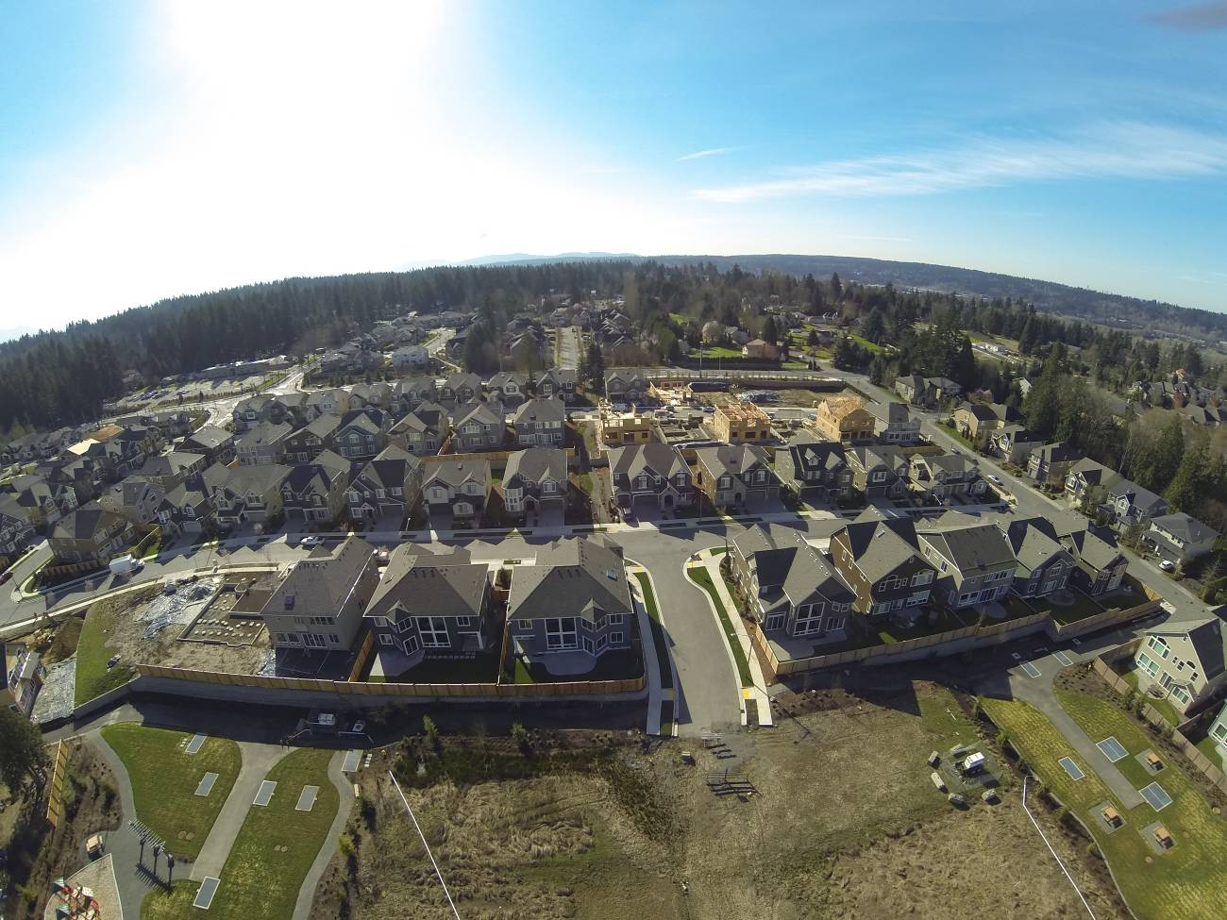
View from drone over study area looking south – March 2015

Multiple steps are needed to study the changes over time that can be observed and analyzed related to this project:

First, the location of the forest clear cut needed to be identified by parameters consistent with Landsat image georeferencing. Latitude and longitude coordinates were noted by GPS.

Next, was to get a view of the area using Google Earth using the latitude and longitude. Identifying a “before” forest clearing Google Earth image date helps us choose a date range for finding a suitable Landsat image for “before” forest clearing. It was necessary to take into consideration the years during which the Landsat 7 satellite was operating with a degraded scanner.

Analysis followed of Landsat images using NDVI analysis method of “before” and “after” images.

Comparing visible imagery from Google Earth and NDVI raster images helps us visualized pattern correlation between difference types of remotely sensed images.

After performing the NDVI analysis, we can use “raster math” to calculate the differences in the values of each pixel in the before and after NDVI raster images.

Next, the image of NDVI difference image is compared to the University of Maryland’s Global Forest Coverage Gain / Loss analysis. Since the time span of this UMGFC project was 2000 to 2016, our selection of dates for Landsat images to analyze was influenced by the need to coincide with UMGFCC data.

Finally, we will draw some conclusions from our many observations.

Part 2:
Creating Maps
Using GIS

Chapter 3:
Installing QGIS and 7-Zip

This chapter includes:
- Instructions to download and install QGIS
- Instructions to download and install 7-Zip for uncompressing files

Step 1. Software Installation - QGIS
Time to complete: 10-20 minutes (depends on your download speed)

Download QGIS from website
http://www.qgis.org/en/site/forusers/download.html
choose Stand Alone Installer

Install QGIS per instructions

At the time these instructions were prepared, the current version of QGIS was 3.4.2

Configure the coordinate projection option

Start QGIS

Select from menu option Settings > Options
Select General tab
Select Style that corresponds to your computer operating system
Change Icon Size to 32
Change Font to Arial (or your choice)
Change Size to 12
(or your choice)
OK

Select from menu option View > Toolbars > Manage Layers Toolbar

Select from menu option Project > Exit QGIS

Step 2. Software Installation - 7-Zip

Download and install 7-Zip from a trusted website such as CNET.com

Step 3. Learning to use QGIS software

Search the internet for resources for learning QGIS.

One online resource for learning QGIS is https://foss4geo.wordpress.com/

Chapter 4:
Locating GIS Maps

This chapter includes:
- Locating appropriate digital maps

One useful source of digital maps for GIS systems is the website for GADM Database of Global Administrative Areas which can be accessed at http://www.gadm.org/

GADM is a spatial database of the location of the world's administrative areas (or administrative boundaries) for use in GIS software. The coordinate reference system is latitude/longitude and the WGS84 datum. These maps can contain up to 5 levels of administrative subdivisions. A general understanding of concept of “administrative areas” is presented in Wikipedia at http://en.wikipedia.org/wiki/Administrative_division

Other useful sites containing data for roads, rivers, population data, etc:

http://www.diva-gis.org/gdata

https://nationalmap.gov/small_scale/

Chapter 5:
Choosing a Study Region
and Creating a Reference Map

This chapter includes:
- Purpose and definition of a study region
- Purpose and definition of the reference map
- Tips on creating a reference map
- Sources and examples of reference maps

Purpose

We need to define a primary study region for our project. For our study region we will use an area bounded by administrative boundaries. One example is to use the boundaries of a county in the US (province or district in many other countries). We will use this method in the exercise in this chapter.

A second option is to define an area by explicitly specifying its boundaries ourselves. We might define a rectangle by specifying the coordinates of its four corners or draw a rectangle of your study region in a map layer of your project. We will learn how to do this later in chapters 6, 18 and 19.

The purpose of creating a reference map is to provide a starting point for displaying data related to the main topic of our study project.

Tips on creating a reference map

Use care in selecting how many detailed features to include on the reference map. Features should be included that will assist the user in interpreting the main topic of the map – the theme of the map. Features that do not add to the user’s understanding should be omitted. The simpler the map, the better; maps cluttered with too much detail can detract from the message you want to communicate.

Exercise

The GADM website is an excellent starting point that provides digital reference maps of regional boundaries (also called administrative areas). We will download a map from this website to begin the work of defining our study region.

Step 1: Define our study region

For our study region, we will use King County in western Washington. Since we will be using Landsat images which use UTM coordinates, we need to know the UTM zone of the study region. There are several conversion programs on the internet (Google “lat to UTM”) that will make the conversion for you. In the case of our study region, we determine that this area is located in UTM zone 10 N.
.

Step 2: Locate and download map files that include our study region

Create a folder on the C drive for your work - name the folder GIS Remote Sensing.
In the GIS Remote Sensing folder, create a sub-folder named Redmond

Download the administrative maps from the GADM website at http://www.gadm.org/
Select Data button
Click on the word country
Select United States from the dropdown menu
Select Shapefile

The file will now be downloaded

We now have map files for the country, states and counties saved in the Download folder. We will only use the map file named USA_adm2 that defines the boundaries for counties.

Step 3: Start QGIS and create a map layer of your study region

Start QGIS
Select Project > New

In QGIS, add a vector layer for all the counties in the US
On the QGIS toolbar bar on left select Add Vector Layer icon
For Vector Dataset, browse to folder Download
Select the file named USA_adm_shp.zip
Open
Add
Select the layer USA_adm2
OK
Close

The county in our study region is named King. Actually, there are two counties in the US named King so we will have to select the one in Washington. The following steps will select King County from all the counties in the United States.

Right click the USA_adm2 layer > Properties
Select Source tab
Select Query Builder button in the Provider feature filter section
Double click NAME_2 in Fields box to insert in Provider specific filter expression box
Single click Operator “=” to insert in Provider specific filter expression box
Choose “All” in Values box
Double click King to insert in Provider specific filter expression box
Single click Operator “AND”
Double click NAME_1 in Fields box to insert in Provider specific filter expression box
Single click Operator “=” to insert in Provider specific filter expression box
Choose “All” in Values box
Double click Washington to insert in Provider specific filter expression box
OK > Apply > OK

Right click the USA_adm2 layer
Select Zoom to layer

Next we will eliminate all the counties that we will not be using. The following steps will clip the layer to remove all data except data for the county of our study region. This will make the QGIS project file load and redraw much, much faster.

On the QGIS main menu select Vector > Geoprocessing Tools > Clip
Choose Input vector layer = USA_adm_2
Choose Clip layer = USA_adm_2
In the Clipped box, click browse icon at right end of line
Select Save to file
Browse to folder named Redmond
In File Name box type StudyRegion
In Save As Type box, select SHP files
Save
Click on Run in background button
Close

Right click on layer named Clipped > Rename
Type StudyRegion over the name Clipped > Enter

Right click the USA_adm_2 layer > Remove > OK

Step 4: Save your project

On the QGIS main menu select Project > Save As
Browse to the folder Redmond
Type File name ReferenceMap > Save

Step 5: Change the map projection

The administrative area map file we downloaded uses latitude / longitude for a coordinate reference system. In the cases where all the map files use that coordinate system, no change is necessary. But, so we will be ready to work with Landsat image files which use UTM coordinates, we need to change the Coordinate Reference System (CRS) of our project from latitude / longitude to the Universal Transverse Mercator (UTM) geographic coordinate system

Create a new shapefile layer with the adjusted coordinates

Right click the StudyRegion layer
Select Save as option
Choose Format = ESRI shapefile
In File Name box
browse to the folder Redmond
type StudyRegionUTM
Save
In the CRS box
Click on the globe icon at the end of the CRS line
In the Filter box, type 10N
In the Coordinate reference systems of the world
choose WGS 84 / UTM zone 10N
OK > OK

Remove the vector layer that is no longer needed
Right click the StudyRegion layer > Remove > OKStep 6: Adjust layer properties

Change the study region to be transparent so that the layer only shows the borders as an outline.

Right click the StudyRegionUTM layer > Properties
Select Symbology tab
Click on Simple Fill
For Fill Style select no brush
For Stroke Color select black
For Stroke Style select Dash Line
For Stroke Width type 0.5
OK

In summary, what we have just completed is to identify our study region, change the region to an outline and convert the coordinate system to UTM. You could use these instructions to define a different study area in the United States by changing the names of the counties in the Query Builder step. To work in regions outside the US, download the appropriate country map from the GADM website as instructed in Step 2 of this chapter.

Our QGIS project file is now optimized to contain only data for our study region of King County.

Example: the reference map of our study region should now look like this:

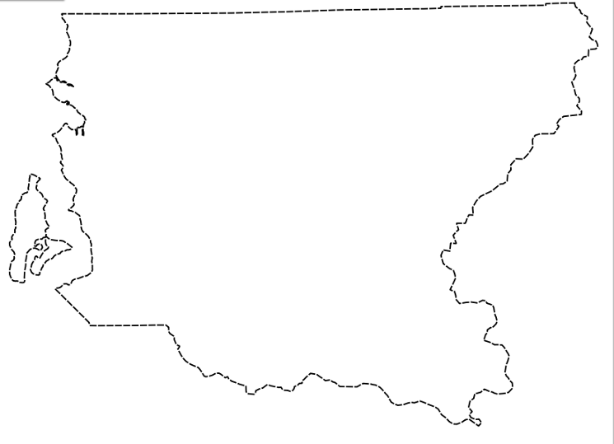

Step 7: Save the project and exit

On the QGIS main menu select Project > Save
On the QGIS main menu select Project > Exit QGIS

Chapter 6:
Adding a Study Area
to the Reference Map

This chapter includes:
- Purpose and definition of a study area
- Adding the study area to the reference map

Purpose

We need to define a primary study area for our project. The study area should be within our study region which we defined when creating our reference map.

A study region is a broad area that contains our study area. The study region gives us some general orientation to the geography around our study area. Our study area focuses narrowly on specific features we are investigating. The surrounding characteristics of the study region may provide some helpful clues to aid us in our analysis.

We will define our study area by specifying its boundaries ourselves. We can define a rectangle by specifying the coordinates of its four corners or we can draw a rectangle of your study area in a map layer of your project.

As we discussed in Chapter 2, the purpose of our study is to analyze satellite remote sensed images to observe changes in vegetation coverage of an area in Redmond, Washington, USA. For our study area we have chosen an area where the trees have recently been cut down and houses are now being built. Some nearby neighborhoods were developed several years before for housing.

Step 1: Start QGIS

Start QGIS

Select menu option Project > Open Recent
Browse to folder Redmond
Select File Name = ReferenceMap > Open

Step 2: Change the coordinates for the project to UTM

Select Project > Project Properties
Select CRS menu item
In the Filter box type 10N
In the Coordinate Reference Box
Select WGS 84 / UTM Zone 10N
Apply > OK

Step 3: Define the study area

We will define our study area using your choice of the following two methods.

Method 1 – create study area using QGIS

Define the four corners of our study area by UTM coordinates (UTM is necessary when we start working with Landsat images). For this study, the boundaries are provided for you using coordinates determined by GPS. For your own projects, you will need to set your own boundaries for your study area.

We will create a vector layer in QGIS using the corners of our study area in UTM which are:

Easting, Northing
565125, 5284566
565125, 5283773
566225, 5283773
566225, 5284566

Copy and paste the five lines above into a text (.txt) file using Notepad and name the file CornerPoints and save the file in the folder Redmond.

Select the menu option Layer
Select Add Layer
On the drop down sub-menu select Add Delimited Text Layer
Browse for the file CornerPoints in the folder Redmond > Open
In the File Format section, select CSV
Open Record and fields option
Select 0 in Number of header lines to discard
Check box next to First record has field names
Open the Geometry Definition section
Select Point Coordinates
In Geometry CRS select WGS 84 / UTM zone 10N
Add > Close

Now, follow the instructions in Chapter 18 to create a study area layer by connecting the corner points of the study area layer.

Left click on the layer CornerPoints
Select Remove > OK

Method 2 – create study area using Google Earth

The center point of the area we want to study is: 10N 565675 5284170

Copy and paste these coordinates into the search line of Google Earth.

Follow the instructions in Chapter 19 and create a vector layer in Google Earth.

The outline of the study area in Google Earth should look like the following figure..

Step 3: Save the project and exit

On the QGIS main menu select Project > Save
On the QGIS main menu select Project > Exit QGIS

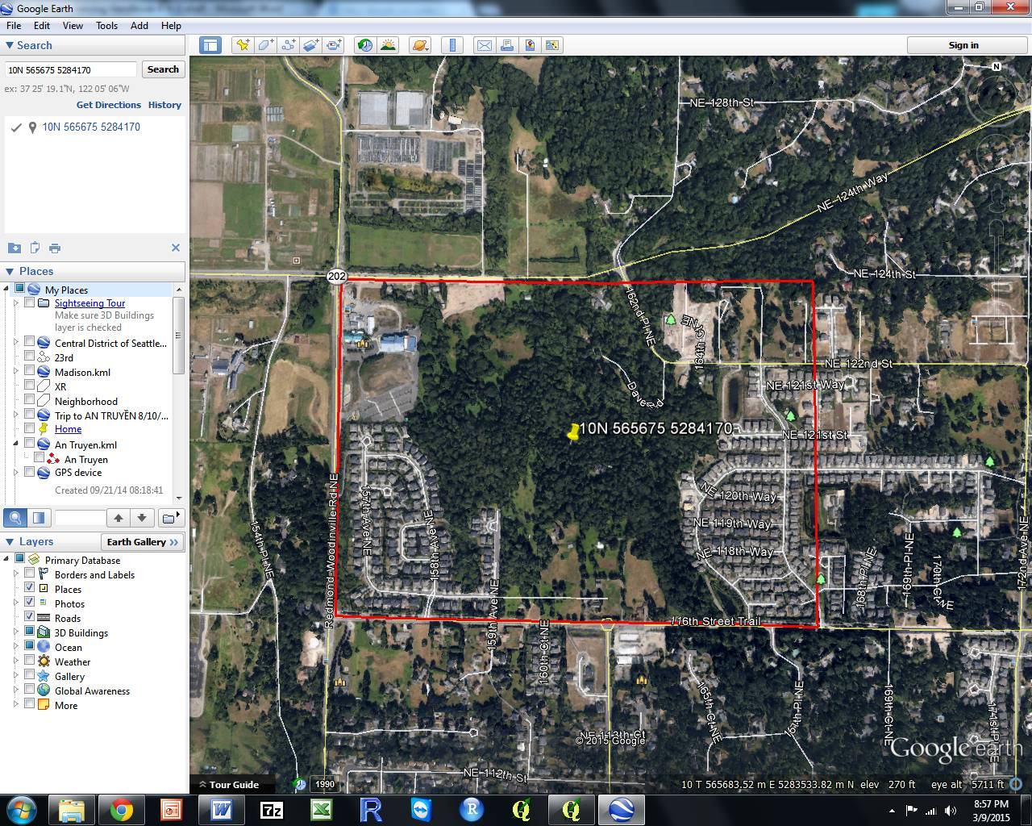

Study area outlines in red and showing coordinates of center point of study area

Part 3:
Adding Remote Sensed Data in GIS

Chapter 7:
Locating Remote Sensed Data

This chapter includes:
- Identifying sources of remote sensed images
- Understanding the data available in the Landsat archive

Identifying sources of remote sensed images

Among the many sources of remote sensed images, the Landsat archive is one of the largest and most assessable. For our exercises, we will use Landsat images. However, you should research and bookmark other sources of images that meet your specific requirements after you become familiar with the process of using remote sensed images in GIS.

The Landsat satellite imaging program was designed by scientists and sponsored by the US government to make large-scale, repetitive surveys of the Earth's land areas. Today, the Landsat image library provides the longest continuous record of environmental conditions of land areas covering our world.

To date, eight Landsat satellites have been launched beginning with Landsat 1 in 1972 and now with Landsat 8 in 2013. Although sensing equipment has been continuously improved, great effort has gone into keeping the format, resolution and spectral sampling parameters consistent. This consistency allows for comparison of land areas characteristics to analyze changes during the 40+ years of Landsat data collection.

For our purposes one of the most attractive features is that the US government has made the 40+ years of Landsat image data available on the internet for downloading at no cost to the public. We will make use of the Landsat image data in this handbook as one of our primary sources while we learn about remote sensing.

This handbook is meant to give you only a very brief introduction to Landsat imagery; a complete discussion of the Landsat history and specifications are beyond the scope of this handbook. For more information on Landsat, visit the USGS website at www.usgs.gov Another excellent source of Landsat information can be found in Chapter 6 of the book “Introduction to Remote Sensing” Fifth Edition by James B. Campbell and Randolph H Wynne. Wikipedia at www.wikipedia.com also contains useful information about Landsat under the search words “Landsat programs”.

EarthExplorer

The EarthExplorer website operated by the US Geodetic Survey is one of the most useful and complete sources of remote sensing data.

In order to download files using EarthExplorer, you must first create a login.
If you have not already set up an account, do so now.

http://earthexplorer.usgs.gov/

On the main menu bar, select Register and follow the directions

My logon is _____________________ my password is ________________

On the main menu bar, select Login > Sign in with your username and password

In the Address/Place box > type Redmond, WA > Show

Select the location you want to find from the ones displayed in the Coordinates box

Select the Decimal tab

Make a note of the latitude and longitude to use in a search with GLOVIS, the next search tool we will use. Note that the longitude has a negative sign.

On the EarthExplorer menu bar, select Logout

GLOVIS (USGS Global Visualization Viewer)

GLOVIS is another format for viewing Landsat images.

http://glovis.usgs.gov

Click on the Launch GLOVIS button

Click on the Jump To icon in the upper right corner of the screen

Type the latitude and longitude from the previous step

Click on the Jump to Location button

You can explore the many features of GLOVIS
later.

LandsatLook

Another place to search for remote sensed image data is on the easy-to-use USGS website http://landsatlook.usgs.gov/ This site allows you to search for a location and then to zoom in to see the full resolution data of all Landsat scenes available. When you select an image to download, the request will be processed by EarthExplorer.

You can explore the many features of LandsatLook later.

Chapter 8:
Acquiring Remote Sensed Data

This chapter includes:
- Researching available data for your study area
- Downloading Landsat data
- Some useful facts about Landsat data

The EarthExplorer website operated by the US Geodetic Survey is one of the most useful and complete sources of remote sensing data. You will download Landsat images covering your study area. A good description of the Landsat program can be found at http://en.wikipedia.org/wiki/Landsat_program

Step 1: Create a folder for saving Landsat images

In the Redmond folder, create a sub-folder named Landsat

Step 2: Create a user account on the USGS website

To download files, you must first create a login.
If you have not already set up an account, follow the instructions in the previous chapter now

Step 3: Log into the USGS website

http://earthexplorer.usgs.gov/

On the main menu bar, select Login > Sign in with your username and password

Step 4: Define the parameters for request for Landsat images

Note: Because the Landsat 7 satellite developed a problem with its scanner in 2003 that caused each image to have strips of missing data, we will use images from before the scanner problem developed. Normally, we would have used later images but for our example, we are choosing images that are not missing data.

In the box Address/Place > type Redmond Washington > Show
Select the location you want to find from the list displayed in the Address/Place box

Select a Date Range
For this exercise choose the date range of 05/01/2002 to 6/30/2002
When choosing date ranges for images, think carefully about the vegetation condition of crops at various times of the year - planting, growing, harvest, fallow.

Select the Data Sets button
Click the + box next to Landsat
Click on Landsat Collection 1 Level-1
Click on Landsat 7 ETM+ C1 Level-1

Click on the Additional Criteria button
Select Scene Cloud Cover amount of less than 20%

Select the Results button at the bottom of the pane

For the image before any development was started
Select image dated June 11, 2002
Select Order Scene icon 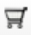 for the map you chose
Select the View Item Basketbutton
Select the Proceed to Checkout button
Click the title of the Data Set in the item basket
Select the Submit Order button

Select Logout
In your email folder you should receive the following emails:
Order confirmation
Processing the order
Processed order available for download

After the “available for download” email arrives
Note the last four digits of the order number
Double click on the link to begin the download
Select the file with correct order number to download (usually the topmost)
Click on Download

After the download completes, browse to locate the downloaded file
Copy / paste the file to the folder Landsat in the folder Redmond
Leave the name of the Landsat file unchanged
OK

Step 5: Uncompress the Landsat file

Uncompress the downloaded Landsat file (7-Zip is a commonly used program for this purpose)
Browse to the folder Landsat
Right click on the Landsat gz file and select 7-Zip (or whatever program you use to uncompress files)
Right click on the Landsat tar file and select 7-Zip (or whatever program you use to uncompress files)
Select folder LandSat as the destination for the unzipped files

Step 6: Cleanup files

When you are finished, you can delete the gz and tar files to save disc space

Some useful Landsat facts:

Check out http://landsat.usgs.gov/L8_band_combos.php:

Part 4:
Analyzing
Remote Sensed
Data

Chapter 9:
Image Interpretation

This chapter includes:
- Interpreting single images
- Interpreting analyzed images

Interpreting single images

Photos and satellite images are useful primarily because we can use them to identify the position and properties of features that interest us. Interpreters use size, shape, color, brightness, texture and location to identify features and convert images into information. Image interpreters must have some familiarity with the features of interest. Ground truthing is essential to developing the local knowledge required for accurate image interpretation.

The practice of image interpretation is a well-developed discipline and uses many specialized techniques. A detailed description of image interpretation is beyond the scope of this handbook. Books and internet resources are available that teach this skill in detail.

Satellite images are like maps: they are full of useful and interesting information, provided you have a key. It is important to remember that satellite images are an overhead view -- an unfamiliar perspective. The following is a review a few of the highlights of image interpretation focusing on satellite images.
Look for a Scale: One of the first things people want to do when they look at a satellite image is to identify the places that are familiar to them: their home, school, or place of business; a favorite park or tourist attraction; or a natural feature like a lake, river, or mountain ridge. The level of detail depends on the image’s spatial resolution. Like digital photographs, satellite images are made up of little dots called pixels. The width of each pixel is the satellite’s spatial resolution. For the Landsat images we will be using, the resolution for one pixel is 30 meters on each side (900 sq meters).
Look for patterns, shapes, and textures: Bodies of water—rivers, lakes, and oceans—are often the simplest features to identify because they tend to have unique shapes and they show up on maps. Other obvious patterns come from the way people use the land. Farms usually have geometric shapes—circles or rectangles—that stand out against the more random patterns seen in nature. When people cut down a forest, the clearing is often square or has a series of herring-bone lines that form along roads. A straight line anywhere in an image is almost certainly human-made, and may be a road, a canal, or some kind of boundary made visible by land use.

Define Colors: The colors in an image will depend on what kind of light the satellite instrument measured. True-color images use visible light—red, green and blue wavelengths—so the colors are similar to what a person would see from space. False-color images incorporate infrared light and may take on unexpected colors.
Water: Water absorbs light, so it is usually black or dark blue.
Plants: Plants come in different shades of green, grasslands tend to be pale green, while forests are very dark green. Land used for agriculture is often much brighter in tone than natural vegetation. In some locations (high and mid latitudes), plant color depends on the season. Spring vegetation tends to be paler than dense summer vegetation. Fall vegetation can be red, orange, yellow, and tan; leafless and withered winter vegetation is brown. For these reasons, it is helpful to know when the image was collected.
Find North: If you know where north is, you can figure out if that mountain range is running north to south or east to west, or if a city is on the east side of the river or the west. These details can help you match the features to a map
Consider your Prior Knowledge: Perhaps the most powerful tool for interpreting a image is knowledge of the place. If you know that a wildfire burned through a forest last year, it’s easy to figure out that the dark brown patch of forest is probably a burn scar, not a volcanic flow or shadow.
Interpreting analyzed images

Because most of us are not trained and experienced interpreters of remote sensed images, we will use some techniques of automated image analysis to help us understand the image data we are seeing. One specialized analysis technique we will learn in the next chapter is Normalized Difference Vegetation Index (NDVI). Instead of attempting to interpret individual images, we will use QGIS software to analyze two images and produce a visualization that is customized for the interpretation of vegetation health.

Using established processes such as NDVI transfers our interpretation requirements from examining raw remote sensed image data to understanding and interpreting automated analysis methods and outputs. More on this topic in the next chapter.

Chapter 10:
Normalized Difference
Vegetation Index (NDVI)

This chapter includes:
- Definition of NDVI
- Instructions for completing NDVI analysis
- Examples of NDVI outputs

The Normalized Difference Vegetation Index (NDVI) has been used for many years to measure and monitor plant growth (vigor), vegetation cover, and biomass production from multispectral satellite data. We will create NDVI image maps using Landsat 30 m resolution spectral data in the visible red and near infrared regions of the electromagnetic spectrum.

NOTE: – For images from Landsat satellites 1-7; band 3 is used for red and band 4 for near-infrared. For Landsat 8 the band designations changed; red is now band 4 and near-infrared is now band 5.

NDVI is calculated as follows:
NDVI = (Band 4 – Band 3) / (Band 4 + Band 3)

The principle behind NDVI is that Band 3 is in the visible red-light region of the electromagnetic spectrum where chlorophyll causes considerable absorption of incoming sunlight. Band 4 is in the near-infrared region of the spectrum where a plant's spongy mesophyll leaf structure creates considerable reflectance (Tucker 1979, Jackson et al.1983, Tucker et al. 1991). As a result, vigorously growing healthy vegetation has low red-light reflectance and high near-infrared reflectance, and hence, high NDVI values.

This relatively simply algorithm produces output values in the range of -1.0 to 1.0.
- Negative values of NDVI (values approaching -1) correspond to deep water.
- Values near zero (-0.1 to 0.1) generally indicate non-vegetated features such as barren surfaces (rock and soil) and water, snow, ice, and clouds.
- Low, positive values represent shrub and grassland (approximately 0.2 to 0.4).
- High values indicate temperate and tropical rainforests (values approaching 1).
- Typical range of values is between about -0.1 (for a not very green area) to 0.6 (for a very green area)

Step 1: Define our study area

In Chapter 6 we defined our study area and created a shapefile named StudyArea that we will use in this exercise. If you have not already created the study area map, follow the instructions in Chapter 6 now.

Step 2: Start QGIS and load the study area reference map layer

For this exercise we will use QGIS open source software. If you have not already downloaded and installed QGIS, refer to Chapter 3 for instructions about how to download and install this software.

At the time these instructions were prepared, the current version of QGIS is 3.4.2. When later versions are released, some changes to these instructions may be needed.

Start QGIS

Select menu option Project > Open Recent
Browse to folder Redmond
Select File Name = ReferenceMap > Open

Step 3: Load the Landsat images into QGIS and clip to study area size

Next, we will load the Landsat images downloaded in Chapter 8 into QGIS and clip the data images to only include data for our study area. Only images from spectral bands red and near infrared (NIR) will be used to calculate NDVI.

The following instructions assume you are using images from Landsat 1-7. If you are using images from Landsat 8, change the band numbers to 4 and 5.
On the QGIS side bar select the Add Raster Layer icon 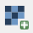
Browse to the folder Landsat
Select the file ending in B3 (band 3)
Open > Add
On the QGIS side bar select the Add Raster Layer icon
Select the file ending in B4 (band 4)
Open > Add

Close

On the QGIS main menu select Project > Save As > browse to the folder Redmond
name your project Redmond_NDVI > Save

Clip the Landsat images to the size of the study area

On the QGIS main menu select Raster > Extraction > Clip raster by mask layer
In the Input Layer box, select the file ending in B3 (band 3)
In the Mask Layer box, select StudyArea

Click the browse box at the end of the Clipped box line
Select Save to File
browse to folder Landsat
Type b3 in File Name box > Save

Click on Run in background button
Close

In the Layers panel
Right click on layer Clipped (mask)
Select Rename
Type b3-2002 in the layer name

On the QGIS main menu select Raster > Extraction > Clip raster by mask layer
In the Input Layer box, select the file ending in B4 (band 4)
In the Mask Layer box, select StudyArea

Click the browse box at the end of the Clipped box line
Select Save to File
browse to folder Landsat
Type b4 in File Name box > Save

Click on Run in background button
Close

In the Layers panel
Right click on layer Clipped (mask)
Select Rename
Type b4-2002 in the layer name

In Clipping mode box, select Mask layer check box
Select Mask layer = StudyArea
Check box Crop the extent of the target data set …..
Check box Load onto canvas when finished
OK > OK

Right click the first Landsat image layer with the long name
Remove > OK
Right click the second Landsat image layer with the long name
Remove > OK

Right click on the layer StudyArea
Select Zoom to Layer

On the QGIS main menu select Project > Save

Your Landsat data displayed on your computer screen should now look like this.

Raster images for bands 3 and 4 for June 11, 2002
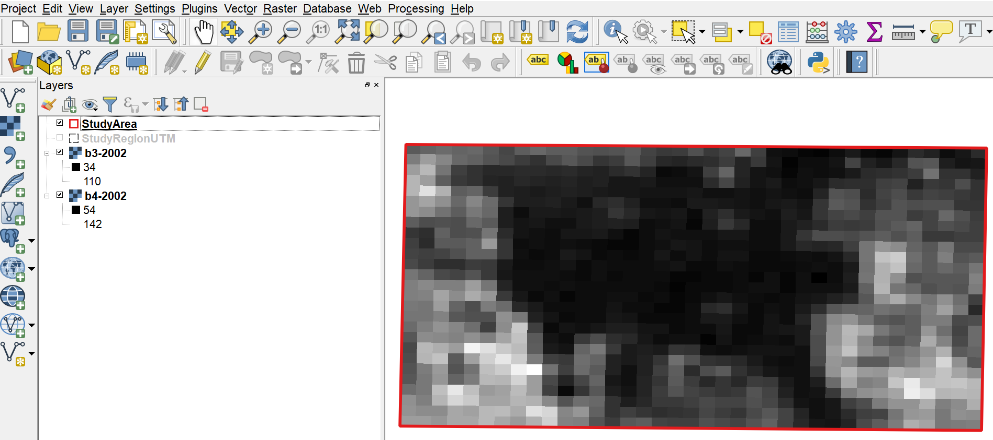

Step 4: Create a new raster image showing NDVI

Each Landsat image is a single band grayscale raster with integer pixel values (1-255). Since NDVI is “normalized” the values are always fractions. Therefore, it is necessary to first multiply the raster b4 by 1.0 to convert it to a real value. Otherwise the result will be an integer, leaving the whole computed NDVI raster with values rounded to 0.

On the QGIS main menu select Raster > Raster calculator
Click on the box to the right of Output layer box
browse to folder Redmond
In File Name box, type NDVI-11-Jun-2002
Save

Click on layer b3-2002@1
Paste the following expression in the Raster calculator expression box
( "b4-2002@1" * 1.0 - "b3-2002@1" ) / ( "b4-2002@1" + "b3-2002@1" )
(optional - manually enter this formula by clicking on each item and operator on the screen)
OK

Right click b3-2002 layer > Remove > OK
Right click b4-2002 layer > Remove > OK

Step 5: Create an NDVI color ramp

This one-time action is needed to create a custom NDVI color ramp in QGIS. The text required is contained in Appendix B of this document. This step creates a custom color ramp file that you will use in the following steps.

Start Word (or compatible program such as Notepad)
Open this document in Word
Copy the text from Appendix B - NVDI Color Ramp – Level-1
File > New to create a blank document
Paste the copied text into the blank document
File > Save As
Browse to the folder Landsat
file name NDVI_Color_Ramp_Level-1
Select Save as type Plain Text
Save > OK
File > Close

Step 6: Adjust the colors of the NDVI raster map

Positive NDVI values, shown in increasing shades of green in the NDVI image, indicate increasing amounts of healthy vegetation. NDVI values near zero and negative values indicate non-vegetated features such as barren surfaces (rock and soil) and water, snow, ice, and clouds.

In QGIS uncheck all the layers except the layer named NDVI-11Jun-2002

Select layer NDVI-11-Jun-2002 > Properties > Symbology
In Render type select Singleband Psuedocolor
In Interpolation select Linear
Scroll down
Click on the file folder icon 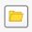
Browse to folder Landsat
Select NDVI_Color_Ramp_Level-1
Open
OK

At this point your screen should look something like this

NDVI analysis for June 11, 2002

Step 7: Update metadata for the NDVI layer

Select layer NDVI-11-Jun-2002 > Properties > Metadata
In the Title box of the Identification tab, copy and paste the following text
NDVI June 11, 2002
In the Abstract box, copy and paste the following text
Data source: USGS, Landsat 7, Path 46 / Row 27
Acquisition Date: 11-JUN-02
Entity ID: LE70460272002162EDC00
In the Rights box of the Access tab, copy and paste the following text
Landsat images courtesy of the U.S. Geological Survey
OK

Step 8: Save Your Project

On the QGIS main menu select Project > Save

Step 9: Interpretation

Recall from the definition of NDVI that the intense green is the most complete coverage of healthy vegetation. At the opposite extreme in our example using our custom color ramp is grey indicating buildings and brown indicating non-vegetative surfaces.

In earlier chapters at times we referred to “forest coverage”. Technically speaking, we should have used the term “vegetation coverage” since NDVI is an analysis of all vegetation not just forests. A football field would show up as green because it is healthy vegetation even though it is definitely not a forest.

Look at the area in the lower left corner of your study area in the NDVI image. Then locate this same area in your Google Earth view. In Google Earth we see that this is an area where homes have been built in 2015. In Google Earth, click on View and then Historical Imagery. Use the time slider in the upper left of the screen to see what this area looked like in the past. We can see that most houses were built after 2004 which is later than the date of our NDVI image (2002). Our conclusion is that in our NDVI image we are seeing mostly bare land in this area of the image. However, a few homes had been built at the time of our NDVI image.

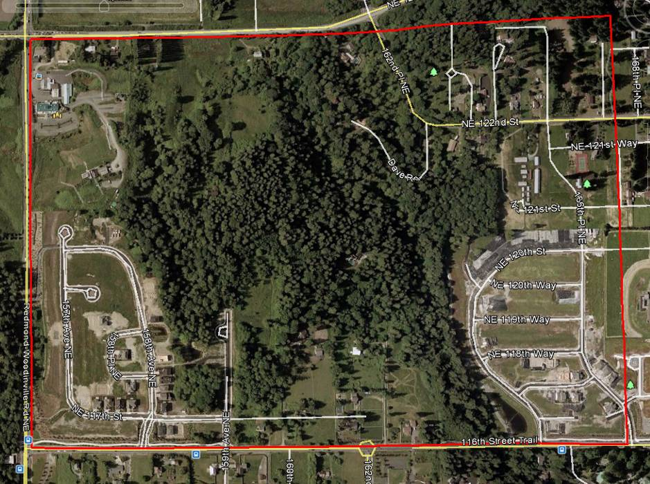
Google Earth view of study area on May 31, 2002

In QGIS
Select the NDVI-11-Jun-2002 layer
Click on the “information icon”
Click anywhere inside the raster
In the lower left corner of the Feature panel
In the View box, choose Table

Move the cursor over a green raster cell
Left click on any dark green cell
You should read values in the range of . to .5.

In the lower left corner of the study area, move the cursor over the gray raster cells (probably roofs of houses or concrete driveways or a combination of both) in the range of -0.30 to -0.15. In contrast, the values bare ground (brown) cells in that area have values in the range of -0.15 to +0.15. Areas with vegetation range from +0.15 to +0.5 We will try to use these approximate value ranges in the next chapter when we interpret cell values in the Landsat 8 images captured in 2016.

Chapter 11:
Create NDVI from a
Raster Image
Acquired by Landsat 8

This chapter includes:
- Download of Landsat 8 image
- Create NDVI using Landsat 8 image
- Interpret the results of the NDVI analysis

Now, let’s jump ahead to a more recent time after the forest has been cleared and house construction has begun. We’ll try to look for Landsat 8 images to analyze from the month of June so that seasonal variations in vegetation will be minimal – June was the month of the images from 2002 that were analyzed in the previous chapter. But, if we search for Landsat 8 images without cloud cover over our study area, we find the closest date of a useful image is 27 July 2016.

Step 1: Download a raster image from Landsat 8 acquired on July 27, 2016

Repeat Steps 3-6 of Chapter 8 to download Landsat 8 image acquired on July 27, 2016

Change your selection from Landsat 7 to Landsat 8

Step 2: Create a second raster image showing NDVI for Landsat 8 remote-sensed image dated July 27, 2016

Repeat Steps 3, 4 and 6 of Chapter 10 using the Landsat 8 image dated July 27, 2016 that you downloaded following the instructions in Chapter 8.

Recall that the bands identifiers have been changed for Landsat 8. See the Note at the beginning of Chapter 10.

When clipping the raster files, you cannot re-use file names. For the file ending in B4 use the name b4-2016 and the file ending in B5 use the name b5-2016

Name this NDVI layer NDVI-27-Jul-2016

Step 3: Example

After performing the NDVI analysis, your image should look similar to this:

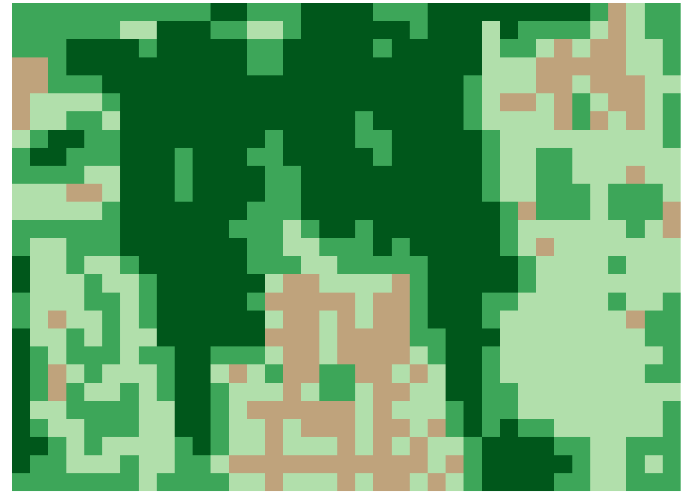

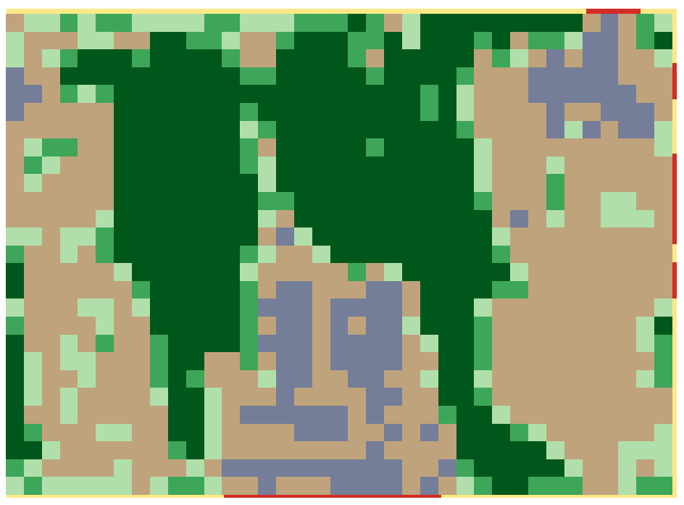
NDVI analysis for July 27, 2016

Step 4: Update metadata for the NDVI layer

Select layer NDVI-27-Jul-2016 > Properties > Metadata
In the Title box of the Identification tab, copy and paste the following text
NDVI July 27, 2016
In the Abstract box, copy and paste the following text
ID:LC08_L1TP_046027_20160727_20170222_01_T1
Acquisition Date:27-JUL-16
Path:46
Row:27
In the Rights box of the Access tab, copy and paste the following text
Landsat images courtesy of the U.S. Geological Survey
OK

Step 5: Interpretation

Look at the area in the lower left corner of your study area in the NDVI image. Then locate this same area in your Google Earth view of July 2016. In Google Earth we see that this is an area today where homes have been built and the area is now well established – lawns and trees have been planted. Look at the area in the lower middle of the study area. This area is where the most recent homes have been built. This area differs from the lower left in that vegetation is not yet well established – this difference can be seen in the Google Earth image but not as distinctly.

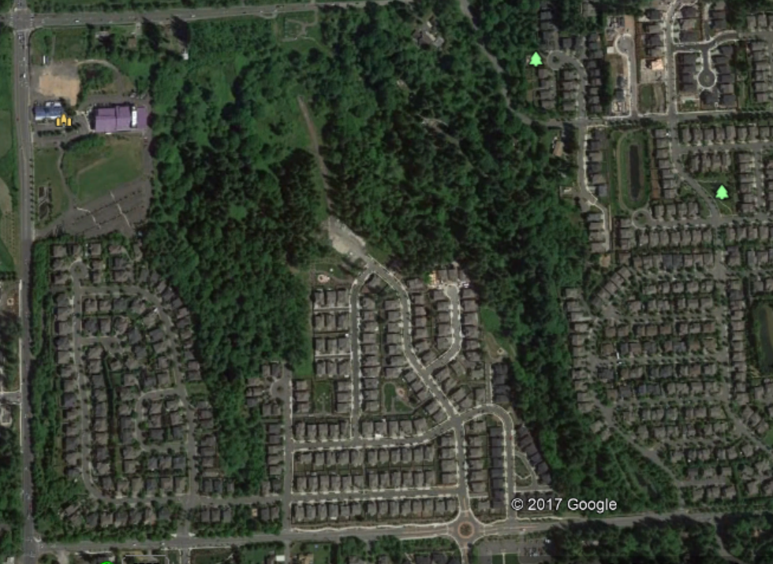

Google Earth view of study area on July 27, 2016

In QGIS
Select the NDVI-27-Jun-2016 layer
Click on the “information icon”
Click anywhere inside the raster
In the lower left corner of the Feature panel
In the View box, choose Table

Move the cursor over a dark green raster cell and read values in the range of .4 to .5.

In the lower middle of the study area, move the cursor over the brown raster cells (probably house roofs) in the range of -0.15 to +0.15. Areas with light vegetation range from +0.15 to +0.5

Chapter 12:
Analyze Images for
Vegetation Changes

This chapter includes:
- Create a new raster that calculates the changes between the two NDVI analyses
- Interpret the results of the change analysis

We can analyze the change of vegetation coverage between June of 2002 and July of 2016 by subtracting the values of the earlier image from the values of the later image, cell by cell. Fortunately, the QGIS software will do the math work for us and we will analyze the meaning of the results.

Step 1: Create a new raster image showing the change between the two NDVI images

On the QGIS main menu select Raster > Raster calculator

Click on the box to the right of Output layer box and browse to folder Landsat
In File Name box type NDVI-Change
Save

Paste the following expression in the Raster calculator expression box
"NDVI-27-Jul-2016@1" - "NDVI-11-Jun-2002@1"
(optional - manually enter this formula by clicking on each item and operator on the screen)
OK

Step 2: Create a custom NDVI color ramp to visualize changes

This one-time action is needed to create a custom NDVI color ramp in QGIS for use with the change analysis. The text required is contained in Appendix B of this document. This step creates a custom color ramp file that you will use in the following steps.

Start Word (or compatible program such as Notepad)
Open this document in Word
Copy the text from Appendix B - NVDI Change Color Ramp
File > New to create a blank document
Paste the copied text into the blank document
File > Save As
Browse to the folder Landsat
file name NDVIChangeColorRamp
Select Save as type Plain Text
Save > OK
File > Close

Step 3: Adjust the colors of the NDVI change raster map

Positive NDVI values, shown in green in the NDVI image, indicate increasing amounts of healthy vegetation. Negative NDVI values indicate loss of vegetation indicated by the red cells. Area of little change in NDVI values are shown in yellow.

In QGIS uncheck all the layers except the layer named NDVI-Change

Select layer NDVI-Change > Properties > Style
In Render type select Singleband Psuedocolor
In Color interpretation select Discrete
Click on the file folder icon
Browse to folder Landsat
Select NDVIChangeColorRamp
Open
OK

Step 4: Example

After performing the NDVI change analysis, your image should look similar to this:

Step 5: Interpretation

In the difference image, the red areas indicate loss of vegetation, the tan areas indicate area of little change in vegetation and the green areas indicate an increase in healthy vegetation between 2002 and 2016.

Remember that our scale of observation is 30 meters by 30 meters so some cells will have a mix of vegetation, house roofs, concrete driveways, streets and trees.

The area of most interest is the red area which clearly indicates the area cleared of trees that were replaced by either bare ground or houses.

If we look at the Google Earth images from 2002 and 2016 in the lower left and right corners, we interpret the green (gain of vegetation) to mean that the house construction is complete and now yards with grass and trees have caused an increase of vegetation from the bare ground of 2002.

Chapter 13:
Comparison with Results of
Other Researchers

This chapter includes:
- Examine the results produced by the University of Maryland Global Forest Coverage Change project
- Interpret the results of the comparison

In 2013 the University of Maryland, Department of Geographical Sciences, conducted an analysis of global forest coverage change. In this study, Earth observation satellite data were used to map global forest loss (2.3 million square kilometers) and gain (0.8 million square kilometers) from 2000 to 2012 at a spatial resolution of 30 meters. The results obtained were from time-series analysis of Landsat images characterizing forest extent and change. The maps were updated in 2016.

Step 1: Locate the Global Forest Coverage Change (GFCC) website

You can access the results of this study at:
http://earthenginepartners.appspot.com/science-2013-global-forest

In January of 2018 the website homepage looked like this:

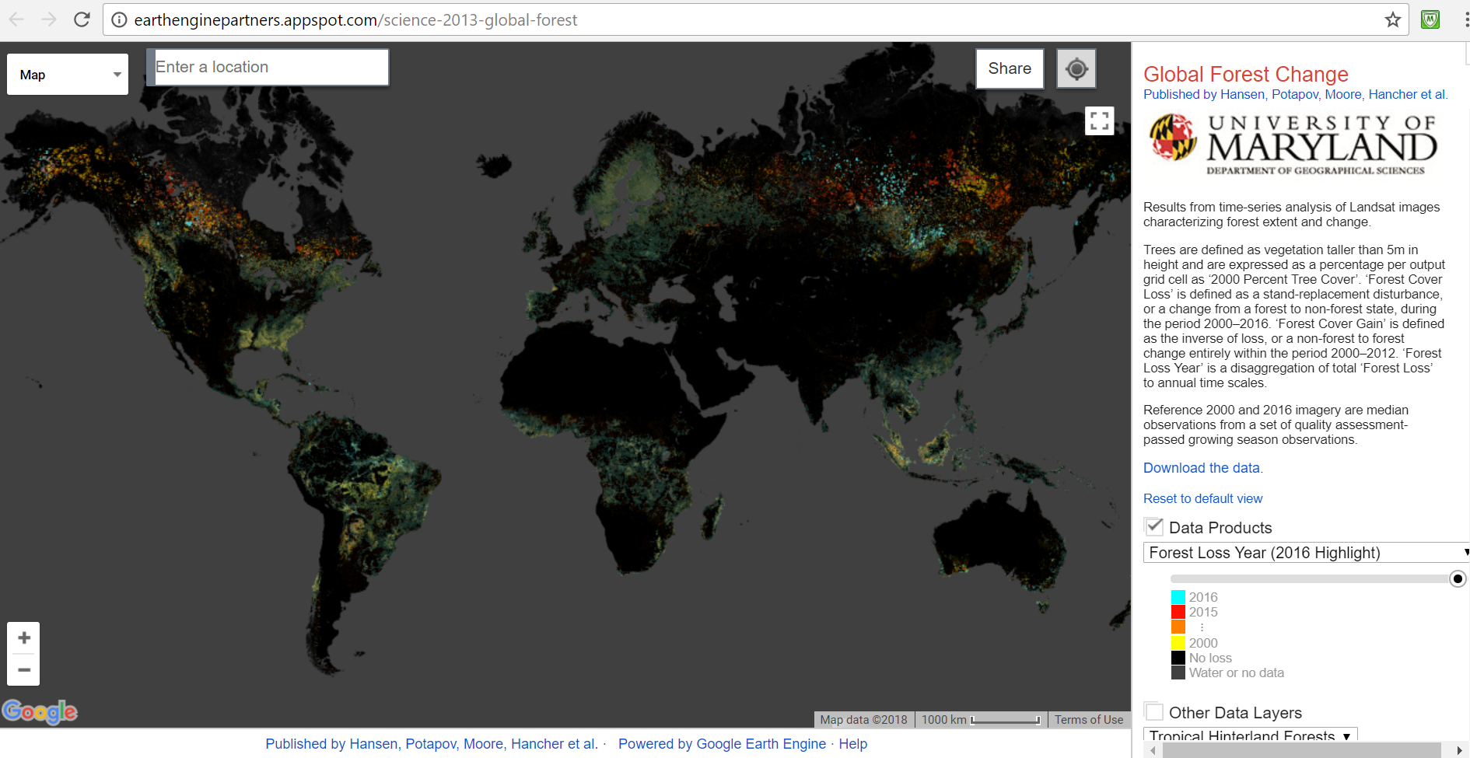

Step 2: Locate the Global Forest Coverage Change (GFCC) image for our study area

We can use the location of our study area to zoom in and see the analysis performed by the team from University of Maryland.

On the GFCC website home page

In the Data Products box
select Forest Cover Loss 2000-2016 (transparent)

Move the transparency slider to the middle of the bar

In the box at the top left of the screen titled Enter a location
type Northeast 117th Way, Redmond, WA and press Enter key

Click once on the minus sign of the Zoom In/Out slider in the lower left corner of the screen

The image should look similar to this:

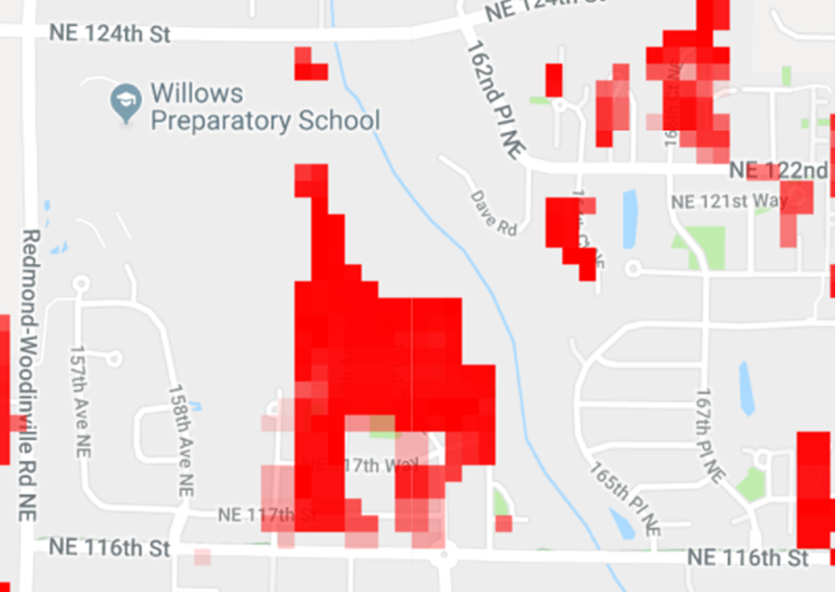

Study Area Forest Coverage Loss (2000-2016)

Step 3: Compare our NDVI change image to the Global Forest Coverage Change (GFCC) image for our study area

The following images compare the gain and loss from our NDVI analysis with the results produced by the University of Maryland researchers in the Global Forest Coverage Change project.

Our Vegetation Coverage Loss (2002-2016) GFCC Forest Coverage Loss (2000-2016)

Step 4: Interpretation

Comparing our NDVI analysis above with the UM GFCC forest gain image, we see good agreement between shapes and area of coverage of “loss”.

It is important to note the reasons why the two images might differ. First, the dates of images used to the produce the analysis are slightly different. University of Maryland used the date range of 2000-2016 and we used a date range of 2002-2016. A second reason for a variance is that the UM analysis was of “forest coverage” with “forest” being defined as trees over 5 meters in height. Our NDVI analysis was more general – we analyzed all vegetation not just forest.

Chapter 14:
Printing Maps and Images

This chapter includes:
- Learning how to prepare maps for distribution
- Creating template for the map
- Adding titles, legends and text boxes to the map

These instructions will help you create a template that will make it much easier to recreate a map with the same legend and symbology. This will save you a lot of time; you will not have to recreate the legend and symbology over and over for each map.

Step 1: Start QGIS

Start QGIS

Select menu option Project > Open Recent
Browse to folder Redmond
Select File Name = Redmond_NDVI > Open

Step 2: Create a new template for printing the map

Select the map layers you want to appear on the printed map.
In the Layers panel on the left of the screen, uncheck layers you don’t want to print.

Select the layer named NDVI-Change

Position the map in the screen as you want it to appear when printed.
(optional) Select the Zoom In icon and, while holding down the left click button, draw a rectangle around the area that you want to appear when the map is printed.

Select menu option Project > New Print Layout
Type NDVI-Diff in the Title box > OK

On the menu bar, select the Add New Map icon
Hold down the left click button, draw a rectangle around the area where you want to the map to appear
If the map does not appear the way you want,
Go back to the main map to adjust the view
Return to Layout Manager

If the map does not render clearly or sharply
Click on the Refresh icon

To keep the map from being accidentally moved, lock its position
Click anywhere inside the map
Right click inside the map
Select Item Properties
In Layers section, check Lock Layers

Select menu option Layout
Select Save as template
Browse to folder Redmond
File Name = NDVI-Diff
Save

Step 3: Add Legend:

A useful feature for formatting the legend titles is the “wrap” feature. You can define a “wrap character” and insert that character in the legend title to force the text following the wrap character to move onto the next line.

On the menu bar, select Add Item > Add Legend
Click in the map at the position where you want the legend to appear
OK

Right click with the cursor inside the Legend box

Select Item Properties tab
In Main Properties section
In Title box type Landsat 2002-2016

Define a Word wrap character (one-time only)
Select Item Properties
In Wrap Text On box type a character such as @

Open Legend Items section
Click to remove the check mark in the Auto Update box
Click on any layer you do not want to appear in the legend
Select Delete icon

Open Fonts section
Click on Title Font > Arial > Font Style > Bold > Size 24 > OK
Click on Sub-Group Fonts > Arial > Font Style > Bold > Size 16 > OK

In Item Font select a font of your choice > OK

Resize the frame of the text box by dragging the edges to fit text

Drag the legend to the upper right corner of the map, then use the arrow keys for fine-tuning position adjustments

Step 4: Add Scale Bar:

On the menu bar, select Add Item > Add Scale Bar
Left click in the lower right corner of the map at the position where you want the Scale Bar to appear
In Height box, type 20
OK

In the Item Properties section
In Scalebar Units box select Meters
In the Label Unit Multiplier box type 1.0
In the Label for Units box type meters
In Segments select Left 0 and Right 3

Check Frame and Background boxes

Resize the frame of the text box by dragging the edges to fit text

Drag the scale bar to the lower right corner of the map, then use the arrow keys for fine-tuning position adjustments

Step 5: Add Map Title:

On the menu bar, select Add Item > Add Label
Click in the map at the position where you want the title to appear
In Height box, type 20
OK

In the Item Properties section
In the Main Properties box type an appropriate title for the map

NDVI Change from 2002 to 2016

Select Font > Arial > Font Style > Bold > Size 16 > OK
Select Alignment Horizontal = Left

Check Frame and Background boxes

Resize the frame of the text box by dragging the edges to fit text

Step 6: Add Data Source Labels:

On the menu bar, select Add Item > Add Label
Click in the map at the position where you want the text box to appear
In Height box, type 20
OK

In the Item Properties section
In the Main Properties box type an appropriate title for the map

Data Sources:
- USGS
- Google Earth

Select Font > Arial > Font Style > Bold > Size 10 > OK
Select Alignment Horizontal = Left

Check Frame and Background boxes

Position the Data Source text box in the lower left corner of the map.

Resize the frame of the text box by dragging the edges to fit text

Step 7: Add Date and Author Label:

On the menu bar, select Add Item > Add Label
Click in the map at the position where you want the text box to appear
In Height box, type 20
OK

In the Item Properties section
In the Main Properties box type an appropriate title for the map

Data Sources:
- USGS
- Google Earth

Select Font > Arial > Font Style > Bold > Size 10 > OK
Select Alignment Horizontal = Left

Check Frame and Background boxes

Resize the frame of the text box by dragging the edges to fit text

Position the date label box in the upper part of the map in a place where it does not cover any site labels.

Step 8: Create image file of map

Select menu option Layout
Select Export as Image
Choose Files of Type jpg
Name file with an appropriate name
Save

Step 8: Print your map from the saved image

Open the JPG Image of your map using any program that will open a JPG file
File > Print > uncheck fit picture to frame
Print

Step 9: Save as Template:
Select menu option Layout > Save as Template
Browse to folder = Redmond
File name = NDVI-diff
Save > Yes

Select menu option Layout > Close

Step 10: Save Project

On the QGIS main menu select Project > Save
On the QGIS main menu select Project > Exit QGIS

Chapter 15:
Ground Truth Sampling
for Remote Sensing

This chapter includes:
- Definition of ground truthing
- Using GPS in ground truthing data collection

Ground truthing is a term used in remote sensing to refer to information collected on location. Ground truth information allows digital image data to be related to real features and materials on the ground.

Ground truthing is usually done on site, performing observations and measurements of various properties of the features of the ground resolution cells that are being studied on the remotely sensed digital image.

Tips on using a GPS for ground truthing data collection

When using a GPS to determine the coordinates of a location, set the GPS datum to the same datum used by the digital maps in your GIS. One of the most commonly used datums is WGS 84. You can determine the datum used in your digital map by using your GIS software to look in the map’s metadata.

Set the GPS’s coordinate unit format to meet the input requirements of your GIS software, e.g., QGIS input requires that latitude and longitude be formatted as a decimal number so you must set the GPS coordinate unit’s format to degrees and decimals of degrees.

Part 5:
Useful Tools

Chapter 16:
Adding Digital Elevation
Contour Lines

This chapter includes:
- About Digital Elevation Model (DEM) data
- Instructions for adding elevation contour lines to a map
- Example of contour lines on a map

NOTE TO CAPSTONE PROJECT MEMBERS:

THIS CHAPTER HAS NOT BEEN UPDATED WITH CHANGES NEEDED WHEN QGIS WAS UPGRADED FROM VERSION 2.18 TO 3.0.

PLEASE MAKE THE NECESSARY CHANGES AS PART OF YOUR PROJECT EXPERIENCE.

The goal of this exercise is to learn how to draw elevation contour lines on a map.
The Shuttle Radar Topography Mission (SRTM) obtained elevation data on a near-global scale to generate the most complete high-resolution digital topographic database of Earth. SRTM consisted of a specially modified radar system that flew onboard the Space Shuttle Endeavour during an 11-day mission in February of 2000. SRTM is an international project spearheaded by the National Geospatial-Intelligence Agency (NGA) and the National Aeronautics and Space Administration (NASA).

Again we will use the EarthExplorer website operated by the US Geodetic Survey as the source of our data

Step 1: Download Digital Elevation Model (DEM) data file

http://earthexplorer.usgs.gov/
If you have not already set up an account, do so now.

On the Menu bar, select Login > select Signin

In the box Address/Place > type Redmond WA > Show
Select the location you want to find from the ones shown
Select the Data Sets button
Click the + box next to Digital Elevation
Check the box SRTM
Check the box SRTM Void Filled
Select the Results button at the bottom of the pane
Select Download Options icon for the map you want (Select the 3 Arc option)

Select Download in GEOTIFF format
Click Select Download Option button
Select Download button for the 3 Arc option
Select Save File > OK

After the Download completes
on the EarthExplorer Menu bar, select Logout

Browse to the folder where files download on your computer
Copy the downloaded TIFF file to your folder named Redmond

Step 2: Run QGIS program and load your NDVI map

Start QGIS
On the QGIS main menu select Project > Open Recent
Select the project Redmond_NDVI

Right click the StudyArea layer > Zoom to Layer

On the QGIS main menu select Project > Save As
Browse to the folder Redmond
In File Name box type Redmond_Elevation
Save

Step 3: Create the elevation contours

On the QGIS main menu select Raster > Extraction > Contour
For Input File > Select > browse to folder Redmond
choose file n47_w123_3arc_v2
Open
For Output File > Select > browse to folder Redmond
Type File Name = Contours > Save
Select Interval between contour lines = 10 (this is meters)
Check box Attribute Name and accept default of ELEV
Check box Load into canvas when finished
OK
When the Processing Complete box displays, click OK

Close

Step 4: Label the elevation contour lines

Select the layer Contours
On the QGIS main menu select Layer > Labeling
Check “X” in box on left of Label this Layer with
In the Label this Layer with box select ELEV
Select Text tab
In Style box, select Bold
In Color box, select Yellow
In Size box, type 10
OK

Select Placement tab
Select Curved and on line
OK

Select Style tab
Click on Simple Line
In Color box, select Yellow
In Pen Width box, type 1
OK

On the QGIS main menu select Project > Save

Step 5: Example

Your map should look similar to the following map

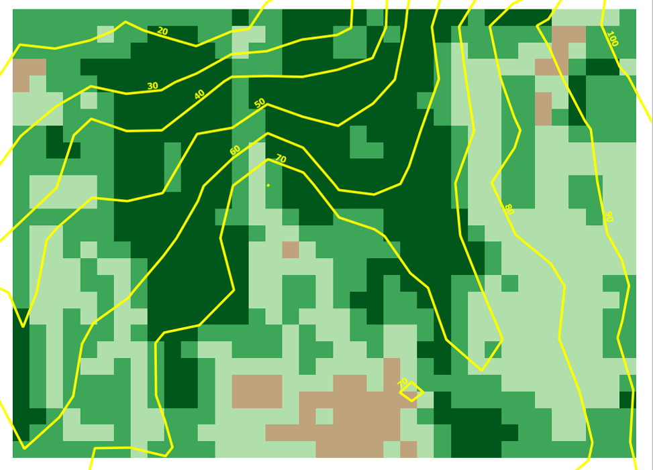

Step 6: Add your elevation contours as a layer in Google Earth (optional)

In QGIS, right click on the layer named Contours
Select menu option Save As
In the Format box, choose Keyhole Markup Language (KML)
Browse to the folder Redmond
In the File Name box type GEcontours
Save > OK > OK

Start Google Earth
Drag and drop the file GEcontours onto the Google Earth display.

Google Earth will rotate to the location covered by your elevation contour file and overlay your elevation contours on the Google Earth display.

Chapter 17:
Coordinate System Conversion

This chapter includes:
- Understanding the need to convert coordinate systems
- Instructions for coordinate system conversion

NOTE TO CAPSTONE PROJECT MEMBERS:

THIS CHAPTER HAS NOT BEEN UPDATED WITH CHANGES NEEDED WHEN QGIS WAS UPGRADED FROM VERSION 2.18 TO 3.0.

PLEASE MAKE THE NECESSARY CHANGES AS PART OF YOUR PROJECT EXPERIENCE.

If your map data is in different coordinate systems, layers will not display properly in QGIS. You know you may have a coordinate mismatch if you select a layer, zoom to layer and notice that another layer disappears. When you selecting the disappearing layer, zoom to layer and notice that the first layer disappears. If this is your situation, the two layers may be projected in different coordinate systems. A classic example is a mismatch between Landsat images (UTM coordinates) and a administrative boundaries layer that may be in lat/long coordinates. In this situation, the administrative boundary layer should be converted to UTM coordinates.

The following instructions show you how to convert map layers coordinate systems.

Step 1: Start the GIS program

Start QGIS

Step 2: Add a raster layer of a Landsat image
On the QGIS side bar select Add Raster Layer icon
Browse to folder Landsat
Select the file ending in B4 (band 4)
Open

Right click LandSat B4 layer > Properties
Select Metadata tab
In the Properties box
Scroll to Layer Spatial Reference System
Make a note of the UTM zone displayed in zone =
Cancel

Step 3: Add a vector layer for the country
On the QGIS side bar select Add Vector Layer icon
For Dataset, browse to folder Redmond and find file: USA_adm2.shp
Open > Open

Step 4: Decide if coordinate conversion is needed

Right click USA_adm2 layer > Properties
Select Metadata tab
In the Properties box
Scroll to Layer Spatial Reference System
Make a note of the UTM zone displayed in zone =
If Layer Spatial Reference System shows proj=longlat then coordinate conversion is needed
Cancel

Step 5: Create a new shapefile layer with adjusted coordinates

Right click the USA_adm2 layer
Select Save as option
Choose Format = ESRI shapefile
In Encoding, choose Selected CRS
Browse CRS to find the UTM zone that matches the UTM from Step 2 OK
Click to put a check in the box Add saved file to map
In Save As box browse to the folder Redmond
In File Name box type, Country_UTM > Save
OK

Step 6: Remove the vector layer that is no longer needed

Right click the USA_adm2 layer
Remove

Step 7: Verify that the conversion worked correctly

Drag the Landsat layer to the top of the layer list

The conversion worked correctly if you see both the vector layer and the Landsat layer on the screen.

Chapter 18:
Creating a Study Area
Using QGIS

This chapter includes:
- Instructions for creating a study area layer as a vector file using QGIS

Purpose

Now that you have some map layers in your GIS project file, you may want to study an area of special interest. Let’s define a new smaller area that is a subset of the full image area.

Step 1: Start QGIS and load a previously saved project

Start QGIS
On the QGIS main menu select Project > Open
Browse to the folder Redmond
Select the project ReferenceMap > Open

Step 2: Create a new shapefile layer

On the QGIS main menu select Layer > Create Layer > New Shapefile Layer
Choose Geometry Type Polygon
Click Specify CRS button
Choose WGS 84 / UTM zone 10N in Selected CRS box

Each shapefile has an attribute table where data about its features can be stored. Add any attribute fields you want in the New Attribute section. Adding fields is optional; fields can always be added later

In Name box type Name
Select Text data in Type box
In Length box type 48
Click on the Add to fields list box

Browse to the folder Redmond
In File Name box type StudyArea > Save
OK

Your new StudyArea layer will automatically be added to the navigation menu on the left of your screen. In addition, the shapefile named StudyArea will now be saved in the folder Redmond.

Step 3: Define the boundaries of your study area

Select View > Toolbars > click X in Digitizing Toolbar

Left click on the CornerPoints layer
Right click on Zoom to Layer

Left click on the StudyArea layer
Select the Toggle Editing icon 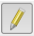 on the toolbar to turn editing “on”
Select the Add Polygon Feature icon

Draw a polygon around your study area
Position the cursor at the upper left corner of your area and left click
Move the cursor to the upper right corner of your area and left click
Move the cursor to the lower right corner of your area and left click
Move the cursor to the lower left corner of your area and left click
Right click to finish the polygon

Type “1” in the Id box
Type Corners in the Name box
OK
Select the Toggle Editing icon on the toolbar to turn editing “off”
Save

Select the StudyArea layer > Properties
Select Symbology tab
Left click on Simple Fill
For Fill Style select no brush
For Stroke Color select red > OK
For Stroke Width type 1
For Stroke Style select solid line
Apply > OK

Step 4: Adjust the boundaries of your subset area

If you want to adjust the shape of your subset area

Left click on the StudyArea layer
Select the Toggle Editing icon on the toolbar to turn editing “on”
Select the Node Tool icon on the toolbar
(the cursor will change to a cross)
Move the “cross” cursor over the corner point you want to move
Hold down left mouse button to drag the point to a new location
Release the left mouse button

When you are finished moving the corner points of your Study Area polygon
Select Toggle Editing icon on the toolbar to turn editing “off”

Choose Save

Step 5: Save the Project

The new shapefile named StudyArea defining your study area has been saved in folder Redmond.

On the QGIS main menu select Project > Save

The vector shapefile named StudyArea can now be used to “clip” images so the images only contain data for the defined study area. Instructions for clipping can be found in Chapter 10, Step 3

Chapter 19:
Creating a Study Area
Using Google Earth

This chapter includes:
- Instructions for creating a study area using Google Earth features

Now that you have some map layers in your GIS project file, you may want to study a different area of special interest. Let’s define a new study area that is a subset of the full image area.

Step 1: Run the Google Earth program and located your area of interest

Start Google Earth

Navigate to the general area you wish to define as your study area.

Step 2: Set the Google Earth coordinate system to match your QGIS project coordinate system

The coordinate system you are using for your QGIS project must be the same as the coordinate system defined in Google Earth so that the file created in Google Earth will register correctly when you bring it into your QGIS project.

Select menu item Tools > Options
Select the 3D View tab
In the Show Lat/Long box
If you plan to work with Landsat images
Choose the Universal Transverse Mercator button
If you plan to work with GADM administrative boundary maps
Choose the Decimal Degrees button
Apply > OK

Step 3: Draw a polygon around your study area
Select the Add Polygon icon

In the Name box, type StudyAreaGE

Move the cursor outside the polygon parameters box to the upper left corner of your desired study area. You may need to move the parameters box out of the way by left clicking in the title bar, then, while holding the left click button down, drag the box to an unused position on your screen.

Position the cursor at the upper left corner of your study area and left click
Move the cursor to the upper right corner of your area and left click
Move the cursor to the lower right corner of your area and left click
Move the cursor to the lower left corner of your area
If your study area is not a rectangle, you can left click on as many points as you need
OK

Step 4: Save your study area polygon as a KML file

On the main menu File > Save > Save Place As
browse to folder named Redmond
type File Name = StudyAreaGE
select File Type = KML
Save

Step 5: Add the KML file of your study area to QGIS project

Start QGIS
On the main menu select Project > Open
Browse to the folder where your project is located
Select your project file
Open
On the QGIS side tabs select Add Vector Layer icon
For Dataset, browse to folder where your project is located
In the box to the right of File Name select file type KML
Select the file named StudyAreaGE
Open > Open

Step 6: Create a shapefile of your study area

Right click the StudyAreaGE layer
Select Save as option
Choose Format = ESRI shapefile
In Encoding, choose Layer CRS
Browse CRS
Select in the Coordinate Reference Systems of the World box the same reference system that you are using for your reference map project > OK
Click to put a check in the box Add saved file to map
In Save As box, browse to folder where your project is located
In File Name box type, StudyAreaGE > Save
OK

Right click on the layer StudyAreaGE
Select Zoom to Layer

Select the StudyAreaGE layer > Properties
Select Style tab
Click on Simple Fill
For Fill Style select no brush
For Border Color select black > OK
For Border Style select solid line
For Border Width type 1
Apply > OK

Right click the StudyAreaGE layer for the KML file
Select Remove > OK

Step 7: Adjusting the boundaries of your study area

If you need to adjust the boundaries of your study area, follow the instructions in Step 4 of Chapter 18.

Step 8: Save the Project

The new shapefile named StudyAreaGE defining your study area has already been saved in folder Redmond.

On the QGIS main menu select Project > Save
On the QGIS main menu select Project > Exit QGIS

New chapter on Level-2

The Landsat 7 Thematic Mapper (TM) and Enhanced Thematic Mapper Plus (ETM+) sensors capture reflected solar energy, convert these data to radiance, then rescale this data into an 8-bit digital number (DN) with a range between 0 and 255.

The Landsat 8 OLI sensor is more sensitive, so these data are rescaled into 16-bit DNs with a range from 0 and 65536.

The raw data of radiance measured at the satellite sensor is recorded as a DN value and is referred to at “real time data – RT”. The measurement we need to work with is the surface reflectance – the value that would be recorded by a hand-held spectrophotometer by someone standing on the ground.

To be able to compare the values from the two different sensors, the images need to be converted to surface reflectance. Fortunately, this has done for us and is readily available by downloading the Level-2 images. The spectral properties of the ORI and ETM corresponding bands are not exactly the same. ADD SOME MORE HERE

Select Order Scene icon for the map you chose
Select the View Item Basketbutton
Select the Proceed to Checkout button
Click the title of the Data Set in the item basket
Select the Submit Order button

Select Logout
In your email folder you should receive the following emails:
Order confirmation
Processing the order
Processed order available for download

After the “available for download” email arrives
Note the last four digits of the order number
Double click on the link to begin the download
Select the file with correct order number to download (usually the topmost)
Click on Download

After the download completes, browse to locate the downloaded file
Copy / paste the file to the folder Landsat in the folder Redmond
Leave the name of the Landsat file unchanged

LE070460272002061101T1-SC20180415173121.tar

Chapter 20:
A Challenge

This chapter includes:
- Challenge to define your own project and practice

You can define your own project and follow this workflow to analyze and document.

QGIS - define study area (5)
QGIS - create reference map (5)
Download Landsat images (7)
QGIS - load Landsat images (8)
QGIS - perform NDVI analysis (10-13)
QGIS - print maps (14)
Download Admin maps (4)
Ground Truthing (15)
Download QGIS software (3)

Appendixes:

Appendix A: References

- Satellite Archeology, National Geographic Magazine, February, 2013, pp 60-61

- Introduction to Remote Sensing, Fifth Edition, Campbell and Wynne, The Guilford Press, 2011

Appendix B: NDVI ColorRamps

Text for NDVI_Color_Ramps

# QGIS Generated Color Map Export File – Landsat Level-1
INTERPOLATION:DISCRETE
0.07,0,76,255,255,Water
0.16,191,163,124,255,Bare Surface / Pavement
0.25,177,223,171,255,Scattered Vegetation
0.4,61,166,89,255,Moderate Vegetation
0.99,0,87,27,255,Dense Vegetation

# QGIS Generated Color Map Export File – Landsat Level-2
INTERPOLATION:DISCRETE
0.17,0,76,255,255,Water
0.31,191,163,124,255,Bare Surface / Pavement
0.4,177,223,171,255,Scattered Vegetation
0.7,61,166,89,255,Moderate Vegetation
0.99,0,87,27,255,Dense Vegetation

Text for NDVI_Change_Color_Ramp

# QGIS Generated Color Map Export File
INTERPOLATION:DISCRETE
0.2,210,45,37,255,Loss

0.9,252,233,134,255,Neutral gain/loss

Index

7-Zip 8
calculator 29, 37
clip
vector 12
Clip 27
color ramp 30, 37
contours
elevation 51
coordinate systems conversion 55
EarthExplorer 19
elevation contours 51
GADM 9
GLOVIS 20
Google Earth 60
Ground truthing 49
Interpretation 24
KML file 61
Landsat 19
facts 22
Landsat 8 26
LandsatLook 20
legend 45
NDVI 26
NIR 27
projection 13
reference map 10
scale bar 46
study area 60
study region 11
title 46
USGS website 21
EarthExplorer 19
LandsatLook 20
UTM 13

