Plant Watering Robot — Hardware Assembly Guide (v2)
Companion to the Hardware Purchase List (v2, hose/pipe + solenoid-valve variant). Prepared 8 June 2026.
This guide assembles the v2 single-zone build: one moisture sensor, one solenoid valve, one relay, one Raspberry Pi — gating an always-available pressurized hose/pipe instead of running a pump from a reservoir. There is no tank to fill or monitor; the trade-off is that a stuck-open valve can flood rather than just run a reservoir dry, so the wiring steps below pair the valve with a hard software cutoff (MAX_WATER_SECONDS in scheduler.py). Wiring steps are specific to the parts in the Hardware Purchase List. It picks up exactly where the SIMULATE-mode software (scheduler.py / plant_state.py / app.py) leaves off.
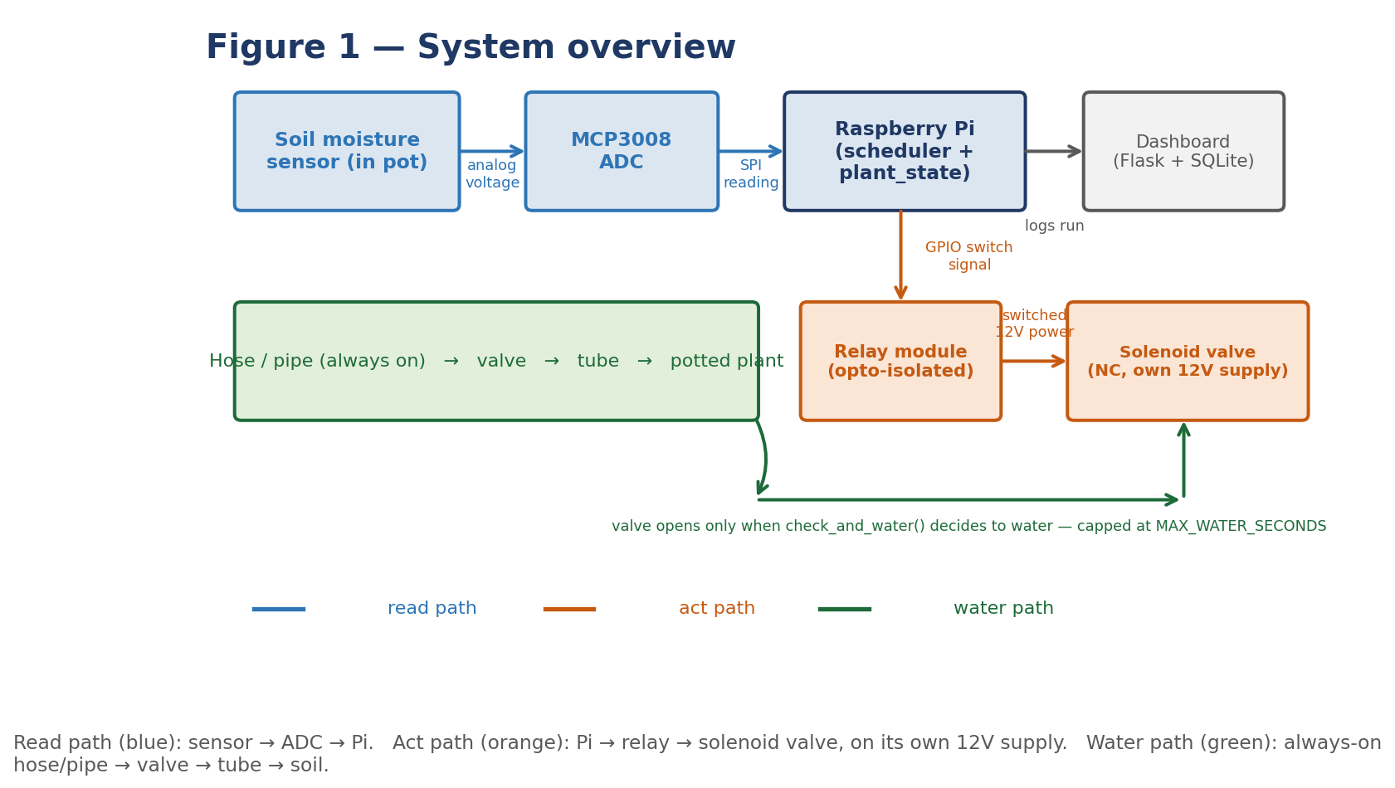
Figure 1 — System overview: sensor reads soil moisture; Pi decides; relay switches the solenoid valve; the valve gates the always-on hose/pipe so water reaches the plant only when commanded.
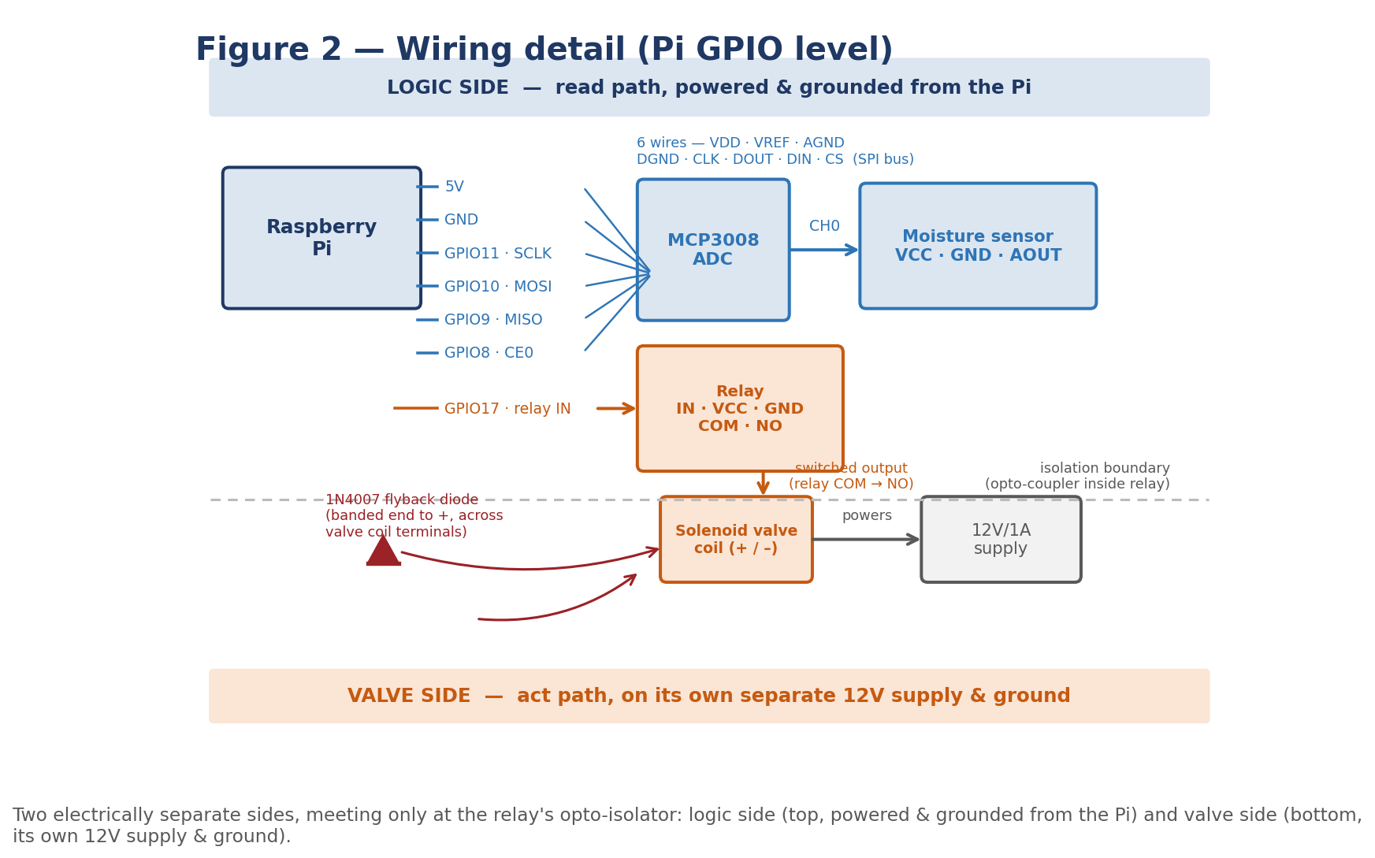
Figure 2 — Wiring detail (Pi GPIO level): logic side (sensor → ADC → Pi, powered & grounded from the Pi) and valve side (relay → solenoid valve, on its own separate 12V/1A supply & ground), meeting only at the relay's opto-isolator.
Read the whole guide once before starting. Build and test the electronics on the bench FIRST, before connecting anything to the hose or mounting near the plant. It's far easier to find a wiring mistake on a table than on a dripping shelf — and far cheaper to catch a stuck-open valve there too.

Safety first
- Disconnect all power before wiring or rewiring anything — for both the Pi's supply and the valve's separate 12V supply.
- Never power the solenoid valve from the Pi's 5V rail. Use a separate 12V/1A supply, matched to the valve coil's rated voltage and switched through the relay — this keeps a valve fault from taking the Pi down with it.
- Wire the 1N4007 diode across the valve coil terminals (banded end toward +) before first power-on — it absorbs the voltage spike when the coil switches off and protects the relay contacts.
- Buy the valve as normally-closed (NC). NC means it stays SHUT with no power applied — so a Pi crash, brown-out, or cable fault leaves the line closed, not gushing.
- Respect MAX_WATER_SECONDS as a hard backstop, not a suggestion. Because the line is always pressurized, the software — not a float switch — is what stands between “idle” and “flooded”. Confirm in simulation that a run always closes the valve well before this limit, before ever connecting to a live hose.
- Double-check polarity on every connection before power-on. Reversed power can destroy the Pi or the ADC instantly.
- Keep all electronics (Pi, ADC, relay) physically separated from and above the hose, valve, and any wet soil — mount the controller box high and dry (see Figure 4).

Stage 0 — Bench-test the electronics
Do this with everything loose on a table, before anything is connected to a hose or near soil. Confirm each part works on its own first.
- Flash the Pi: write Raspberry Pi OS to the microSD with a card reader, boot the Pi, confirm it reaches the desktop/terminal.
- Run the simulation: copy this project onto the Pi and run python app.py with SIMULATE = True — confirm the dashboard loads and “Run check now” logs a row to plant.db, and that the simulated run always reports closing the valve at or before MAX_WATER_SECONDS.
- Wire the ADC: connect the MCP3008 to the Pi's SPI pins (MOSI/MISO/CLK/CS + power/ground); confirm the Pi can read a channel (e.g. with a potentiometer or by touching the sensor pins).
- Test the moisture sensor alone: power it at 5V, dip the probe in water vs. dry air, and confirm the ADC reading changes meaningfully between the two.
- Test the relay + valve alone (off the hose): wire the relay's signal pin to a Pi GPIO, the solenoid valve coil to the relay's switched output and its own 12V/1A supply (with the 1N4007 diode across its terminals), and confirm the Pi can open and shut the valve on command — you should hear it click. Do this dry, before any water is connected.
Only move on once every part has worked individually on the bench.

Stage 1 — Power distribution
Two separate supplies, one shared isolation point:
From | To | Notes
Pi power supply (5V/3A, micro-USB or USB-C) | Raspberry Pi | Powers the Pi, the MCP3008, the sensor, and the relay's signal side — this is the only supply the Pi ever sees
Separate 12V/1A adapter | Relay's switched output → solenoid valve coil | The valve's own supply, matched to its rated coil voltage — isolated from the Pi by the relay's optocoupler
Pi GND | MCP3008 GND, sensor GND, relay signal GND | Logic-side common ground — keep this separate from the valve-side ground
12V supply GND | Valve coil (–) terminal, relay switched-side GND | Valve-side ground — only meets the logic ground through the relay's isolation
Keeping the logic ground and valve ground separate (joined only via the relay's opto-isolation) is what makes a valve-side glitch harmless to the Pi.

Stage 2 — Sensor → ADC → Pi (read path)
- Wire the MCP3008 to the Pi's SPI bus: VDD/VREF → 3.3V, AGND/DGND → GND, CLK → SCLK (GPIO11), DOUT → MISO (GPIO9), DIN → MOSI (GPIO10), CS → CE0 (GPIO8).
- Wire the moisture sensor: VCC → 5V, GND → GND, AOUT → MCP3008 channel 0 (CH0).
- Enable SPI: in raspi-config, enable the SPI interface and reboot.
- Read a value: confirm a Python SPI read from CH0 changes when the probe goes from dry air to wet soil/water — this is the live version of read_moisture() in plant_state.py.

Stage 3 — Pi → relay → solenoid valve (act path)
- Wire the relay signal side: relay VCC → 5V, GND → GND, IN → a Pi GPIO pin (e.g. GPIO17).
- Wire the valve side: separate 12V/1A supply (+) → relay COM, relay NO → valve coil (+), valve coil (–) → supply (–). Place the 1N4007 diode across the coil terminals, banded end to (+).
- Test the switch (still dry): drive the GPIO pin high/low from Python and confirm the relay clicks and the valve opens/shuts only when commanded — this is the live version of run_valve() in plant_state.py. Time how long it takes to audibly open and shut; this should be near-instant and well inside MAX_WATER_SECONDS.
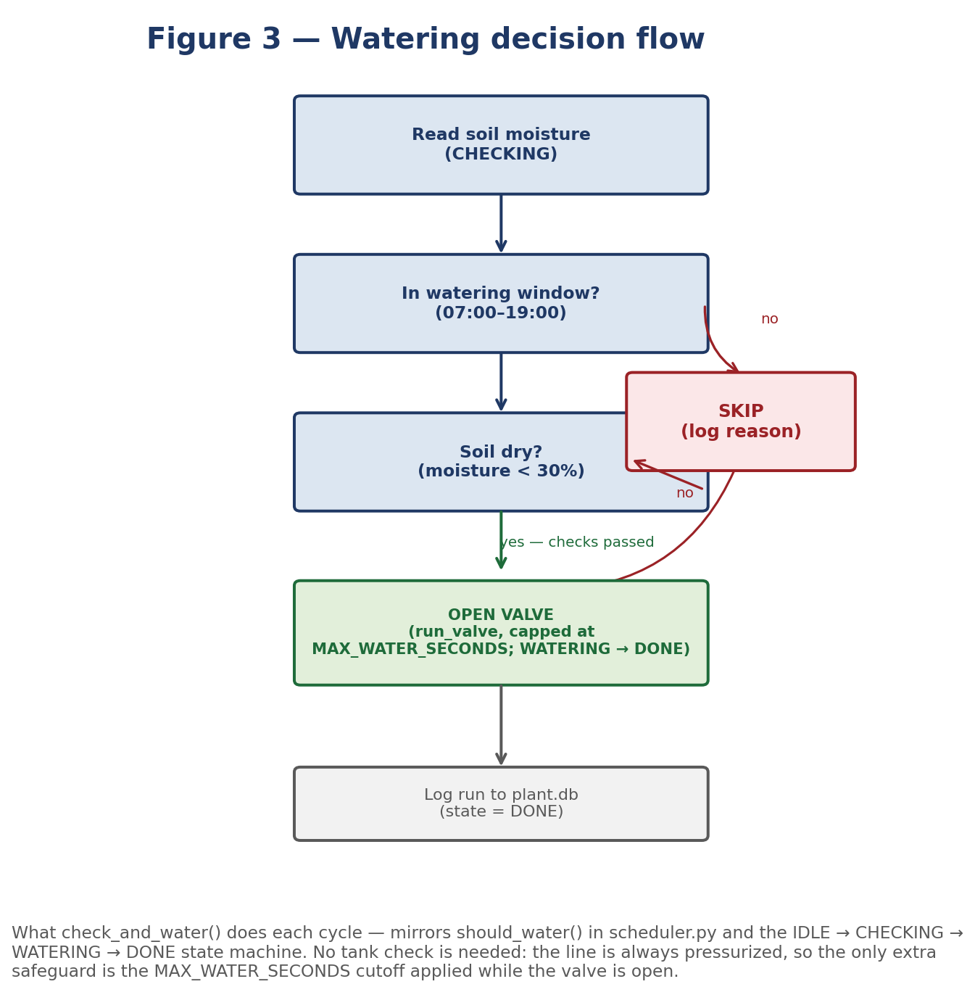
Figure 3 — Watering decision flow: how check_and_water() combines the time-window and soil-moisture checks into a water/skip decision, opens the valve for at most MAX_WATER_SECONDS, and logs the outcome to plant.db. (No tank-level check — the line is always pressurized.)

Stage 4 — Mounting & plumbing
- Mount the controller box (Pi + ADC + relay) high and dry: on a shelf edge or wall bracket, well above and away from the hose, valve, and any wet soil — never directly over the pot or the plumbing run.
- Splice the solenoid valve inline on the existing hose/pipe: use the hose-to-BSP fittings (with thread tape) to connect the always-on supply line to the valve's inlet — the valve becomes the single point that turns the line “on” for the plant.
- Run the outlet tubing from the valve's outlet to a point just above the soil near the plant's base, sloping gently downhill so it self-drains between waterings — this matters even more here than with a pump line, since the supply side stays pressurized right up to the valve.
- Insert the moisture probe a few centimetres into the soil, away from the direct stream of the tube outlet (so it reads ambient soil moisture, not a fresh puddle).
- Route and dress all cables so the wet side (hose, valve, tubing, probe tip) and dry side (Pi, ADC, relay, connectors, control cable) stay physically separated — drips should never reach a connector.
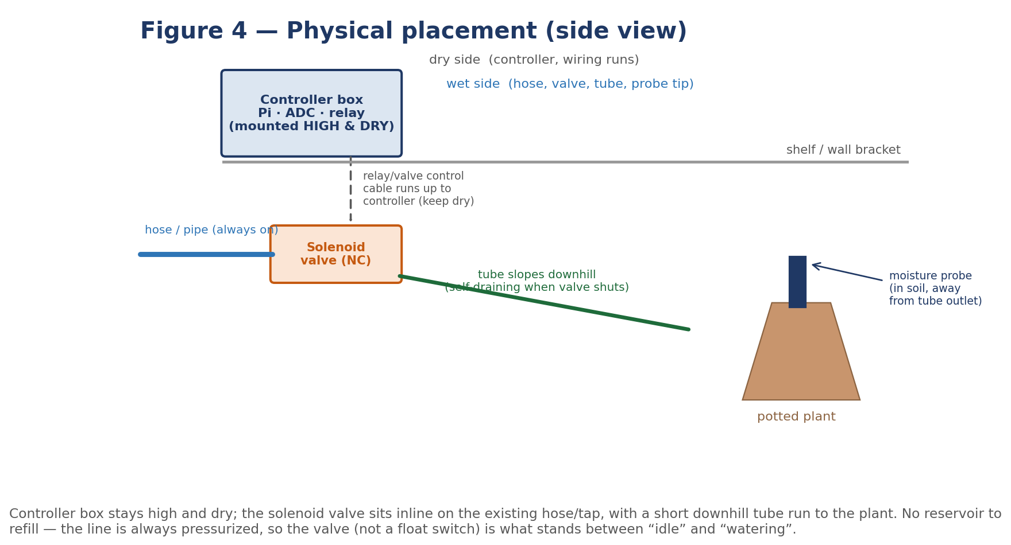
Figure 4 — Physical placement (side view): controller box mounted high and dry; the solenoid valve sits inline on the existing hose, with a short downhill tube run to the plant; the sensor probe sits in the soil, away from the tube outlet. No reservoir to place or refill.

Stage 5 — First live run
- Flip SIMULATE = False in plant_state.py once the real read_moisture() and run_valve() are wired in to replace the simulated stand-ins. There is no read_tank_level() to wire up in this variant — one less thing that can go wrong.
- Run one manual check from the dashboard (“Run check now”) with the valve still disconnected from the live hose, and confirm the logged moisture reading and the open/shut timing look sane.
- Connect the hose and watch the first full cycle end to end — dry soil, in-window — and confirm the valve opens, water reaches the plant, the valve shuts again at or before MAX_WATER_SECONDS, and the run logs correctly to plant.db.
- Tune the thresholds (MOISTURE_THRESHOLD, watering window, MAX_WATER_SECONDS) in scheduler.py once you've watched a few real cycles for your specific plant, pot size, and the actual flow rate of your line.
Worst case if something's off: a plant gets a bit too much or too little water for one cycle — exactly the gentle failure mode this project was chosen for. The MAX_WATER_SECONDS cutoff and the NC valve's fail-shut behaviour are what keep “something's off” from ever becoming “the shelf is flooded.” Adjust and re-run.

