**Celebrating Asian and Pacific Islander American Heritage Month with Data**

To celebrate [Asian and Pacific Islander American Heritage Month](https://en.wikipedia.org/wiki/Asian_Pacific_American_Heritage_Month), PSRC staff dove into American Community Survey data about Asian and Pacific Islander people living in our region.

Idea for a picture (I like this one)

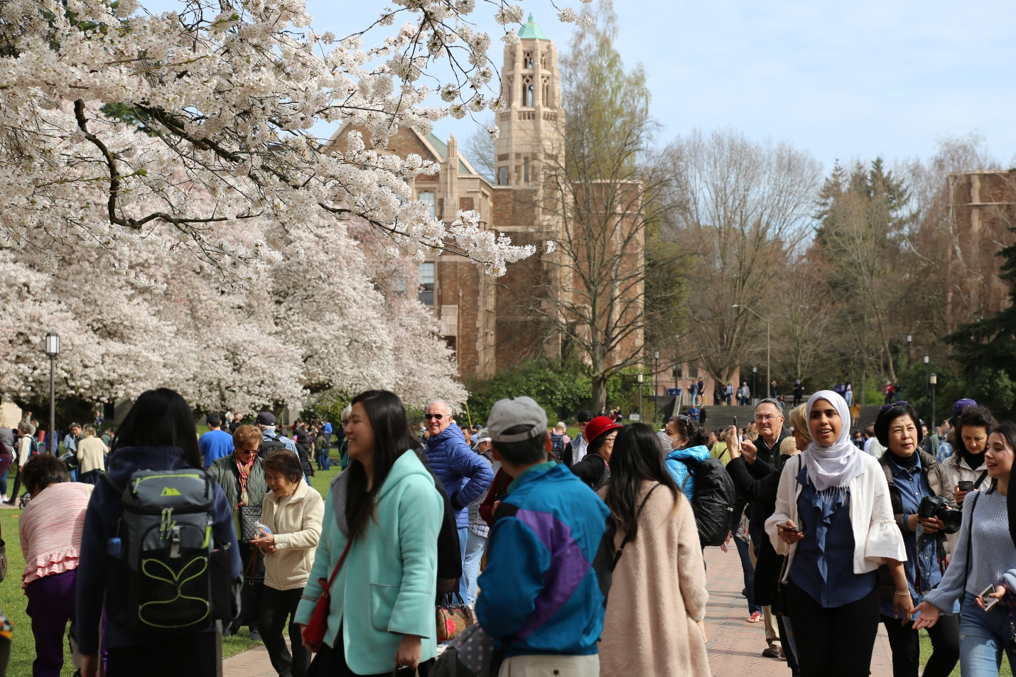

From 2010 to 2019, the Asian population in the region increased 46% from 408,000 to 596,000. The number of people who speak Chinese increased 74% from 67,000 to 117,000[1]. The Native Hawaiian and Other Pacific Islander population increased 10%. In comparison, the Black or African American population increased 26%, and the white population only increased 5%.

According to a [Social Explorer analysis](https://www.socialexplorer.com/blog/post/asians-likely-remained-nation-s-fastest-growing-racial-group-during-last-decade-11358?utm_source=email&utm_medium=newsletter&utm_campaign=newsletterApril2021&sslid=M7M0tzAwMTCwMDE1BAA&sseid=MzIyMDQ2sjQzMwcA&jobid=7dd7ea32-7fad-46c2-9be9-fc3c709ff19c) of American Community Survey data,

*"the Asian population has grown roughly 26 percent since 2010 – faster than the Hispanic population (22.5 percent); more than three times faster than the Black population (7.7 percent); and almost 80 times faster than the White population (0.3 percent)."*

Although the Asian population in the US grew rapidly, the Asian population in the Puget Sound Region grew at nearly double the rate.

In 2019, over 596,000(14%) people in our region identify their race as Asian Alone, and 35,000 people(1%) identify their race as Native Hawaiian and Other Pacific Islander.[2]

Regionally, the highest share of Asian people lives in King County of the four-county region at 19% of people identifying as Asian. The highest share of Total Native Hawaiian and Other Pacific Islander people live in Pierce County (1.4%).

However, the greatest percent growth by County in Asian alone population has occurred in Snohomish County, where the Asian alone population has increased 56%. The greatest growth in the Native Hawaiian and Pacific Islander population was also in Snohomish County at 15%.

Check in later this month on our blog find out about to learn more the demographics and travel choices of Asian and Pacific Islanders in our region!

1. Data in this post comes from the 2010 and 2019 American Community Surveys 1 -year data, table B02001 for Race and table C16001 for language
2. 2019 ACS Estimate, table B02001