In a previous blog post (hyperlink), we looked at the basic statistics on Asian and Pacific Islander people in our region. We were only able to scratch the surface in understanding what the Census could tell us about Asian people in our region, so we wanted to follow up with more detail.

Picture of people here.

**Which diverse Asian- Pacific Islander heritages are represented in our region?**

People of Asian and Pacific Islander heritage represent a great diversity of cultures and countries which we celebrate during [Asian American and Pacific Islander month]( https://asianpacificheritage.gov/). The top three groups people identify with in our region are: Chinese (121,700 people), Asian Indian(104,400 people), and Filipino (86,000). There are **14 subgroups** of Asian and Pacific Islander people with over 5,000 people in our region: Chinese, Asian Indian, Filipino, Vietnamese, Korean, Japanese, Two or more Asian groups, Cambodian, Samoan, Guamanian or Chamoro, Taiwanese, Laotian, Pakstani, and Thai.[1]

Here’s an idea for data visualization, but feel free to play with it.

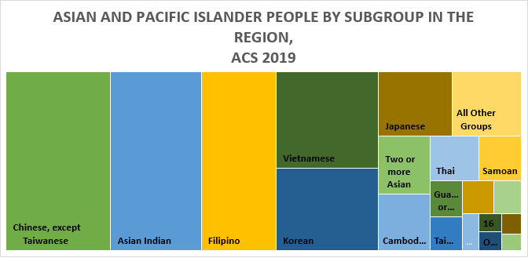

Only subgroups with over 5,000 people are shown in detail.

Here’s the data. (numbers of been rounded to the nearest hundred because the data accuracy does not support reporting more decimals)

|  |  |
| --- | --- |
| Person Asian or Pacific Islander Subgroup | Estimate |
| Chinese, except Taiwanese | 120740 |
| Asian Indian | 104400 |
| Filipino | 86500 |
| Vietnamese | 63700 |
| Korean | 54300 |
| Japanese | 30500 |
| Two or more Asian | 19300 |
| Cambodian | 18500 |
| Samoan | 12300 |
| Guamanian or Chamorro | 7600 |
| Taiwanese | 7000 |
| Laotian | 6700 |
| Pakistani | 5700 |
| Thai | 14000 |
| All Other Groups | 28500 |

**Where were all these diverse Asian and Pacific Islander people in our region born?**

The region has attracted Asian and Pacific Islander talent from around the world to our region with our strong economy and innovative universities. About 2/3rds(64%) of Asian and Pacific Islander people in our region are foreign born. About 20% of Asian and Pacific Islander people in the region are from the state of Washington.

|  |  |
| --- | --- |
| Place of Birth | Share of Asian and Pacific Islander People |
| Born in state of residence | 20% |
| Born in other state in the United States | 12% |
| Native; born outside the United States | 4% |
| Foreign born | 64% |

**Where do Asian and Pacific Islander people live in our region?**

Asian and Pacific Islander people live throughout the PSRC region, with strong concentrations on the Eastside, South Seattle, Lake Union, the University District, and S. Snohomish County. Many of these areas correspond to tech or education sector concentrations such as Microsoft, Amazon, the University of Washington, and Boeing. Asian and Pacific Islander people from Washington and all over the world have enriched our tech sectors and brought vibrant cultural traditions to our beautiful region, and we celebrate them for that this month!

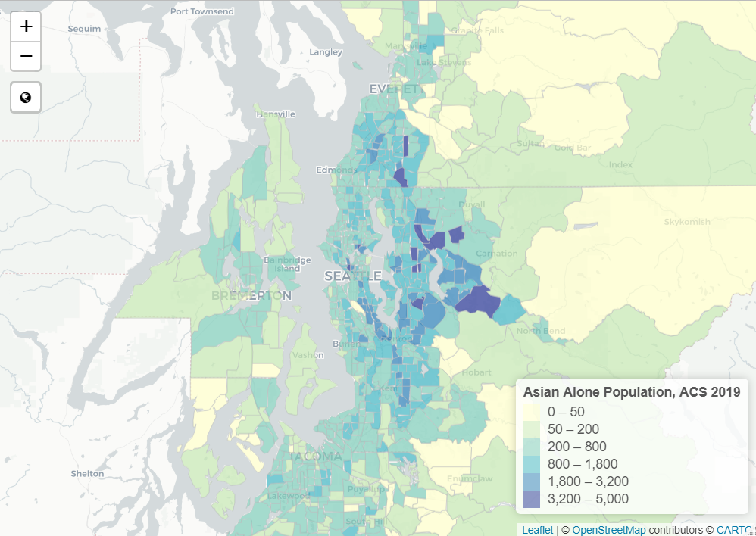

1. ACS 2019 table B02015 Asian Alone by Subgroup/B02016 Native Hawaiian and Pacific Islander by Subgroup