Visuals for Equity Tracker

Mary Richards

August 07, 2023

# 3 visuals for webpage

This code will help produce the three visuals that are going to be a part of each equity tracker indicator webpage: regional map (tract level) of most recent data, chart of the most recent data, chart of trends over time. The inputs/variables will need to be adjusted depending on the indicator characteristics - data source and value type.

## 1. Map of most recent data

To create the map of the most recent data, there are two different approaches that will depend on the indicator’s data source.

a.) **If the indicator is a PUMS/OPSI indicator that can be accessed through Elmer.** If this is the case, it requires accessing data at the regional/tract level from ACS since the Elmer dataset is already aggregated to equity group/quintile. If this is the case, please start adjusting the code around line 190.

b.) **If the indicator is available through a tract-level data set.** Getting the data to a workable version may require some data transformation. To map data in this form, there should be a value corresponding to each census tract. Depending on the year of the data, this could be 700 rows for data at 2010 census tracts, or 900 rows for data at 2020 census tracts. If this is the case, please start adjusting the code around line 320.

### a) using PUMS/OSPI data from Elmer

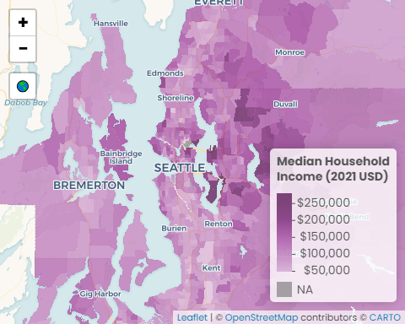

#### Data call outs

1. $104,500: The region’s median household income
2. $250,000: The highest median income for five tracts in Seattle, Mercer Island, Bellevue, Clyde Hill, Yarrow Point, and Hunts Point
3. $28,200: The lowest median income for five tracts in the region

#### Insights & Analysis

### b) using tract level data from other source

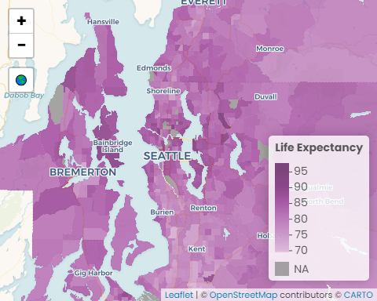

#### Data call outs

1. 78.8 years: The region’s average life expectancy
2. 80.8 years: The region’s median life expectancy
3. 28.1 years: The difference in the number of years between those living in the census tracts with the highest and lowest life expectancy

#### Insights & Analysis

## 2. Facet of most recent data

### a.)

Median Household Income

values are adjusted to 2021 dollars

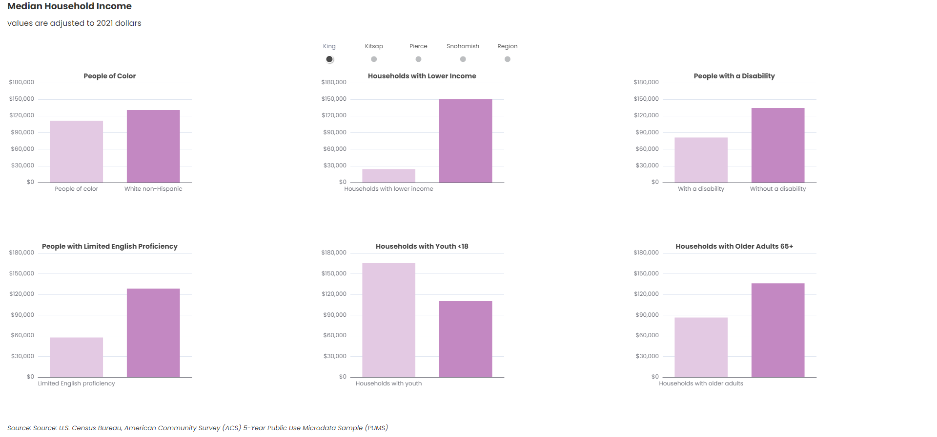

Source: U.S. Census Bureau, American Community Survey (ACS) 5-Year Public Use Microdata Sample (PUMS)