Voter Participation
Visuals for Equity Tracker (tract data)
Mary Richards
February 19, 2026

3 visuals for webpage
This code will help produce the three visuals that are going to be a part of each equity tracker indicator webpage: regional map (tract level) of most recent data, chart of the most recent data, chart of trends over time.
If the indicator is available through a tract-level data set. Getting the data to a workable version may require some data transformation. To explore, clean, transform, and generate a final data set, please use the data-gen-tract-template. This script will generate an .rda for the map and an .rda for the charts. These data sets will be loaded in before the data visualization code.

Indicator Explanation
Voter participation provides a way to understand a community’s political engagement. Differences between groups of people can highlight differing access to engagement opportunities. The ability to participate in civic processes ensures fair representation and adequate access to services and resources, all of which influence a population’s connection to their community.
Voter participation is calculated by dividing the number of ballots cast by the number of people over 18 within a census tract. This process uses data from the Washington Secretary of State office (ballots cast per precinct) and population data from the United States Census Bureau American Community Survey (ACS) and Washington State Office of Financial Management (OFM) Small Area Estimates Program (SAEP). The population over 18 is calculated by weighting the OFM estimates by the ratio of adults 18+/total population from ACS. There are a few data caveats: 1) Some voters may be registered in one location, but reside in another. This could cause mismatches in the way that they are accounted for in the numerator (ballots cast) and the denominator (population); 2) There is a distinction between residential addresses (which must be in Washington State and where you are considered registered for voting purposes) and mailing addresses (which can be anywhere). Therefore, the number of registered voters refers to the number of voters who have their residential address in that precinct; 3) Data from smaller precincts are occasionally “masked” into a larger precinct in order to protect the privacy of voters and maintain confidentiality. It is also possible for last minuet ballots to be cast (such as by UOCAVA voters, or Military and Overseas Voters, defined by https://www.eac.gov/uocava) that must be accorded to a precinct. As a result, the voter turnout results calculated at the tract level are estimates and may reflect some margin of error.

1. Map of most recent data

Create Visual
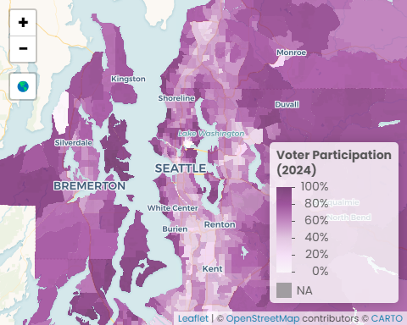 Sources: Washington Office of Secretary of State 2024 general election data; U.S. Census Bureau, American Community Survey (ACS) 2024 5-Year Estimates; U.S. Census Bureau, Geography Division 2020 TIGER/Line Shapefiles

Data call outs
- 61%: The region’s voter participation rate
- 78%: The regional voter participation rate for communities with low concentrations of households of color is 78%, 34 percentage points higher than the rate for communities with high concentrations
- 55%: Regionally, communities with high concentrations of people with disabilities have voter participation rates 7 percentage points lower than communities with low concentrations

Insights & Analysis
- Kitsap County has the highest voter participation (69%), followed by Snohomish (62%), Pierce (60%), and King (59%).
- There are six census tracts that have voter participation rates of 95% or higher - these include two neighborhoods on Bainbridge Island in Kitsap County, one neighborhood in Artondale in Pierce County, and three neighborhoods in Seattle in King County: Broadview, Briarcliff and Magnolia, and Arroyo Heights and Arroyo Beach.
- The four census tracts that have the lowest voter participation rates in the region (below 10%) are in King and Pierce counties - around the UW campus in Seattle and surrounding Joint Base Lewis-McChord including Fort Lewis and North Fort Lewis, respectively. These areas have high concentrations of students and military members - those who are less likely to be registered as voters of Washington state.

2. Facet of most recent data

Create Visual
Voter Participation
2024 election data
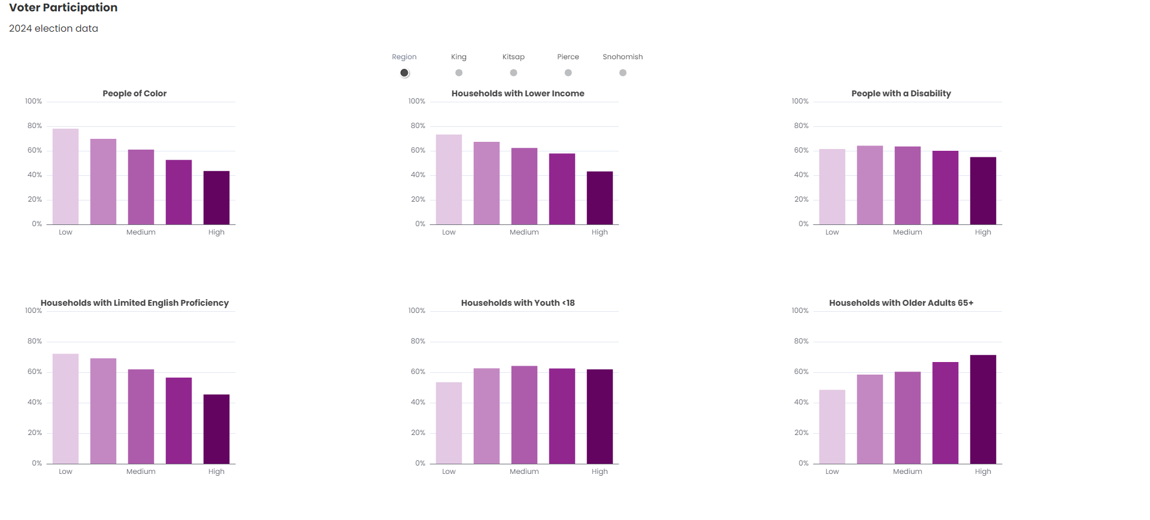
Washington Office of Secretary of State 2024 general election data; U.S. Census Bureau, 2020-2024 American Community Survey 5-Year Estimates, Tables B02001, C17002, B22010, B11005, B11007, C16002

Data call outs

Insights & Analysis
- Communities with higher concentrations of people of color have lower voter participation rates than those with lower concentrations - the largest difference is in King County (38 percentage points).
- For communities with high concentrations of households who are below 200% of the poverty level, voter participation rates are highest in Kitsap County (53%), followed by Snohomish (50%), King (42%), and Pierce County (38%).
- Voter participation is lower in communities with higher concentrations of households with limited English proficiency compared to communities with lower concentrations. King County has the highest difference (30 percentage points), while Kitsap County has the smallest difference (8 percentage points).
- In contrast to the other equity communities, those with higher concentrations of households with older adults have consistently higher voter participation rates compared to those with lower concentrations. The largest differences are in Kitsap and Pierce counties where higher concentrations of households with older adults have higher voter participation rates by 30 and 28 percentage points, respectively. The differences are smaller in King and Snohomish counties - 20 and 17 percentage points, respectively.

3. Facet of trend data

Create Visual
Voter Participation
2024 election data
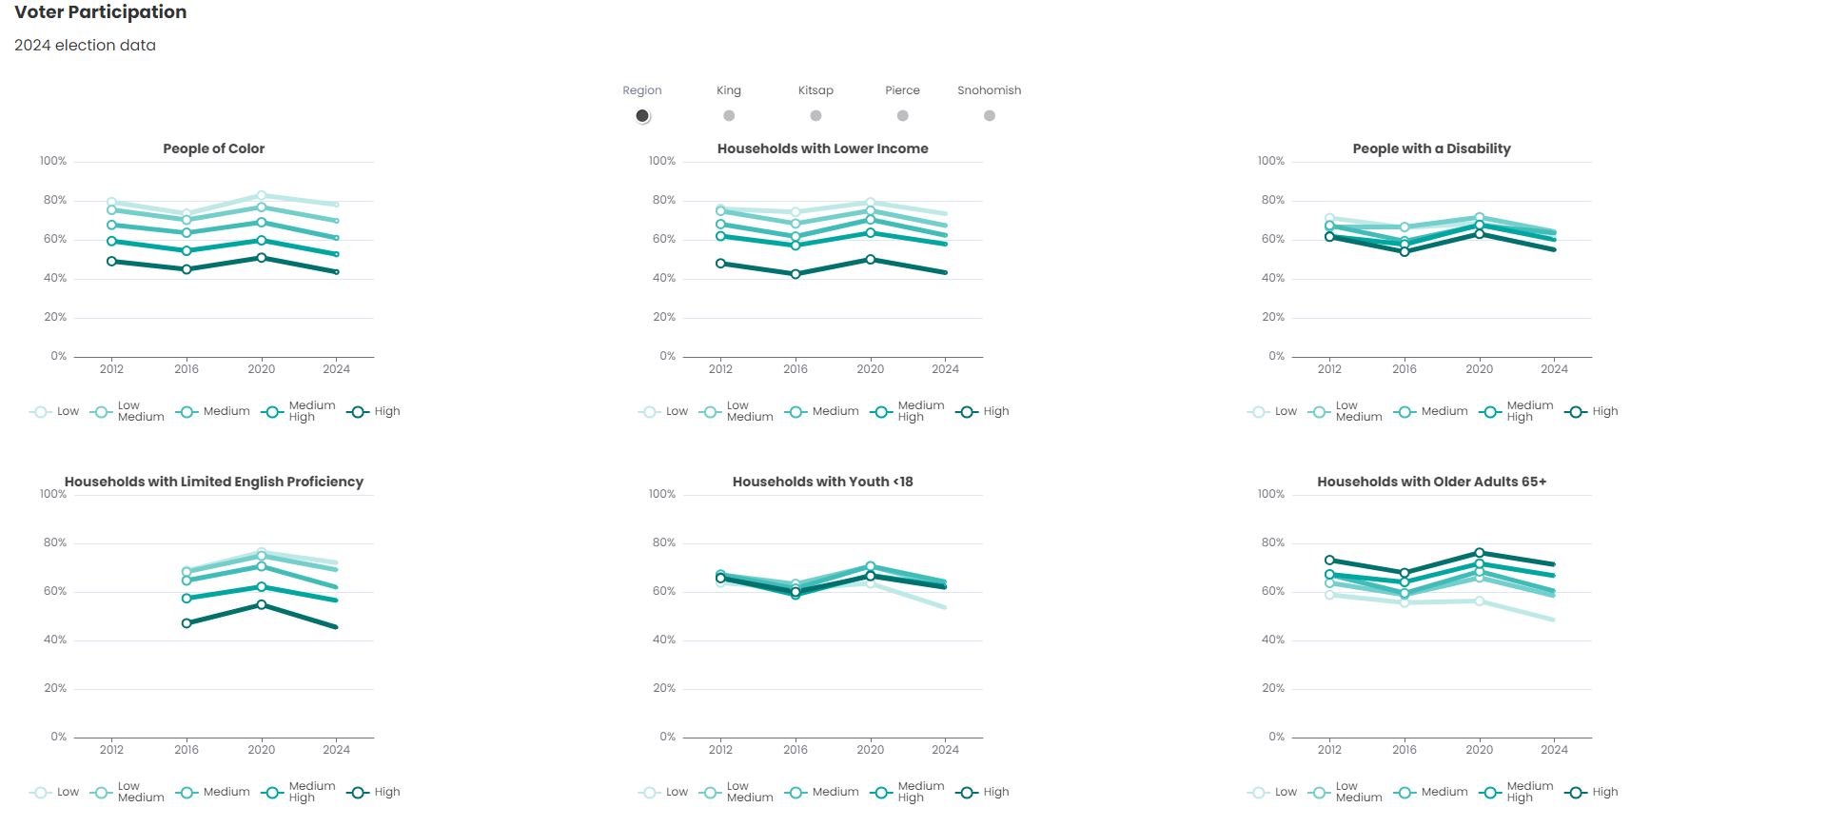
Washington Office of Secretary of State 2012, 2016, 2020, 2024 general election data; U.S. Census Bureau, 2008-2012, 2012-2016, 2016-2020, 2020-2024 American Community Survey 5-Year Estimates, Tables B02001, C17002, B22010, B11005, B11007, C16002

Data call outs

Insights & Analysis
- Areas with higher concentrations of people of color have lower voter participation than areas with lower concentrations - a difference which has increased 13% between 2012 and 2024. The largest change was in Kitsap County (60%) and the smallest was in Snohomish County (9%).
- Communities with higher concentrations of households below 200% of the poverty line consistently had lower voter participation than communities with lower concentrations. Between 2012 and 2024, the voter participation gaps decreased in Snohomish County (7 percentage points) and slightly decreased in King (2 percentage points). and Kitsap (0.9 percentage points) counties. In Kitsap and Pierce counties the gap increased four and one percentage points, respectively.
- In 2024, communities with high concentrations of households with limited English proficiency had lower voter participation than communities with lower concentrations, a trend consistent with 2016. The difference between areas with high and low concentrations increased in Kitsap (100%), Snohomish (26%), and Pierce (16%) counties between 2016 and 2024. The difference decreased 3% in King County.
- Regionally, communities with higher concentrations of older households have higher voter participation than communities with lower concentrations - a difference which has increased 64%% between 2016 and 2024.

Transfer files

Copy files from Github > Y drive/update folder
This step will transfer all of the Rmd output files (html and docx) to the network for review. It will keep the Rmd files within GitHub so that code is kept in a central place. Always run this chunk of code. If this is the first time you are generating visuals for an indicator, comment out the ‘update’ part of the ‘y.drive.folder.update’ variable because this is the first version that is being created.

Copy files from Y drive/indicator folder > Y drive/indicator/archive folder
This step will transfer the previous data and files to the archive folder. This step is meant to retain the older versions in case they are needed for reference. Only run this chunk of code if updating visuals for indicator - if there is already existing visuals on a webpage. Don’t run if this is the first time visuals are being created for indicator.

Delete old files from indicator folder
This step will clean the indicator folder to make room for the new versions. Only run this chunk of code if updating visuals for indicator - if there is already existing visuals on a webpage. Don’t run if this is the first time visuals are being created for indicator.

Copy new files from Y drive/update folder > Y drive/indicator folder
This step will move all of the updated data/files to the general indicator folder. They should be moved from the update (draft staging directory) to the parent folder so that the htmls can be copied to the webpage folder (outside the firewall). Only run this chunk of code if updating visuals for indicator - if there is already existing visuals on a webpage. Don’t run if this is the first time visuals are being created for indicator.

Clear Y drive/update folder
This step will help keep the folders organized and ready for the next update.Only run this chunk of code if updating visuals for indicator - if there is already existing visuals on a webpage. Don’t run if this is the first time visuals are being created for indicator.

Copy files from Y drive/indicator folder > website folder
This step copies the htmls for the webpage (3 visuals) from the network to the folder outside the firewall- this ‘external’ folder connects directly to the webpage. Always run this chunk of code.
Back to top of the page

