SNAP

Visuals for Equity Tracker (PUMS data)

Kristin Mitchell, updated by Mary Richards

October 02, 2024

# 3 visuals for webpage

This code will help produce the three visuals that are going to be a part of each equity tracker indicator webpage: regional map (tract level) of most recent data, chart of the most recent data, chart of trends over time.  
  
**If the indicator is a PUMS/OPSI indicator that can be accessed through Elmer.** Getting the data to a workable version may require some data transformation. To explore, clean, transform, and generate a final data set, please use the *data-gen-pums-template*. This script will generate an .rda for the map and an .rda for the charts. These data sets will be loaded in before the data visualization code.

## Indicator Explanation

[Please include the following for a general, layperson audience: 1-2 sentences explaining what your indicator is/measures, what it says about people’s life outcomes; 1 sentence describing why it is useful/relevant in the indicator’s theme]

## 1. Map of most recent data

To map data in this form, it requires accessing data at the regional/tract level from ACS since the Elmer data set is already aggregated to equity group/quintile.

### Create Visual

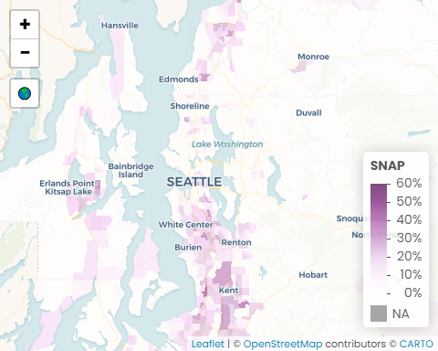 Source(s): U.S. Census Bureau, 2018-2022 American Community Survey 5-Year Estimates, Table S2201; U.S. Census Bureau, Geography Division 2020 TIGER/Line Shapefiles

1. 9.0%: The region’s average SNAP participation
2. 49.4%: The highest average SNAP participation at the census tract level in the region
3. 3.5x: People with a disability are more than 3.5 times more likely to participate in SNAP

#### Insights & Analysis

* King County has the lowest average for SNAP participation (8.0%), followed by Snohomish (8.8%), Kitsap (10.0%), and Pierce (11.7%).
* There are 38 census tracts with no SNAP participation with 30 tracts in King County, two in Kitsap, two in Pierce, and four in Snohomish.
* The four census tracts with the highest participation include one tract in the Eastside neighborhood of Tacoma (49.4%), Downtown Tacoma (44.1%), southeast Des Moines (39.3%), and southeast Kent (35.8%).
* The national average SNAP participation is 11.5%.

## 2. Facet of most recent data

### Create Visual

SNAP Participation by Community

Percent of households participating in SNAP

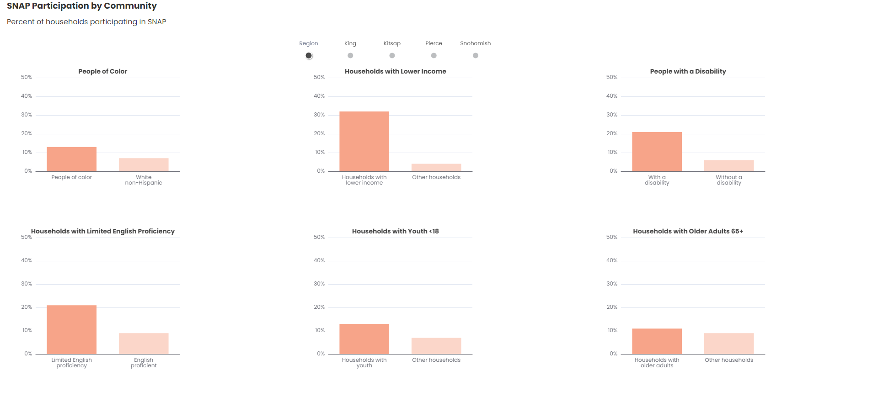

U.S. Census Bureau, 2018-2022 American Community Survey 5-Year Public Use Microdata Sample

#### Data call outs

#### Insights & Analysis

* In King County, households with limited English proficiency are more than three times as likely to participate in SNAP.
* As a region, 32% of households with lower income participate in SNAP, leaving room for increased participation.
* SNAP uses an income threshold of 200% of the federal poverty level for qualification, the same definition used here to identify households with lower income.
* 4% of non-lower income households in the region reported participating in SNAP, which is likely a data anomaly due to how the Census Bureau asks about household income.
* Households with limited English proficiency are over twice as likely to participate in SNAP.
* People of color are almost twice as likely to participate in SNAP.

## 3. Facet of trend data

### Create Visual

SNAP Participation Trend by Community

Percent of households participating in SNAP

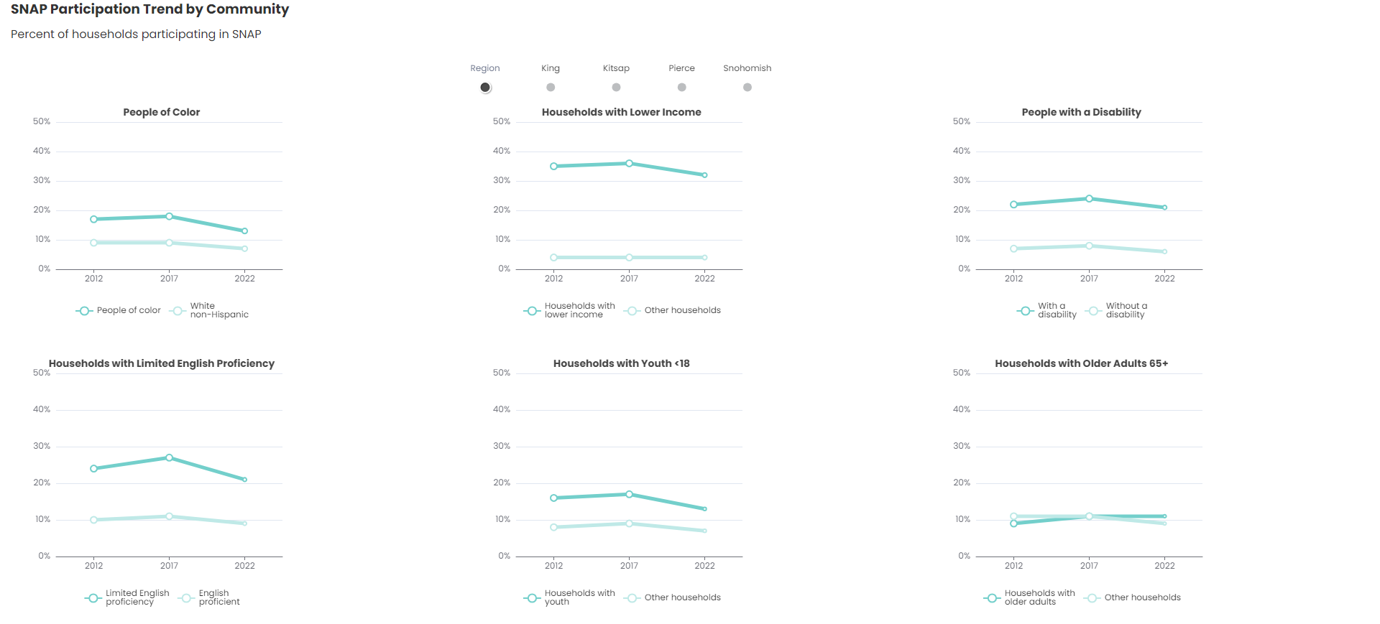

U.S. Census Bureau, 2008-2012, 2013-2017, 2018-2022 American Community Survey 5-Year Public Use Microdata Sample

#### Data call outs

#### Insights & Analysis

* Regionally, people of color have consistently been almost twice as likely to participate in SNAP compared to the white non-Hispanic population; however, the disparity between these two groups decreased in all counties - Snohomish (-50%), King (-40%), Kitsap (-33%), Pierce (-22%).
* SNAP participation decreased in all counties for households with limited English proficiency between 2012 and 2022, except for Pierce County where participation for the same group increased from 21% in 2012 to 23% in 2022.
* SNAP participation among people with disabilities in the region either stayed the same (Kitsap and Pierce counties) or decreased (King and Snohomish counties) from 2012 to 2022.
* The share of participating lower income households reached 40% in 2017, the highest for any group in the past decade; however, between 2012 and 2022, there was a three percentage point decrease in SNAP participation for households with lower income across the region

# Transfer files

## Copy files from Github > Y drive/update folder

This step will transfer all of the Rmd output files (html and docx) to the network for review. It will keep the Rmd files within GitHub so that code is kept in a central place.

## Copy files from Y drive/indicator folder > Y drive/indicator/archive folder

This step will transfer the previous data and files to the archive folder. This step is meant to retain the older versions in case they are needed for reference.

### Delete old files from indicator folder

This step will clean the indicator folder to make room for the new versions.

## Copy new files from Y drive/update folder > Y drive/indicator folder

Once the data and planning reviews are complete, this step will move all of the updated data/files to the general indicator folder. They should be moved from the update (draft staging directory) to the parent folder so that the htmls can be copied to the webpage folder (outside the firewall).

## Clear Y drive/update folder

This step will help keep the folders organized and ready for the next update.

## Copy files from Y drive/indicator folder > website folder

This step copies the htmls for the webpage (3 visuals) from the network to the folder outside the firewall- this ‘external’ folder connects directly to the webpage.

Back to top of the page