Gross Median Rent

Visuals for Equity Tracker (PUMS data)

Meg Grzybowski

August 21, 2023

# 3 visuals for webpage

This code will help produce the three visuals that are going to be a part of each equity tracker indicator webpage: regional map (tract level) of most recent data, chart of the most recent data, chart of trends over time.  
  
**If the indicator is a PUMS/OPSI indicator that can be accessed through Elmer.** Getting the data to a workable version may require some data transformation. To explore, clean, transform, and generate a final data set, please use the *data-gen-pums-template*. This script will generate an .rda for the map and an .rda for the charts. These data sets will be loaded in before the data visualization code.

## 1. Map of most recent data

To map data in this form, it requires accessing data at the regional/tract level from ACS since the Elmer data set is already aggregated to equity group/quintile.

### Create Visual

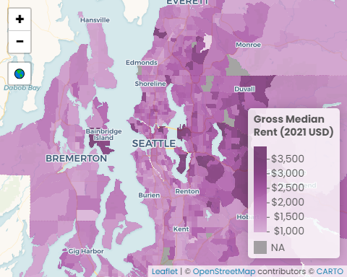

#### Data call outs

1. $3,500: The region’s highest average gross median rent
2. The highest gross rent belongs to seven tracts in Seattle, Mercer Island, Bellevue, Bainbridge Island, and Sammamish
3. $576: The lowest average gross median rent in the region

#### Insights & Analysis

* King County has the highest median income ($106,300), followed by Snohomish ($95,600), Kitsap ($84,600), and Pierce ($82,600)
* The seven census tracts tied with the highest gross median rent ($3,500) are in King County: two tracts in southern Mercer Island, southern Bainbridge Island, Bellevue, the neighborhood east of Lake Sammamish, the neighborhood south of Ames Lake, and Clyde Hill
* The three census tracts with the lowest gross median rent are in Pierce and Snohomish Counties; Yakima ($574), Silver Firs just west of Route 9 ($619), and the Tulalip Reservation ($775)

## 2. Facet of most recent data

### Create Visual

Median Household Income

values are adjusted to 2021 dollars

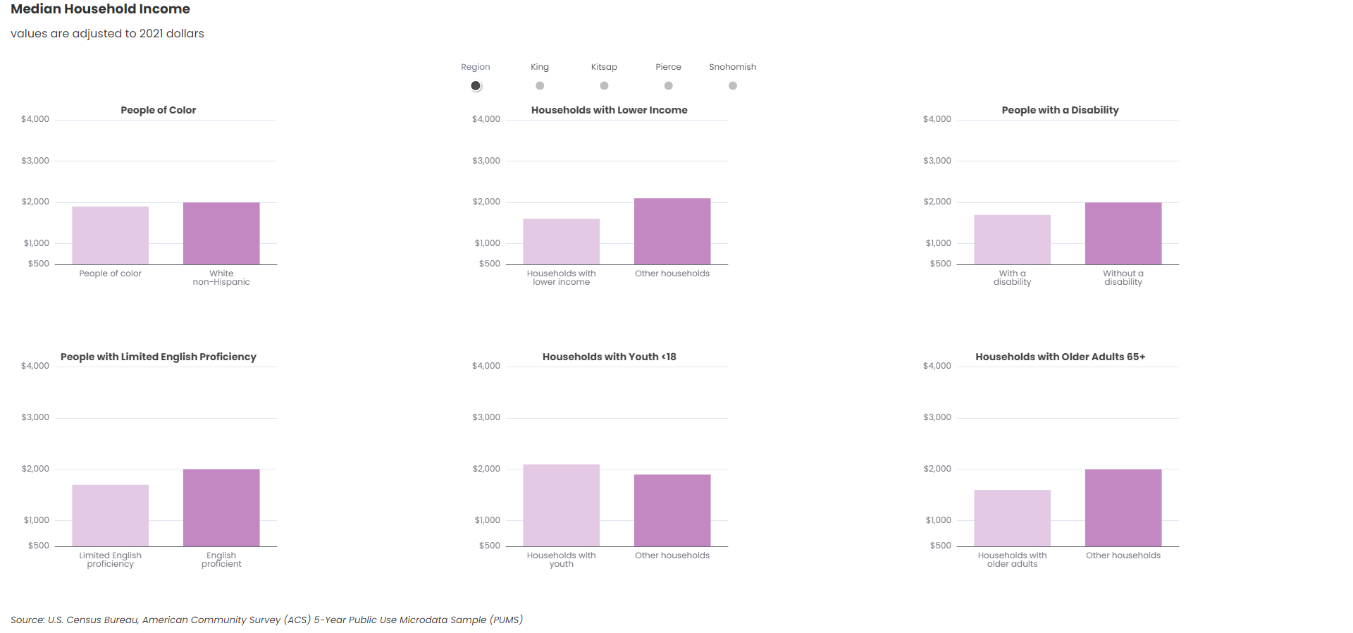

U.S. Census Bureau, American Community Survey (ACS) 5-Year Public Use Microdata Sample (PUMS)

#### Data call outs

1. $515: The difference in gross median rent for those households that are below 200% of the poverty level and non-low-income households
2. $300: Regional English proficient households pay an average of $300 more than Non-English proficient households
3. $200-$300: Households with children (below 18 years old) pay $200-$300 more than households without children

#### Insights & Analysis

* The smallest difference in gross median rent payments between people of color and white non-Hispanic is in Snohomish County ($4,100), while the largest difference is in King County ($19,400)
* For households who are below 200% of the poverty level, the largest difference in gross median rent is in King County ($1,700-$2,300), followed by Kitsap ($1,900-$1,400), Snohomish ($2,000-$1,600), and Pierce ($1,800-$1,500)
* The largest difference in gross median rent between households with childen (youth under 18 years) is in Kitsap, Pierce, and Snohomish Counties ($300), while the smallest difference is in King County ($200)

## 3. Facet of trend data

### Create Visual

Median Household Income

values are adjusted to 2021 dollars

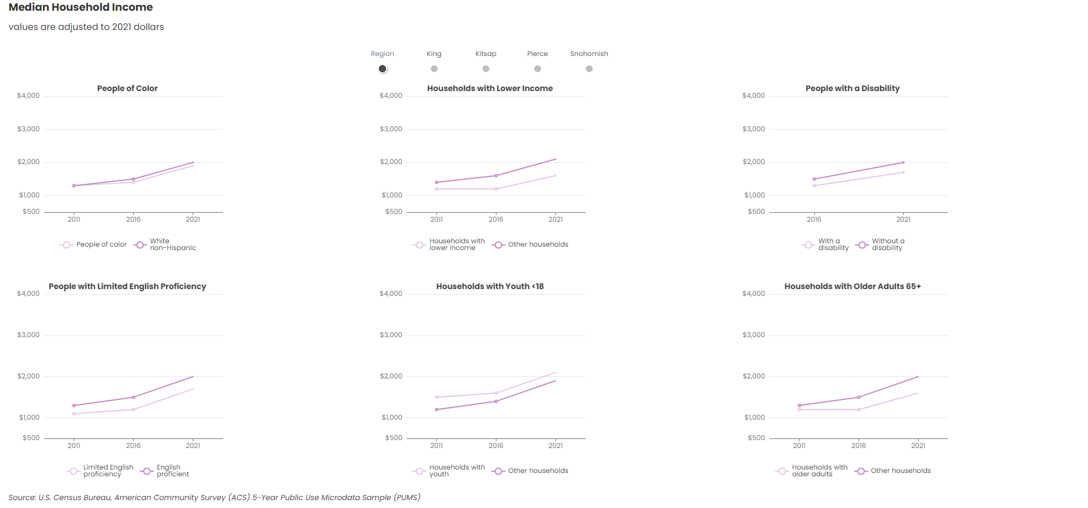

U.S. Census Bureau, American Community Survey (ACS) 5-Year Public Use Microdata Sample (PUMS)

#### Data call outs

1. $500: In 2021, households in the region who were below 200% of the poverty line paid an average of $500 less than households above the 200% poverty line, a 150% larger gap than in 2011
2. $100: Regionally, people of color spend an average $100 lower in gross median rent than white non-Hispanic households, a gap which has remained relatively consistent in King County and Regionally in the last ten years, but has narrowed in Kitsap, Pierce, and Snohomish counties
3. 300%: The median gross rent of households in the region with older adults is $400 lower than households without older adults, an increase of 300% from 2011
4. 0%: While households with children (youth under 18 years) pay an average of $300 more in gross median rent than households without children, there has been no gap increase from 2011 to 2021

#### Insights & Analysis

* Median gross rent has consistently increase across the region from 2011 to 2021, with no counties being exempt
* The median gross rent of households (regardless of income) stayed relatively static in Kitsap and Pierce County over time, while the the gross median rent of households increased greatly in King County (more than 54% for households who are below 200% of the poverty level and 64% for For households who are above 200% of the poverty level). Similarly in Snohomish County households who are below 200% of the poverty level are paying 45% more than they did in 2011 and 53% more for households who are above 200% of the poverty level
* The difference in gross median rent for people with a disability compared to those without a disability between 2011 and 2021 remained relatively consistent in all counties, including King County

# Transfer files

## Copy files from Github > Y drive

## Copy files from Y drive > website folder

Back to top of the page