Median Gross Rent

Visuals for Equity Tracker (PUMS data)

Meg Grzybowski

October 20, 2023

# 3 visuals for webpage

This code will help produce the three visuals that are going to be a part of each equity tracker indicator webpage: regional map (tract level) of most recent data, chart of the most recent data, chart of trends over time.  
  
**If the indicator is a PUMS/OPSI indicator that can be accessed through Elmer.** Getting the data to a workable version may require some data transformation. To explore, clean, transform, and generate a final data set, please use the *data-gen-pums-template*. This script will generate an .rda for the map and an .rda for the charts. These data sets will be loaded in before the data visualization code.

## Indicator Explanation

Gross rent measures the average rent for the location, in this case being census tract, and “median” indicates that the middle value in between the census tracts highest gross rent and lowest gross rent is what represents the gross median rent value. Oftentimes, a higher gross median rent can indicate that some families and households are priced out of an area, limiting options of living close to transit, in neighborhoods with good schools, and limiting opportunity and access.

## 1. Map of most recent data

To map data in this form, it requires accessing data at the regional/tract level from ACS since the Elmer data set is already aggregated to equity group/quintile.

### Create Visual

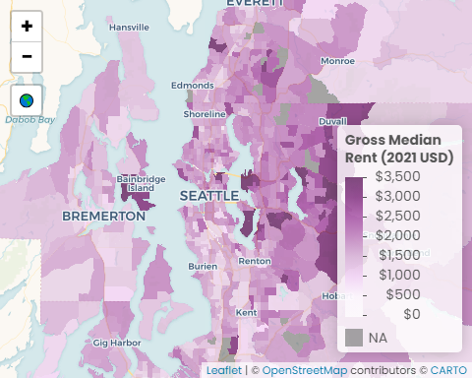

Sources: U.S. Census Bureau, American Community Survey (ACS) 2021 5-Year Estimates; U.S. Census Bureau, Geography Division 2020 TIGER/Line Shapefiles

#### Data call outs

1. $1,790: Regional median gross rent
2. $3,500: Highest median gross rent (in King County)
3. $1,440: Lowest median gross rent (in Pierce County)

#### Insights & Analysis

* King County has the highest median gross rent ($1,800), followed by Snohomish ($1,640), and Kitsap and Pierce (both $1,440)
* Ten census tracts tied with the highest median gross rent ($3,500) are all in King County: three tracts in southern Mercer Island, two in Clyde Hill/Hunts Point/Medina/Yarrow Point, two in Bellvue, two in Sammamish, and on in southwestern Bainbridge Island
* The highest median gross rent in Pierce, Kitsap, and Snohomish County are: in the far eastern portion of Pierce county near Issaquah ($3,110) by in the southwestern portion of Bainbridge ($3,500), and southern Mulkiteo ($3,400)

## 2. Facet of most recent data

### Create Visual

Gross Median Rent

values are adjusted to 2021 dollars

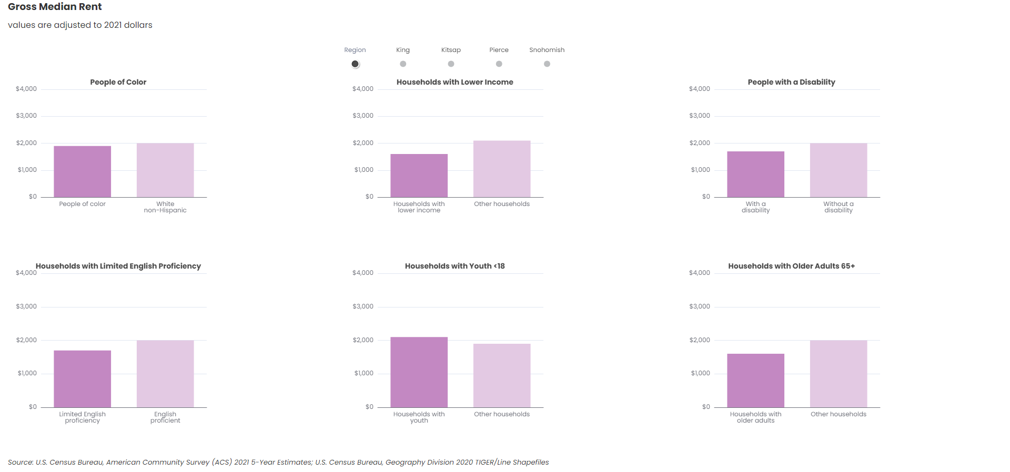

U.S. Census Bureau, American Community Survey (ACS) 2021 5-Year Estimates; U.S. Census Bureau, Geography Division 2020 TIGER/Line Shapefiles

#### Data call outs

1. $500: Median gross rent for households in the region living below 200% of the federal poverty level is $500 less those living above
2. $300: Households in the region with English proficiency pay an average of $300 more than limited English proficient households
3. $300: Regional median gross rent for those with children is $300 higher than those without

#### Insights & Analysis

* People of color in Snohomish, Pierce, and Kitsap counties are paying the same median gross rent as white non-Hispanic households, while in King County, white non-Hispanic households are paying $100 more in rent than people of color.
* For households living below 200% of the poverty level, King County households are paying the most at ($1,700), followed by Snohomish ($1,600), Pierce ($1,500), and Kitsap ($1,400).
* Households with childen (youth under 18 years) are paying the most in King County ($2,300), followed by Snohomish ($2,100), then Kitsap and Pierce counties ($1,900)
* These insights may indicate that while low vulnerability households are paying more in median gross rent than high vulnerability categories, it may mean that high vulnerability folks cannot afford higher-rent homes

## 3. Facet of trend data

### Create Visual

Gross Median Rent

values are adjusted to 2021 dollars

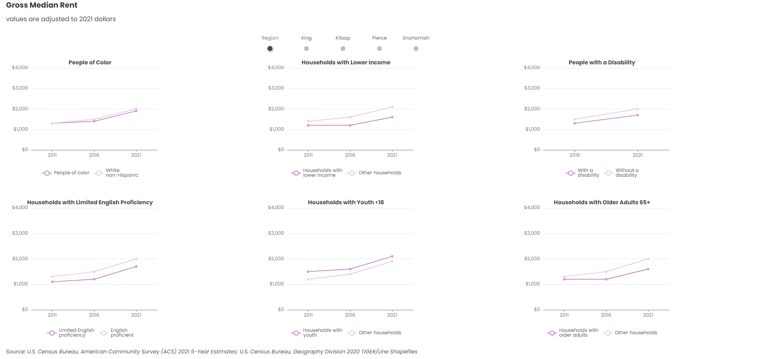

U.S. Census Bureau, American Community Survey (ACS) 2021 5-Year Estimates; U.S. Census Bureau, Geography Division 2020 TIGER/Line Shapefiles

#### Data call outs

1. $500: In 2021, households in the region living below 200% of federal poverty line paid an average of $500 less than those living above; a 150% larger gap than in 2011
2. $100: Regionally, people of color spend an average $100 less in median gross rent than white non-Hispanic households, a gap which has remained relatively consistent in King County and Regionally in the last ten years, but has narrowed in Kitsap, Pierce, and Snohomish counties
3. 300%: Median gross rent of households in the region with older adults is $400 lower than households without older adults, an increase of 300% from 2011

#### Insights & Analysis

* Median gross rent has consistently increased across the entire region from 2011 to 2021
* Median gross rent of households (regardless of income) stayed relatively static in Kitsap and Pierce County over time, while the median gross rent of households increased greatly in King County (more than 54% for households who are below 200% of federal poverty level and 64% for thos living above).
* Similarly in Snohomish County households living below 200% of the poverty level are paying 45% more than they did in 2011 and 53% more for those living above
* The gap between median gross rent for people with a disability compared to those living without remained relatively consistent in all counties (from 2016 to 2021)

# Transfer files

## Copy files from Github > Y drive

## Copy files from Y drive > website folder

Back to top of the page