Overcrowding (renters)

Visuals for Equity Tracker (PUMS data)

Meg Grzybowski

December 20, 2023

# 3 visuals for webpage

This code will help produce the three visuals that are going to be a part of each equity tracker indicator webpage: regional map (tract level) of most recent data, chart of the most recent data, chart of trends over time.  
  
**If the indicator is a PUMS/OPSI indicator that can be accessed through Elmer.** Getting the data to a workable version may require some data transformation. To explore, clean, transform, and generate a final data set, please use the *data-gen-pums-template*. This script will generate an .rda for the map and an .rda for the charts. These data sets will be loaded in before the data visualization code.

## Indicator Explanation

Overcrowding is an indicator that people are living in homes that may be too small for their household needs or family size. For this measure, we are focusing on renter households and dividing the number of people in the household by the number of rooms in their home. We are defining overcrowding as households with more than 1.5 person(s) per room. Although overcrowding can occur in owner-occupied homes, renters are often at a disadvantage in terms of housing stability [this explanation needs more work about why we are focusing on renters].

## 1. Map of most recent data

To map data in this form, it requires accessing data at the regional/tract level from ACS since the Elmer data set is already aggregated to equity group/quintile.

### Create Visual

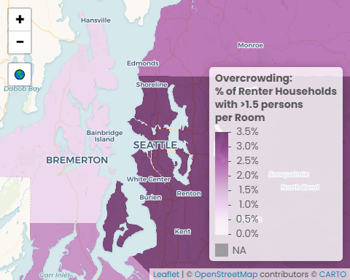

Sources: U.S. Census Bureau, American Community Survey (ACS) 2021 5-Year Estimates; U.S. Census Bureau, Geography Division 2020 TIGER/Line Shapefiles

#### Data call outs

1. 2.9%: The regional average of overcrowded renting households
2. 3.5%: King County has the highest rate of overcrowding renting households
3. 1.2%: Average percentage of households in Kitsap County, the county with the lowest overcrowding rates

#### Insights & Analysis

* King County has the highest rates of overcrowding among renters (3.5%), followed by Snohomish (2.3%), Pierce (2.1%), and Kitsap (1.2%)
* King County’s higher rates of overcrowding for renters is likely related to having the lowest homeownership rates within the region
* Compared to King County, Kitsap County’s overcrowding rate among renters is about one-third as high, while Pierce is about three-fifths as high and Snohomish is two-thirds as high

## 2. Facet of most recent data

### Create Visual

Overcrowding (renters)

More than 1.5 person(s) per room

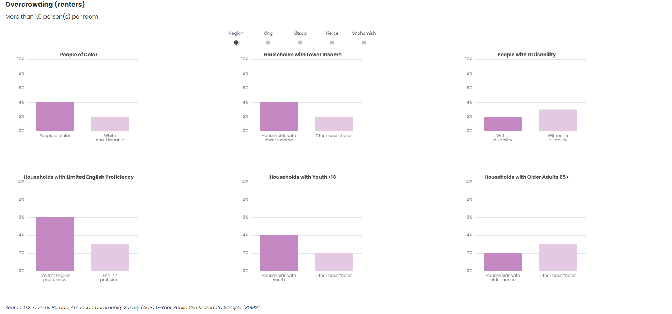

U.S. Census Bureau, American Community Survey (ACS) 5-Year Public Use Microdata Sample (PUMS)

#### Data call outs

1. 2x: Among renting households in the region, the overcrowding rate for people of color is 2 percentage points higher than white non-Hispanic households, or twice as high
2. 4%: The region’s households below 200% of federal poverty line that are experiencing overcrowding
3. 6%: Percentage of limited English proficient households experiencing overcrowding, 3 percentage points higher than than English proficient households, or twice as high

#### Insights & Analysis

* The largest difference in overcrowding rates between people of color and white non-Hispanic is in King County (3 percentage points), while the other counties have a 1 percentage point difference between people of color and white non-Hispanic
* King County has the highest rate of overcrowding among renting households below 200% of federal poverty (5%), followed by Snohomish and Pierce (3%), and Kitsap (2%)
* Renting households with limited English proficiency have the highest rates of overcrowding across all of the demographic groups, regardless of county

## 3. Facet of trend data

### Create Visual

Overcrowding (renters)

More than 1.5 person(s) per room

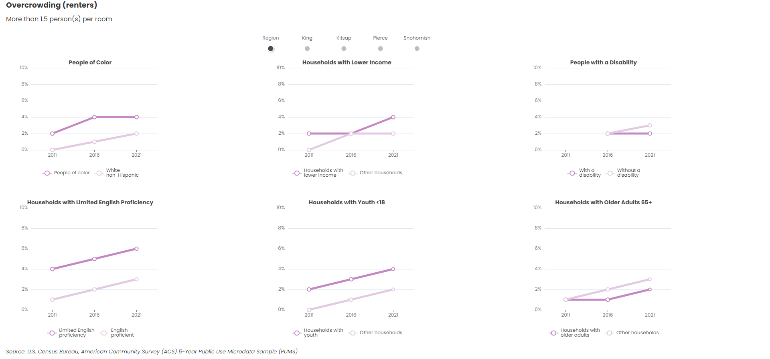

U.S. Census Bureau, American Community Survey (ACS) 5-Year Public Use Microdata Sample (PUMS)

#### Data call outs

1. 2: The regional gap in overcrowding between people of color and white, non-Hispanic remained 2 percentage points between 2011 and 2021
2. 200%: Overcrowding among renting households in the region who were below 200% of federal poverty line increased 100% between 2011 and 2021 (2% to 4%)
3. 33%: The regional share of overcrowding households with limited English proficiency increased 33% between 2011 and 2021

#### Insights & Analysis

* The difference in overcrowding for households with people of color and white non-Hispanic has varied across the region over time: increasing in King (200% increase), Pierce and Snohomish (50% increase), and decreasing in Kitsap County (50% decrease) and Pierce County (50% decrease)
* In King County, the share of overcrowded households below 200% of federal poverty line increased steadily between 2011 and 2021 (4 percentage points), while Snohomish and Pierce Counties experienced a slight increase (1 percentage point), and Kitsap experienced a slight decrease (1 percentage point).
* Overcrowding experienced by people with a disability stayed the same in King (3%) and Pierce (2%) counties, while it increased 1 percentage point in Kitsap and Snohomish counties (1% to 2%) between 2016 and 2021
* The difference in overcrowding experienced by households with limited English proficiency compared to English proficient households has increased in King (300% increase), remained consistent in Pierce, and decreased in Kitsap (25% decrease) between 2011 and 2021. There is no data for households with limited English proficiency in Snohomish County in 2011, but between 2016 and 2021 the difference decreased 25%.
* The share of overcrowding in households with youth (below 18 years old) increased in all of the counties between 2011 and 2016, except for Kitsap, where the share remained at 3%

# Transfer files

## Copy files from Github > Y drive

## Copy files from Y drive > website folder

Back to top of the page