Median Income

Visuals for Equity Tracker (PUMS data)

Mary Richards

August 11, 2023

# 3 visuals for webpage

This code will help produce the three visuals that are going to be a part of each equity tracker indicator webpage: regional map (tract level) of most recent data, chart of the most recent data, chart of trends over time.  
  
**If the indicator is a PUMS/OPSI indicator that can be accessed through Elmer.** Getting the data to a workable version may require some data transformation. To explore, clean, transform, and generate a final data set, please use the *data-gen-pums-template*. This script will generate an .rda for the map and an .rda for the charts. These data sets will be loaded in before the data visualization code.

## 1. Map of most recent data

To map data in this form, it requires accessing data at the regional/tract level from ACS since the Elmer data set is already aggregated to equity group/quintile.

### Create Visual

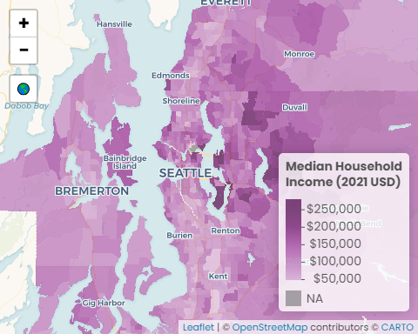

#### Data call outs

1. $96,500: The region’s median household income
2. $250,000: The highest median income for five tracts in Seattle, Mercer Island, Bellevue, Clyde Hill, Yarrow Point, and Hunts Point
3. $21,000: The lowest median income census tract in the region

#### Insights & Analysis

* King County has the highest median income ($106,300), followed by Snohomish ($95,600), Kitsap ($84,600), and Pierce ($82,600)
* The five census tracts tied with the highest median income ($250,000) are in King County: Laurelhurst neighborhood in Seattle, Clyde Hill/Yarrow Point/Hunts Point, Bellevue, and two tracts on Mercer Island
* The three census tracts with the lowest median income are Seattle’s University of Washington ($21,000), downtown Tacoma ($26,400), and Auburn around Route 167 ($28,400)

## 2. Facet of most recent data

### Create Visual

Median Household Income

values are adjusted to 2021 dollars

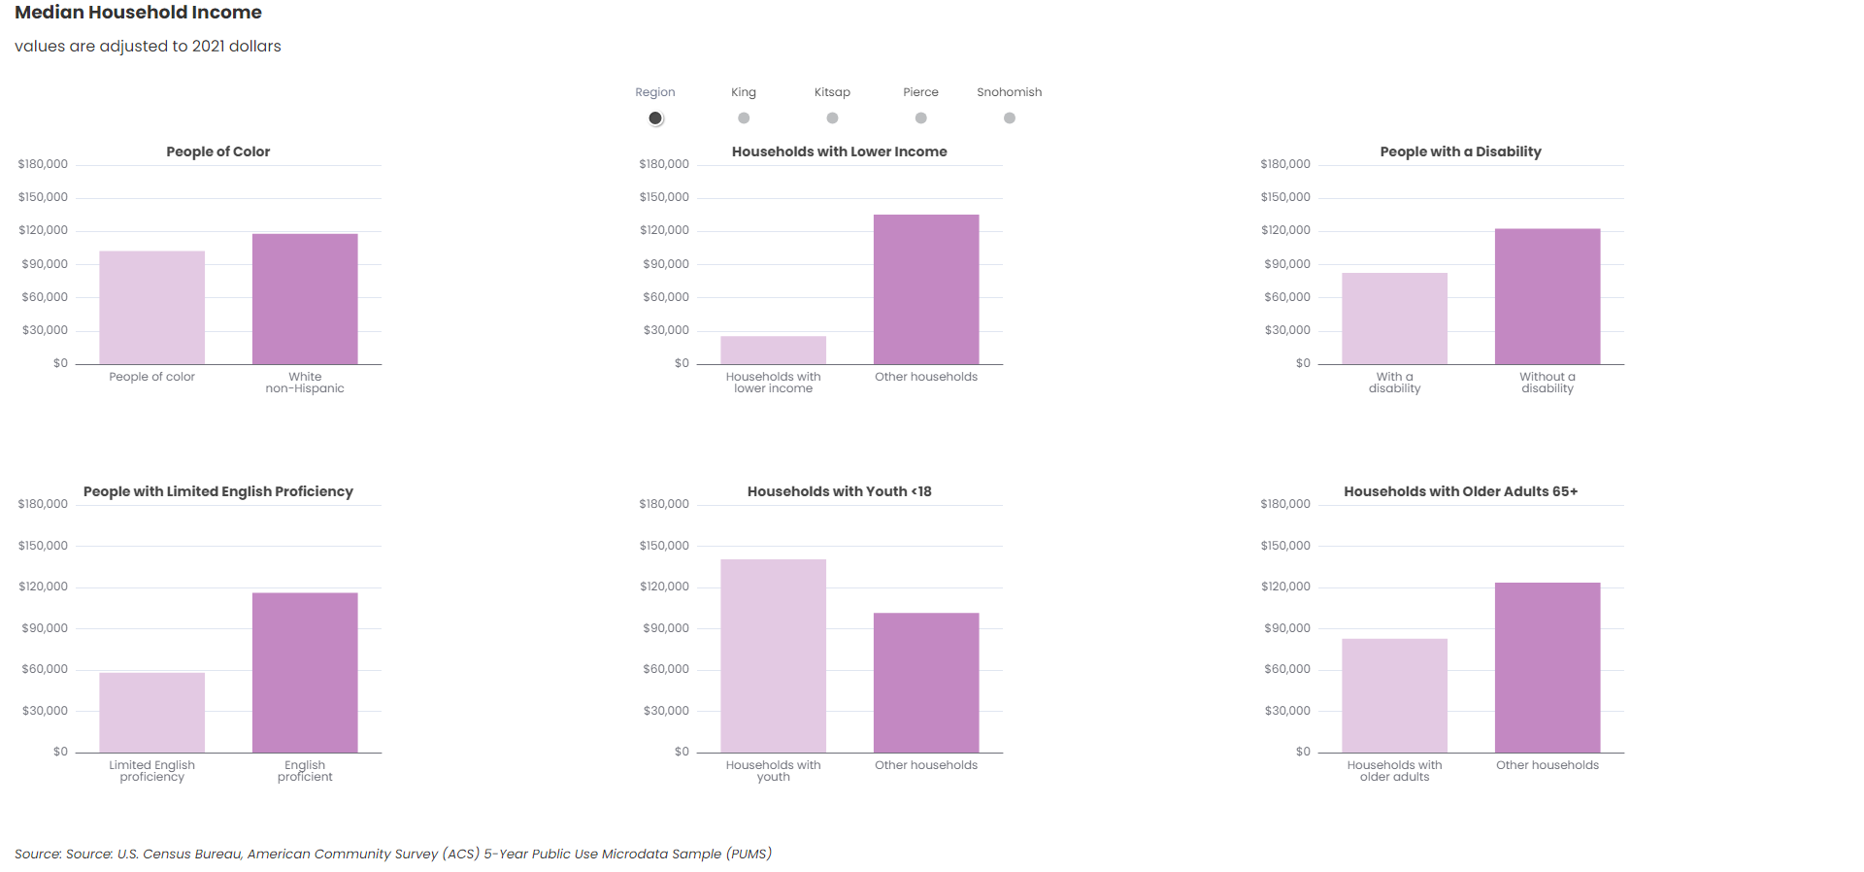

Source: U.S. Census Bureau, American Community Survey (ACS) 5-Year Public Use Microdata Sample (PUMS)

#### Data call outs

1. $25,400: The regional household median income of those who are below 200% of the poverty level
2. $58,400: Non-English proficient households have median household incomes $58,400 lower than English proficient households
3. $39,300 years: The median household income of households with children (below 18 years old) is $39,300 higher than households without children

#### Insights & Analysis

* The smallest difference in median income between people of color and white non-Hispanic is in Snohomish County ($4,100), while the largest difference is in King County ($19,400)
* For households who are below 200% of the poverty level, the median income is lowest in King County ($24,100), followed by Snohomish and Kitsap ($26,100), and Pierce ($27,700)
* The largest difference in median income between people with and without a disability is in King County ($53,100), while the smallest difference is in County ($20,100)
* Snohomish County is the only county where Non-English proficient households have higher median incomes ($67,800) than the region’s Non-English proficient households ($58,300)

## 3. Facet of trend data

### Create Visual

Median Household Income

values are adjusted to 2021 dollars

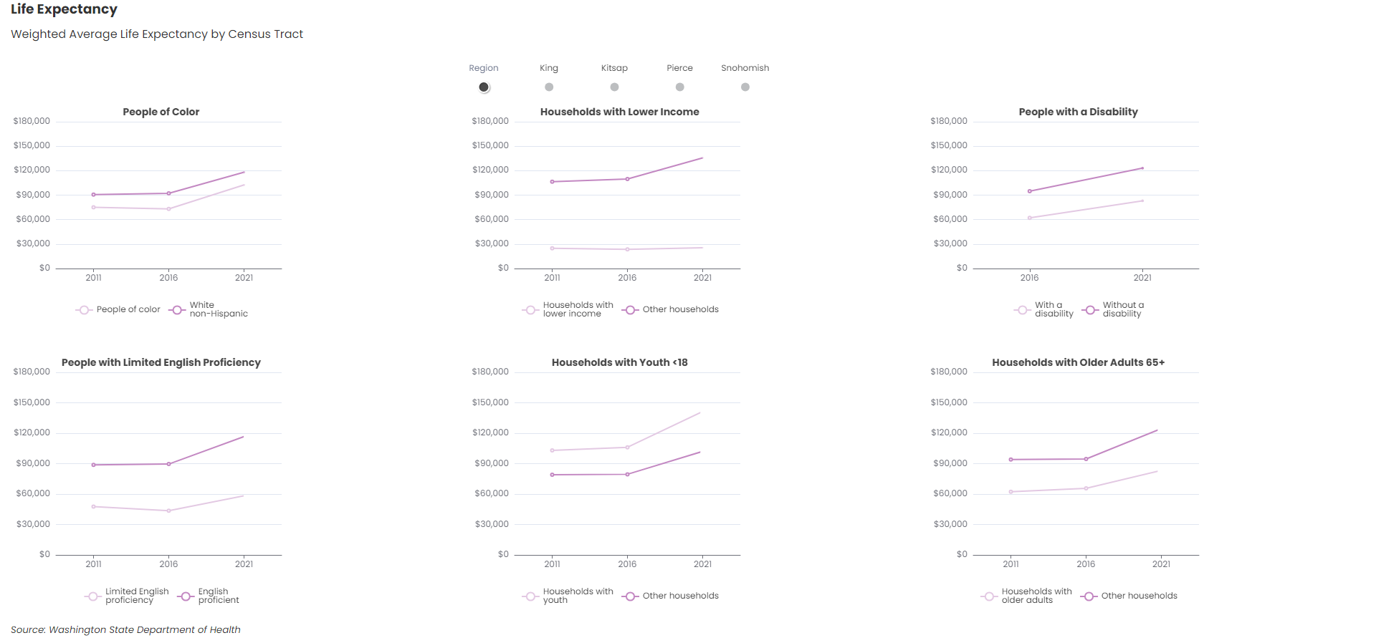

Source: U.S. Census Bureau, American Community Survey (ACS) 5-Year Public Use Microdata Sample (PUMS)

#### Data call outs

1. $110,200: In 2021, households in the region who were below 200% of the poverty line made $110,200 less than households above the 200% poverty line, a 34.9% larger gap than in 2011
2. $15,600: Regionally, people of color have median households incomes $15,600 lower than white non-Hispanic households, a gap which has remained relatively consistent in the last ten years
3. $36,600: The median household income of households in the region with older adults is $36,600 lower than households without older adults, an increase of 29.9% from 2011

#### Insights & Analysis

* The difference in median income of people of color and white non-Hispanic over time has differed between counties: shifting slightly in King County (+16.1%) and Kitsap County (-18.9%), while almost doubling in Pierce County (91.0%), and decreasing significantly in Snohomish County (-74,1%)
* The median income of households below 200% of the poverty line stayed relatively static over time, while the the median income of households above 200% of the poverty line increased between 2011 and 2021, especially in King County ($52,000) and Snohomish County ($33,500)
* The difference in median income of people with a disability compared to those without a disability between 2016 and 2021 stayed the same in all counties, except for King County, where the difference increased ($13,900)

# Copy files from Y drive > website folder

Back to top of the page