Life Expectancy

Visuals for Equity Tracker (tract data)

Mary Richards

August 11, 2023

# 3 visuals for webpage

This code will help produce the three visuals that are going to be a part of each equity tracker indicator webpage: regional map (tract level) of most recent data, chart of the most recent data, chart of trends over time.  
  
**If the indicator is available through a tract-level data set.** Getting the data to a workable version may require some data transformation. To explore, clean, transform, and generate a final data set, please use the *data-gen-tract-template*. This script will generate an .rda for the map and an .rda for the charts. These data sets will be loaded in before the data visualization code.

## 1. Map of most recent data

To map data in this form, there should be a value corresponding to each census tract. Depending on the year or source of the data, this could be about 700 rows for data at the 2010 census tract resolution, or about 900 rows for data at the 2020 census tract resolution.

### Create Visual

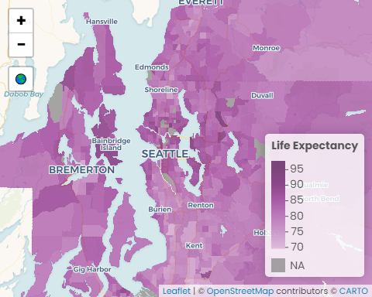

#### Data call outs

1. 78.8 years: The region’s average life expectancy
2. 80.9 years: The region’s median life expectancy
3. 28.1 years: The difference in the number of years between those living in the census tracts with the highest and lowest life expectancy

#### Insights & Analysis

* Snohomish County has the highest life expectancy (80.7 years), followed by King (79.4 years), Kitsap (78.9 years), and Pierce (75.7 years)
* The census tracts with the highest life expectancy are in Auburn, Pierce County (95.4 years); Ravenna/U-District neighborhoods (Seattle), King County (92.1 years); Redmond, King County (91.3 years)
* The census tracts with the lowest life expectancy are in the Lincoln International District (Tacoma), Pierce County (67.3 years); Lakewood, Pierce County (69.7 years); Tulalip Reservation, Snohomish County (70.1 years)

## 2. Facet of most recent data

### Create Visual

Life Expectancy

values are adjusted to 2021 dollars

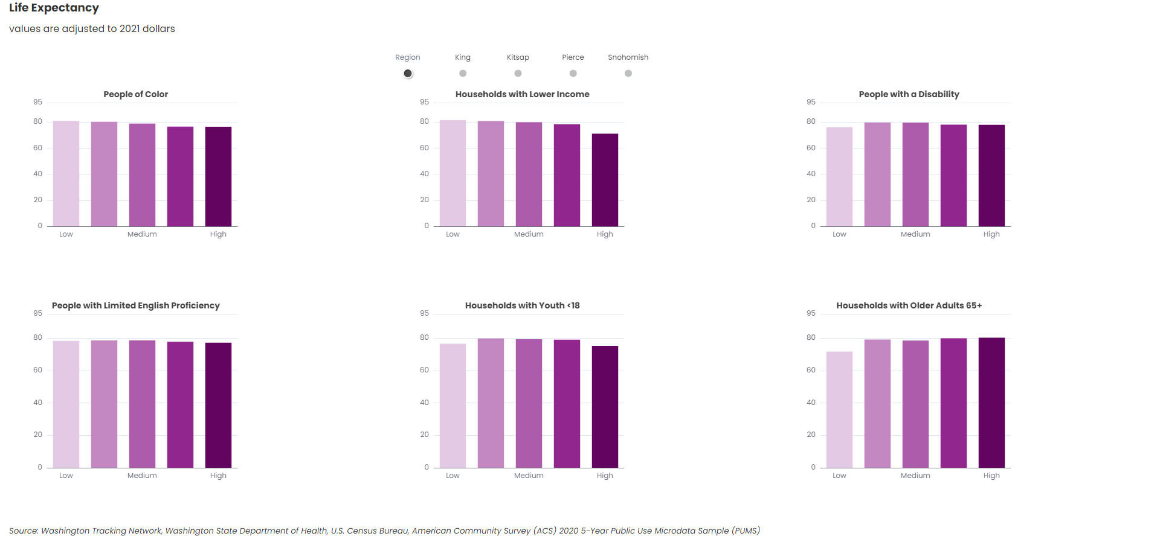

Washington Tracking Network, Washington State Department of Health, U.S. Census Bureau, American Community Survey (ACS) 2020 5-Year Public Use Microdata Sample (PUMS)

#### Data call outs

1. 76.7 years: The regional life expectancy of people living in census tracts with the highest concentration of people of color, compared to 81.2 in census tracts with the lowest concentrations of people of color
2. 7.9 years: The life expectancy of those living census tracts with the highest concentration of low income households is lowest in Pierce County - a difference of 7.9 years when compared to the regional average
3. 7.0 years: Those living in census tracts with the highest concentration of limited English proficient households have a shorter life expectancy in Pierce County by 7.0 years, when compared to the regional average

#### Insights & Analysis

* The smallest difference in life expectancy between census tracts with the highest and lowest concentrations of households with lower income is in Snohomish County (3.6 years), while the largest difference is in Pierce County (17.4 years)
* The life expectancy of those living in census tracts with the highest concentration of limited English proficient households is lower in all the counties except for Snohomish County
* There is no noticeable relationship between life expectancy and living in census tracts with high and low concentrations of people with disabilities
* When comparing the life expectancy of those living in census tracts with the highest and lowest concentrations of households with children under 18 years old, life expectancy is slightly higher in King County (2.9 years) and Snohomish County (1.4 years) and much lower in Kitsap County (-22.4 years) and Pierce County (-9.3 years)

## 3. Facet of trend data

### Create Visual

Life Expectancy

values are adjusted to 2021 dollars

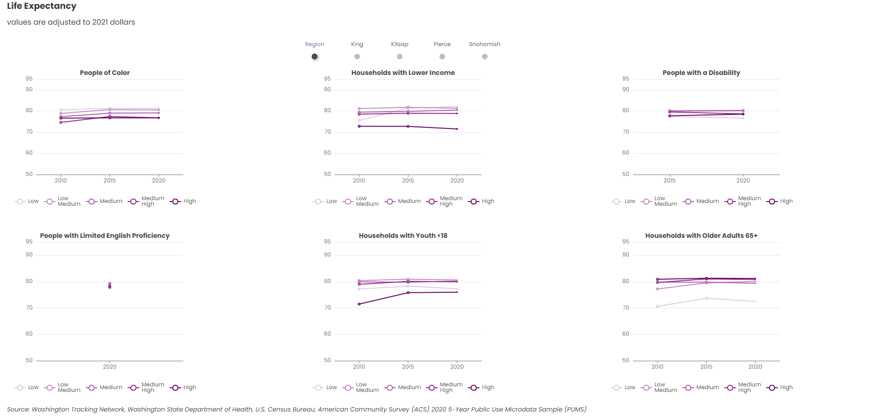

Washington Tracking Network, Washington State Department of Health, U.S. Census Bureau, American Community Survey (ACS) 2020 5-Year Public Use Microdata Sample (PUMS)

#### Data call outs

1. 3.9 years: The regional life expectancy gap between census tracts with the highest and lowest concentrations of people of color in 2010, a 15.8% smaller gap than in 2020
2. 293%: The increase in the regional life expectancy gap between census tracts with the highest and lowest concentrations of households below 200% of the poverty line between 2010 and 2020
3. 71.5 years: The 2020 regional life expectancy in tracts with the highest concentrations of households below 200% of the poverty line, 7 years fewer than the regional average (78.8) and 9 years fewer than the regional median (80.9)

#### Insights & Analysis

* Snohomish County is the only county in the region where the life expectancy of the census tracts with the highest concentration of people of color exceeds the life expectancy of the census tracts with the lowest concentration of people of color, a trend consistent over the past decade
* The life expectancy gaps between census tracts with the highest and lowest concentration of households below 200% of the poverty line increased in all counties between 2010 and 2020, with the largest gap change in Pierce County (7.2 years) and the smallest gap change in Kitsap County (1.6 years)
* The 2020 life expectancy of those living in the census tracts with the highest concentrations of households with limited English proficiency is shortest in Pierce County (70.4 years), compared to King County () and Snohomish County (80.5 years)

# Copy files from Y drive > website folder

Back to top of the page