Low Wage Housing Fit

# Methodology

This methodology for a Low Wage Job to Affordable Housing Fit is based on a University of California Davis Urban Geography methods study that looked at ways to calculate the prescense of afforable housing for workers of various incomes. Affordable rental data is pulled from 5yr ACS Census Tract level data for all census tracts in the Puget Sound Region via the census api. Jobs data is pulled from the LEHD LODES dataset corresponding to the Census Data Year.

For more details on the methodology developed by UC Davis, please see <https://regionalchange.ucdavis.edu/sites/g/files/dgvnsk986/files/inline-files/Urban%20Geography%20benner%20karner.pdf>. The abstract from their study is included here for reference:

Finding the right jobs-housing balance has long been an important concern for urban planners. More recently, attention has turned to jobs-housing fit – the extent to which housing price is well matched to local job quality. Prior analyses have been constrained by a lack of local data on job quality, making it difficult to identify the geography and scale of the problem. We introduce a new methodology for calculating the low-wage jobs-housing fit at both a jurisdiction and neighborhood scale that was designed in collaboration with affordable housing advocates and has been directly applied in urban planning and affordable housing policy efforts. Low-wage fit is particularly important because of ongoing difficulties with affordable housing provision and the disproportionate benefits of reducing transportation costs for low-income earners. We use the calculated metric at both a city and neighborhood scale to identify what can be learned from a low-wage jobshousing fit metric that is not evident in traditional measures of jobs-housing balance. In contrast to jobs-housing balance, the low-wage fit analysis clearly highlights those jurisdictions and neighborhoods where there is a substantial shortage of affordable housing in relation to the number of low-wage jobs. Because of the geographic coverage of the data sources used, the results can be widely applied across the United States by affordable housing advocates, land-use planners, and policy makers.

## Jobs Data

The methodology developed by Benner & Karner was purposely designed to use readily available and updated national datasets of jobs and housing costs that are available at the Census Tract geography. For jobs, the LEHD Origin-Destination Employment Statistics (LODES) dataset was utilized to determine how many jobs by various income levels are available by Census Tract. LODES provides estimates of jobs by three income categories at the Census Block greography and currently exists from 2002 to 2017 with future annual updates planned. The three wage categories for jobs in LODES are:

1. Less than $1250 per month (less than $15,000 per year)
2. $1251 to $3333 per month ($15,000 to $40,000 per year)
3. More than $3333 per month (more than $40,000 per year)

It should be noted that job estimates in LODES are for wage and salary jobs that are covered by unemplyoment insurance and do not include the self employed, postal workers, the military and some employess at non-profits and religious institutions.

## Housing Data

Data for housing unit costs come from the American Community Survey (ACS) 5-yr estimates. The 5-yr data is required to obtain rental cost information at the Census Tract geography. ACS data is released annualy (typically in late fall/early winter) and currently exists via the Census API from 2009 through 2018. The calculation of an affordable unit was defined by Benner & Karner as being a maximum of 30% of the total household income. The researchers were constrained by available data andd the wage categories provided by LODES but used observed worker per household numbers from Census Data in Northern California to define the threshold of an afforable rental unit.

In the end, the researches determined that the average affordable unit would be $750/mo or less. The calculation used:

$$ ($30,000 *0.30) / 12 = $750 per month $$

The researchers were not assuming that every low income household has two workers but was using this as a reasonable upper end to the lower income household’s for use in afforable rental calculations.

In the PSRC analysis, we also wanted to consider what monthly rental costs would be considered afforable for a moderate income household. For a moderate income threshold, we considered the current median household income for the Central Puget Sound Region - which varies from nearly $60,000 per year in three of the four counties to over $90,000 per year in King County. For purposes of moderately affordable rentals, we calculated a monthly rental cost based on a $60,000 household income as:

$$ ($60,000 * 0.30) / 12 = $1500 per month $$

The following sections show the results of applying the Benner & Karner approach for data for counties, sub-areas and census tracts in the Central Puget Sound Region.

# Summary Data by County

The first geography used for analysis of the availability of affordable rental housing for lower wage households are the four counties in the Central Puget Sound Region.

## Jobs

Lower wage jobs account for 15% to 23% of the total covered employment in counties the PSRC region.

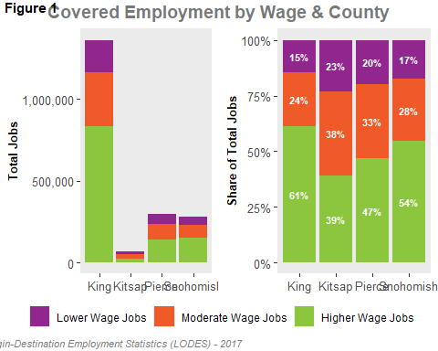

## Rentals

Stuff to say about rentals ……………..

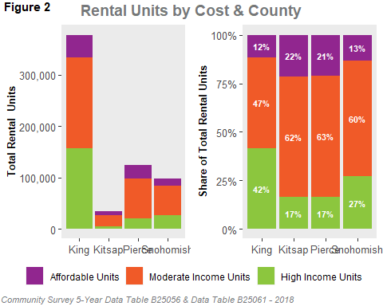

## Housing Fit

Stuff to say about wages to rental affordability …………….. 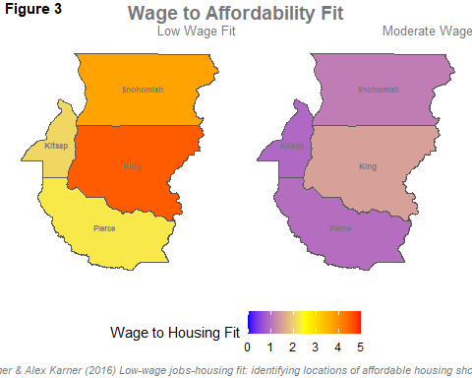

# Summary Data by Subarea

The second geography used for analysis of the availability of affordable rental housing for lower wage households are the eighteen subareas used in the sunmmarization of forecast products in the Central Puget Sound Region.

## Jobs

Stuff to say about jobs ……………..

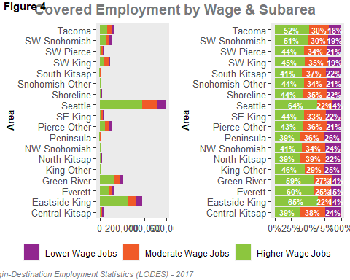

## Rentals

Stuff to say about rentals ……………..

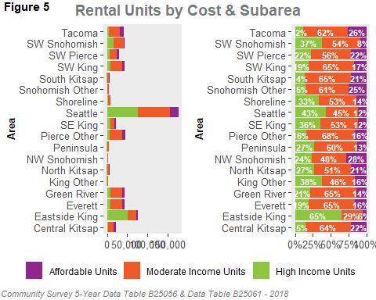

## Housing Fit

Stuff to say about wages to rental affordability …………….. 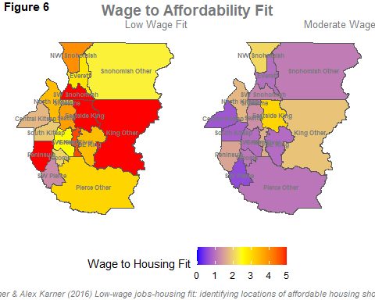

# Summary Data by Census Tract

The final geography used for analysis of the availability of affordable rental housing for lower wage households are all Census Tracts in the Central Puget Sound Region.

