# Trends in Employment and Telecommuting



## Major workplace changes happened in 2021

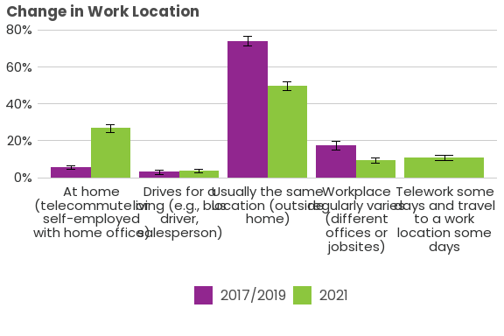

## Large changes seen in telecommuting

### Yearly increases in weekly rates of telecommuting

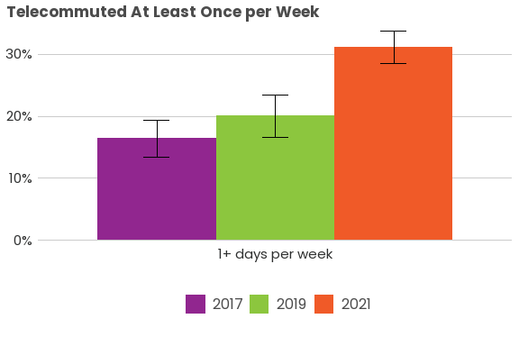

### Telecommute frequencies did not increase evenly

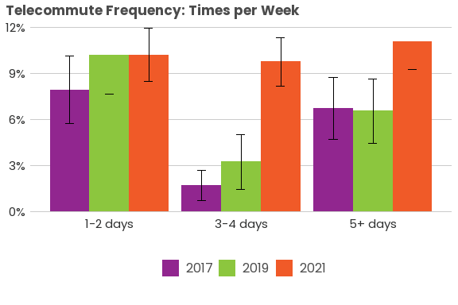

### Telecommute frequency varied by gender

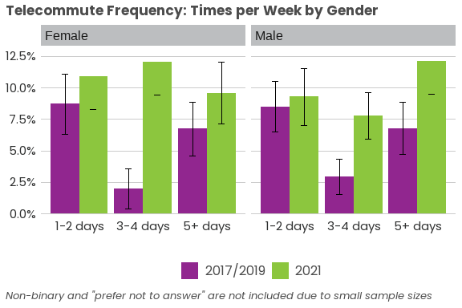

### Telecommute frequency also varied by race and ethnicity

## Trends in workplace travel and worker industry in 2021

### Males working outside the home more than females

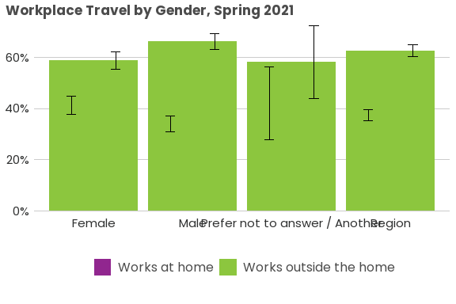

### More African American and Hispanic workers working outside the home

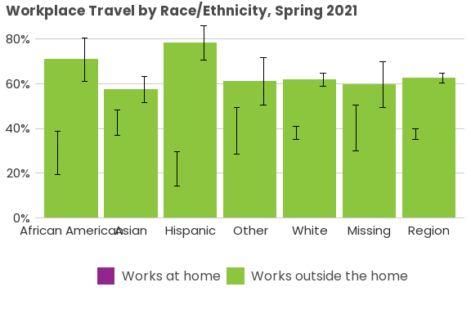

### Differences seen in workplace travel based on worker industry

