ARA - Active River Area Framework

GRASS GIS Version Guide

Version 1.3

Aug 2022

Table of contents

1 Introduction 3

2 Motivation 3

3 Development environment 3

4 Input parameters 4

5 Execution 8

6 Output visualization 8

6.1 Viewing the files in ArcGIS 8

# Introduction

This guide describes the usage of the *GRASS GIS ARA* (Active River Area) framework implementation of the *ArcGIS* *Active River Area (ARA) Three-Stream Class (3SC) Toolbox* (December 2011 version), developed by TNC.

This first release of the *GRASS GIS* implementation is standalone based, that is, is not yet integrated to a graphical user interface. Its execution is done from a command prompt and the results (raster and vector data) produced should be viewed in an external *GIS* tool, such as *ArcGIS* or *QGIS*.

This implementation preserves the steps, names, and the raster categories, as defined by the original *ArcGIS* implementation (*ArcGIS10_ARA_3SC_Toolbox_Dec2011*). Also, a prior step was included in the toolbox, for extracting the river network streams from the DEM. The original toolbox assumed that this step was executed beforehand.

The following sections describes the motivation for building the *GRASS GIS* version of the ARA toolbox, the parameters supported by the tool, along with some requirements that must be met prior to its execution, the execution itself, and the visualization of the raster (grid) and vector data produced in each step of the ARA framework.

# Motivation

PSR has been working with TNC in several projects, one of them, in the implementation of the *Blueprint* conservation framework in PSR’s HERA software program. One of the steps of the Blueprint framework, consists in the delineation of the basin’s Active River Area. The ArcGIS ARA framework toolbox was shared with PSR by TNC. PSR analyzed the inner workings of the geoprocessing operations carried out by the toolbox, as part of the effort to further integrate the framework to the HERA software, developed by PSR.

During the analyzes, compatibility issues with the ArcGIS recent versions were found. Part of these incompatibilities, due to the deprecation of geoprocessing tools and others, changed the behavior of some of the tools used by the framework. We had 2 choices ahead: fix the incompatibilities issues in *ArcGIS* or migrate the ARA framework to an Open-Source solution, that would further facilitate the integration effort to the HERA software. Since the HERA is based on open-source components, one of them the GRASS GIS geoprocessing libraries, we decided to use the GRASS GIS geoprocessing libraries and Python, as the programming language of choice.

# Development environment

This version of the *ARA* toolbox was developed in Python scripting language with the use of the *GRASS* GIS geoprocessing libraries. More information about *GRASS GIS* can be found on the product website at <https://grass.osgeo.org/>

The choice for these technologies were motivated by the following reasons:

* Python:
  + Python has been the language of choice in several GIS software, such as *ArcGIS* and *QGIS* for extending existing functionality.
  + High popularity.
  + Availability of a wide range of geoprocessing and scientific programing libraries.
* Grass GIS
  + Availability of all the geoprocessing tools required by the ARA framework to run.
  + Mature. *GRASS GIS* has been around since 1982, originally developed by the US Army of Corps Engineer’s.
  + Open Source: In 1999, GRASS GIS started to be released under the GNU General Public License (GPL).
  + The HERA software was developed using the QGIS graphical widgets and GRASS GIS geoprocessing libraries. Therefore, the ARA integration effort to the HERA software would be facilitated.

# Input parameters

The ARA toolbox input parameters should be defined in an external XML file named   
***ara_parameters.xml*.** A sample of this file is shown below:

Figure ‑: sample ara_parameters.xml file

|  |  |  |  |  |
| --- | --- | --- | --- | --- |
| PARAMETER | DESCRIPTION | DATA TYPE | ARA STEP | REMARKS |
| log_level | Defines the level of detail of the log information. | Integer | N/A | Possible values: [1,2]   * 1: *debug:* detailed information, typically of interest only when diagnosing problems. * *2: Info*: confirmation that things are working as expected. |
| grass_work_directory | Project folder where the *GRASS GIS* database and the output files created, during the ARA execution process, will be stored. | N/A | N/A |  |
| DEM | Complete path of the DEM (digital elevation model). | N/A | N/A | * The DEM should be in metric coordinates (projected) * The DEM should be in *GeoTIFF* format (*.tif* file extension) |
| fill_dem | Flag indicating whether to fill or not to fill the DEM. | Logic | ARA Data Prep | Possible values: [*True*,*False*] |
| minimum_catchment_area_ha | The minimum catchment area, in hectares, that will be considered as the water contributing area threshold for the river network extraction algorithm. | Integer | N/A |  |
| headwater_strahler_order | River order mapping rule for the headwaters class streams. | Interval | ARA Data Prep | [lower_order_number:upper_order_number]  (*) will be considered as headwaters class, the Strahler stream orders which falls into the informed interval, including the lower_order_number and upper_order_number |
| medium_river_strahler_order | River order mapping rule for the medium river class streams. | Interval | ARA Data Prep | <lower_order_number>:<upper_order_number>  (*) will be considered as medium size river class, the Strahler stream orders which falls into the informed interval, including the lower_order_number and upper_order_number |
| large_river_strahler_order | River order mapping rule for the large river class streams. | Interval | ARA Data Prep | <lower_order_number>:<upper_order_number>  (*) will be considered as large size river class, the Strahler stream orders which falls into the informed interval, including the lower_order_number and upper_order_number |
| max_distance_cost | The threshold that the accumulative cost value cannot exceed, when building the cost distance surface (*) (*) note about differences in the cost computation between *GRASS* and *ArcGIS*: *ArcGIS* multiplies the cost with the cell resolution value, while *GRASS* does not. That means that the equivalent in *GRASS* for a cost threshold of 5000, using a 30 meters DEM resolution, would be 5000/30 = 166. | Float | ARA Step 1 |  |
| headwaters_flood_zone_threshold | Threshold for headwaters base riparian zone. | Float | ARA Step 2 |  |
| headwaters_wetflat_zone_threshold | Threshold for headwaters wetflat zone. | Float | ARA Step 2 |  |
| medium_rivers_flood_zone_threshold | Threshold for medium rivers base riparian zone. | Float | ARA Step 2 |  |
| medium_rivers_wetflat_zone_threshold | Threshold for medium rivers wetflat zone. | Float | ARA Step 2 |  |
| large_rivers_flood_zone_threshold | Threshold for large rivers base riparian zone. | Float | ARA Step 2 |  |
| large_rivers_wetflat_zone_threshold | Threshold for large rivers wetflat zone. | Float | ARA Step 2 |  |
| wet_threshold | Threshold to distinguish between wet/dry cells | Float | ARA Step 4 |  |
| region_group_number_of_neighboring_cells | Number of neighboring cells to be considered by the region group algorithm | Integer | ARA Step 4 | Possible values:  4: Do not consider diagonal cells. 8: Consider diagonal cells. |
| number_cells_to_expand | Number of cells by which the input water cells will be expanded. | Integer | ARA Step 5 |  |

# Execution

The ARA tool is a standalone application executed from a *DOS Shell* (*cmd.exe*). In order to execute it, open a shell, switch to the ARA framework directory and then enter **ara.exe**

During its execution, the tool will output log information that will allow the user to follow the ongoing execution status. This log is also recorded to an external file named *ara_execution.log*.



Figure ‑: execution the ARA framework from the Shell

# Output visualization

The file outputs (in raster and/or vector format) created during the execution of the ARA tool, is organized in a set of folders, each one associated to the ARA framework step in which the files were created:

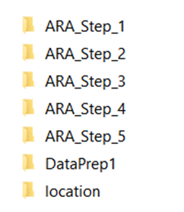

Figure ‑: Output folder organization

The *location* folder is created and used internally by the *GRASS GIS* environment and, thus, should be ignored.

The outputs in raster (grid) format are exported as *GeoTIFF* (*.*tif* file extension) files, while the vector files in *ESRI shapefile* file format.

## Viewing the files in ArcGIS

In order to view the raster categories in ArcGIS follow the steps below:

* Open the raster file in ArcGIS
* Access the raster properties, by right clicking the raster file and accessing the *properties* context menu
* Navigate to the Symbology tab
* Select Unique Values option
* Confirm the window dialog shown
* Press the ok button

These steps are depicted by the print screens below

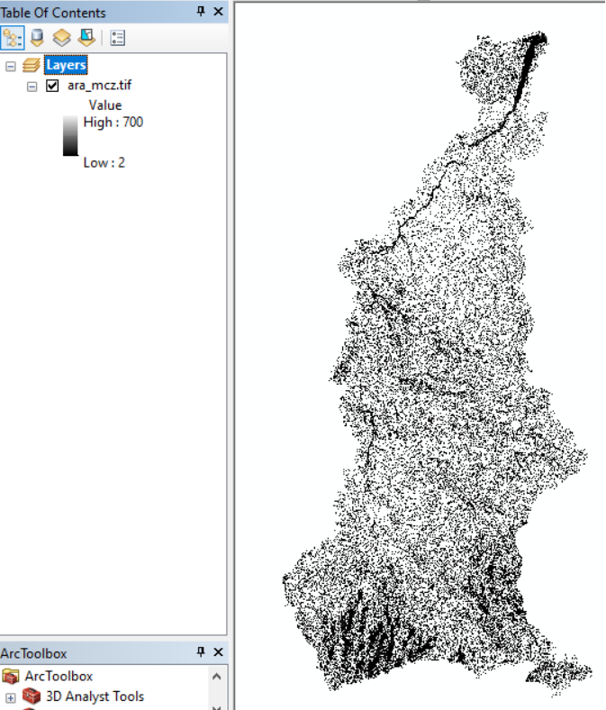

Figure ‑: raster values shown in ArcGIS

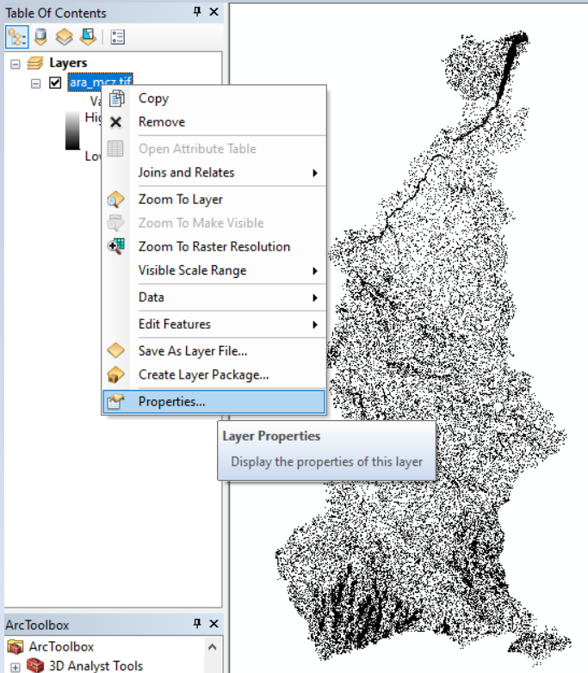

Figure ‑: raster properties

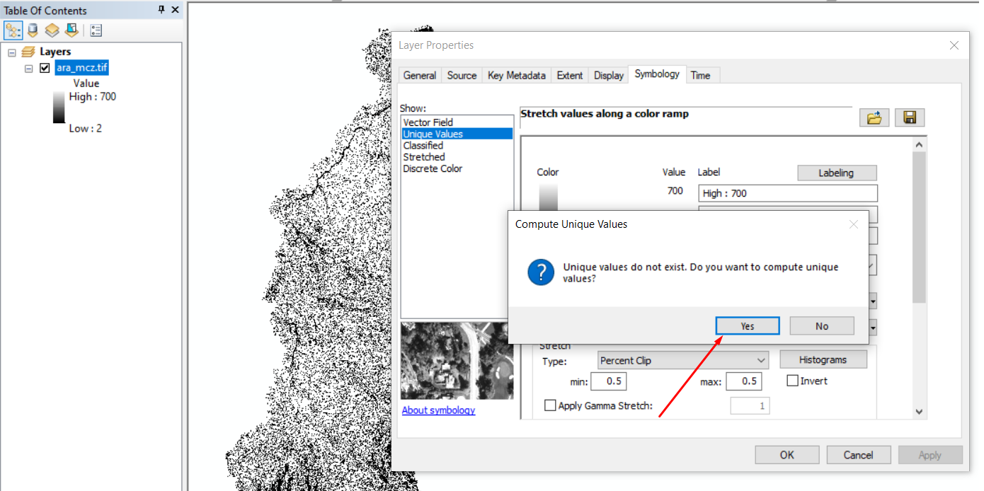

Figure ‑: converting the raster symbology to Unique Values

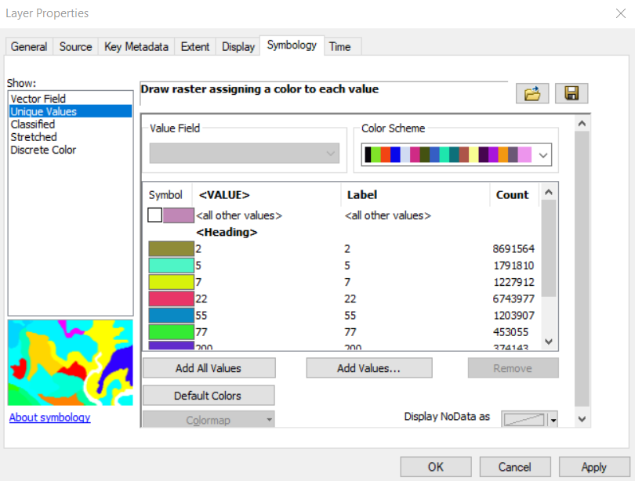

Figure ‑: raster Unique Values symbology

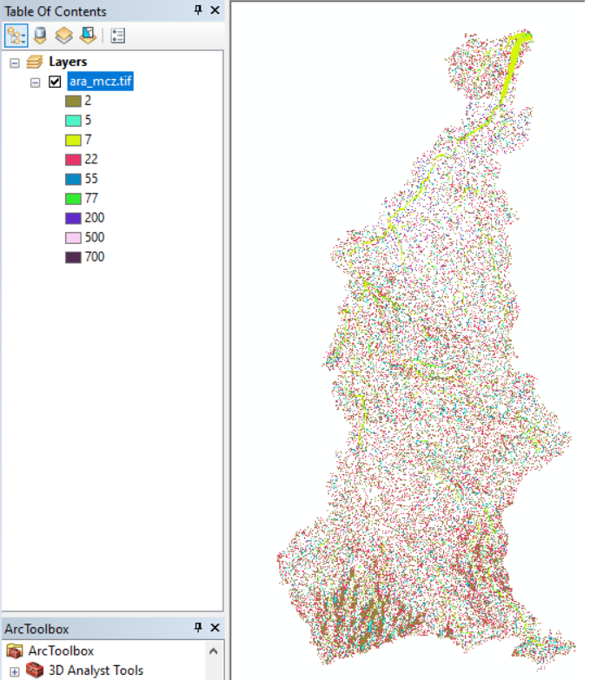

Figure ‑: raster categories