**Comparing Codebooks**

**As of 14 March 7:45AM ET. Almost but not yet complete -PSR**

Your task is to compare two different codebooks that were created for the same set of data, by identifying codes in the two codebooks that match.

This will be done using an Excel spreadsheet that contains the two codebooks, one on the left, and one on the right. Here is an example where the dataset was a sample of responses from previously suicidal people explaining what got them through their dark times.

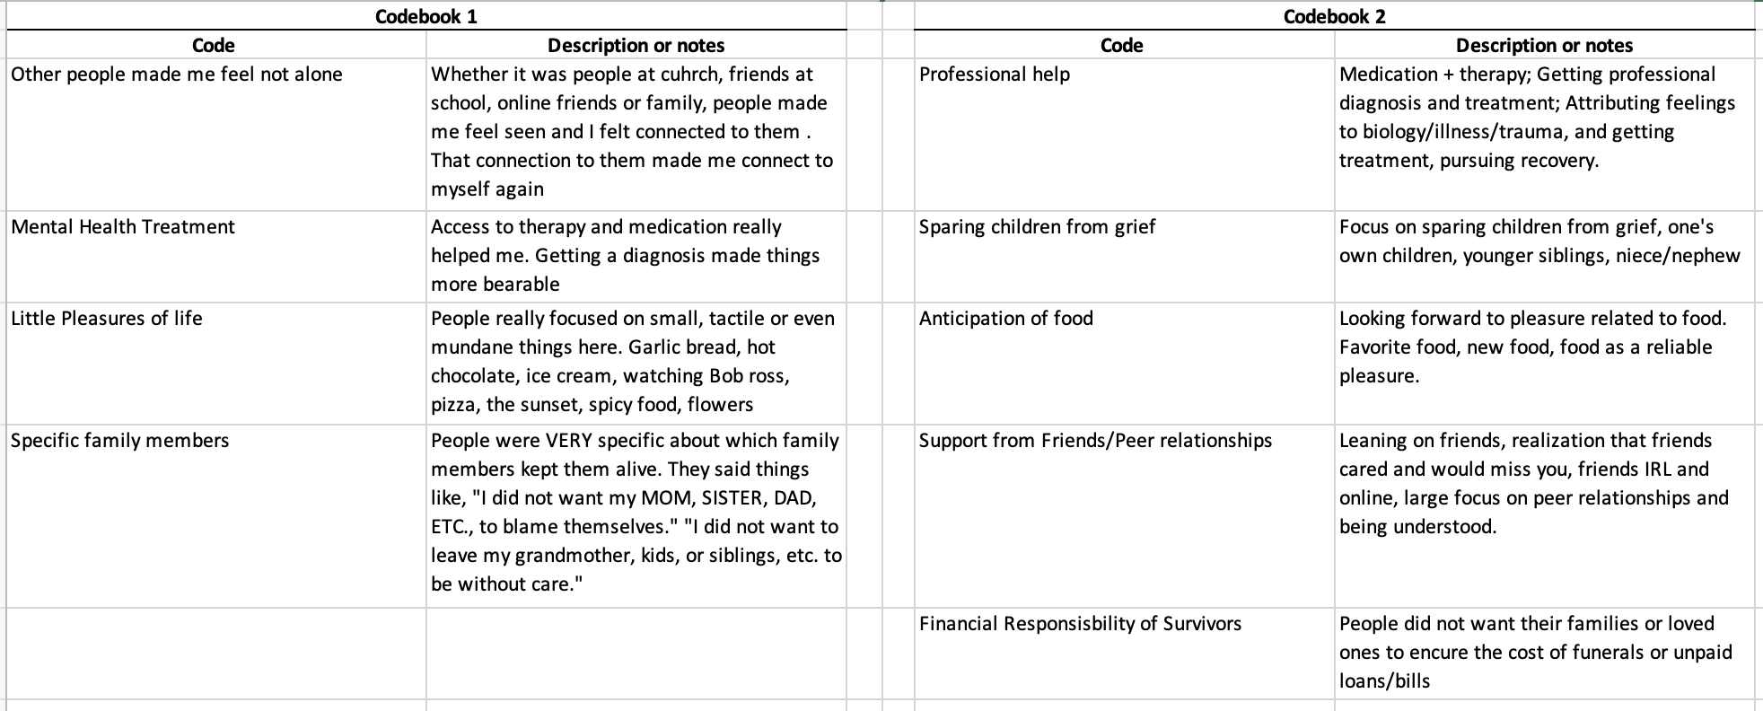

There are two different criteria that can be used for matching codes. You’ll be told which criterion to use (or you might be asked to do this twice, once each way).

**Loose match instructions:** Two codes are considered to be a loose match if they have concepts in common, even if they aren't exactly describing the same thing. This could include one being more general than the other (e.g., a code for "Lethal weapons" would be a loose match with "Kinds of firearms"), or the two having significant overlap (e.g. a code for "Zoo animals" would be a loose match for "Large mammals" -- you find snakes and birds in a zoo and you don't generally find moose or narwhals -- but "Wild animals" would *not* be a loose match for "House pets"). If these codes were each used to group documents, you would expect overlap of many (but not necessarily all) of the documents in the groups.

**Tight match instructions**: Two codes are considered to be a tight match if they seem to be rough paraphrases of one another, basically what you would expect if two people had identified the same basic concept, but were expressing it in different ways.  For example, "Faculty positions" and "University teaching jobs" would be a tight match (even though they're not *exactly* a match, e.g. research professors don't teach). If these codes were each used to group documents, you would expect more or less the same documents to be in both groups.

In your spreadsheet you’ll have a blank center section for codes that match. It looks like this:

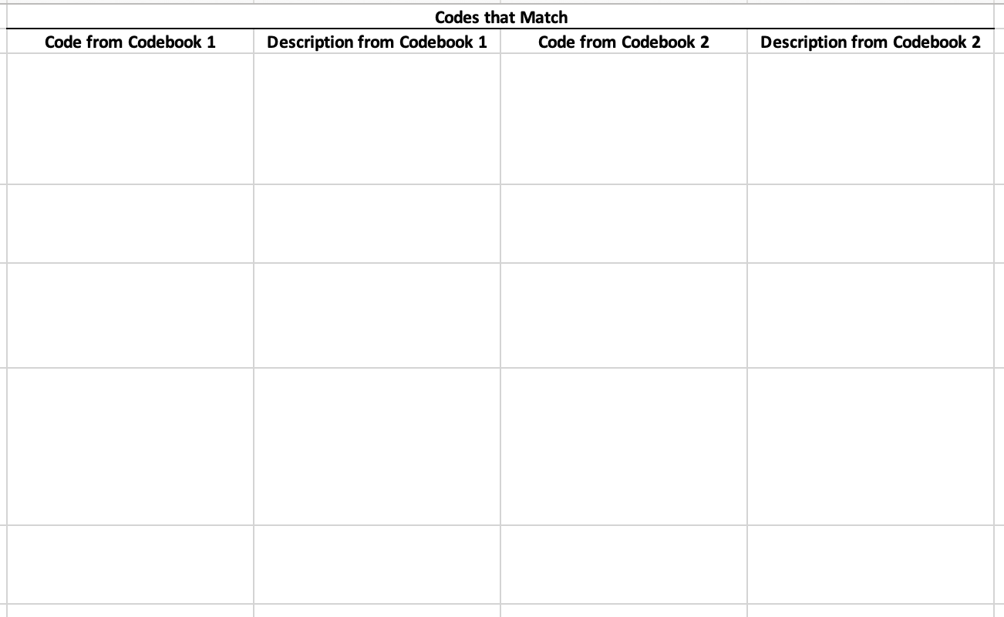

The process for creating the matching is very simple and it’s the same for either the loose or tight instructions: if you decide that two codes from the different codebooks match, cut-and-paste those Codes and Code Descriptions so that they’re on the same line in the center. Note that codes should be matched *one-to-one* (not one-to-many or many-to-one), which means that if one codebook has more codes than the other, some codes will *necessarily* be left over for the larger one.

Here’s the result for the example using the *tight* criterion.

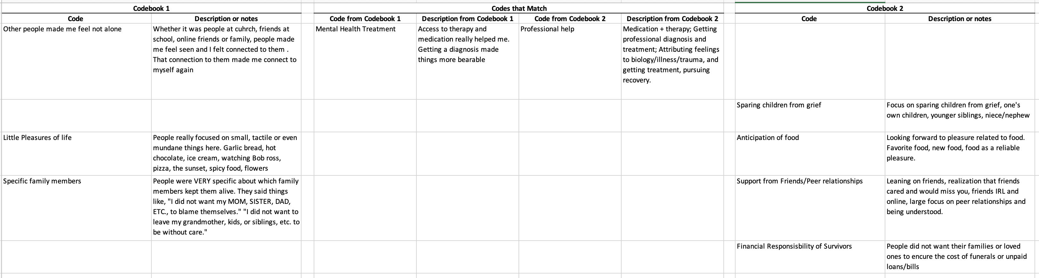

Here only the Mental Health Treatment and Professional Help codes were considered to be matches, strictly speaking. Reasoning:

* Other people made me feel not alone *and* Support from Friends/Peer relationships
  + Fails tight match because Codebook 2 is more specific about
* ... **Example needs to be continued – not sure if there should be any other matches. If so edit evaluation_example-MATCHED spreadsheet Strict (rename to Tight for consistency) and replace images here with the new versions**

Here’s the result for the example using the *loose* criterion.

... **Example needs to be continued – not sure if there should be any other matches. If so edit evaluation_example-MATCHED spreadsheet Loose sheet and replace images here with the new versions**