Industrial and Telecommunications Networks Challenges and Solutions for Critical Infrastructure Cybersecurity

**Abstract**: In the current digital era, the cybersecurity of critical infrastructure is a significant concern, with industrial and telecommunications networks serving as prime targets for cyberattacks. This curiosity makes me investigate the difficulties these two kinds of networks encounter and offers creative methods to improve their security. I look at prospective attack vectors, new dangers, and the effects of cyber incidents on vital infrastructure. Additionally, it emphasizes the significance of cooperation between the public and private sectors as well as the incorporation of cutting-edge technologies in order to protect these crucial systems. The research's conclusions shed important light on how industrial and telecommunications networks are to growing cyber dangers.

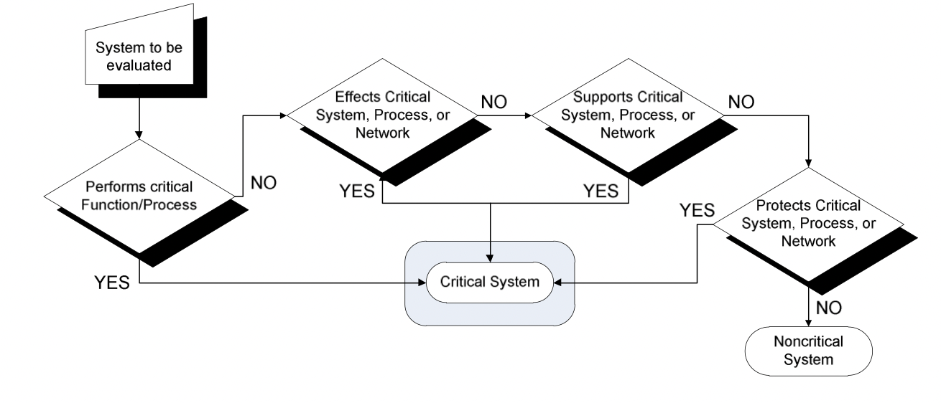

1. **Introduction:** The significance of industrial and communications networks as a component of essential infrastructure is discussed. It outlines the objectives of the research and emphasizes the value of tackling certain cybersecurity difficulties.

2. **Cyber Threat Landscape for Industrial and Telecommunications Networks:** In this section, the current cyber threat landscape is examined, along with the threats and attack methods that are specifically aimed at industrial and telecommunications networks. It identifies typical weaknesses and possible reasons for cyberattacks on these crucial systems.

3. **The Difficulties of Securing Industrial Networks**: This section focuses on the specific difficulties in securing industrial networks, such as legacy systems, connectivity issues, and complexity brought on by the convergence of operational technology (OT) and information technology (IT). Also highlighted are potential consequences of a successful cyber-attack on industrial systems.

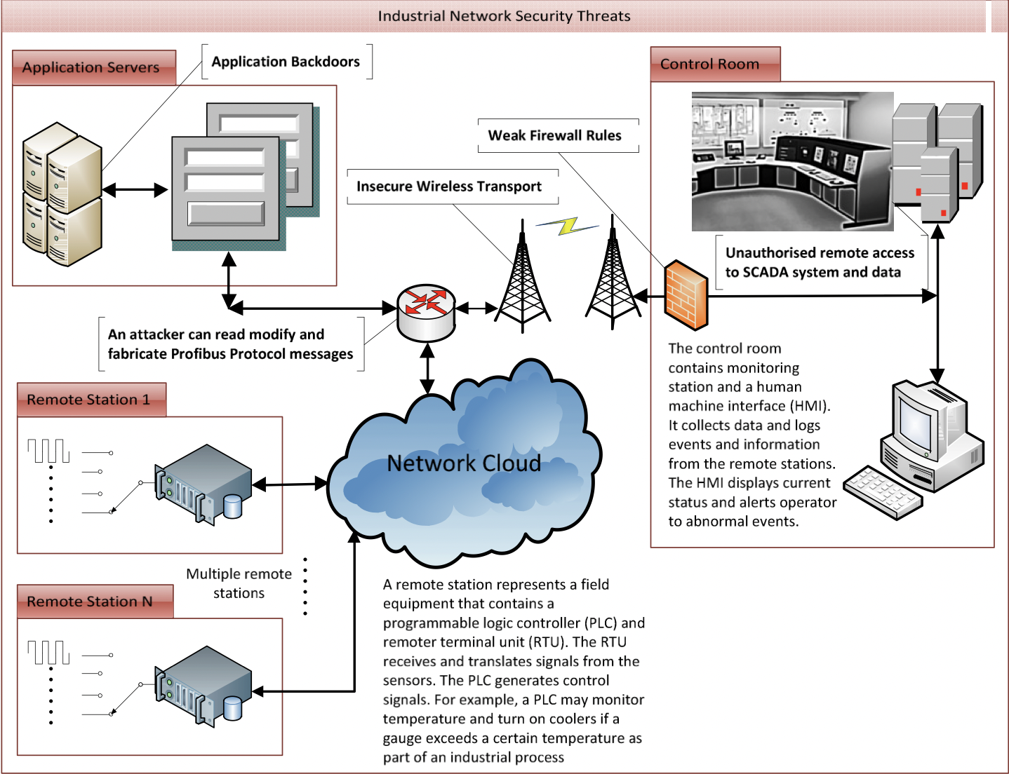

4. **The Difficulties of Securing Telecommunication Networks:** The increasing reliance on 5G and the Internet of Things (IoT), the prevalence of distributed denial-of-service (DDoS) attacks, and the potential impact on crucial communication services are just a few of the cybersecurity challenges that are unique to telecommunications networks.

5. Real-world case studies of cyber events that impacted Telecommunications and industrial networks are included in the research report. These case studies give useful information about the actual consequences of successful cyberattacks on vital infrastructure, as well as lessons learned for enhancing cybersecurity safeguards.

For Telecommunications -

**The Dyn Cyberattack of 2016 -**

A large Distributed Denial of Service (DDoS) attack against Dyn, a business that manages a sizeable chunk of the domain name system (DNS) infrastructure on the internet, was launched in October 2016. Permissions to relevant websites like Twitter, Reddit, and CNN were delayed by the attack. Multiple botnet devices were used in IoT devices which includes cameras and DVRs, were used to attack for creating a record amount of traffic and bury Dyn’s servers.

Impact: The incident exposed the internet's interconnectedness's weaknesses and the potential for worldwide internet services to be disrupted by a focused attack on a single target.

For Industrial Networks -

**Malware Triton/Trisis Incident of 2017 -**

A new malware family called Triton (or Trisis) targeted a petrochemical firm in Saudi Arabia in 2017. This malware was made specifically to attack safety instrumented systems (SIS), a class of industrial control system used to guarantee the security of industrial processes. The attackers may have intended to physically harm the facility instead of stealing data.

**I**mpact: This attack brought attention to the constantly changing nature of threats to industrial networks and the potential for cyber disasters to spill over into real-world situations that result in harm or even fatalities.

6. **Innovative Solutions for Industrial Networks:** This section examines advance guarding strategies to support industrial networks' cybersecurity. The usage of blockchain for secure data transactions, AI and ML for anomaly detection, and ICS access control implementation are all covered in this article.

7. **I**nnovative Solutions for Telecoms Networks: Like the previous part, this one focuses on creative approaches to boosting telecoms networks' cybersecurity. The application of advanced DDoS mitigation strategies, the implementation of security-by-design principles in 5G and IoT devices, and the usage of Software-Defined Networking (SDN) for network security are among the topics covered.

8. Concluding Reiterating the need of tackling cybersecurity issues in industrial and telecommunications networks, the conclusion section summarizes the research findings. It highlights the necessity of proactive and teamwork in protecting crucial infrastructure from changing cyberthreats.

**References:** <https://uhra.herts.ac.uk/bitstream/handle/2299/12999/Infrastructure_Sec_NA_final_v3.pdf?sequence=2&isAllowed=y>

<https://books.google.co.in/books?hl=en&lr=&id=V2RzAwAAQBAJ&oi=fnd&pg=PP1&dq=Critical+Infrastructure+Security+Threats:+Industrial+Networks&ots=54CaRcszji&sig=mNkGvCGhtlmbq2xzruE0A8rQGn8&redir_esc=y#v=onepage&q&f=true>