Points

- print(dir(dict)) - #to print methods in dict

PEP-Python Enhancement Proposal
30/7/2021

StanfordUniversity
cs231n

https://www.youtube.com/watch?v=vT1JzLTH4G4

data camp

MongoDb

https://docs.mongodb.com/manual/tutorial/install-mongodb-on-windows/

https://docs.mongodb.com/mongodb-shell/connect/

===========
Best Python training site
https://pythoninstitute.org/

==================
printing database

31/7/2021

https://www.w3schools.com/python/python_mongodb_getstarted.asp

seen till
https://www.w3schools.com/python/python_mongodb_create_db.asp

===================
removing daTAbase

===============
creating collection

=================

~~~~~~~~~~~`todays class notes
GITHUB
www.gaggle.com

Version Control system
- SCM
...,

refer in website to training schedule. http://www.datascienceintamil.com/

- GIT.....
- GITHUB.COM

GITHUB DESKTOP

MICROSOFT GIT

put in Private,Protected file.

GENKINS

1/8/2021

https://www.upgrad.com/blog/what-is-a-version-control-system-git-basics-benefits/

2/8/2021
https://pypi.org/project/emoji/

pip install emoji

when error occurs do the corrections,

in command prompt search

>where pip
find its path and set correctly in the environment variable > path
similarly
>where python

3/8/2010

GI/GITHUB TUTORIALS downloaded.

6min in video

8/5/2021

git - the simple guide
just a simple guide for getting started with git. no deep shit ;)
https://rogerdudler.github.io/git-guide/

6/8/2021
class:Django Introduction part
notes given

7/8/21,8/8/21
YESTERDAYS CLASS WORKOUTS GOING from the document given.

9/8/21
file given : DataScience-MongoDB-Session2
MongodB setup document given and it is setup

Connection String :: mongodb://localhost

11/8/21

14/8/21
Seeing MongoDB session videos

session2
@55:27,installing in Windows will come.
mongodb://localhost

15/8/21
Session3

cfg file.

Access tools,command tools
>> 13:25 mins.
Commandline tool installation

install MongoDB shell.

Install MongoDB database tools.

>>18:30-- bringing data IN

https://github.com/LearnWithNathan/MongoDBsampleData

c:\Mongodb\Samples\sample-data\dump>mongorestore.

'mongorestore.' is not recognized as an internal or external command,
operable program or batch file.

fixed:'mongod' is not recognized as an internal or external command, operable program or batch file.
youtube.com/watch?v=y2kRwNhZDhY

>> 33.40
going insde real MongoDB.

>>35.50
collection tab missing issiue.
>>40.46
CreateReadUpdateDelete

>>45:13
curly bracket start{ and end } means an objecr.
Array means square bracket [ ]

Data Types are very important.
In case of JSONonly 5 data types are available.

Example of inserting 2 data

-----------
parameter write concern
>>59:00

1:11

Session4
watch few mins to understand the last section of session3 ((find and extract data)) quickly.

Seen till 12:58

16/8/21

qaa
qq

cursor is the memory address.(to fetch many)

OR missing.

Between.

Seen tilll 53:18

open command prompt in admistrative mode and run the commands to start MONGODB shell

>net start mongodb

>Mongo

after getting inside commands used are:
>show dbs
> use sample_geospatial
>db.dropdatabase
> use sample_mflix

> mongorestore –drop.

In Compass Tool
open sample_airbnb

in filter type and enter
- {beds:3}
- {beds:{$gte:3}}
- {beds:{$gte:3,$lt:5}}

when only specific line is required,se-lect in otions.(1:03)

some more conditionns.(1:06)
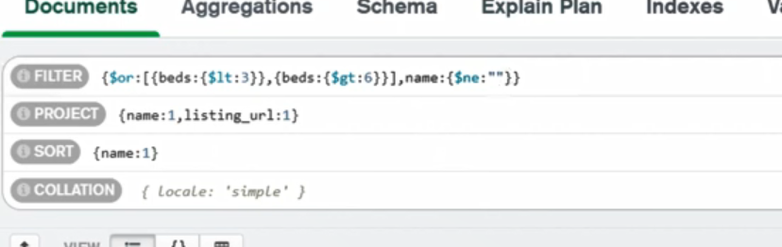

import and overwrite even if data available.
datafolder>mongostore –drop .

Session5
stop the proocess.
Before deleting and taking backup.

>mongodump gzip

>mongodummp –help

mongorestore command is used to import bson file.

23/8/21
class
maths-linear algebra

search in google
Gilbert Strang MIT lecture Linear Algebra + Data lecture
search

going inside class at 25:50

25/8 matrix

symettric and skew symmetric matrices.

SESSSION2 STARTED
31/8/2021

for every object these properties are there

id
type
content

1/9/2021

Learn and update Domain knowledge.

Collection
1.List
2.Tuple
3.Set
4.Dictionary

parameters and arguments
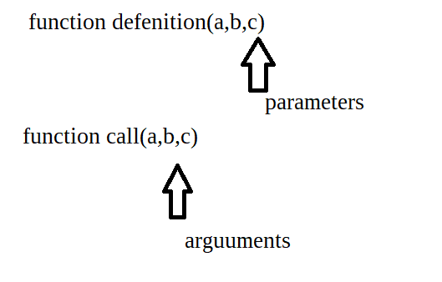

in python intendation is 4 0r 8 spaces
can be set in Pycharm.

FILE > SETTINGS > EDITOR >CODE STYLE > PYTHON

3 sept 21
Python in Tamil - Day 04 - Core Basic - Comments, Documentation, Indent, Dedent - 2021-09-03

comments
Docstring

4 sept 21

Python in Tamil - Day 05 - Core Basic - If Condition - 2021-09-04

5/9/2021

Let’s see how, here are the steps to follow for Data Science

1- Learn the fundamentals of mathematics and statistics.

2- Learn Programming R/Python.

3- Understand Machine Learning algorithms and Deep Learning.

4- Learn SQL, and Spark

5- Data Visualization tools - Tableau, Google Data Studio.

5- Cloud Deployment of model

6- Work on Real-time projects

https://www.hirist.com/

6/9/21
repr - reptesenntation (for empty strings)
usage print(repr(a))

FOR is finite loop
WHILE is Inffinite loop.

9/9/21
class
list

ewnumerate:

10/9
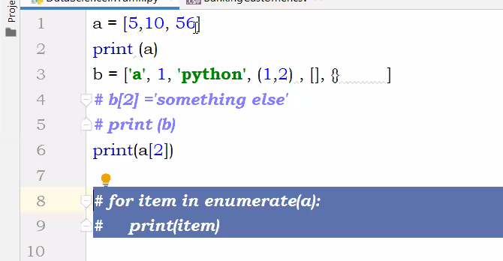

functions for a list
use dir
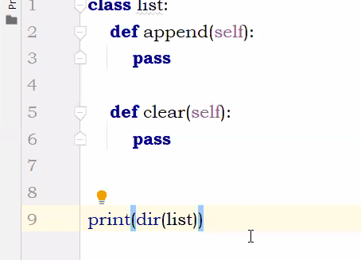

==============================

SEEING HELP

============================

13-3-2021
``````````````````````revision previous class
shallow copy

import copy
copy.copy() method

deep copy
duplicatelist=copy.deepcopy(originallist)
copies ID of each element in a list.

``````````````````````````````````````````````````````

# import only system from os
from os import system, name

# import sleep to show output for some time period
from time import sleep

# define our clear function
def clear():

# for windows
if name == 'nt':
_ = system('cls')

# for mac and linux(here, os.name is 'posix')
else:
_ = system('clear')

# print out some text
print('hello geeks\n'*10)

from os import system, name

def clear():

# for windows
if name == 'nt':
_ = system('cls')

# for mac and linux(here, os.name is 'posix')
else:
_ = system('clear')

print("BASKAR")
clear()
print("BASKAR PERUMAL")

15-09-21

Most python objects (booleans, integers, floats, strings, bytes, bytearray, complex frozen
set and tuples) are immutable
All immutable are hashable
List, dict, set are mutable ie unhashable

cLASS
Python in Tamil - Day 14 - Set continuity and Dict data type - 2021-09-15
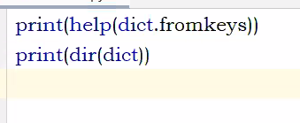

Why use Python Counter?
Here, are major reasons for using Python 3 Counter:
- The Counter holds the data in an unordered collection, just like hashtable objects. The elements here represent the keys and the count as values.
- It allows you to count the items in an iterable list.
- List,tuple(collections which allow duplicates*(important)
iterable An object capable of returning its members one at a time. Examples of iterables include all sequence types (such as list, str, and tuple) and some non-sequence types like dict, file objects, and objects of any classes you define with an __iter__ () or __getitem__ () method.

from collections import Counter
list1 = ['x','y','z','x','x','x','y', 'z']
print(Counter(list1))

type ::
<class 'collections.Counter'>

A function or method(dont include magic methods __xx__) which has self parameter is method to that collection , for example type ‘ list.’

import random

see and do 34 th minute.

Dictionary 40:00

56 min -dict(list of tuples)

dict ( [ ( , ) ] )

dont use list of sets.

Comma can be addded after the last item in dictionary since it is mutable.
Cant be for TUPLE or FROZEN SET

1.14

seen till 1:28
``````````````````````````````````````````````
deep copy example

import copy
a = [10,20,30,40]
b = a.copy()

print("Address of a : ", id(a))
print("Address of b : ",id(b))

print("Value of a : ",a)
print("Value of b : ",b)

print(dir(dict)) #to print methods in dict ,output will be in list format.

To get an help of a function for example fromkeys in dictionary do like.
>>> print(help(dict.fromkeys))

put like this

for fns in dir(dict):
print(fns)

except the names starting with _ _ ..... are the functions.

Another example:

from collections import Counter

for fns in dir(Counter):
print(fns)

#Program to find functions in a collection
for fns in dir(tuple):
if '__' not in fns:
print(fns)

```````````````````````````````````````````````````

fromkeys dictionay method:

keys=['a','e','i','o','u']
value=[1]
vowels=dict.fromkeys(keys,value)
print(vowels)

output:
{'a': [1], 'e': [1], 'i': [1], 'o': [1], 'u': [1]}

------------------18/9--------------------

important libraries

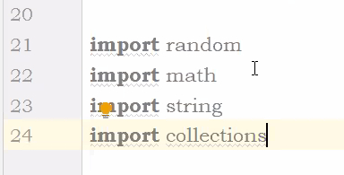

once if dictionary is counter type we can do arithmetic operations.(+ and – only)

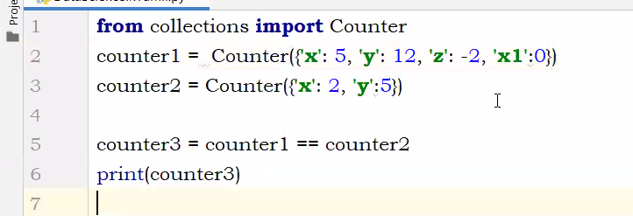

printr

Quiz discussion Sunday19/9/21

range will support only integers

THONNY

pop will print output everytime when executes

help(keywords) to list keywords
list
append takes as single element
extend includes induvidual elements.

21/9 Project discussion

sys.exit()

22/9/21

whatsapp

import pywhatkit
try:
pywhatkit.sendwhatmsg("+91xxxxxxxxxx","Welcome to TamilNadu",21,10)
print("Message Sent Successfully")
except:
print("An unexpected Error")
from GoogleNews import GoogleNews
googlenews = GoogleNews()
googlenews = GoogleNews(period = '7d')
googlenews.search('India')
result = googlenews.result()
for x in result:
print("-"*50)
print("Title--",x["title"])
print("Date/Time--", x["date"])
print("Description--", x["desc"])
print("Link--", x["link"] )

https://pypi.org/

C:> pip install GoogleNews

password generation

From Loganathan to Everyone: 09:20 PM
import string
from secrets import choice
characters = string.ascii_letters + string.punctuation + string.digits
print(characters)
password = "".join(choice(characters) for x in range(0,15))
print("Your password is : ", password)

package-name pyTelegram

23/9

GIT and GITHUB study

https://www.youtube.com/watch?v=eulnSXkhE7I

>git clone<url of the repository> to download

>git add <filename>
>touch (command to create a file)
eg.,
>touch hello.html

>code filename (to edit)
eg.,
code hello.html

git commit -m “message”
to commit the adced files.((add before you commit)

git commit -am
add and merge.
Then git push

>git status (tells what is happening in my GIT repository)

>git push (take the file and push in server)((changes from computer to server))

>git pull (changes from server to computer)

22:00

25:00 – merge conflicts

>git rm removes the file after next cmmit. 30:50

36:42
>git branch
>git checkout
git checkout -b (branch name)
>git merge

Deleting a branch
40:00

>git branch -D (branch name)

42:30
>git push –set-upstream orign red

>

~~~~~~~~~~~~~~~~~~~~
# packing and unpacking concepts..since y contains star
# after first element every others are packed to y
x,*y=(1,2,3)
print (y)
print(x)

24/9

told by Maheshwara moorty.

print(" Welcome to DSIT Seminar ".center(100, "*"))

Open source contribution

https://www.python.org/psf/

25/9/2021

https://www.jetbrains.com/help/pycharm/commit-and-push-changes.html

26/9/2021

doing assignment2

1. Clear Screen
os.systems(‘clear’)
You need to import library os in the begining of program like
import os
2. String methods used.
1. String.ljust
2. String.rjust
3. String.center

https://www.w3schools.com/python/ref_string_center.asp
string.center(length, character)

Parameter Values
Parameter | Description
length | Required. The length of the returned string
character | Optional. The character to fill the missing space on each side. Default is " " (space)

27/9/2021

class n Objects.

HASH ID will come only for immutable items.
Objects are immutable

28/9/2021
seeing yesterdays recording
30 mins

when we declare a variable in CLASS it is called as class variable or class attribute.
This variable can be used by all methods within a class.

Variable defined within a method is local only to that method,it cannot be used by other methods.

34 mins.

objectname=classname()
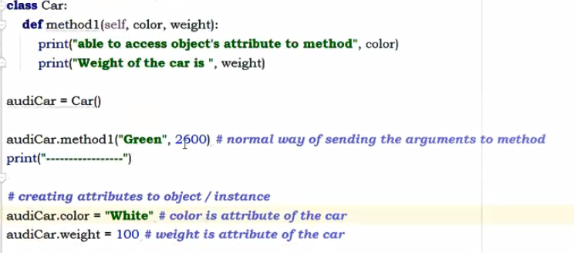

separately creating attributes.

`````````````````````````````````````````````````````````

Constructors are generally used for instantiating an object. The task of constructors is to initialize(assign values) to the data members of the class when an object of the class is created. In Python the __init__() method is called the constructor and is always called when an object is created.

Syntax of constructor declaration :
def __init__(self):
# body of the constructor

example:

class GeekforGeeks:

# default constructor
def __init__(self):
self.geek = "GeekforGeeks"

# a method for printing data members
def print_Geek(self):
print(self.geek)

# creating object of the class
obj = GeekforGeeks()

# calling the instance method using the object obj
obj.print_Geek()

Output :
GeekforGeeks

variable inside constructor is INSTANCE VARIABLE

SHOULD ALWAYS WITH SELF
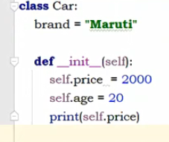

for calling constructor we dont have to create object.
Just calling the class,executes the constructor.

1:09

only 1 constructor for a class can be created.

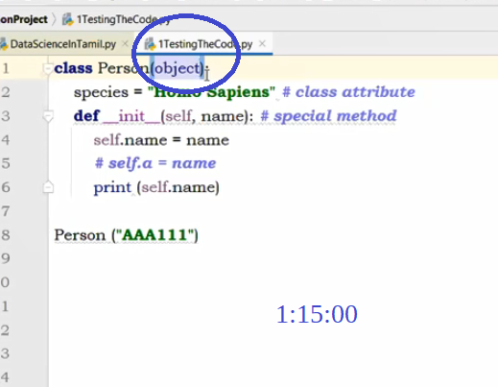

Passing multiple arguments.
Put * in parameter defenition.
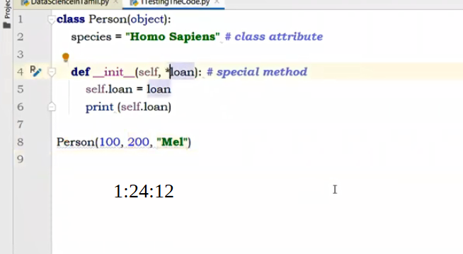

1:33:31

object can be told as instance

1:43:48
see from 1:46:00 , he give summary like.

1:47:30 important

constructor wont have return

method will have return

`````````````````````
29/9/21
session2
Python in Tamil - Day 20 - Class Continue 02 – 2021-09-28

5:00
``````````````````````````````````
class::

we are instantiating the value of the parameter "name" to the instance variable , self.name

Instantiating means, declaring and defining in the same statement
declaring the variable means the variable has no value set for it
defining the variable means assigning the value to the variable

2/10

print(“\n”*5)

2

tabulate

3

press anykey to continue

4-oct
my task

5-Oct
Assignment.

file assignment_fileparameters

fileEx=open(file="Medical.txt,
mode="r",
buffering=-,
encoding=None,
errors=None,
newline=None,
closefd=True,
opener=None)

refer
https://www.programiz.com/python-programming/methods/built-in/open

refer
https://pynative.com/python-file-open/

Python open()
The open() function opens the file (if possible) and returns the corresponding file object.

The syntax of open() is:
open(file, mode='r', buffering=-1, encoding=None, errors=None, newline=None, closefd=True, opener=None)

open() Parameters
- file - path-like object (representing a file system path)
- mode (optional) - mode while opening a file. If not provided, it defaults to 'r' (open for reading in text mode). Available file modes are:
Mode | Description
'r' | Open a file for reading. (default)
'w' | Open a file for writing. Creates a new file if it does not exist or truncates the file if it exists.
'x' | Open a file for exclusive creation. If the file already exists, the operation fails.
'a' | Open for appending at the end of the file without truncating it. Creates a new file if it does not exist.
't' | Open in text mode. (default)
'b' | Open in binary mode.
'+' | Open a file for updating (reading and writing)
- buffering (optional) - used for setting buffering policy
- encoding (optional) - the encoding format
- errors (optional) - string specifying how to handle encoding/decoding errors
- newline​ (optional) - how newlines mode works (available values: None, ' ', '\n', 'r', and '\r\n'
- closefd (optional) - must be True (default); if given otherwise, an exception will be raised
- opener (optional) - a custom opener; must return an open file descriptor

Return Value from open()
The open() function returns a file object which can used to read, write and modify the file.
If the file is not found, it raises the FileNotFoundError exception.

start.

Python Open()
The open() function opens the file (if possible) and returns the corresponding file object.

The syntax for open() is

open(file, mode='r', buffering=-1, encoding=None, errors=None, newline=None, closefd=True, opener=None)

open() Parameters
- file - This parameter value gives the pathname (absolute or relative to the current working directory) of the file to be opened.

Example 1: How to open a file in Python?
# opens bank.txt file of the current directory
f = open("bank.txt")
print(f.read())

# specifying the full path
f = open("C:/example/bank.txt")
print(f.read())

Since the mode is omitted, the file is opened in 'r' mode; opens for reading.

- mode (optional) - This is the optional string that specifies the mode in which a file will be opened. The default value is 'r'

Available file modes are:

- 'r' Open a file for reading. (default)
Example2:
f = open("C:/example/bank.txt",mode='r')
- 'w' Open a file for writing. Creates a new file if it does not exist or truncates the file if it exists.
Example3:
f = open("C:/example/bank.txt",mode='w')
- 'x' Open a file for exclusive creation. If the file already exists, the operation fails.
- 'a' Open for appending at the end of the file without truncating it. Creates a new file if it does not exist.
Example4:
# Open and Append at last
f = open("C:/example/bank.txt",mode='a')
f.write(" Added this line by opening the file in append mode ")

# Opening the file again to read
f = open("C:/example/bank.txt", "r")
print(f.read())
f.close()
- 't' Open in text mode. (default)
- 'b' Open in binary mode.
- '+' Open a file for updating (reading and writing)

- buffering(optional) - This is an optional integer used to set the buffering policy. Pass 0 to switch buffering off (only allowed in binary mode), 1 to select line buffering (only usable in text mode), and an integer > 1 to indicate the size in bytes of a fixed-size chunk buffer.
- encoding(optional) - This is the name of the encoding used to decode or encode the file. The default one is platform dependant.
utf-8 - a.k.a. Unicode - international standard (should be always 1 used!)
iso-8859-1 - ISO standard for Western Europe and USA

iso-8859-2 - ISO standard for Central Europe (including Poland)

cp1250 or windows-1250 - Polish encoding on Windows

cp1251 or windows-1251 - Russian encoding on Windows

cp1252 or windows-1252 - Western European encoding on Windows

ASCII - ASCII characters only

- errors(optional) - These are optional string denotes how the standard encoding and decoding errors have to be handled.
- newline (optional) - This is the parameter that indicates how the newline mode works (it only applies to text mode). It can beNone,' ','\n','r', and'\r\n'
- closefd(optional) - This parameter indicates whether to close a file descriptor or not. The default value is True. If closefd is False and a file descriptor rather than a filename was given, the underlying file descriptor will be kept open when the file is closed.
- opener(optional) - a custom opener; must return an open file descriptor

class
Counter

6/10/21

coll module is container module.

MRO– method reference identifier
shows the parent details

NAMED TUPLE
https://www.pythontutorial.net/advanced-python/python-namedtuple/

deque

assinment given for me.
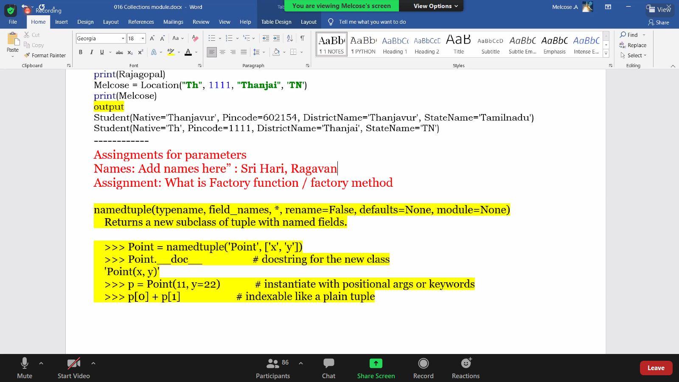
In deque we can appent left

iterable
iterate
nex

7/10/21

GENERATOR FUNCTION

yield function.

8/10/21

see his chat

20:26:51 From Veera to Everyone:
please unmute me
20:27:59 From Veera to Everyone:
Can we use generator for pagination functionality?
20:29:14 From Maheswara Moorthy to Everyone:
we can use based on the requirement
20:30:15 From Ahamed Sabry to Everyone:
2,3,4
20:30:56 From Veera to Everyone:
Okay
20:37:17 From Antony Jesu to Everyone:
sir, different between iterator and generator?
20:53:58 From Maheswara Moorthy to Everyone:
<dict_keyiterator object at 0x0000026C44626EA0>
20:54:40 From Maheswara Moorthy to Everyone:
d = {1:10,2:20,3:30}

myit = iter(d)

print(myit)
21:23:44 From KAMAL to Everyone:
def genfun():
while True:

print('calling yield 1')
yield 'a'
print('calling yield 2')
yield 'b'
print('calling yield 3')
yield 'c'

a=genfun()
21:37:30 From Muthuraj to Everyone:
def genfun():
while True:
print("calling yield 1")
yield "a"
print("calling yield 2")
yield "b"
print("calling yield 3")
yield "c"
a = genfun()
print(next(a))
print(next(a))
print(next(a))
a.close()
# print(next(a))
b = genfun()
print(next(b))
21:37:53 From Muthuraj to Everyone:
if we place the close after third next, the second b is working
22:00:20 From Sᴏʙɪɢᴀɴ 10D to Everyone:
ithula for loop podama list poda enna nadakkum sir
22:09:12 From Maheswara Moorthy to Everyone:
def msj():
a = yield
yield a+10
yield 1
yield 20

my = msj()
print(my)
next(my)
print(my.send(10))
print(my.__next__())
print(my.__next__())
22:11:46 From Thirumal Murugan to Everyone:
Kindly please mute yourself, unless speaking
22:15:19 From Melcose to Everyone:
def informToBank():
a = yield
b = yield
yield a + 10
yield b + 20

msg = informToBank()
next(msg)
print(msg)
print(msg.send(10))

print(msg.send(100))
print(next(msg))
22:15:23 From Tharanan to Everyone:
Thank you sir
22:15:38 From Jkm Karu to Everyone:
Thank you
22:15:45 From Raghul A B to Everyone:
THANK YOU SIR
22:16:54 From sharanya to Everyone:
thank you sir
22:17:51 From Vallikkannu chockalingam to Everyone:
thank you sir
22:22:16 From Madasamy to Everyone:
ok sir
22:22:22 From Madasamy to Everyone:
thank you
22:22:45 From sundara rajan to Everyone:
def informToBank():
a = yield
b = yield
yield a + 10
yield b + 20

msg = informToBank()
next(msg)
print(msg)
print(msg.send(10),'this is 10')
# print(next(msg))
print(msg.send(100), 'this is 100')
print(next(msg),'this is start')

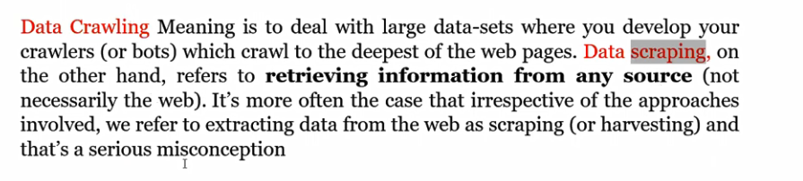

reading a google news function see 1:12:31 in video

webscrapping

see about DMZ tool

9/10/2021

==============
import string # Required library to make a list of English lower characters.

lower_list = list(string.ascii_lowercase) # Create the aforementioned list.

name = input("Please enter your name: ").lower() # Get input from user, and change it to lower case characters.
# E.g: Govarthenan Rajadurai -> govarthenan rajadurai

split_name = name.split(' ') # Split the input at spaces to make the looping easier.
# govarthenan rajadurai -> ['govarthenan', 'rajadurai']

split_name = ''.join(split_name) # Join the split words to get one string without any spaces.
# ['govarthenan', 'rajadurai'] -> 'govarthenanrajadurai'

for char in split_name: # Check every single character in the string `govarthenanrajadurai'
if char not in lower_list: # If the character isn't in the list we created earlier...
print(f"\n'{char}' is not an English character.") # Whatever you want to do here.
# You can break the loop or print an error message, like shown above.
==============
For a list with decimal digits: list(string.digits)
For a list with all the characters in the English alphabet: list(string.ascii_letters)
For a list with uppercase letters: list(string.ascii_uppercase)
For a list with lowercase characters: list(string.ascii_lowercase)
For a list with all special characters: list(string.punctuation)
For a list with whitespace characters (newline, space, tab, etc.): list(string.whitespace)

============
tabulate

important modules.
- collections module

- itertools module(do things cannot be done in Genaratr,iTERATOR,Iterables module)

- random module

- operator module
===========
3 types.
1.Infinite iterators
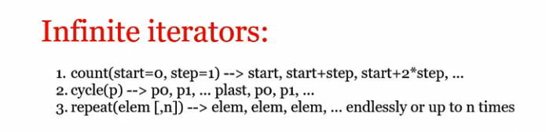
2.Iterators ending on shortest input sequence
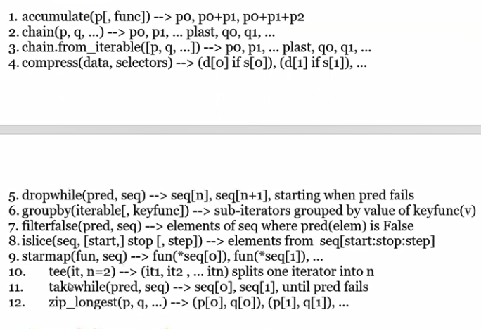
3.Combinatoric generators.

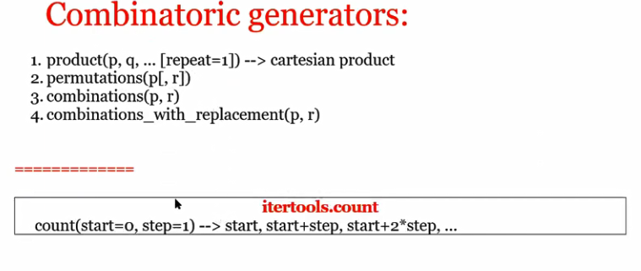

NEXT and ITER methods.......will be used by the iterables.

to take only ONE value change to ITERATOR

13/10

Predicate fuction
take while
drop while
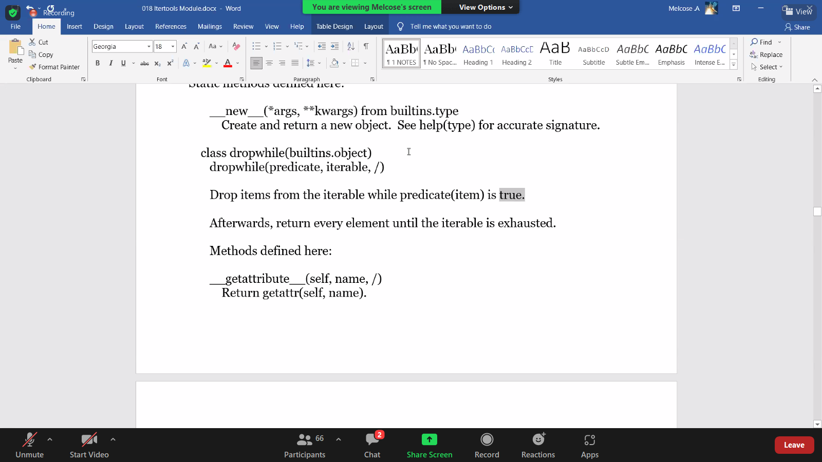

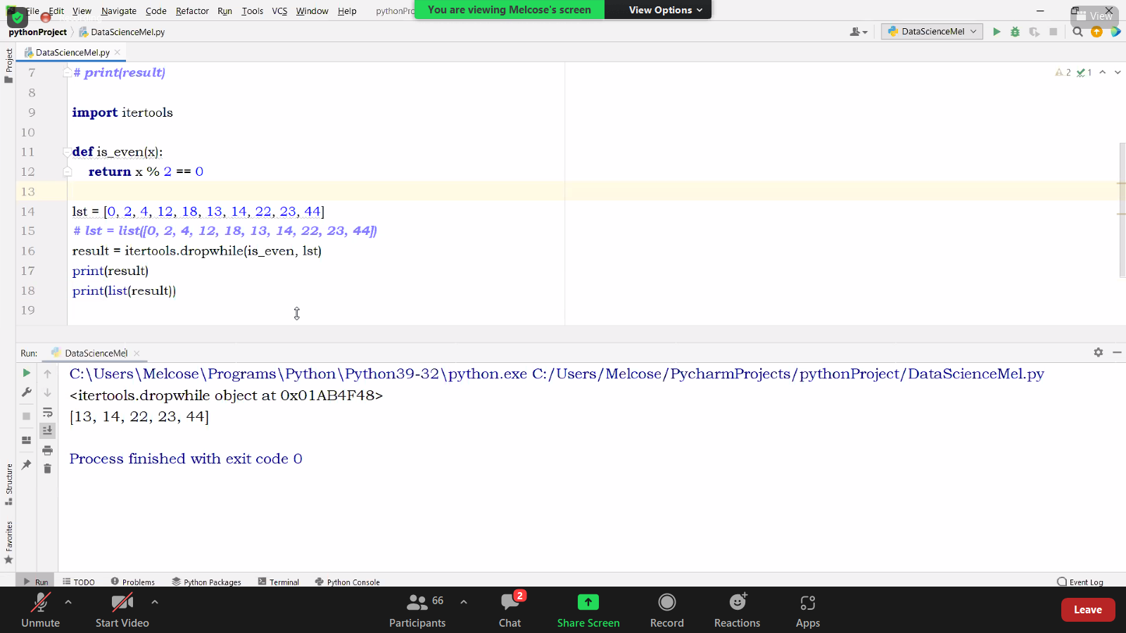
both

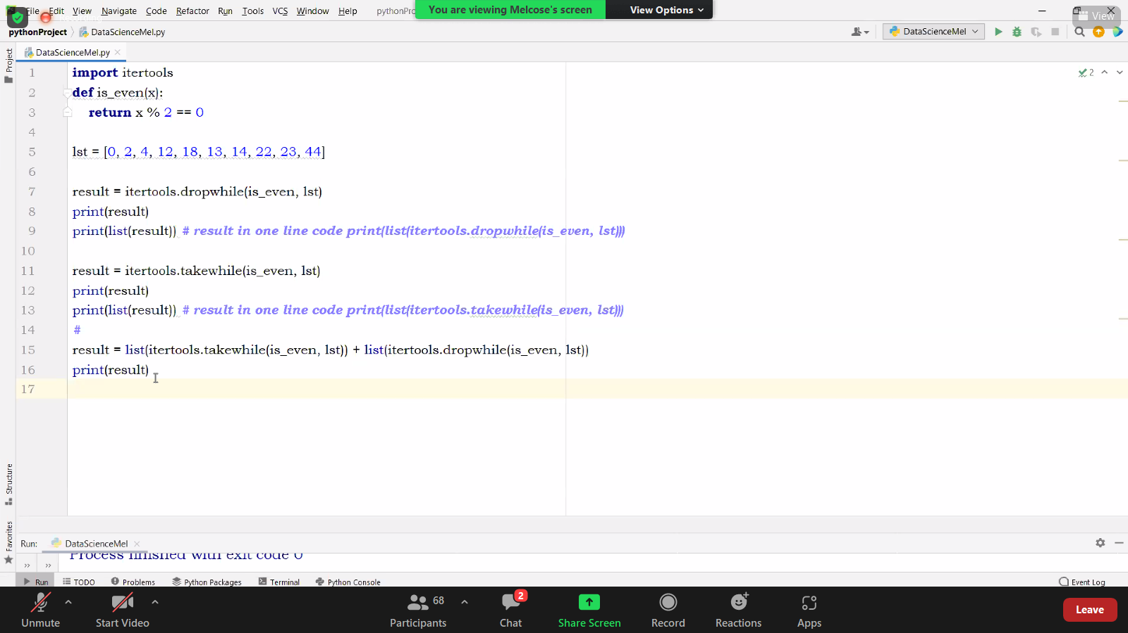

take while
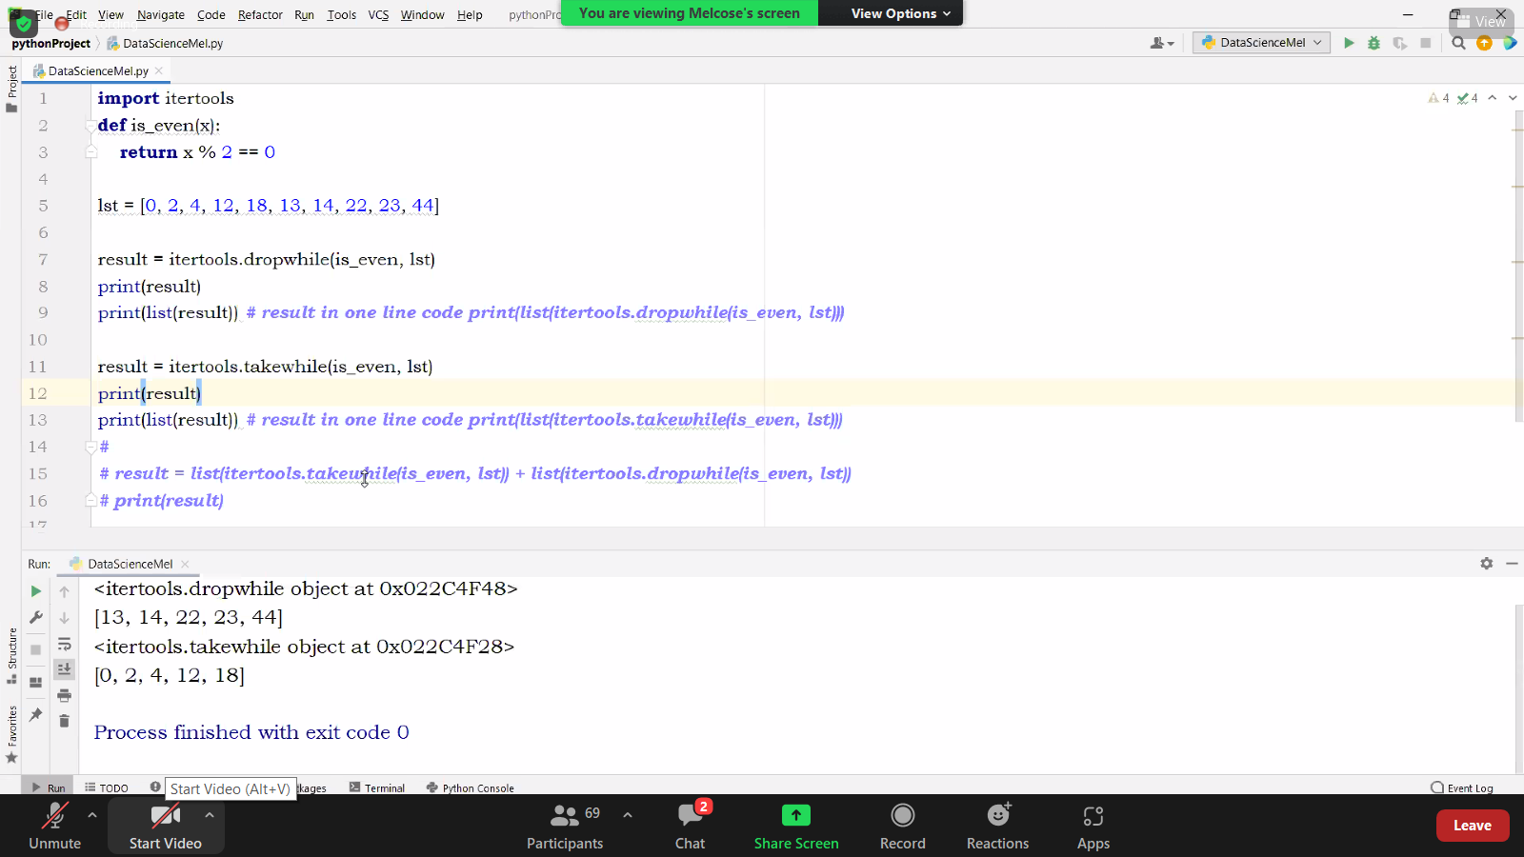
concatinating both will give original
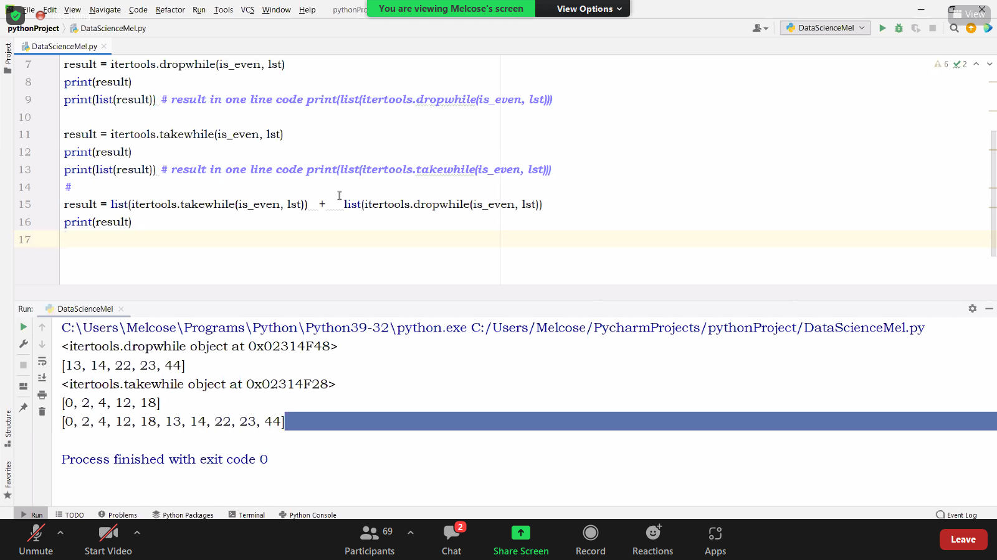

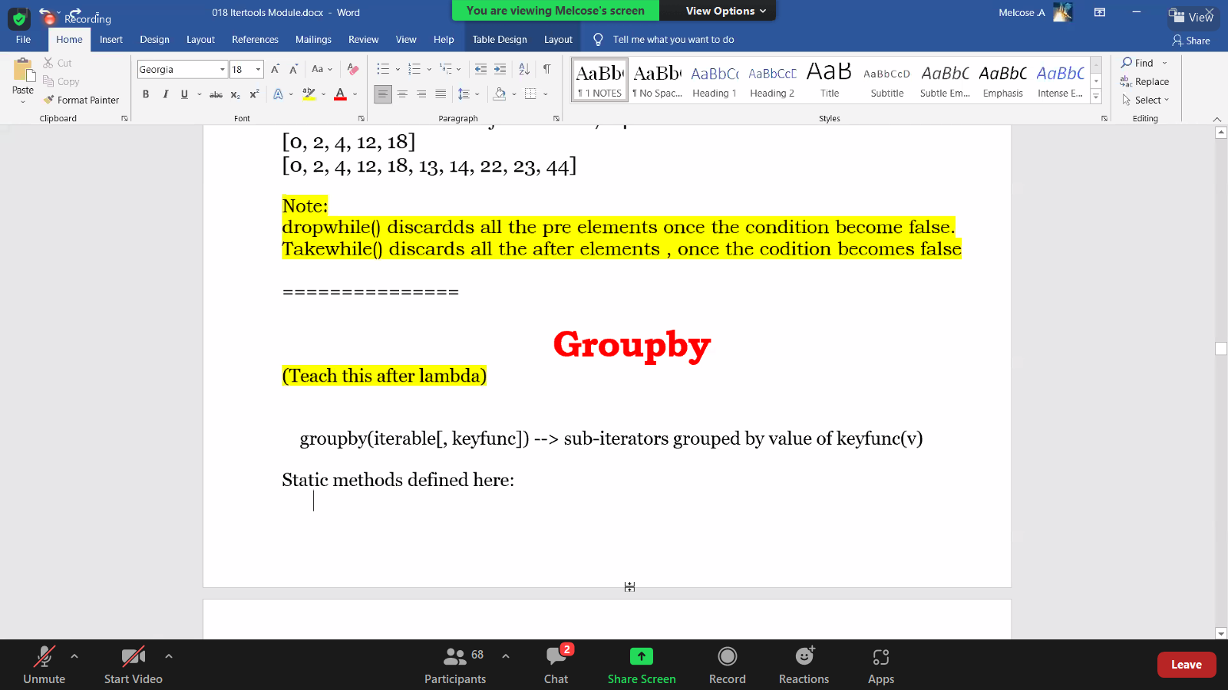

SORTED
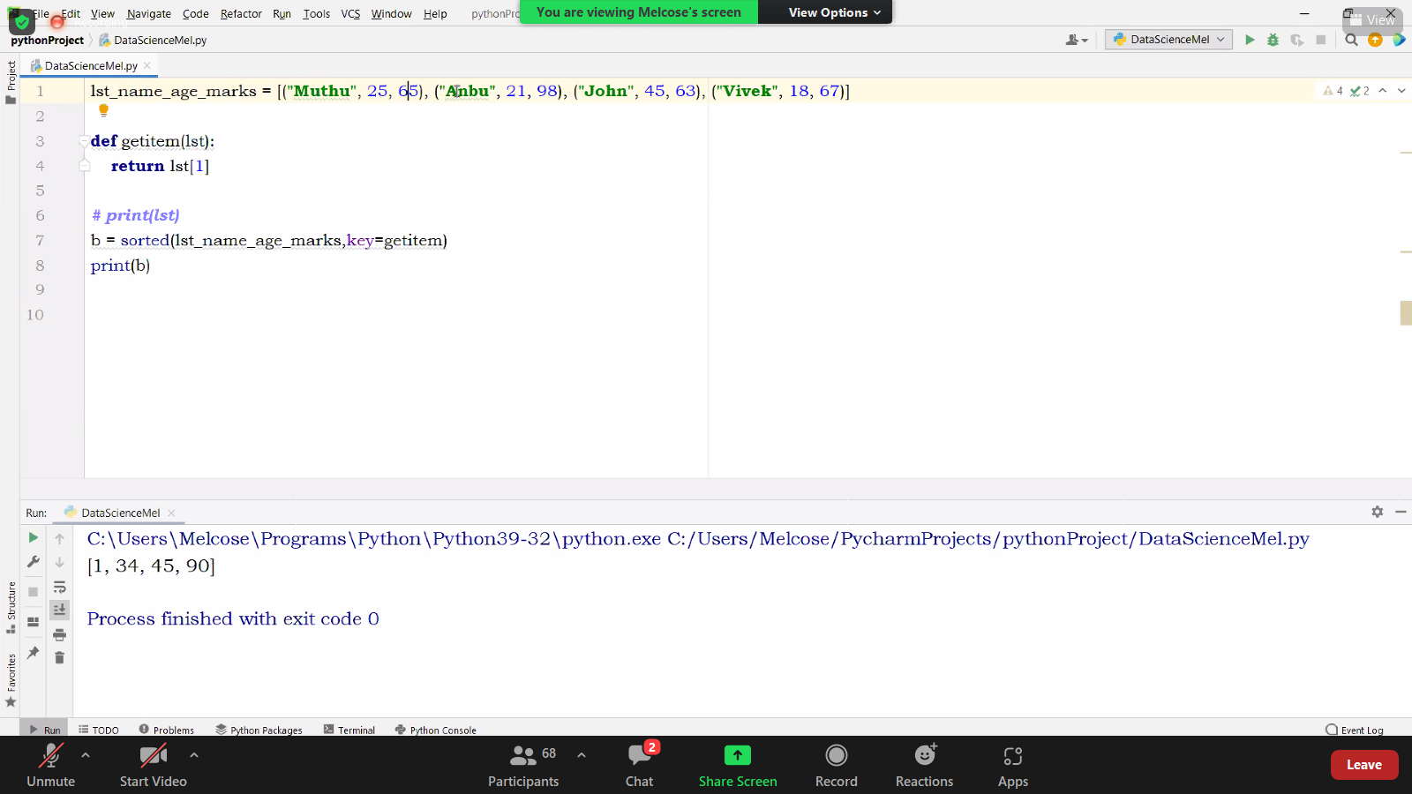
using reverse parsmeter
both are made.

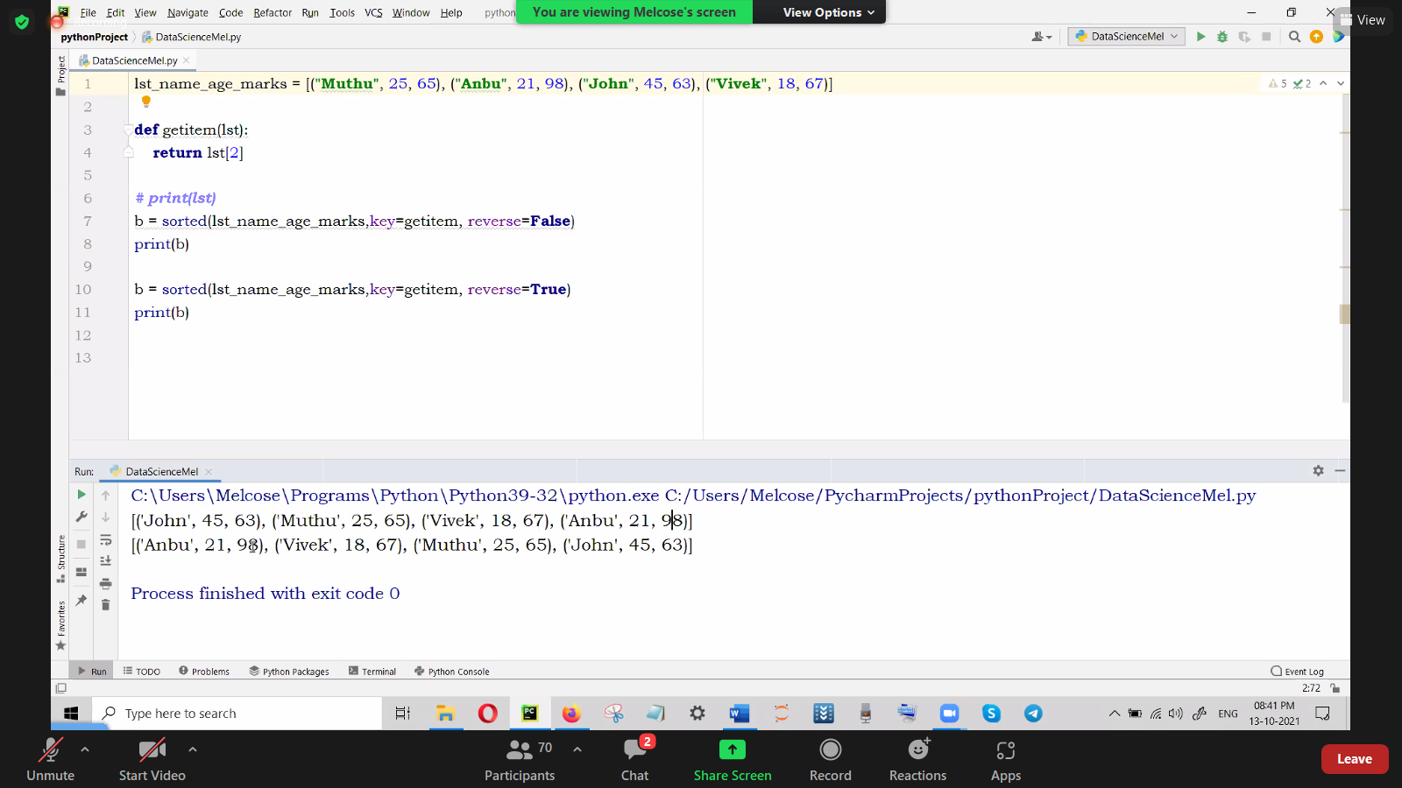

Rearranged again

passing only function name;not the function.

MRF-high orderfunction example
map Release functionality

ZIP
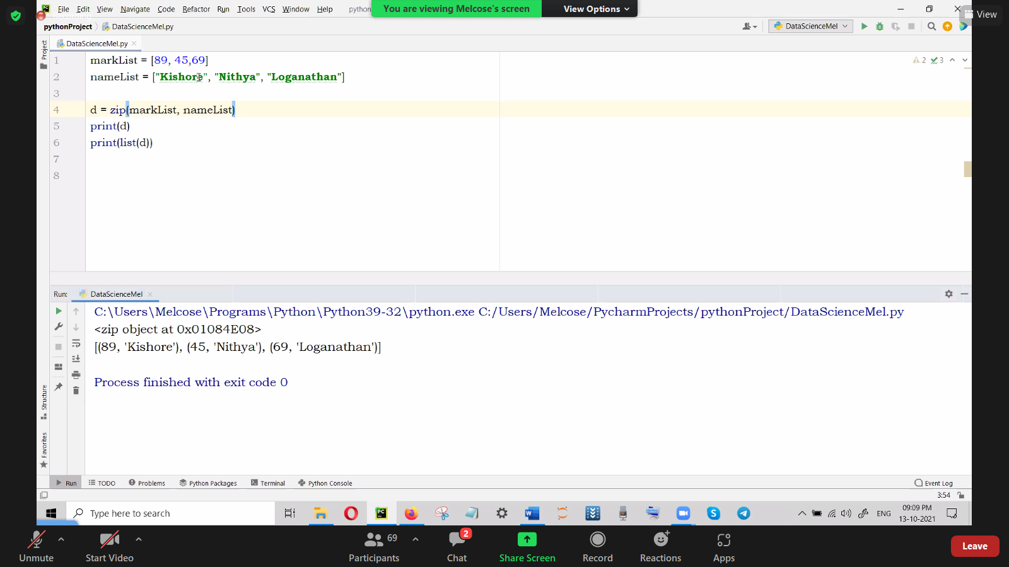

ALSO CAN BE DONE AS DIUCT
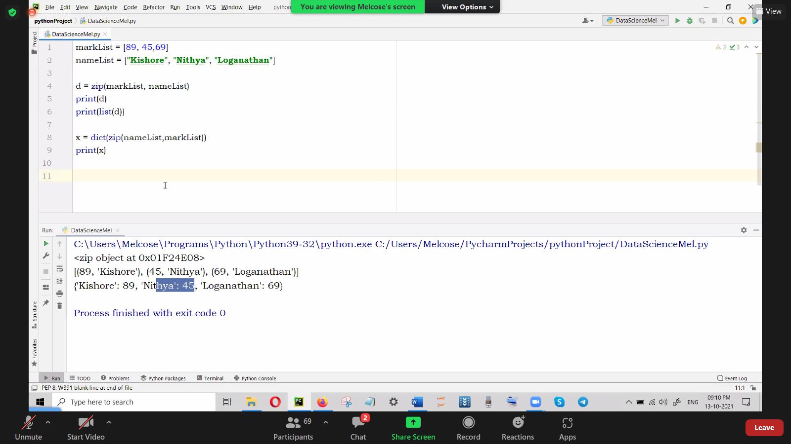

ZIP LONGest

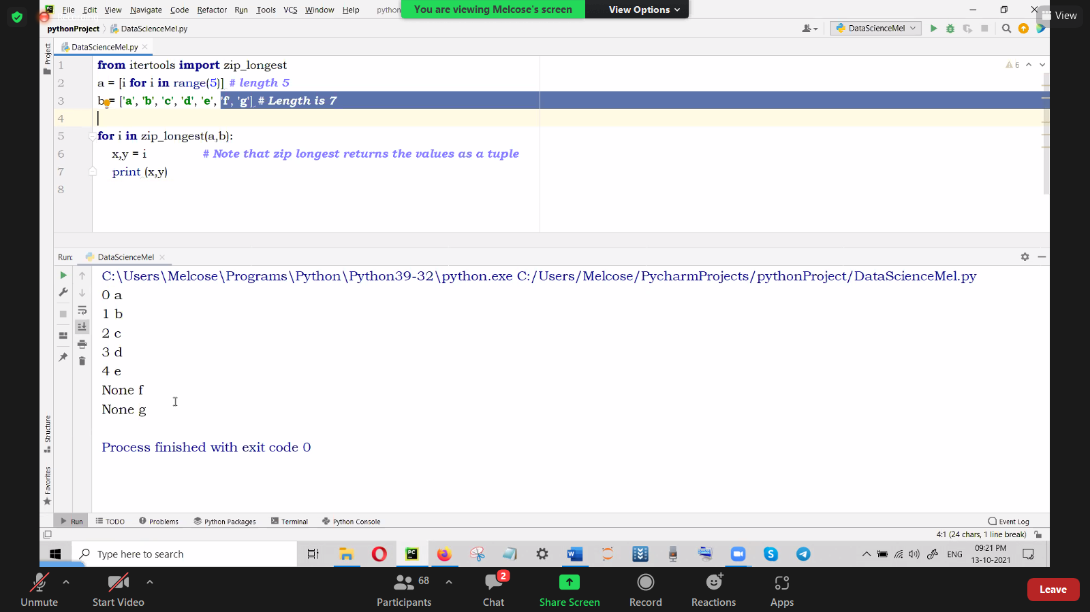

dict of list

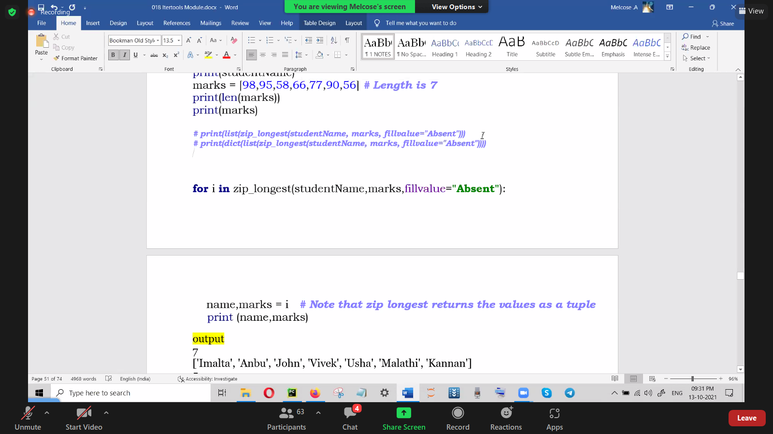

_____sizeof____
sir asked to give assignment
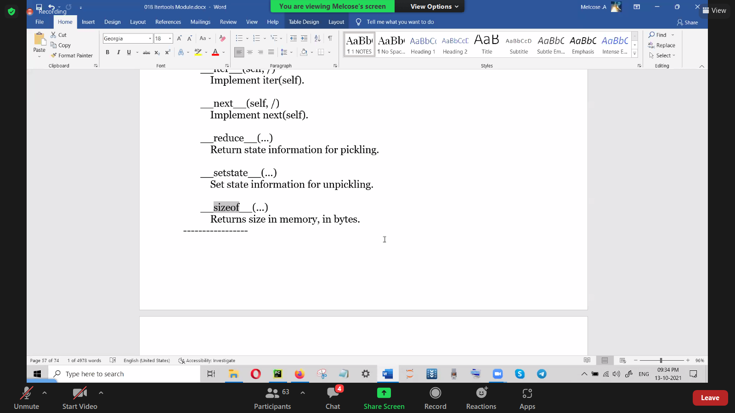
Cartsan Product

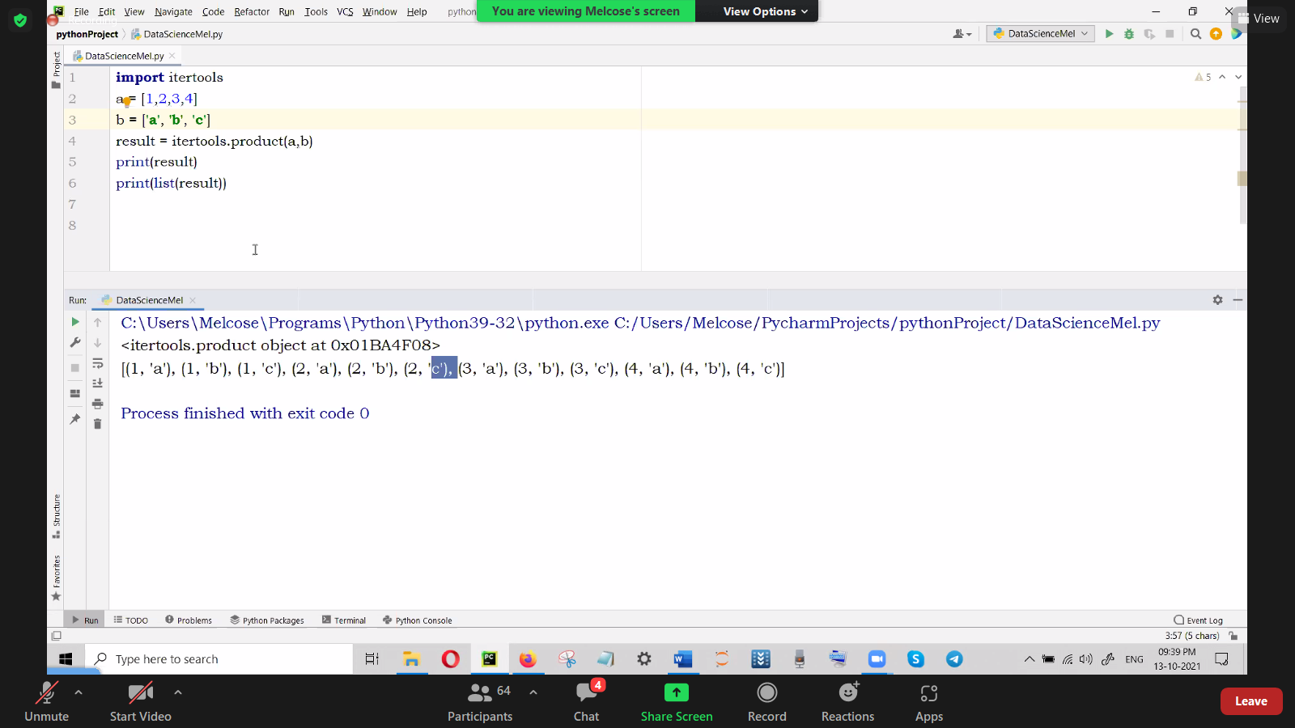

assignment for repeat

print(help.itertools

17/10/21
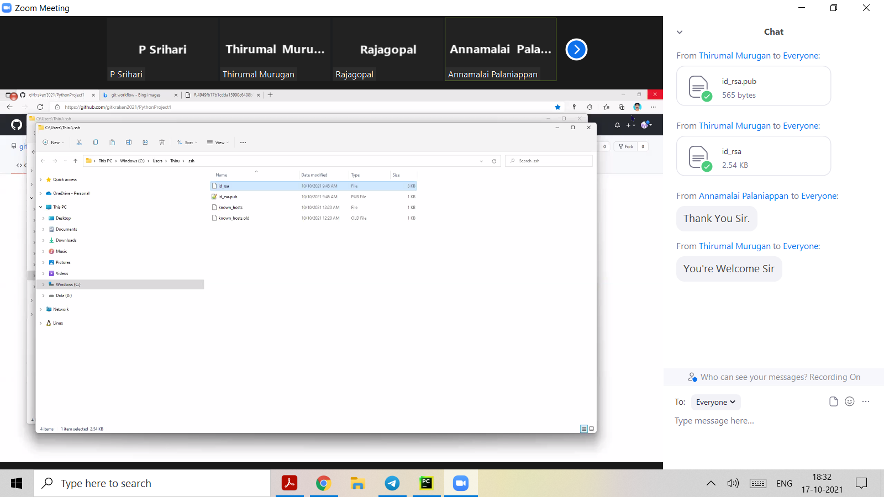

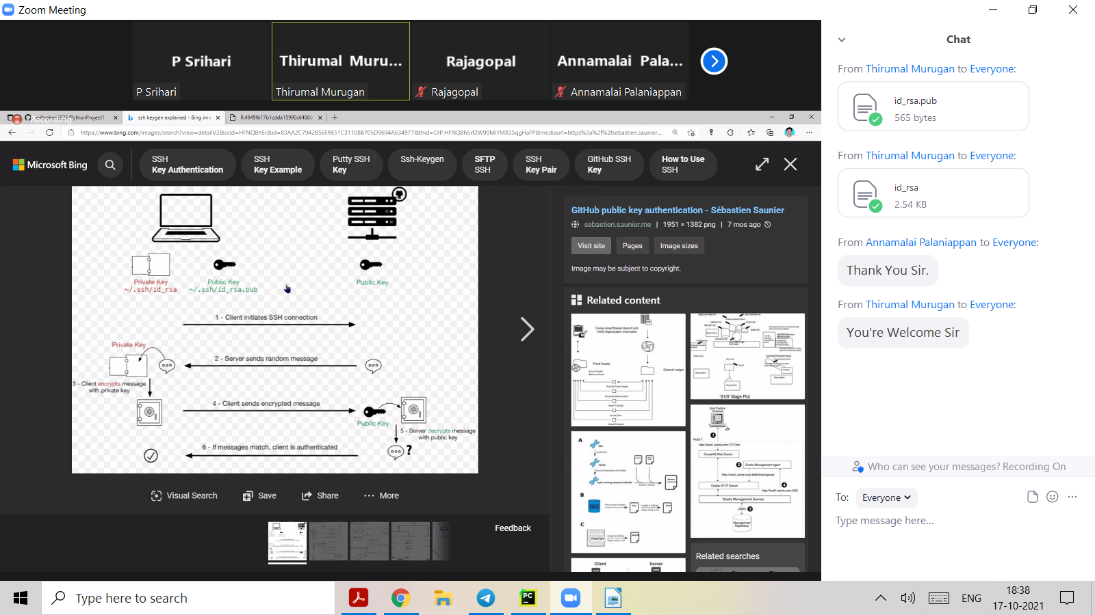

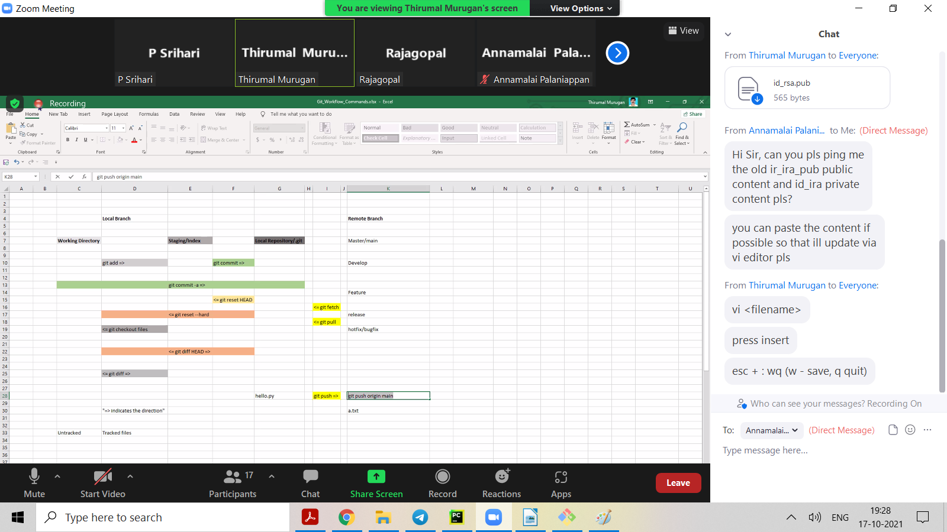

18/10
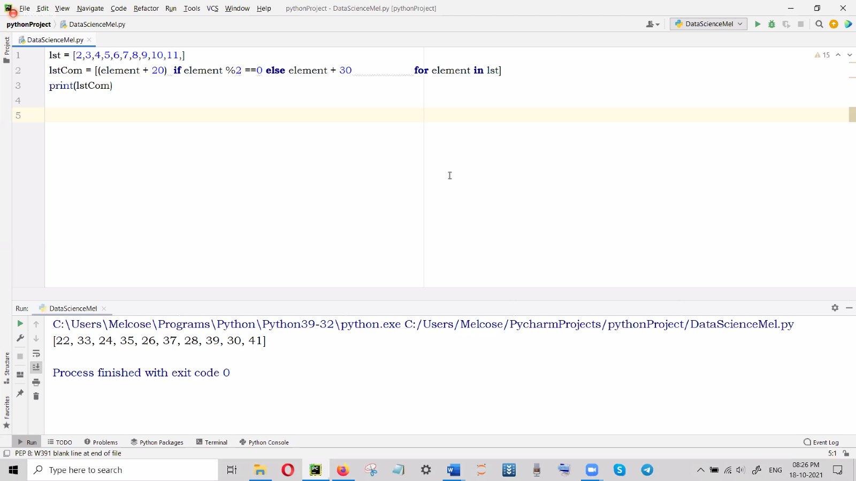

19/10

20/10
https://gist.github.com/psrihari/659b87d151599adc253195d4f0815bba
overloading is not in in Python inheritance
in python, if many methods are there lastly defined method will be used.

@dispatch is used to overcome the limits in inheritance.(decorator(@decoratorname will be used)

from multiple dispatch import dispatch

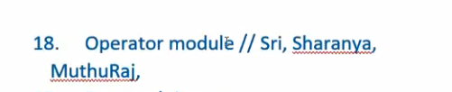

22/10
PYTHON OPERATOR MODULE NOTES PREPARATIO TO TAKE CLASS

Operator Functions in Python

Python has predefined functions for many mathematical, logical, relational, bitwise etc operations under the module “operator”. Some of the basic functions are covered in this article.

1. add(a, b) :- This functions returns addition of the given arguments.
Operation – a + b.

2. sub(a, b) :- This functions returns difference of the given arguments.
Operation – a – b.

3. mul(a, b) :- This functions returns product of the given arguments.
Operation – a * b.

# Python code to demonstrate working of
# add(), sub(), mul()

# importing operator module
import operator

# Initializing variables
a = 4

b = 3

# using add() to add two numbers
print ("The addition of numbers is :");
print (operator.add(a, b))

# using sub() to subtract two numbers
print ("The difference of numbers is :");
print (operator.sub(a, b))

# using mul() to multiply two numbers
print ("The product of numbers is :");
print (operator.mul(a, b))

Output:
The addition of numbers is:7
The difference of numbers is :1
The product of numbers is:12

4. truediv(a,b) :- This function returns division of the given arguments.
Operation – a / b.

5. floordiv(a,b) :- This function also returns division of the given arguments. But the value is floored value i.e. returns greatest small integer.
Operation – a // b.

6. pow(a,b) :- This function returns exponentiation of the given arguments.
Operation – a ** b.

7. mod(a,b) :- This function returns modulus of the given arguments.
Operation – a % b.

# Python code to demonstrate working of
# truediv(), floordiv(), pow(), mod()

# importing operator module
import operator

# Initializing variables
a = 5

b = 2

# using truediv() to divide two numbers
print ("The true division of numbers is : ");
print (operator.truediv(a,b))

# using floordiv() to divide two numbers
print ("The floor division of numbers is : ");
print (operator.floordiv(a,b))

# using pow() to exponentiate two numbers
print ("The exponentiation of numbers is : ");
print (operator.pow(a,b))

# using mod() to take modulus of two numbers
print ("The modulus of numbers is : ");
print (operator.mod(a,b))

Output:

The true division of numbers is: 2.5
The floor division of numbers is: 2
The exponentiation of numbers is: 25
The modulus of numbers is: 1

8. lt(a, b) :- This function is used to check if a is less than b or not. Returns true if a is less than b, else returns false.
Operation – a < b.

9. le(a, b) :- This function is used to check if a is less than or equal to b or not. Returns true if a is less than or equal to b, else returns false.
Operation – a <= b.

10. eq(a, b) :- This function is used to check if a is equal to b or not. Returns true if a is equal to b, else returns false.
Operation – a == b.

# Python code to demonstrate working of
# lt(), le() and eq()

# importing operator module
import operator

# Initializing variables
a = 3

b = 3

# using lt() to check if a is less than b
if(operator.lt(a,b)):
print ("3 is less than 3")
else : print ("3 is not less than 3")

# using le() to check if a is less than or equal to b
if(operator.le(a,b)):
print ("3 is less than or equal to 3")
else : print ("3 is not less than or equal to 3")

# using eq() to check if a is equal to b
if (operator.eq(a,b)):
print ("3 is equal to 3")
else : print ("3 is not equal to 3")

output:
3 is not less than 3
3 is less than or equal to 3
3 is equal to 3

11. gt(a,b) :- This function is used to check if a is greater than b or not. Returns true if a is greater than b, else returns false.
Operation – a > b.

12. ge(a,b) :- This function is used to check if a is greater than or equal to b or not. Returns true if a is greater than or equal to b, else returns false.
Operation – a >= b.

13. ne(a,b) :- This function is used to check if a is not equal to b or is equal. Returns true if a is not equal to b, else returns false.
Operation – a != b.

# Python code to demonstrate working of
# gt(), ge() and ne()

# importing operator module
import operator

# Initializing variables
a = 4

b = 3

# using gt() to check if a is greater than b
if (operator.gt(a,b)):
print ("4 is greater than 3")
else : print ("4 is not greater than 3")

# using ge() to check if a is greater than or equal to b
if (operator.ge(a,b)):
print ("4 is greater than or equal to 3")
else : print ("4 is not greater than or equal to 3")

# using ne() to check if a is not equal to b
if (operator.ne(a,b)):
print ("4 is not equal to 3")
else : print ("4 is equal to 3")

output
4 is greater than 3
4 is greater than or equal to 3
4 is not equal to 3

More functions:

1. setitem(ob, pos, val) :- This function is used to assign the value at a particular position in the container.
Operation – ob[pos] = val

2. delitem(ob, pos) :- This function is used to delete the value at a particular position in the container.
Operation – del ob[pos]

3. getitem(ob, pos) :- This function is used to access the value at a particular position in the container.
Operation – ob[pos]

# Python code to demonstrate working of
# setitem(), delitem() and getitem()

# importing operator module
import operator

# Initializing list
li = [1, 5, 6, 7, 8]

# printing original list
print ("The original list is : ",end="")
for i in range(0,len(li)):
print (li[i],end=" ")

print ("\r")

# using setitem() to assign 3 at 4th position
operator.setitem(li,3,3)

# printing modified list after setitem()
print ("The modified list after setitem() is : ",end="")
for i in range(0,len(li)):
print (li[i],end=" ")

print ("\r")

# using delitem() to delete value at 2nd index
operator.delitem(li,1)

# printing modified list after delitem()
print ("The modified list after delitem() is : ",end="")
for i in range(0,len(li)):
print (li[i],end=" ")

print ("\r")

# using getitem() to access 4th element
print ("The 4th element of list is : ",end="")
print (operator.getitem(li,3))

output

The original list is : 1 5 6 7 8
The modified list after setitem() is : 1 5 6 3 8
The modified list after delitem() is : 1 6 3 8
The 4th element of list is : 8

4. setitem(ob, slice(a,b), vals) :- This function is used to set the values in a particular range in the container.
Operation – obj[a:b] = vals

5. delitem(ob, slice(a,b)) :- This function is used to delete the values from a particular range in the container.
Operation – del obj[a:b]

6. getitem(ob, slice(a,b)) :- This function is used to access the values in a particular range in the container.
Operation – obj[a:b]

# Python code to demonstrate working of
# setitem(), delitem() and getitem()

# importing operator module
import operator

# Initializing list
li = [1, 5, 6, 7, 8]

# printing original list
print ("The original list is : ",end="")
for i in range(0,len(li)):
print (li[i],end=" ")

print ("\r")

# using setitem() to assign 2,3,4 at 2nd,3rd and 4th index
operator.setitem(li,slice(1,4),[2,3,4])

# printing modified list after setitem()
print ("The modified list after setitem() is : ",end="")
for i in range(0,len(li)):
print (li[i],end=" ")

print ("\r")

# using delitem() to delete value at 3rd and 4th index
operator.delitem(li,slice(2,4))

# printing modified list after delitem()
print ("The modified list after delitem() is : ",end="")
for i in range(0,len(li)):
print (li[i],end=" ")

print ("\r")
# using getitem() to access 1st and 2nd element
print ("The 1st and 2nd element of list is : ",end="")
print (operator.getitem(li,slice(0,2)))

Output
The original list is : 1 5 6 7 8
The modified list after setitem() is : 1 2 3 4 8
The modified list after delitem() is : 1 2 8
The 1st and 2nd element of list is : [1, 2]

7. concat(ob1,obj2) :- This function is used to concatenate two containers.
Operation – obj1 + obj2

8. contains(ob1,obj2) :- This function is used to check if obj2 in present in obj1.
Operation – obj2 in obj1

# Python code to demonstrate working of
# concat() and contains()

# importing operator module
import operator

# Initializing string 1
s1 = "geeksfor"

# Initializing string 2
s2 = "geeks"

# using concat() to concatenate two strings
print("The concatenated string is : ", end="")
print(operator.concat(s1, s2))

# using contains() to check if s1 contains s2
if (operator.contains(s1, s2)):
print("geeksfor contains geeks")
else:
print("geeksfor does not contain geeks")

OUTPUT:

The concatenated string is : geeksforgeeks
geeksfor contains geeks

9. and_(a,b) :- This function is used to compute bitwise and of the mentioned arguments.
Operation – a & b

10. or_(a,b) :- This function is used to compute bitwise or of the mentioned arguments.
Operation – a | b

11. xor(a,b) :- This function is used to compute bitwise xor of the mentioned arguments.
Operation – a ^ b

12. invert(a) :- This function is used to compute bitwise inversion of the mentioned argument.
Operation – ~ a

# Python code to demonstrate working of
# and_(), or_(), xor(), invert()

# importing operator module
import operator

# Initializing a and b

a = 1

b = 0

# using and_() to display bitwise and operation
print ("The bitwise and of a and b is : ",end="")
print (operator.and_(a,b))

# using or_() to display bitwise or operation
print ("The bitwise or of a and b is : ",end="")
print (operator.or_(a,b))

# using xor() to display bitwise exclusive or operation
print ("The bitwise xor of a and b is : ",end="")
print (operator.xor(a,b))

# using invert() to invert value of a
operator.invert(a)

# printing modified value
print ("The inverted value of a is : ",end="")
print (operator.invert(a))

Output

The bitwise and of a and b is : 0
The bitwise or of a and b is : 1
The bitwise xor of a and b is : 1
The inverted value of a is : -2

references:

https://www.geeksforgeeks.org/operator-functions-in-python-set-1/
https://www.geeksforgeeks.org/operator-functions-python-set-2/?ref=rp

````` CLASS ```````
Method Overrding.

In overloading Inheritance is not required.
Pyhon by default doesnt support overloading by default.so we use dispatch decorator.

Urllib module
webscrapping,.

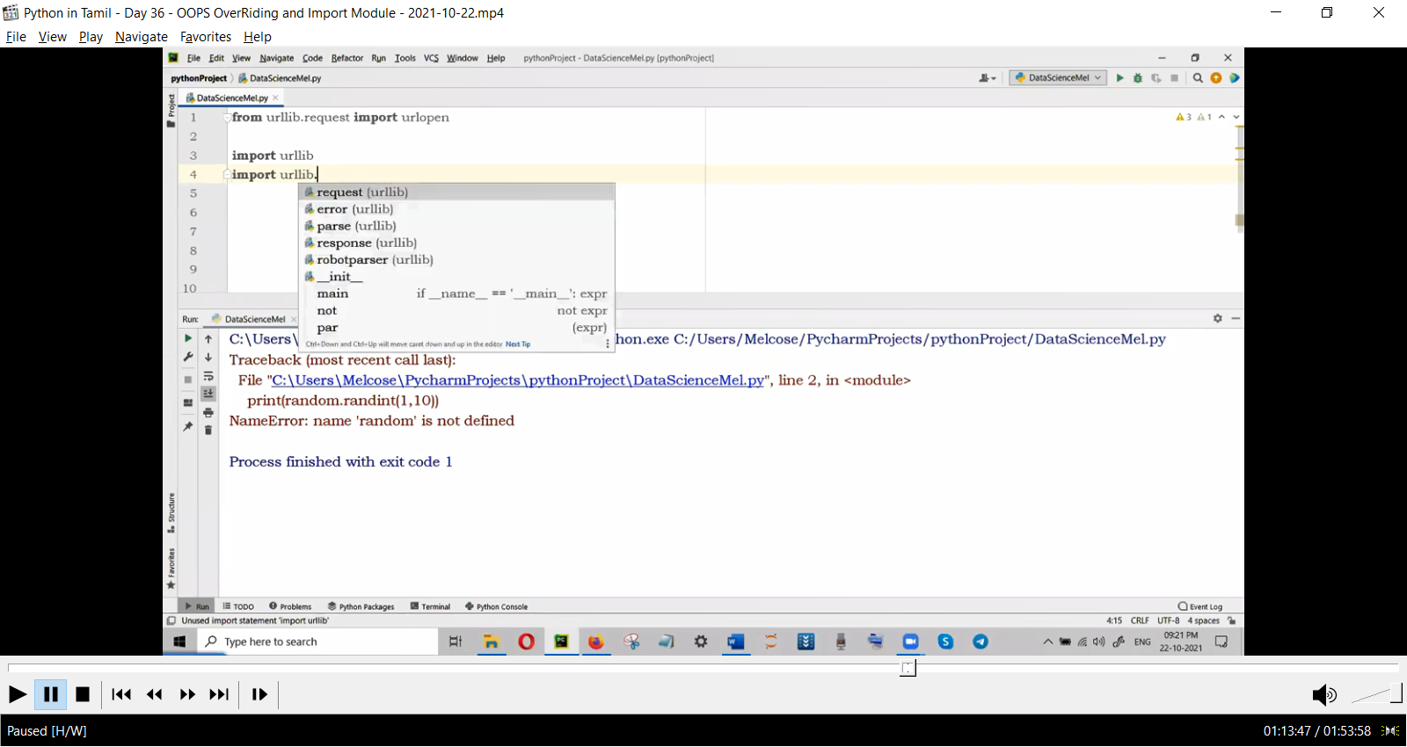

Modules
collection of modules is Package
collection of packagesis library.

25/10/21
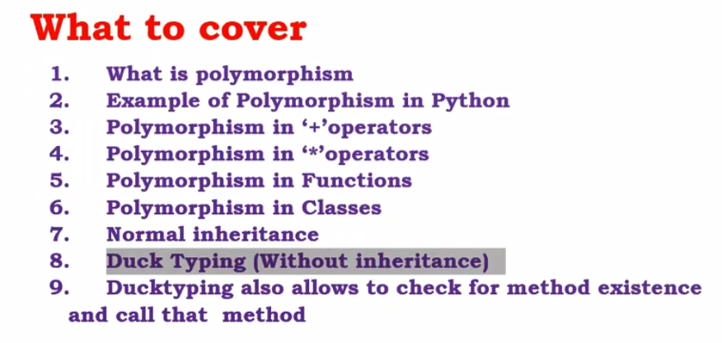

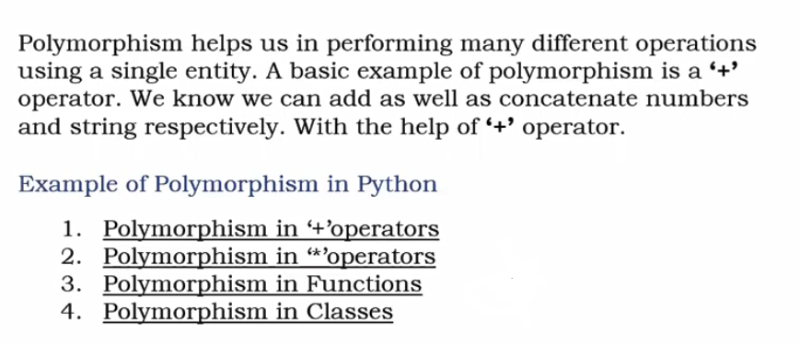
27/10/2021

Integral of sinh(x)/cosh(x)
https://youtu.be/mjYsw32rx-g

----------------------------------------------
30/10
class : regex

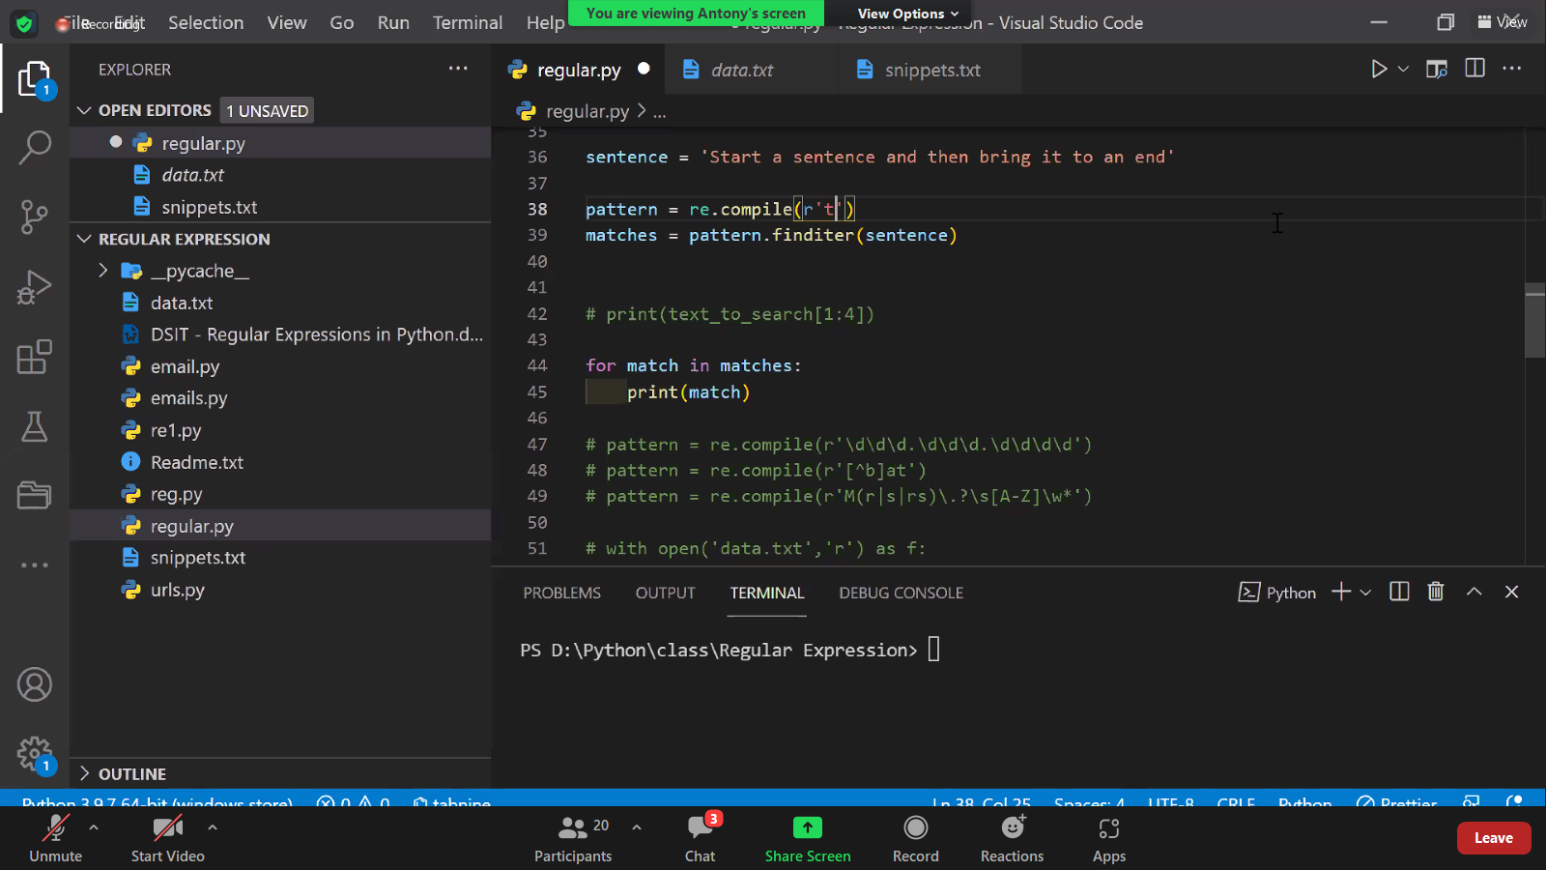

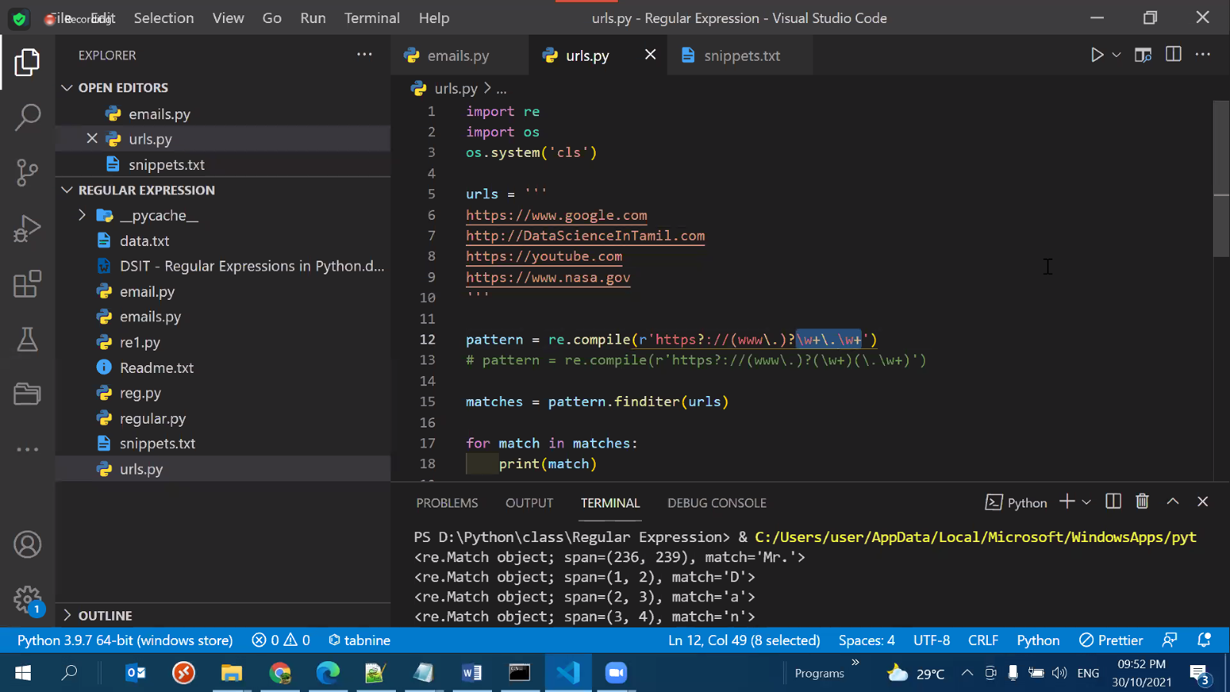

Exceptions

https://realpython.com/python-exceptions/

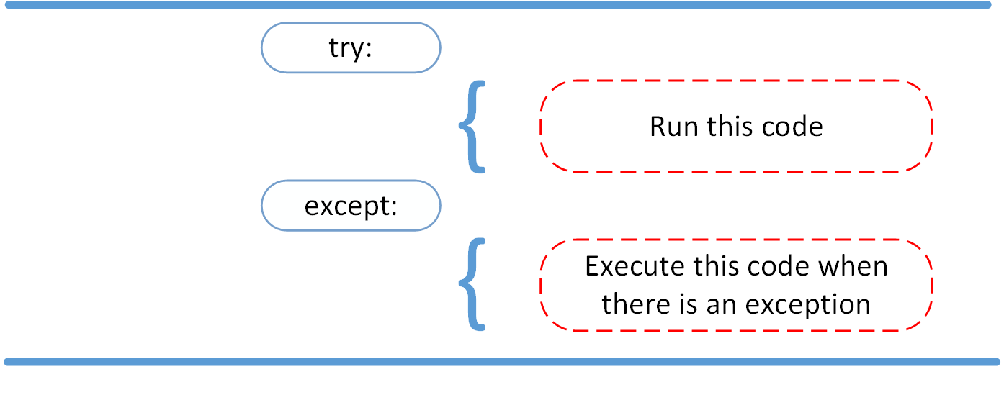
try:
linux_interaction()
except:
print('Linux function was not executed')

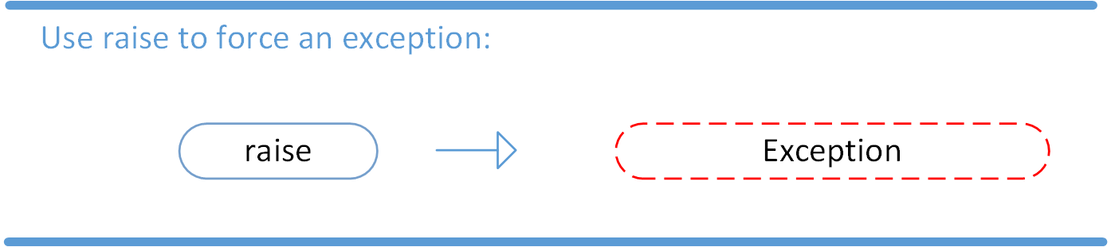

2/11/2021

kaggle.com

for ertification easier;
IO
control flow

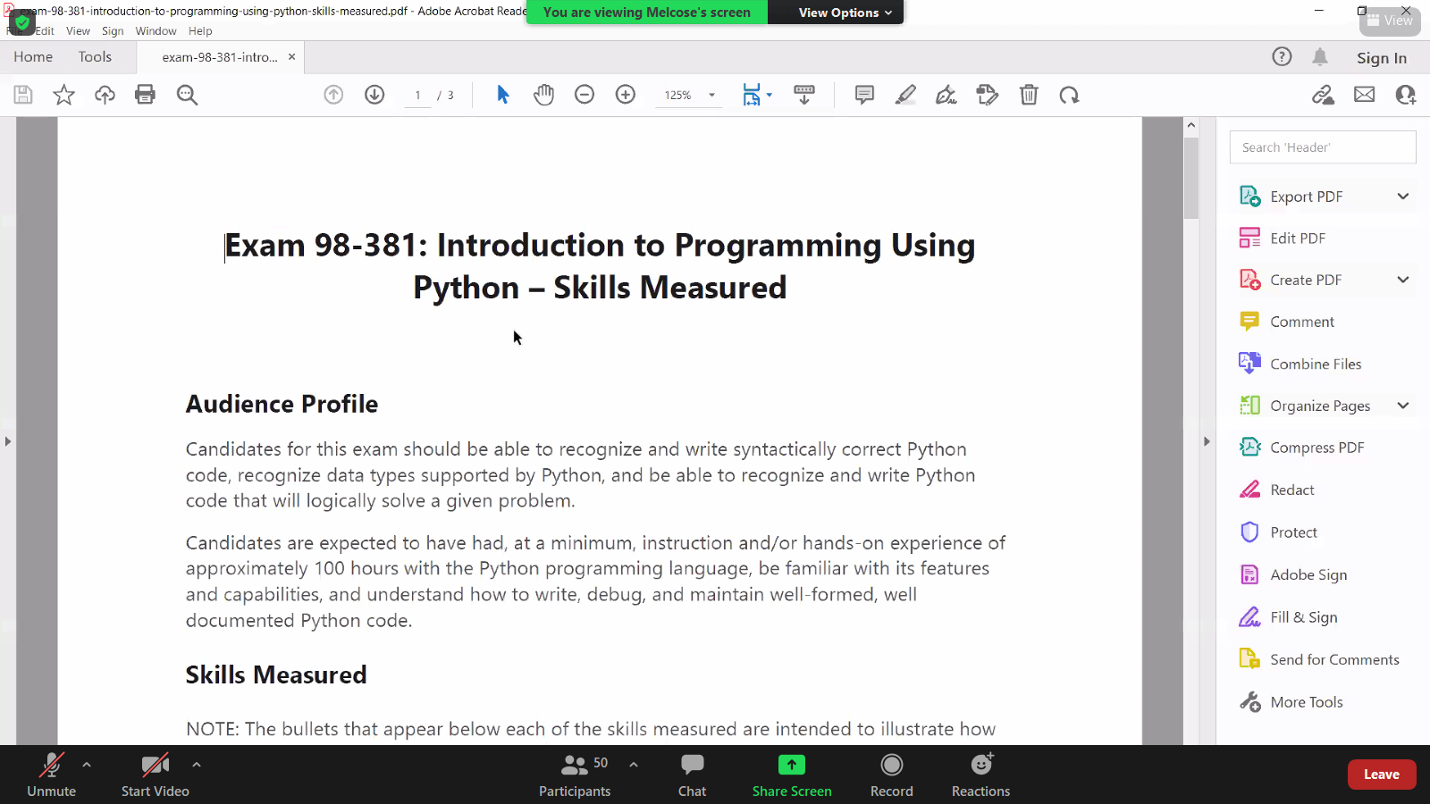
june22 – sylabus change
4500/- microsoft
5500/-ibm

~~~~~~~~~~~~~~~~~~~~~~~~~~
7/11

https://youtu.be/-nh9rCzPJ20

Visual Studio Code (Windows) - Setting up a Python Development Environment and Complete Overview

Installing package in pycharm
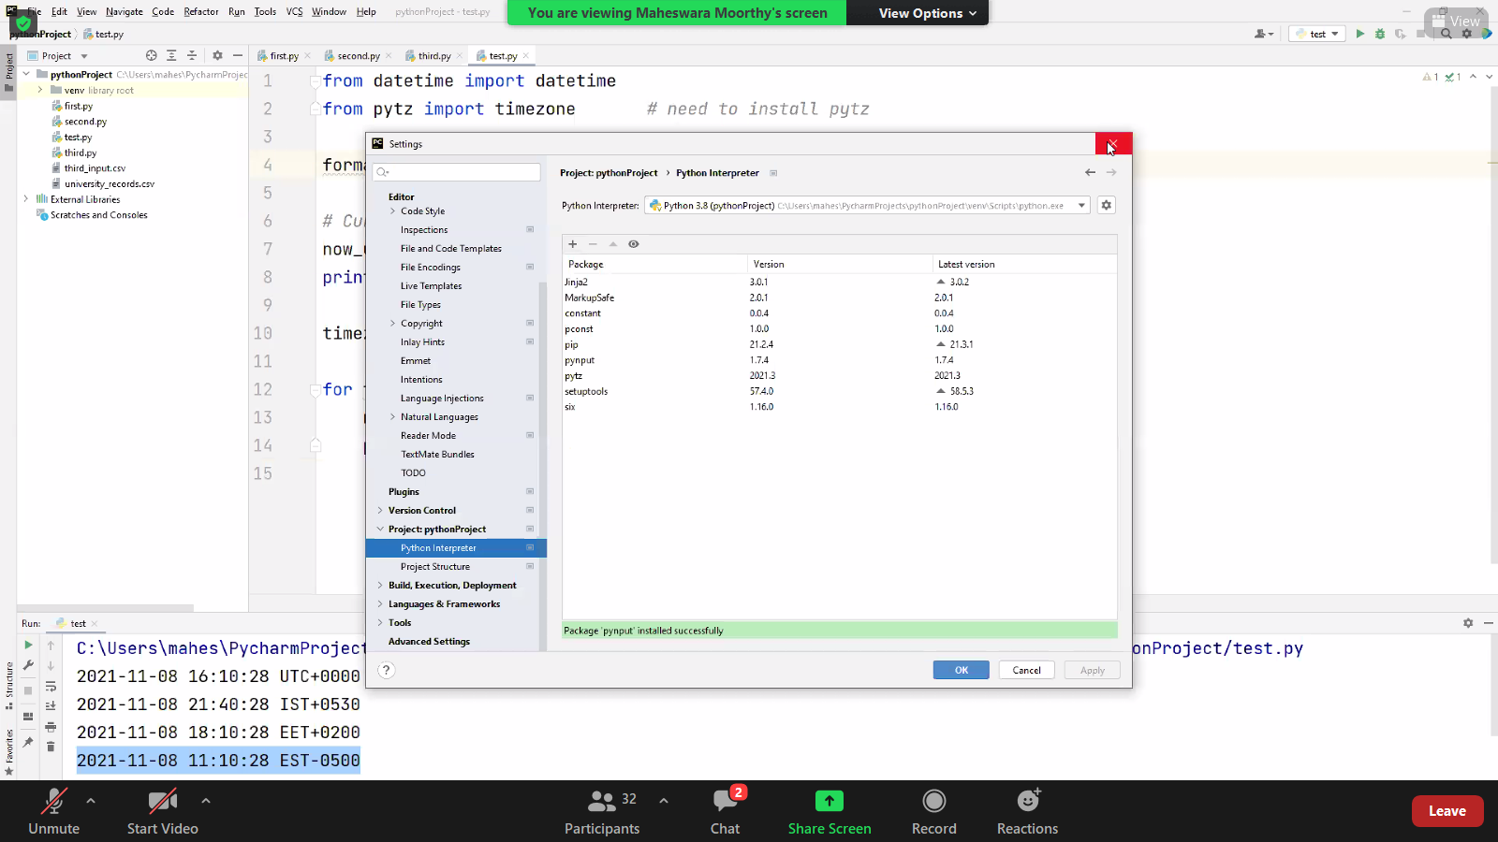

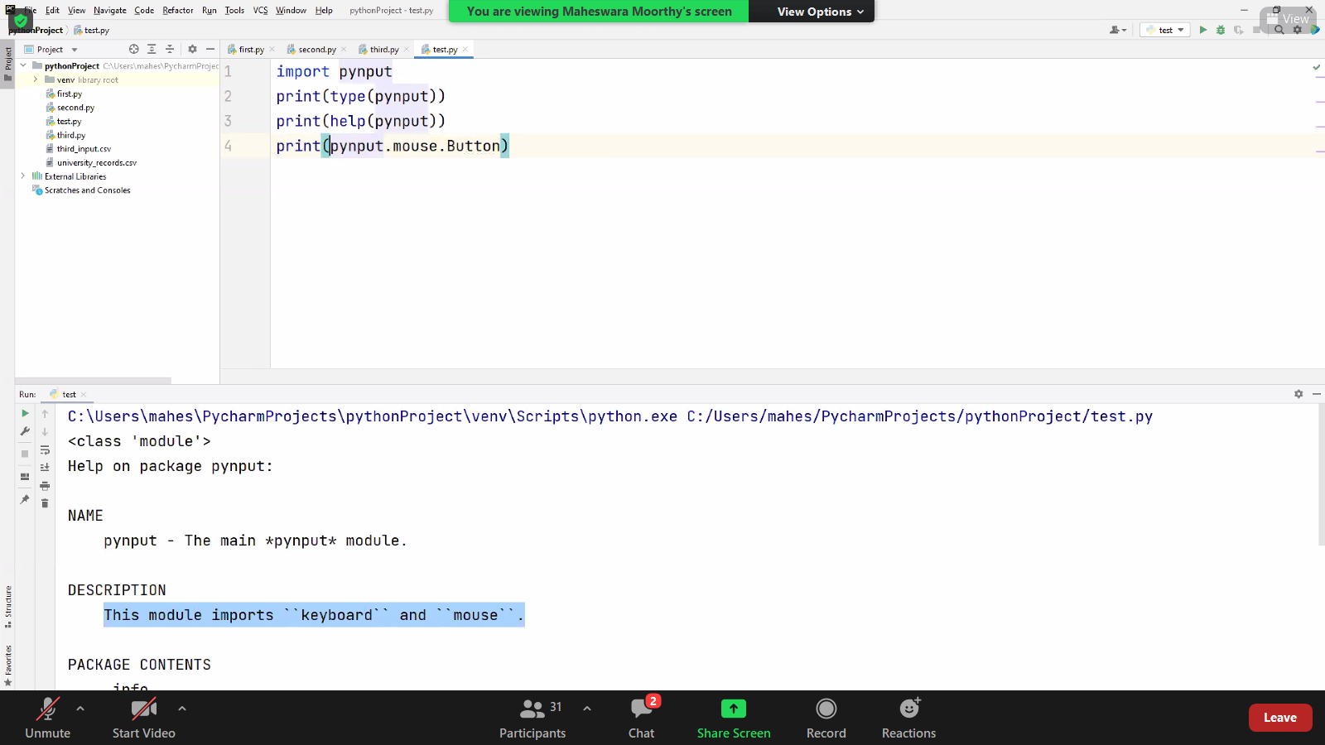

9/11/2021
Certification support day1

maheshwaramoorthy.

String variable is immutable,

https://pynative.com/python-if-else-and-for-loop-quiz/

except non zero everything is true.

Evev -1 is true.

From Loganathan

https://pythoninstitute.org/

