DIGITAL CLOCK REPORT

EE23BTECH11208(K.MANOHAR) EE233BTECH11215(P SRIKAR VARMA)

INTRODUCTION:

the project given is to implement a digital clock on vaman FPGA a board using verilog language.

Apparatus:
Vaman board,16 x 2 LCD Display, 10k Potentiometer,Breadboard,Jumper wires

for the Vaman Board refer to ‘https://github.com/gadepall/vaman/tree/master’

- the breadboard is used for making connections from LCD Display to potentiometer to Vaman board.

LCD Display(LCD 16×2) (JHD 162A):

- the LCD display has 16 pin and each of it has a specific functionality.

- Pin1 (Ground/Source Pin): This is a GND pin of display, used to connect the GND terminal of the microcontroller unit or power source.
- Pin2 (VCC/Source Pin): This is the voltage supply pin of the display, used to connect the supply pin of the power source.
- Pin3 (V0/VEE/Control Pin): This pin regulates the difference of the display, used to connect a changeable POT that can supply 0 to 5V.
- Pin4 (Register Select/Control Pin): This pin toggles among command or data register, used to connect a microcontroller unit pin and obtains either 0 or 1(0 = data mode, and 1 = command mode).
- Pin5 (Read/Write/Control Pin): This pin toggles the display among the read or writes operation, and it is connected to a microcontroller unit pin to get either 0 or 1 (0 = Write Operation, and 1 = Read Operation).
- Pin 6 (Enable/Control Pin): This pin should be held high to execute Read/Write process, and it is connected to the microcontroller unit & constantly held high.
- Pins 7-14 (Data Pins): These pins are used to send data to the display. These pins are connected in two-wire modes like 4-wire mode and 8-wire mode. In 4-wire mode, only four pins are connected to the microcontroller unit like 0 to 3, whereas in 8-wire mode, 8-pins are connected to microcontroller unit like 0 to 7.
- Pin15 (+ve pin of the LED): This pin is connected to +5V
- Pin 16 (-ve pin of the LED): This pin is connected to GND.

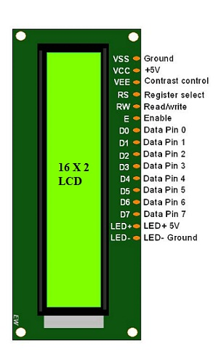
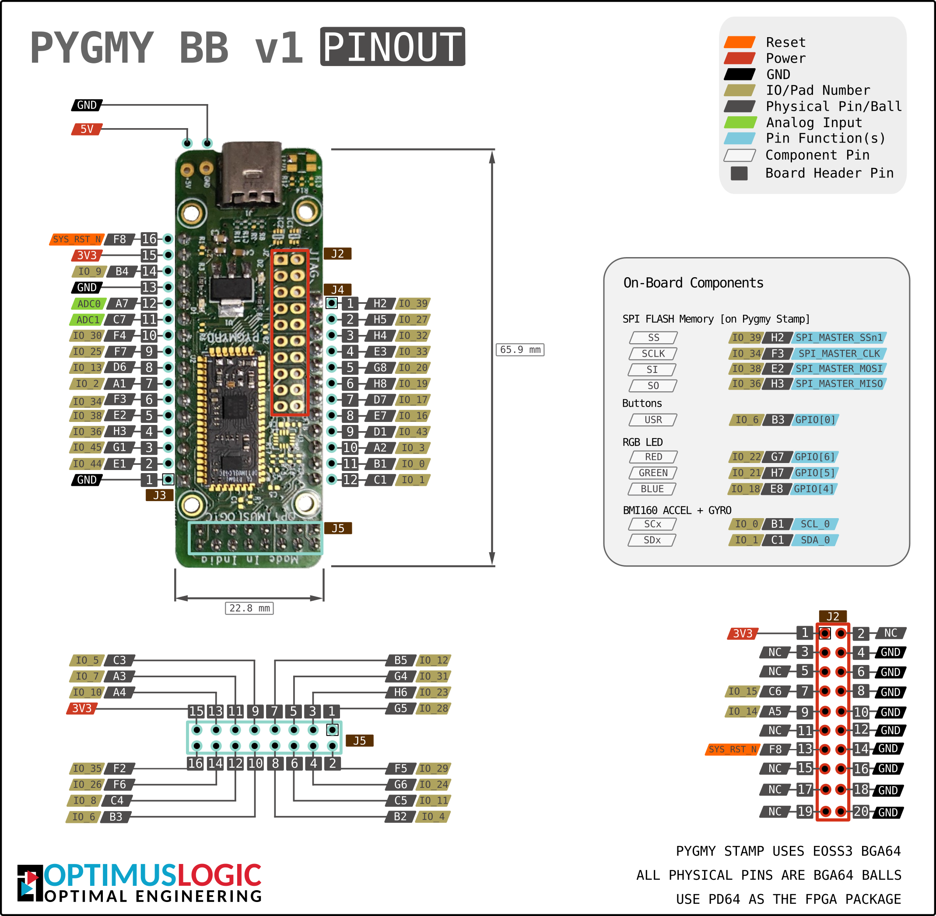

LCD Display

Vaman Board Pins
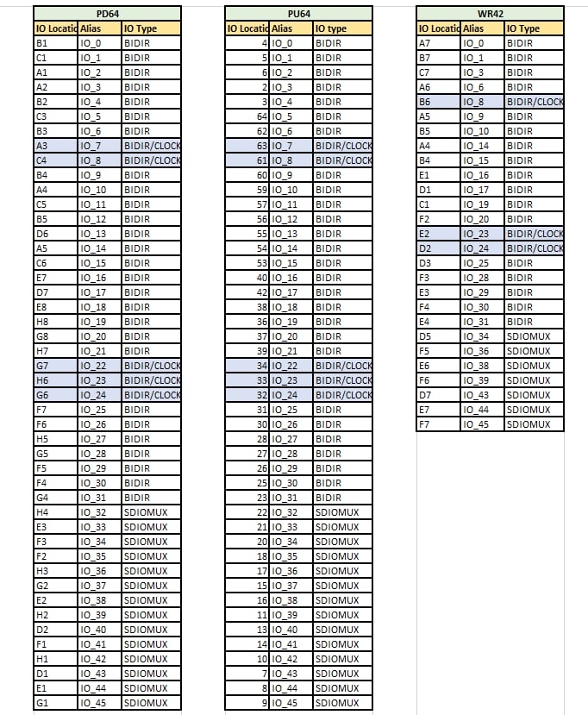
PU64 Pins Data

PCF file:

set_io data(7) IO_30
set_io data(6) IO_29
set_io data(5) IO_28
set_io data(4) IO_27
set_io en IO_26
set_io rs IO_25

verilog code:

module co7(output reg rs, output reg en, output reg [7:4] data);
reg [7:0] one_sec,min9,hour9;
reg [7:0] ten_sec,min5,hour2;module co7(output reg rs, output reg en, output reg [7:4] data);
reg [7:0] one_sec,min9,hour9;
reg [7:0] ten_sec,min5,hour2;
reg [7:0] ten_sec_,min5_,hour2_,one_sec_,min9_,hour9_;
// up counter
integer i=1;
integer count=0;
reg [3:0] nibs [1:51];
//reg [3:0] delay;//delay should go up till 10
reg [26:0] delay;
integer x=0;
initial begin
delay = 8'd48;

end
wire clk;
qlal4s3b_cell_macro u_qlal4s3b_cell_macro (
.Sys_Clk0 (clk),
);

always@(posedge clk) begin
if(delay<12000000)
delay<=delay+1;

else
begin
delay<=27'b0000;

if (x==0)begin
one_sec = 8'd0;
min9 = 8'd0;
hour9 = 8'd0;
ten_sec = 8'd0;
min5 = 8'd0;
hour2 = 8'd2;
ten_sec_=8'd48;
min5_=8'd48;
hour2_=8'd48;
one_sec_=8'd48;
min9_=8'd48;
hour9_=8'd48;
x=0;

end
else if (x==0)
begin
if (ten_sec==8'd5 && one_sec==8'd9 && min5==8'd5 && min9==8'd9 && hour9==8'd3 && hour2==8'd2) begin
ten_sec<=8'd0;
one_sec<=8'd0;
min9<=8'd0;
min5<=8'd0;
hour9<=8'd0;
hour2<=8'd0;
end
else if (ten_sec==8'd5 && one_sec==8'd9 && min5==8'd5 && min9==8'd9 && hour9==8'd9) begin
ten_sec<=8'd0;
one_sec<=8'd0;
min9<=8'd0;
min5<=8'd0;
hour9<=8'd0;
hour2<= hour2+8'd1;
end
else if (ten_sec==8'd5 && one_sec==8'd9 && min5==8'd5 && min9==8'd9) begin
ten_sec<=8'd0;
one_sec<=8'd0;
min9<=8'd0;
min5<=8'd0;
hour9<=hour9+8'd1;
end

else if (ten_sec==8'd5 && one_sec==8'd9 && min9==8'd9 ) begin
ten_sec<=8'd0;
one_sec<=8'd0;
min9<=8'd0;
min5 <= min5 + 8'd1;
end
else if (ten_sec==8'd5 && one_sec==8'd9) begin
ten_sec<=8'd0;
one_sec<=8'd0;
min9 <= min9 + 8'd1;
end
else if(one_sec==8'd9) begin
one_sec<=8'd0;
ten_sec<=ten_sec+3'd1;
end

else if(one_sec<8'd9) begin

one_sec <= one_sec + 8'd1;

end
end
end
end

parameter u=8'd0;

always @(posedge clk) begin
ten_sec_= ten_sec + 8'd48;
one_sec_ = one_sec + 8'd48;
min5_ = min5 + 8'd48;
hour2_ = hour2 + 8'd48;
min9_ = min9 + 8'd48;
hour9_ = hour9 + 8'd48 ;

u = hour2 * 10 + hour9 ;

if (u>=8'd12 && u < 8'd24) begin
nibs[34]=4'h5;
nibs[35]=4'h0;
nibs[36]=4'h4;
nibs[37]=4'hD;
end
else if (u<8'd12 && u>=8'd0) begin
nibs[34]=4'h4;
nibs[35]=4'h1;
nibs[36]=4'h4;
nibs[37]=4'hD;
end

nibs[1]=4'h3;
nibs[2]=4'h3;
nibs[3]=4'h3;
nibs[4]=4'h2;
nibs[5]=4'h2;
nibs[6]=4'h8;
nibs[7]=4'h0;
nibs[8]=4'hC;
nibs[9]=4'h0;
nibs[10]=4'h6;
nibs[11]=4'h0;
nibs[12]=4'h1;
nibs[13]=4'h8;
nibs[14]=4'h0;
nibs[15]=1'b1;
nibs[16]=hour2_[7:4];//hours
nibs[17]=hour2_[3:0];
nibs[18]=hour9_[7:4];
nibs[19]=hour9_[3:0];
nibs[20]=4'h3;
nibs[21]=4'hA;
nibs[22]=min5_[7:4];//mins
nibs[23]=min5_[3:0];
nibs[24]=min9_[7:4];
nibs[25]=min9_[3:0];
nibs[26]=4'h3;
nibs[27]=4'hA;
nibs[28]=ten_sec_[7:4];//sec
nibs[29]=ten_sec_[3:0];
nibs[30]=one_sec_[7:4];
nibs[31]=one_sec_[3:0];
nibs[32]=4'h2;
nibs[33]=4'h0;
nibs[38]=4'hC;
nibs[39]=4'h0;
nibs[40]=4'h2;
nibs[41]=4'h0;
nibs[42]=4'h2;
nibs[43]=4'h0;
nibs[44]=4'h2;
nibs[45]=4'h0;
nibs[46]=4'h2;
nibs[47]=4'h0;
nibs[48]=4'h2;
nibs[49]=4'h0;
nibs[50]=4'h2;
nibs[51]=4'h0;

if(i<15)
begin
rs<=1'b0;
data=nibs[i];
en<=1'b1;
if(count == 800)
begin
en<=1'b0;
count<=0;
i<=i+1;
end
else
count<=count+1;
end
if(i==15)
begin
if(count==60000)
begin
count<=8'd0;
i<=i+1;
end
else
count<=count+1;
end

if((i>15 && i<38)||(i>39 && i<=51))
begin
rs<=1'b1;
data=nibs[i];
en<=1'b1;
if(count==800)
begin
en<=1'b0;
count<=8'd0;
i<=i+1;
end
else
count<=count+1;
end
if(i>=38 && i<=39)
begin
rs<=1'b0;
data = nibs[i];
en<=1'b1;
if(count==800)
begin
en<=1'b0;
count<=8'd0;
i<=i+1;
end
else
count<=count+1;
end
if(i>51)
i<=13;
end
endmodule

// code for 12 hour clock

/*
else if(button==0)//12hours begin
delay<=27'b0000;

if (ten_sec==8'd5 && one_sec==8'd9 && min5==8'd5 && min9==8'd9 && hour9>=8'd1 && hour2>=8'd1) begin//resetting clock to 00:00:00 after 23:59:59
ten_sec<=8'd0;
one_sec<=8'd0;
min9<=8'd0;
min5<=8'd0;
hour9<=8'd0;
hour2.<=8'd0;
end
else if (ten_sec==8'd5 && one_sec==8'd9 && min5==8'd5 && min9==8'd9 && hour9==8'd9) begin //resetting minutes and sec
ten_sec<=8'd0;
one_sec<=8'd0;
min9<=8'd0;
min5<=8'd0;
hour9.<=8'd0;
hour2.<= hour2.+8'd1;
end
else if (ten_sec==8'd5 && one_sec==8'd9 && min5==8'd5 && min9==8'd9) begin
ten_sec<=8'd0;
one_sec<=8'd0;
min9<=8'd0;
min5<=8'd0;
hour9.<=hour9.+8'd1;
end

else if (ten_sec==8'd5 && one_sec==8'd9 && min9==8'd9 ) begin
ten_sec<=8'd0;
one_sec<=8'd0;
min9<=8'd0;
min5 <= min5 + 8'd1;
end
else if (ten_sec==8'd5 && one_sec==8'd9) begin
ten_sec<=8'd0;
one_sec<=8'd0;
min9 <= min9 + 8'd1;
end
else if(one_sec==8'd9) begin
one_sec<=8'd0;
ten_sec<=ten_sec+3'd1;
end

else if(one_sec<8'd9) begin

one_sec <= one_sec + 8'd1;

end
end

if (hour2 <=8'd1 && hour9 < 8'd2) begin
part1=4'h4;
part2=4'h1;
end
else if (hour2 >= 8'd1 && hour9 >= 8'd2 )begin
part1=4'h7;
part2=4'h0;
end

end

end //end for always */

/*
module alarmHex(clk, rst, en_in, time_in, time_set_in, set_time, ring, end_ring);
input clk, rst, set_time, end_ring, en_in;
output reg ring;
input [10:0] time_set_in, time_in;
reg [10:0] time_alarm;

reg en;

//set alarm time
always@(posedge clk or posedge rst)
begin
if(rst)
begin
time_alarm <= 11'd0;
end
else
begin
time_alarm <= (set_time) ? time_set_in : time_alarm;
end
end

//handle to ringing of the alarm
always@(posedge clk or posedge rst)
begin
if(rst)
begin
ring <= 1'b0;
end
else
begin
if(en)
begin
//while ringing: stop if end ring pressed
//otherwise start ringing when time is equal to snooze
ring <= (ring) ? (~end_ring) : (time_alarm == time_in);
end
end
end

//keep ringing shut after end_ring if high, but not disable for next day
always@(posedge clk)
begin
if(time_alarm == time_in)
begin
en <= (end_ring) ? 1'b0 : en;
end
else
begin
en <= en_in;
end
end
endmodule//alarm
*/
reg [7:0] ten_sec_,min5_,hour2_,one_sec_,min9_,hour9_;
// up counter
integer i=1;
integer count=0;
reg [3:0] nibs [1:51];
//reg [3:0] delay;//delay should go up till 10
reg [26:0] delay;
integer x=0;
initial begin
delay = 8'd48;

end
wire clk;
qlal4s3b_cell_macro u_qlal4s3b_cell_macro (
.Sys_Clk0 (clk),
);

always@(posedge clk) begin
if(delay<12000000)
delay<=delay+1;

else
begin
delay<=27'b0000;

if (x==0)begin
one_sec = 8'd0;
min9 = 8'd0;
hour9 = 8'd0;
ten_sec = 8'd0;
min5 = 8'd0;
hour2 = 8'd2;
ten_sec_=8'd48;
min5_=8'd48;
hour2_=8'd48;
one_sec_=8'd48;
min9_=8'd48;
hour9_=8'd48;
x=0;

end
else if (x==0)
begin
if (ten_sec==8'd5 && one_sec==8'd9 && min5==8'd5 && min9==8'd9 && hour9==8'd3 && hour2==8'd2) begin
ten_sec<=8'd0;
one_sec<=8'd0;
min9<=8'd0;
min5<=8'd0;
hour9<=8'd0;
hour2<=8'd0;
end
else if (ten_sec==8'd5 && one_sec==8'd9 && min5==8'd5 && min9==8'd9 && hour9==8'd9) begin
ten_sec<=8'd0;
one_sec<=8'd0;
min9<=8'd0;
min5<=8'd0;
hour9<=8'd0;
hour2<= hour2+8'd1;
end
else if (ten_sec==8'd5 && one_sec==8'd9 && min5==8'd5 && min9==8'd9) begin
ten_sec<=8'd0;
one_sec<=8'd0;
min9<=8'd0;
min5<=8'd0;
hour9<=hour9+8'd1;
end

else if (ten_sec==8'd5 && one_sec==8'd9 && min9==8'd9 ) begin
ten_sec<=8'd0;
one_sec<=8'd0;
min9<=8'd0;
min5 <= min5 + 8'd1;
end
else if (ten_sec==8'd5 && one_sec==8'd9) begin
ten_sec<=8'd0;
one_sec<=8'd0;
min9 <= min9 + 8'd1;
end
else if(one_sec==8'd9) begin
one_sec<=8'd0;
ten_sec<=ten_sec+3'd1;
end

else if(one_sec<8'd9) begin

one_sec <= one_sec + 8'd1;

end
end
end
end

parameter u=8'd0;

always @(posedge clk) begin
ten_sec_= ten_sec + 8'd48;
one_sec_ = one_sec + 8'd48;
min5_ = min5 + 8'd48;
hour2_ = hour2 + 8'd48;
min9_ = min9 + 8'd48;
hour9_ = hour9 + 8'd48 ;

u = hour2 * 10 + hour9 ;

if (u>=8'd12 && u < 8'd24) begin
nibs[34]=4'h5;
nibs[35]=4'h0;
nibs[36]=4'h4;
nibs[37]=4'hD;
end
else if (u<8'd12 && u>=8'd0) begin
nibs[34]=4'h4;
nibs[35]=4'h1;
nibs[36]=4'h4;
nibs[37]=4'hD;
end

nibs[1]=4'h3;
nibs[2]=4'h3;
nibs[3]=4'h3;
nibs[4]=4'h2;
nibs[5]=4'h2;
nibs[6]=4'h8;
nibs[7]=4'h0;
nibs[8]=4'hC;
nibs[9]=4'h0;
nibs[10]=4'h6;
nibs[11]=4'h0;
nibs[12]=4'h1;
nibs[13]=4'h8;
nibs[14]=4'h0;
nibs[15]=1'b1;
nibs[16]=hour2_[7:4];//hours
nibs[17]=hour2_[3:0];
nibs[18]=hour9_[7:4];
nibs[19]=hour9_[3:0];
nibs[20]=4'h3;
nibs[21]=4'hA;
nibs[22]=min5_[7:4];//mins
nibs[23]=min5_[3:0];
nibs[24]=min9_[7:4];
nibs[25]=min9_[3:0];
nibs[26]=4'h3;
nibs[27]=4'hA;
nibs[28]=ten_sec_[7:4];//sec
nibs[29]=ten_sec_[3:0];
nibs[30]=one_sec_[7:4];
nibs[31]=one_sec_[3:0];
nibs[32]=4'h2;
nibs[33]=4'h0;
nibs[38]=4'hC;
nibs[39]=4'h0;
nibs[40]=4'h2;
nibs[41]=4'h0;
nibs[42]=4'h2;
nibs[43]=4'h0;
nibs[44]=4'h2;
nibs[45]=4'h0;
nibs[46]=4'h2;
nibs[47]=4'h0;
nibs[48]=4'h2;
nibs[49]=4'h0;
nibs[50]=4'h2;
nibs[51]=4'h0;

if(i<15)
begin
rs<=1'b0;
data=nibs[i];
en<=1'b1;
if(count == 800)
begin
en<=1'b0;
count<=0;
i<=i+1;
end
else
count<=count+1;
end
if(i==15)
begin
if(count==60000)
begin
count<=8'd0;
i<=i+1;
end
else
count<=count+1;
end

if((i>15 && i<38)||(i>39 && i<=51))
begin
rs<=1'b1;
data=nibs[i];
en<=1'b1;
if(count==800)
begin
en<=1'b0;
count<=8'd0;
i<=i+1;
end
else
count<=count+1;
end
if(i>=38 && i<=39)
begin
rs<=1'b0;
data = nibs[i];
en<=1'b1;
if(count==800)
begin
en<=1'b0;
count<=8'd0;
i<=i+1;
end
else
count<=count+1;
end
if(i>51)
i<=13;
end
endmodule

// code for 12 hour clock

/*
else if(button==0)//12hours begin
delay<=27'b0000;

if (ten_sec==8'd5 && one_sec==8'd9 && min5==8'd5 && min9==8'd9 && hour9>=8'd1 && hour2>=8'd1) begin//resetting clock to 00:00:00 after 23:59:59
ten_sec<=8'd0;
one_sec<=8'd0;
min9<=8'd0;
min5<=8'd0;
hour9<=8'd0;
hour2.<=8'd0;
end
else if (ten_sec==8'd5 && one_sec==8'd9 && min5==8'd5 && min9==8'd9 && hour9==8'd9) begin //resetting minutes and sec
ten_sec<=8'd0;
one_sec<=8'd0;
min9<=8'd0;
min5<=8'd0;
hour9.<=8'd0;
hour2.<= hour2.+8'd1;
end
else if (ten_sec==8'd5 && one_sec==8'd9 && min5==8'd5 && min9==8'd9) begin
ten_sec<=8'd0;
one_sec<=8'd0;
min9<=8'd0;
min5<=8'd0;
hour9.<=hour9.+8'd1;
end

else if (ten_sec==8'd5 && one_sec==8'd9 && min9==8'd9 ) begin
ten_sec<=8'd0;
one_sec<=8'd0;
min9<=8'd0;
min5 <= min5 + 8'd1;
end
else if (ten_sec==8'd5 && one_sec==8'd9) begin
ten_sec<=8'd0;
one_sec<=8'd0;
min9 <= min9 + 8'd1;
end
else if(one_sec==8'd9) begin
one_sec<=8'd0;
ten_sec<=ten_sec+3'd1;
end

else if(one_sec<8'd9) begin

one_sec <= one_sec + 8'd1;

end
end

if (hour2 <=8'd1 && hour9 < 8'd2) begin
part1=4'h4;
part2=4'h1;
end
else if (hour2 >= 8'd1 && hour9 >= 8'd2 )begin
part1=4'h7;
part2=4'h0;
end

end

end //end for always */

/*
module alarmHex(clk, rst, en_in, time_in, time_set_in, set_time, ring, end_ring);
input clk, rst, set_time, end_ring, en_in;
output reg ring;
input [10:0] time_set_in, time_in;
reg [10:0] time_alarm;

reg en;

//set alarm time
always@(posedge clk or posedge rst)
begin
if(rst)
begin
time_alarm <= 11'd0;
end
else
begin
time_alarm <= (set_time) ? time_set_in : time_alarm;
end
end

//handle to ringing of the alarm
always@(posedge clk or posedge rst)
begin
if(rst)
begin
ring <= 1'b0;
end
else
begin
if(en)
begin
//while ringing: stop if end ring pressed
//otherwise start ringing when time is equal to snooze
ring <= (ring) ? (~end_ring) : (time_alarm == time_in);
end
end
end

//keep ringing shut after end_ring if high, but not disable for next day
always@(posedge clk)
begin
if(time_alarm == time_in)
begin
en <= (end_ring) ? 1'b0 : en;
end
else
begin
en <= en_in;
end
end
endmodule//alarm
*/

explanation:

- the inputs and outputs are assigned in the pcf file according to the top module.
- There is an inbuit clock in Vaman Board
qlal4s3b_cell_macro u_qlal4s3b_cell_macro (.Sys_Clk0 (clk),)
- in the first few lines we defined all parameters , variable and integers req for required to generate a clock.
- {ten_sec,min5,hour2}represents ten_sec is the tenths place of second,min5 is tenths place of minutes,hour2 is the tenths place of hour.
- { one_sec,min9,hour9}these are the units place of second , minute and hour .
- We then introduce an integer x = 0 , we used it to intitiate the units and tenth’s values of sec , min ,hour . By creating an if statement in side the first always block.
- And when they are intialised after that x value is made 1 so that the same ‘if‘ block doesnt get excetued many .
- When the value of x=1,the main code stars.
- In the first if block we reset the time when it reaches 23:59:59.
- in the first else if block we reset the time when unit place of hour reaches 9 and also add ‘+1’ to tenths place of hour ‘and‘ reset when min is 59 ‘and’ reset when sec is 59.
- in the second if else block min ‘and ‘ sec are reset as they reach 59.
- inthe third if else block the sec resets as it reaches 59 and the thenths pplace of min gets increment of +1 as units place reaches 9.
- in the fourth if else block the sec get reset as it reaches 59.
- in the fifth if else block the seconds get reset when the units digit reaches 9 and increments tenths place by +1.
- In the next always block we try to display the clock with AM / PM.
- We uised a parameter u to find wether the hours part is greater than or equal to 12 of less then 12 to show AM /PM.
- We took help of Rajashekar sir to implement the LCD display and by using the hex value table we assigned the values of hours,min and sec to respective cells in a LCD display.
- We then made an if statement depending on u wether to print AM,PM.
- We then have some If else Statements which are used to assign the values of the hours , min ,sec to data [7: 4] .
- at last we also included our 12 hour clock code , since we dont how to get input by giving an port into FPGA , we tried many combinations of ports and ran several bin file creations but was always not giving the expected LCD display.
- This part of 12 hour clock was working when seperated from the 24 hour clock.
- Another code for alarm was written but not implimented as we were facing issues due to LCD display and changing the modes in clock.

Flashing the code into Vaman FPGA:

the code used to generate a bin file is
“ ql_symbiflow -compile -d ql-eos-s3 -P PU64 -v clovk245.v -t co7 -p .pcf -dump binary ”

the code used to send this bin file into Vaman FPGA
“ python3 TinyFPGA-Programmer-Application/tinyfpga-programmer-gui.py --port /dev/ttyACM0 --appfpga co7.bin --mode fpga –reset
”
Conclusion:
In conclusion, the Vaman FPGA board's digital clock has been successfully implemented using Verilog, proving the usefulness of digital design principles in actual embedded systems.

The link for codes and video:

https://github.com/Manohark25/clock25 -------codes
https://drive.google.com/file/d/1FyeQV09TPwFVnOXhEq9D8zPGMOAZiwPi/view?usp=sharing ------video

