Useful in developing  
(css not there ☹ )  
<https://www.youtube.com/watch?v=iublAXAm8HQ>  
  
Controls in:  
https://getbootstrap.com/docs/4.4/components/navbar/  
https://jqueryui.com/dialog/

Angular  
<https://www.youtube.com/watch?v=Ous6v0r7kXc>  
  
jQuery Ajax In Asp.Net MVC - CRUD Operations Using JSON / Tabs:  
<https://www.youtube.com/watch?v=DI_YppvLgJ8>  
  
Faced Issues:  
> Getting EF data to WebAPI (gave abn error when creating the Controller – went away once all r compiled, VS closed & re opened …)  
  
> To Get WebAPI to MVC – needed to hv Web Client … as standard practice  
(or else was able to use the URL & get data … - as done in another project)  
  
  
Getting JQery can be done by getting the files from site or get the http or add nuget  
  
> Bootstrap

DB Move to Express

<https://stackoverflow.com/questions/16088151/how-to-find-server-name-of-sql-server-management-studio>  
  
Documents\script.sql

IIS – IP related issues  
  
1. Check the public IP (internet search my public IP) , & Local IP (ipconfig in DOS)  
  
Current Values :   
public : <http://108.162.175.75/>  
local : <http://192.168.1.175/>   
  
If the public URL : <http://108.162.175.75/RanmoDataAppMVC> or the local is not working  
  
check the values again (specially the local IP)  
If that is changed,  
  
**Router**  
1. Go to router login: <http://192.168.1.1/> or <http://router.asus.com/index.asp>   
2. Go to WAN, Virtual Server / Port Forwarding and in the bottom look at the http ….  
3. The local IP has to be same as the local IP in ipconfig  
4. If not remove the existing and add the correct one  
 When adding, get http from famous server list, key in the proper IP, set local port to 81 and make protocol as both and click the + button then click Apply  
  
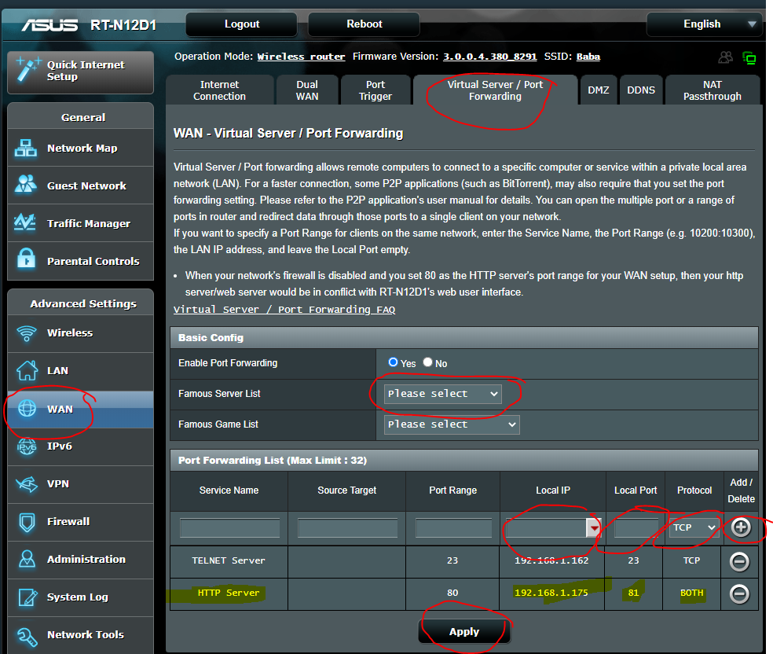

IIS  
  
1. Go to IIS – Sites – Default Web Site -- RHS panel Bindings  
2. In Site Bindings, remove the non-working 81 port and add the working IP for 81  
  
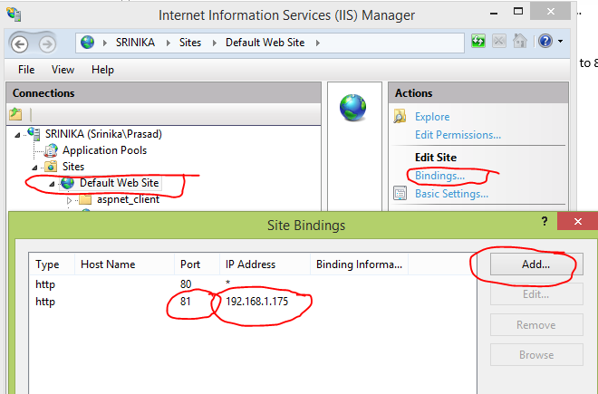

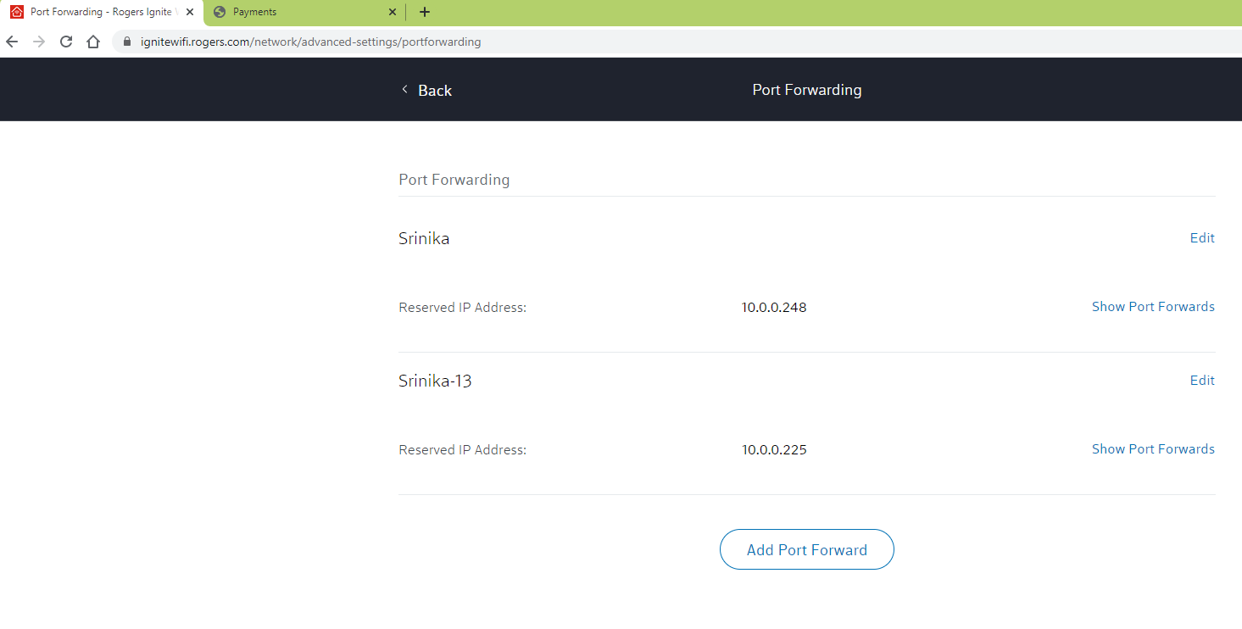

IIS  
  
1. Go to IIS – Sites – Default Web Site -- RHS panel Bindings  
2. In Site Bindings, remove the non-working 81 port and add the working IP for 81

