VyapaarMate incubation brief
We seek a product review and incubation support to validate VyapaarMate with local food businesses. The product connects direct orders, payment status and customer follow-up. A working local demonstration has been tested; live deployment and provider verification remain prerequisites for a merchant pilot.

Company and founder
Detail | Supplied information
Company | PSHR INNOVEX PRIVATE LIMITED
Founder | Putha Sri Hari Reddy
CIN | U62099AP2025PTC119971
Incorporation date | 25 June 2025
Application preference | Andhra Pradesh, Kadapa / Tirupati Spoke
Contact | psriharireddy@pshrinnovex.com | +91 8867474196
Company identifiers and founder details above are taken from the supplied application materials. This brief does not independently certify incorporation, DPIIT status, finances or traction.

The problem and initial customers
A merchant may take an order in a chat, check payment in another app and keep the customer record separately. Our pilot will test whether a connected workflow reduces the effort of managing the day. The business owner pays; authorised staff operate the workspace and customers use the catalogue.

Two separate pilot cohorts
Bengaluru and Andhra Pradesh will be tracked separately. The first interviews will focus on food businesses such as tiffin centres, small restaurants, bakeries and cafes. We will choose a comparable initial segment and record each merchant’s location, recruitment source, consent and reporting period. A Bengaluru-specific promotion will not automatically apply to the Andhra Pradesh cohort.

Commercial approach
Monthly software subscriptions are implemented. Annual subscriptions remain proposed. Any additional configuration or onboarding service is scoped separately. We will compare actual willingness to pay with cloud, messaging, onboarding and support costs, and report software income separately from merchant order value and other PSHR service work.

Product and technical evidence
The September 2026 local review covered the supplied 13-page pitch deck, the original 3-page brief and the working website. The demonstration uses synthetic accounts and transactions; its displayed figures are not customers, revenue or evidence of adoption.

Connected operating workflow
The local order workflow was tested from customer creation through authoritative menu pricing, recorded cash payment and sequential fulfillment to completion and receipt. Owner, customer, administrator and support-agent sign-in flows were exercised. Role and tenant checks protect operating records; assigned support agents have restricted ticket access.
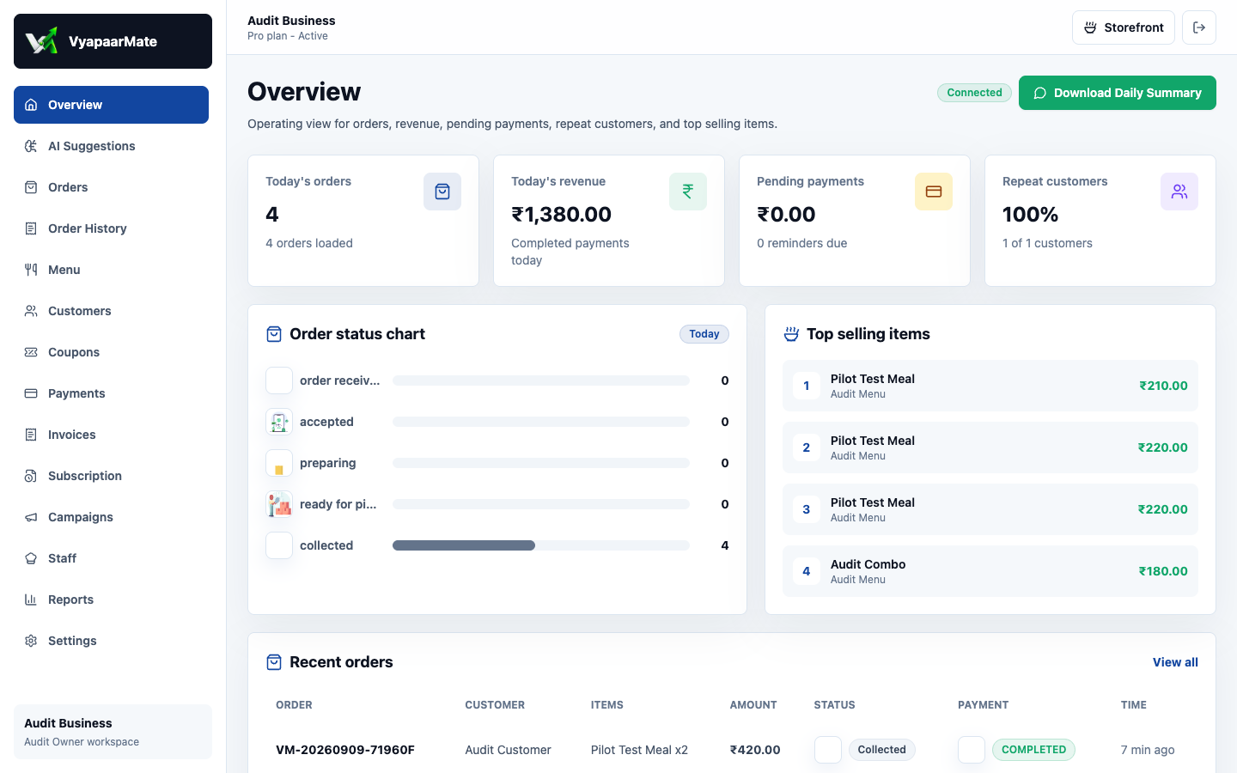
Local owner workspace with synthetic fixture data. This capture is demonstration evidence only.

Implementation and readiness
The current web architecture uses Next.js, React and TypeScript with Prisma and PostgreSQL, shared domain services, provider adapters and scheduled jobs. The local production build and automated tests passed. A hosted deployment, production database/security review, backup restore, load tests and actual provider callbacks remain separate release requirements.

Decision support and current limits
Rules and scoring can highlight next actions for an owner. Model or recommendation usefulness must be measured against real pilot data and merchant feedback. Campaign drafts now persist in the business account, but campaign delivery is not enabled. Daily summaries can be downloaded; live WhatsApp, payment, email and SMS integrations need independent delivery and failure-path checks.
The supplied brief reported a paused public deployment on 8 September 2026. Local operation has been verified in this review; the public deployment was not restored or changed. Native app release and store submission are outside this local website review.

Pilot execution and incubation request
The first 90 days start from an agreed pilot launch. The targets below are proposed across the two cohorts in total; they are not completed interviews, onboarded customers, revenue or an agreed RTIH programme.
Period | Proposed work | Evidence to review
Days 1 to 30 | Resolve release gates; complete 20 owner interviews; choose the initial segment. | Working deployed demo, dated interview notes, segment and pricing hypotheses.
Days 31 to 60 | Onboard 5 consenting pilot businesses in total across Bengaluru and AP. | Consent references, onboarding time, first real order, weekly activity and support effort.
Days 61 to 90 | Review repeat use, paid adoption, support cost and willingness to pay. | Cohort comparison, receipts, reasons for inactivity and a documented next decision.

Measures and evidence quality
The administrator pilot report separates Bengaluru and Andhra Pradesh. It reports enrolled businesses, completed setup, first real order, current and previous weekly activity, repeat use, recorded paid subscriptions, recurring value excluding GST and merchant order value. Test and demo businesses are excluded. Historical records still require provenance review before external reporting.
Weekly repeat use is businesses active in both seven-day windows divided by businesses active in the previous window. Active means at least one live, non-cancelled order after enrollment. An empty denominator is not presented as a percentage. Interviews, consent documents, onboarding minutes and support cost require a dated private pilot log.

Support requested from RTIH
We request mentoring on segment choice, pilot design, pricing and reliability; introductions to suitable MSMEs and local networks; and a discussion about workspace and technical support. Funding and investor guidance would help us prepare a costed milestone plan. This request does not imply admission, a grant, investor interest or any guaranteed outcome.

Preparation for investment review
We will assemble company and ownership records, founder responsibilities, IP ownership, product evidence, merchant consent, paid invoices, cohort results and a milestone budget. The budget should use actual costs and quotes for people, infrastructure, messaging, onboarding and support. Revenue and funding claims will be supported by records, not demo dashboards.

Three year direction
Year one will focus on repeat use and a repeatable paid offer. Year two will improve retention, sales, onboarding and support in the selected cohorts. Expansion into additional local clusters or categories will depend on customer outcomes and operating costs.
References: supplied VyapaarMate pitch deck and supporting brief; current local product audit dated 9 September 2026; official RTIH overview at https://rtih.co.in/. The original supplied files remain unchanged.

