About US

-------------

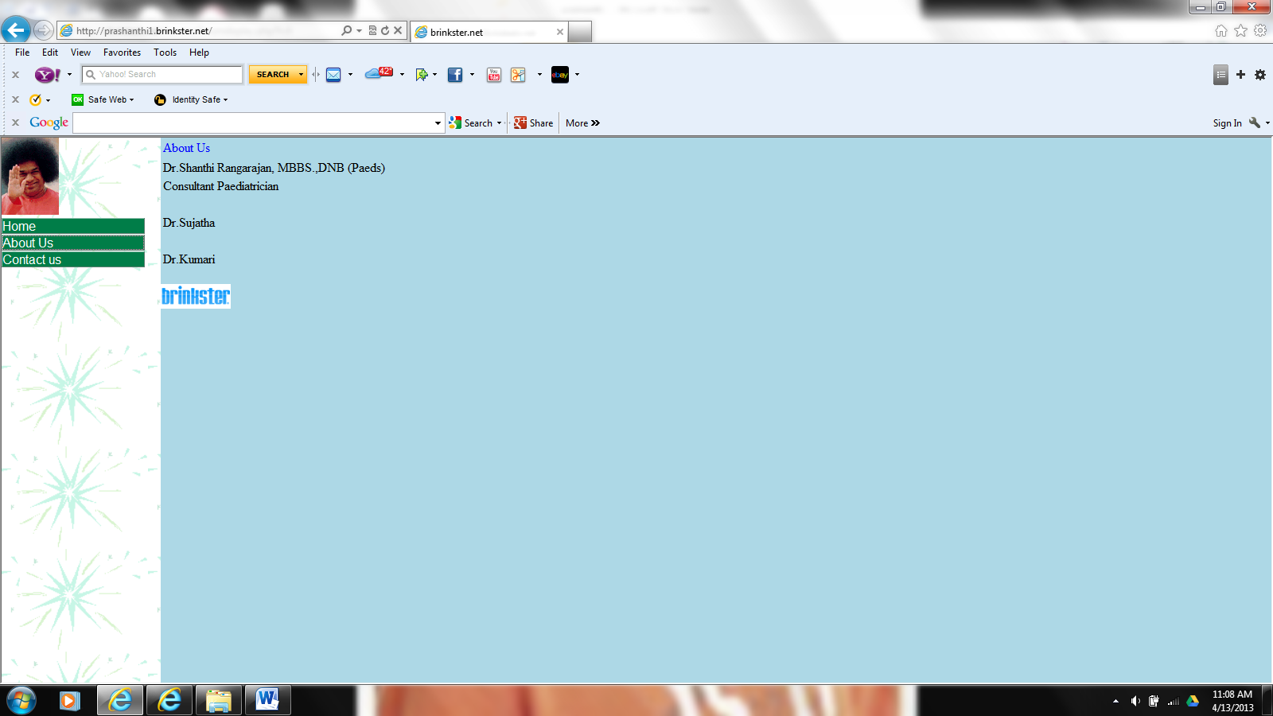

Contact US

---------------

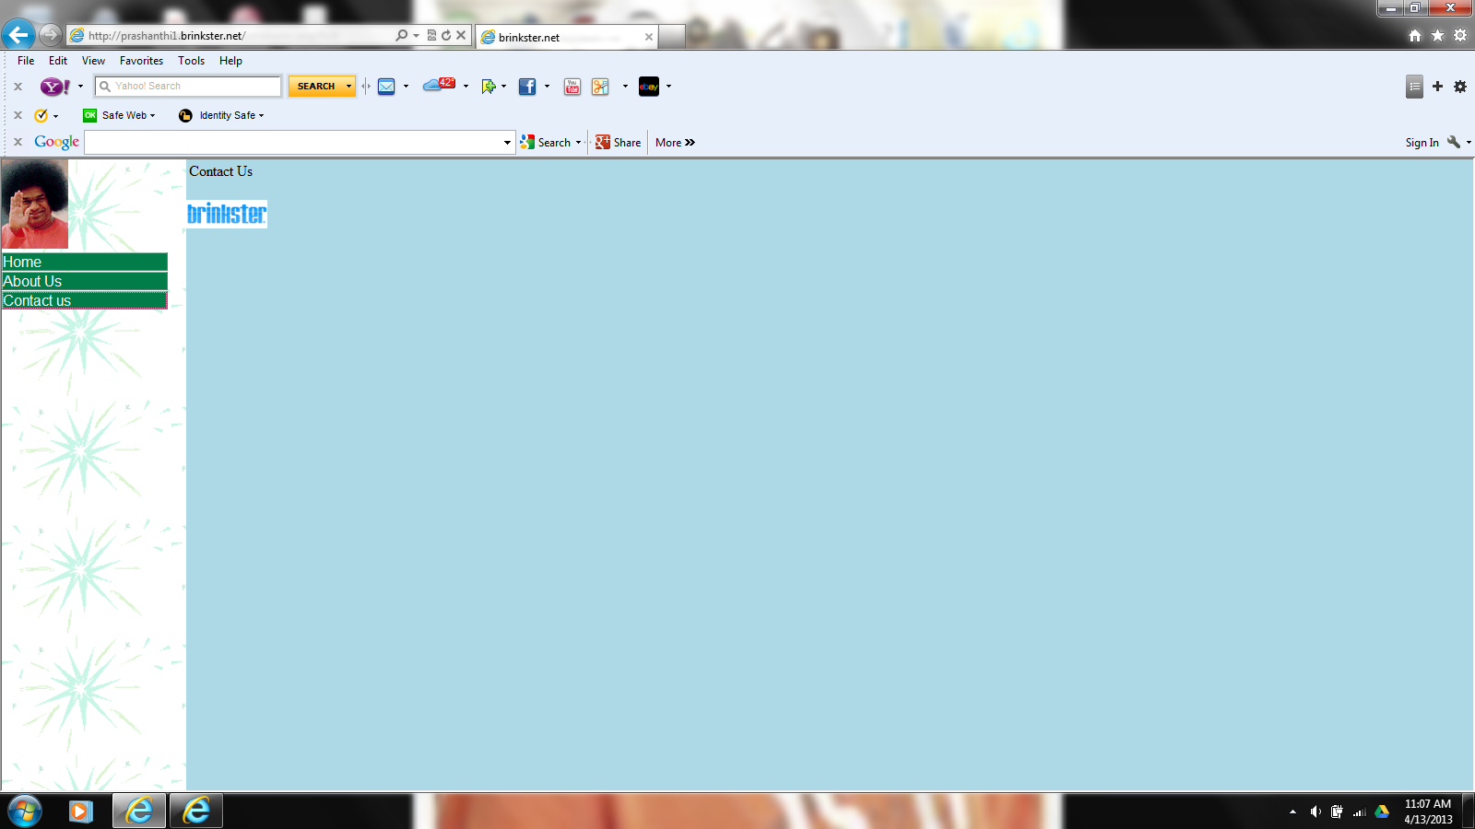

Home

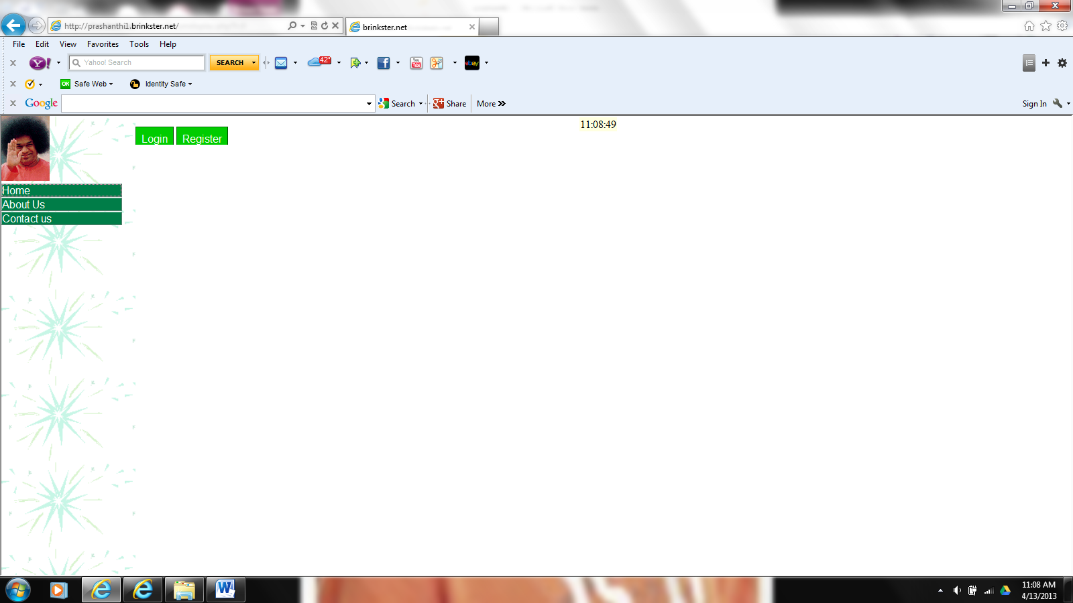

Login

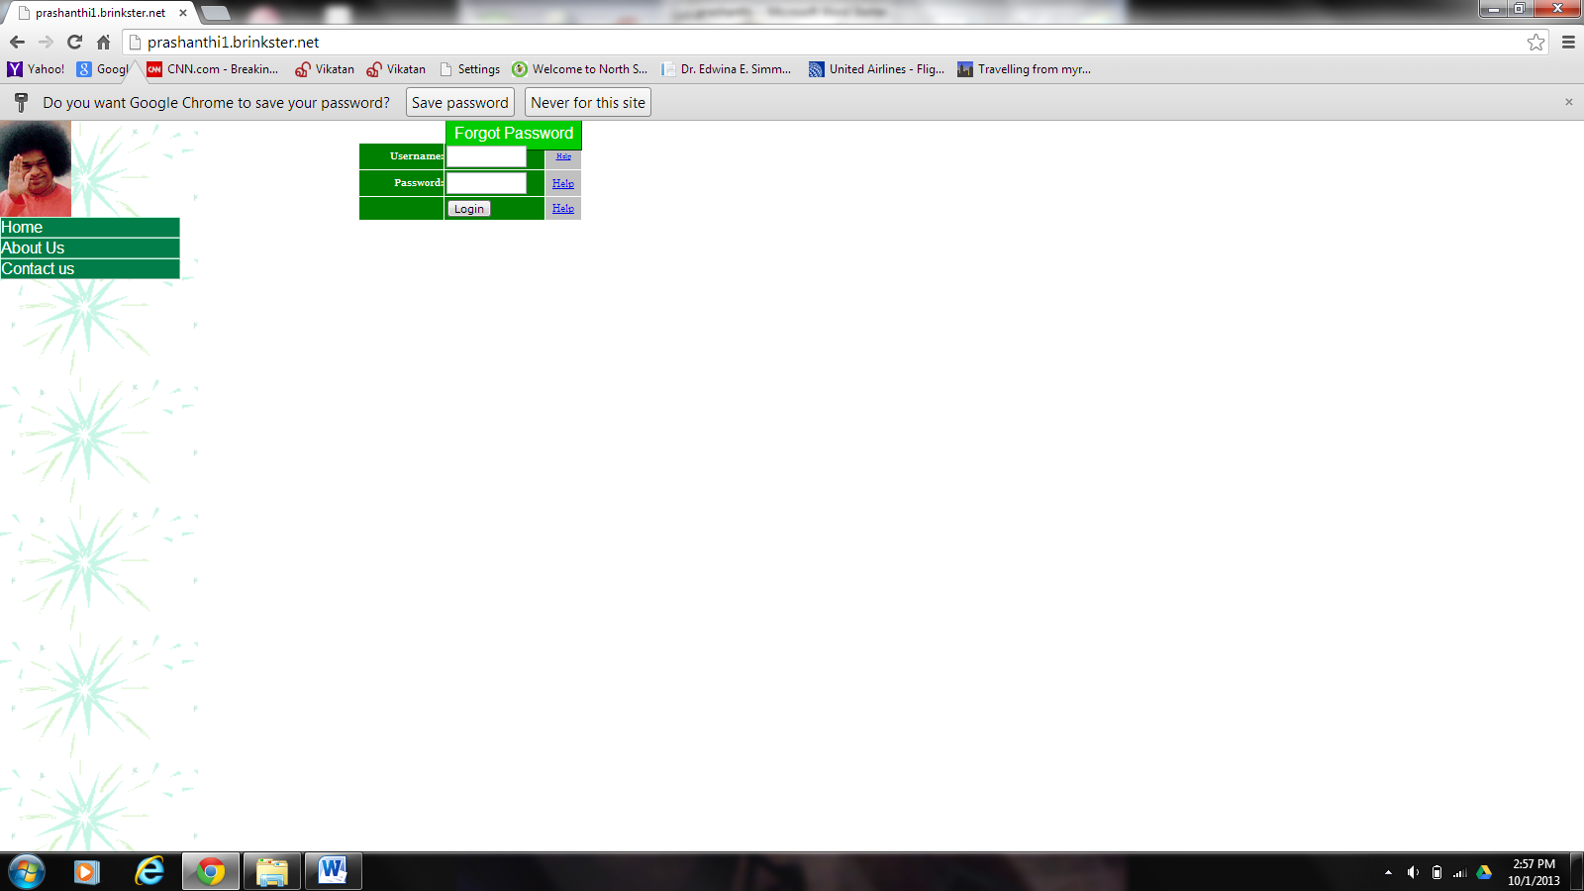

Login as a patient

User name : ramki

Password : ram

Or

Username : avyukthsai

Password : test

Or

User name : prabha

Password : pass1

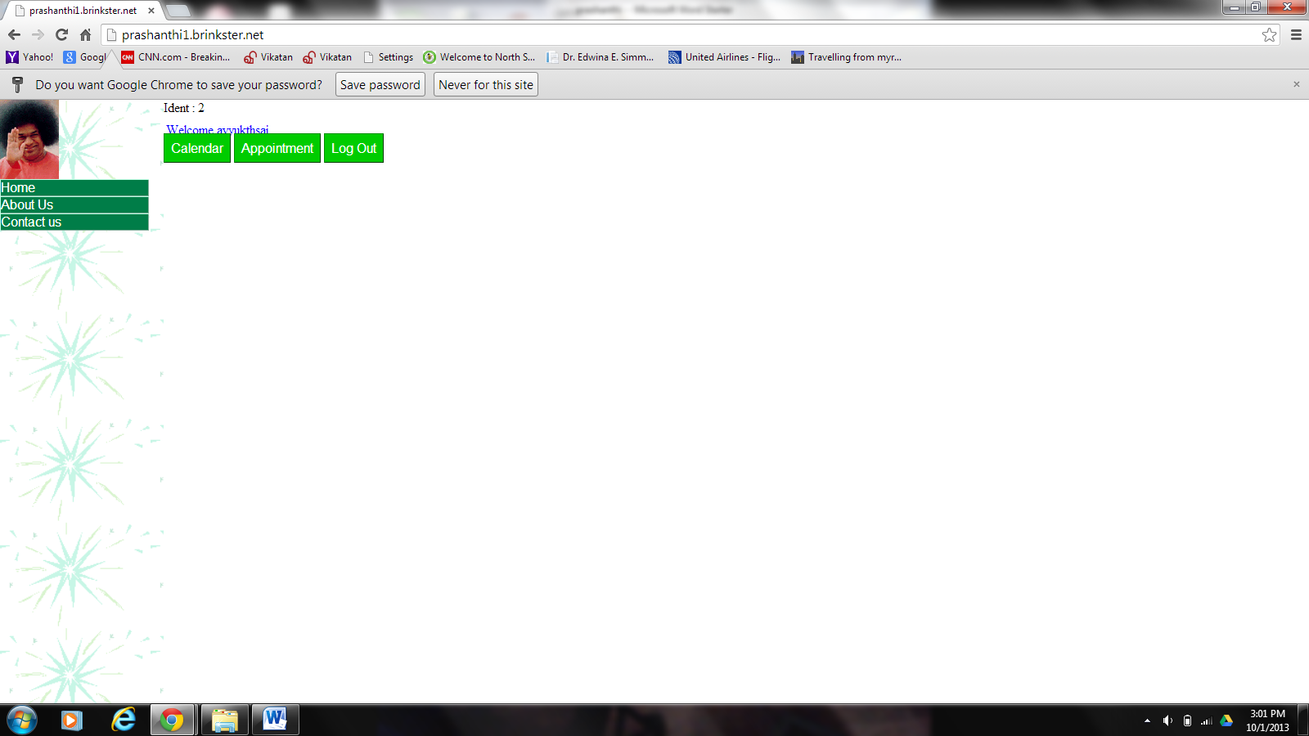

Appointment

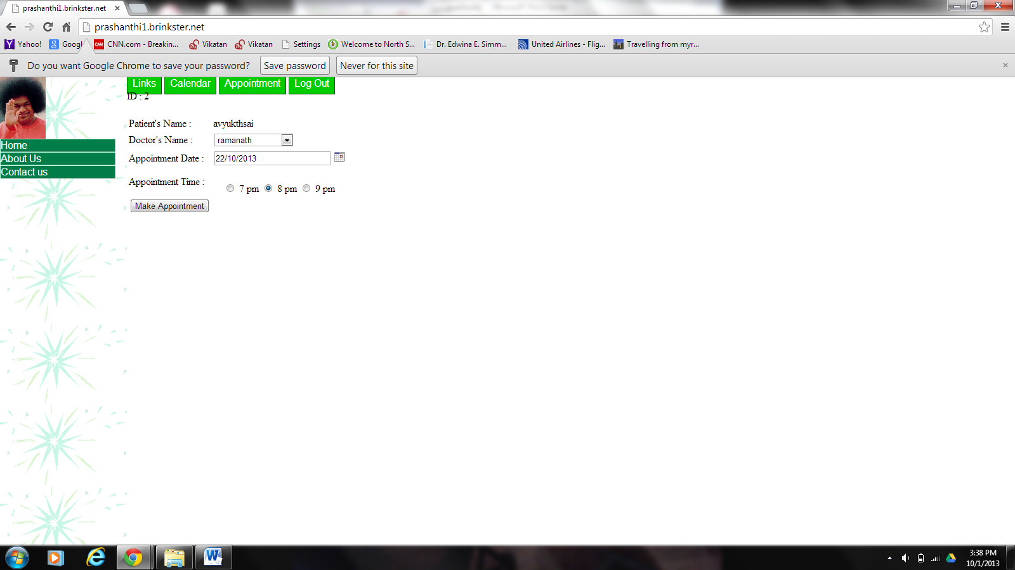

Login as a Doctor

User name : shanthi

Password : saga11

Or

Username : ramanath

Password : rama11

Or

User name : sujatha

Password : suja11

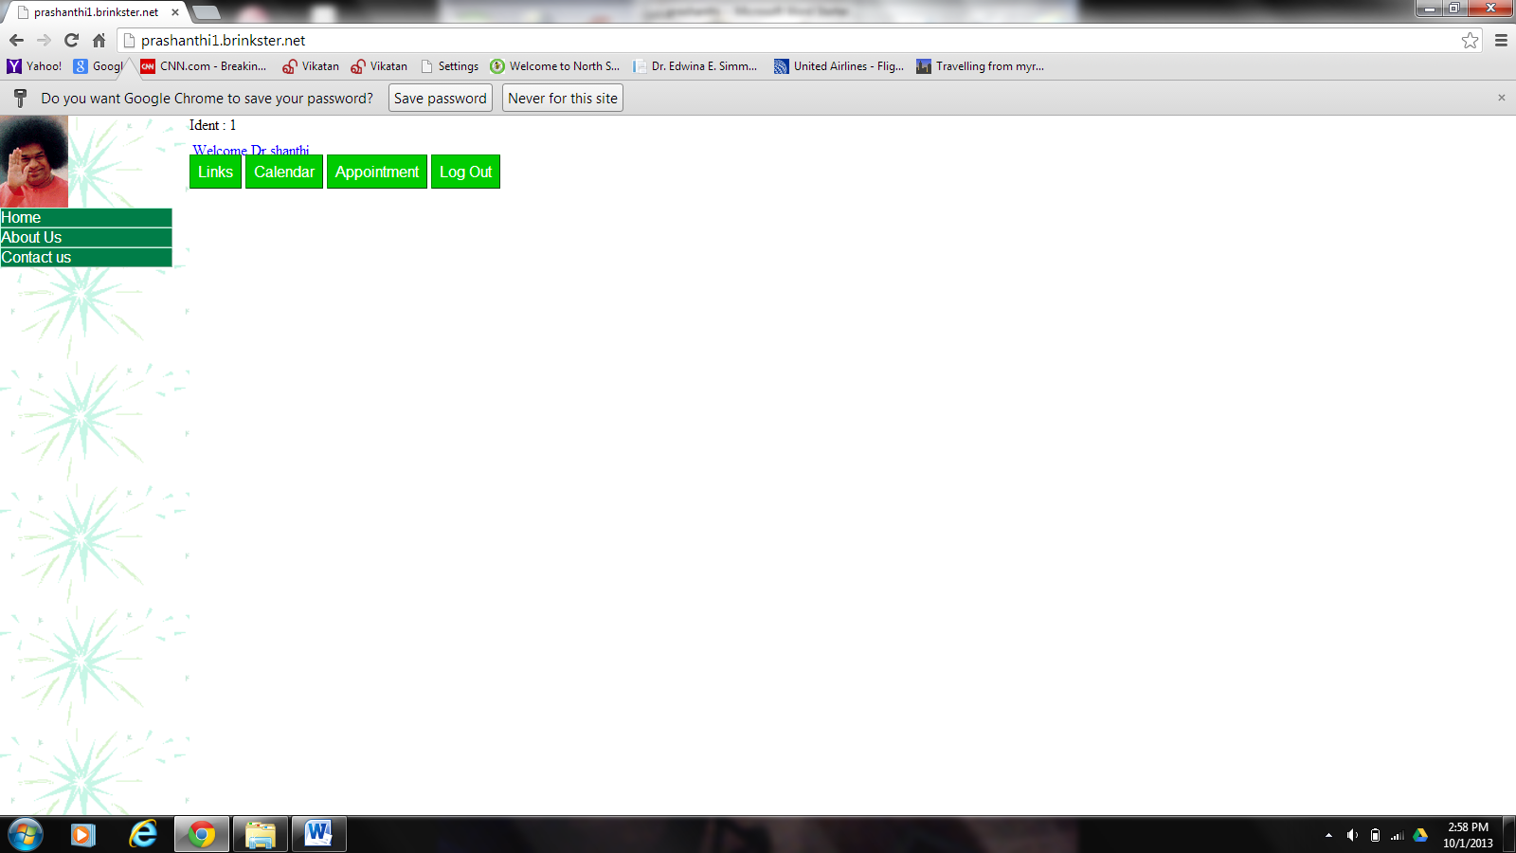

Login as an Admin

User name : admin

Password : admin11

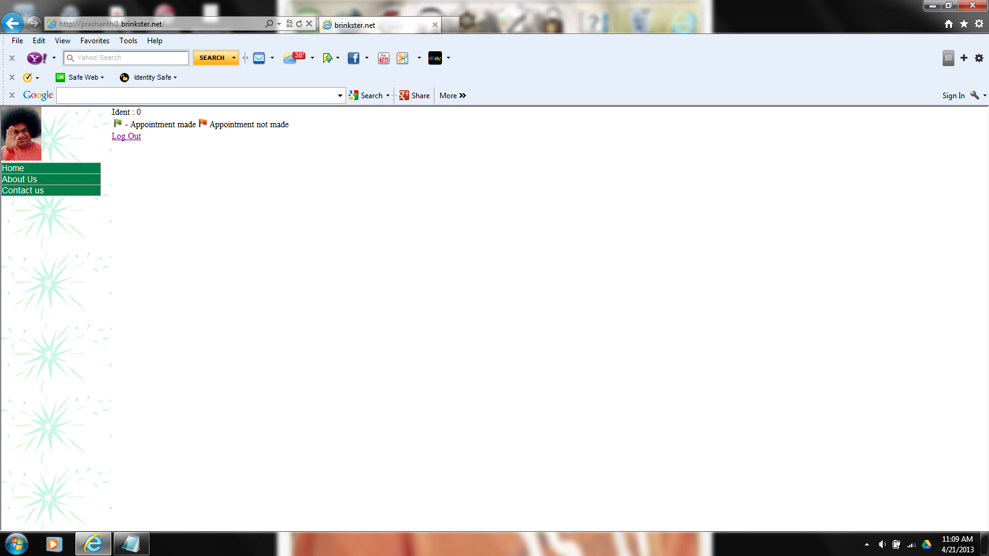

Calendar

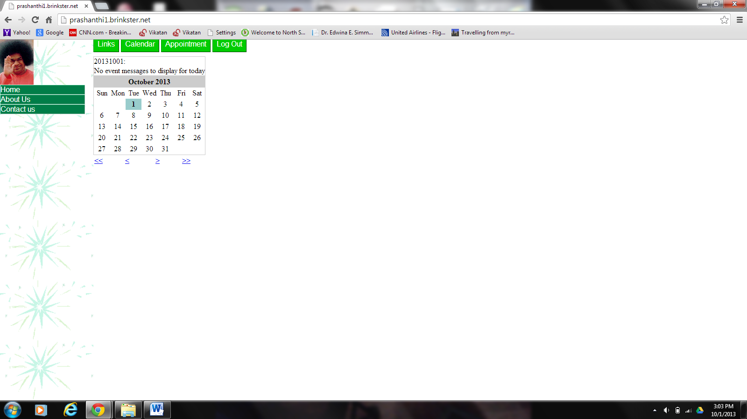

Appointment

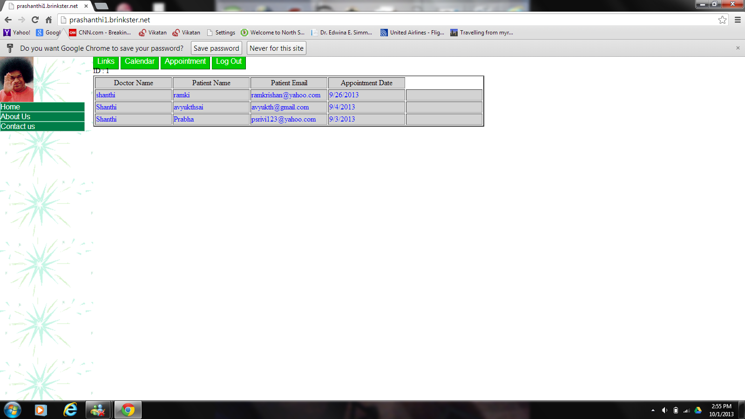

Register



Wrong Register



Change Password

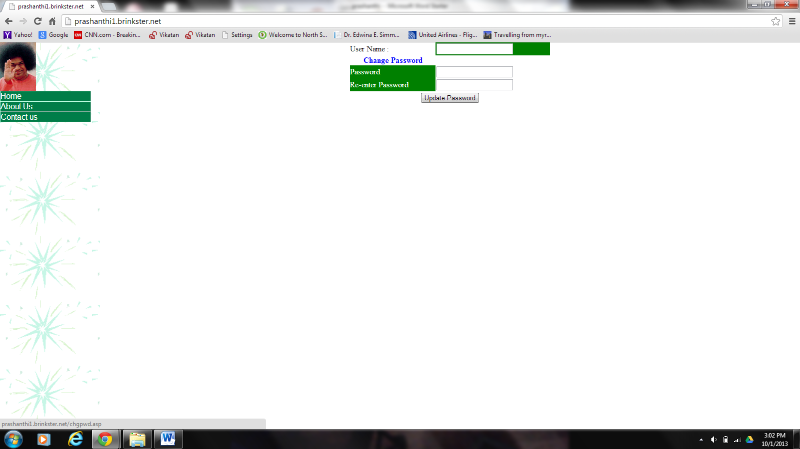

Calendar

create table Calendar

(Subject char(20),

message char(30),

Dy int ,

Mnth int ,

Yr int,

Added char(20),

DtAdded DateTime)

Insert into Calendar

(Subject, message,Dy,Mnth,Yr,

Added,DtAdded)

values ("Meeting 1","Doctor meet 1","30","05","2013","Shanthi",

now())