Portainer

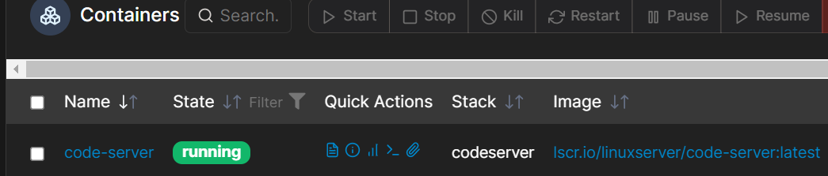

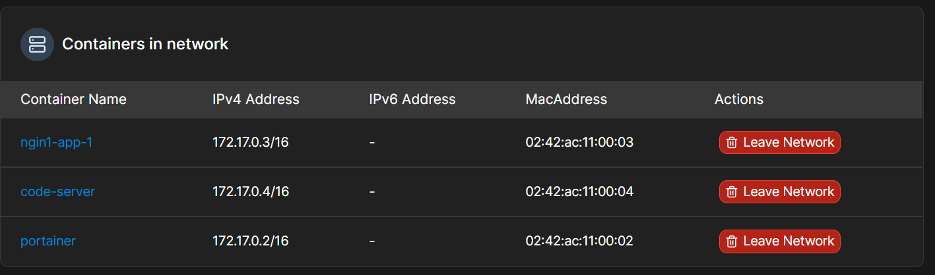

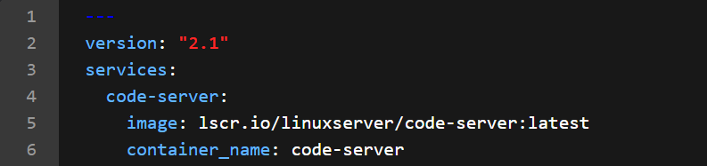

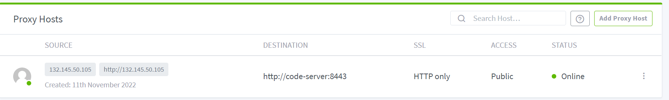

apt-get update
apt-get install iputils-ping

Is Jellyfin available without Nginx? Let's assume Jellyfin runs on all interfaces (0.0.0.0) on port 8096.
Then Jellyfin should be reachable without Nginx bij navigating to:
- localhost:8096
- 127.0.0.1:8096
- Local IP of the box : 8096 (for example 192.168.0.1:8096)
The first two are loopback addresses and will only function from the box/server itself.
Is Jellyfin actually running? sudo service jellyfin status might tell you more.

https://www.thesmarthomebook.com/2021/08/25/nginx-proxy-manager-setup-and-a-fix-for-your-502-gateway-errors/
https://github.com/louislam/uptime-kuma/issues/1800
https://blog.knoldus.com/lets-see-how-the-communication-between-docker-containers-is-done/
https://blog.knoldus.com/lets-see-how-the-communication-between-docker-containers-is-done/
https://cloudkul.com/blog/understanding-communication-docker-containers/ https://sophilabs.com/blog/communication-between-containers-and-host-machine
https://stackoverflow.com/questions/48546124/what-is-linux-equivalent-of-host-docker-internal
https://stackoverflow.com/questions/24319662/from-inside-of-a-docker-container-how-do-i-connect-to-the-localhost-of-the-mach
https://stackoverflow.com/questions/41093812/how-to-get-docker-containers-to-talk-to-each-other-while-running-on-my-local-hos

