Sonarqube runs on port 9000

 

Below is the sonarqube server

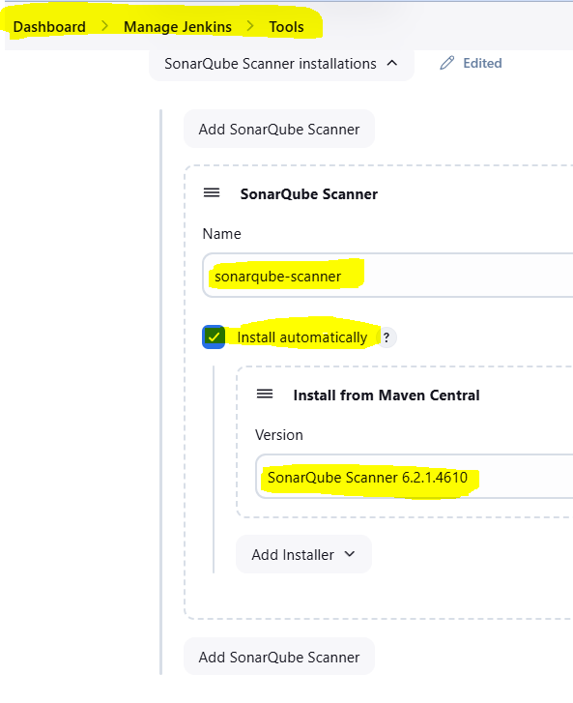

Option-1

stage('Code Analysis') {

steps {

script {

// Run SonarQube scan

sh '''mvn clean verify sonar:sonar -Dsonar.java.binaries=. -Dsonar.projectKey=test -Dsonar.projectName='test' -Dsonar.host.url=http://3.107.55.196:9000 -Dsonar.login=${SONAR_TOKEN}'''

}

}

}

Option-2

stage('Run Sonarqube') {

environment {

scannerHome = tool 'sonarqube-scanner';

}

steps {

withSonarQubeEnv(credentialsId: 'sonarqube-token', installationName: 'sonarqube') {

sh "${scannerHome}/bin/sonar-scanner -Dsonar.projectKey=test -Dsonar.projectName='test' -Dsonar.java.binaries=. "

}

}

}