DOCKER

Docker is an open platform which is used for developing, shipping and running Linux applications. It automates the deployment of applications inside software containers by providing an additional layer of abstraction and automation of operating system level virtualization on Linux. It does this using container. Containers are used to package up an application with all other parts, such as libraries and other dependencies, and ship it up as one package. This makes it easier to run applications on any other Linux machine. Docker consists of two main components – Docker Engine and Docker Hub. Docker engine is light weight and powerful open source container virtualization technology combined with workflow to build and containerize applications.

Current technology used:

The technology used by docker is that it uses the tried and tested features of the Linux kernel. It either makes use of these features directly or builds upon them to provide new functionality. The main components of docker include the docker daemon, docker client and the docker.io registry. The daemon runs on the host machine. The user does not interact with it directly but uses the docker client which is the primary user interface to docker. Docker.io registry is the global directory which consists of user supplied docker container read only templates. The basic elements of docker include containers, images which are used to build containers and a Dockerfile which contains instructions to build the docker images.

Benefits:

A docker container shares the Linux kernel it uses with the operating system running on the host machine. It also shares the kernel with other containers running on the same machine and thus less amount of space is used. For running applications with different requirements, docker containers can be used so that no applications interfere with each other. As all the libraries and other dependencies are included in the container itself, the time required to run applications is also less. It also provides better security as even if one container gets hacked, there is no effect on other containers. It also becomes very easy to add or remove applications by simply creating or deleting containers.

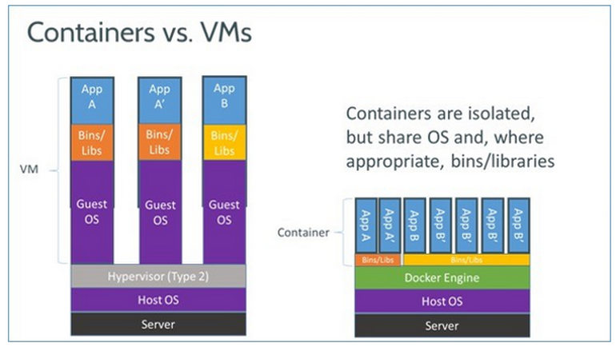

Limitations:

The limitations of using docker is that it only works with Linux base kernels and any applications using Windows or other operating systems cannot be run. Also, it is not possible to do systemwide things like loading modules, changing firewall settings as it may risk the security.

References:

<http://opensource.com/resources/what-docker>

<http://docs.docker.com/introduction/technology/>

<http://www.zdnet.com/article/what-is-docker-and-why-is-it-so-darn-popular/>

<http://www.quora.com/What-are-some-disadvantages-of-using-Docker>