**Question 1:**

The first question asked for the LU decomposition of matrix A, done by hand. The following

steps were performed, bearing in mind A = LU.

1. Obtain the row-echelon form of A via row-reduction, which yields U
   1. -1R1 + R2 and -2R1 + R3 are the first 2 row operations
   2. Now we can express U = l1*A, which is the multiplication representation of the 2 row operations
   3. Then -2/3(R2)+(R3) was performed
   4. Now we can express U = l2 * l1 * A
2. Multiplying the two matricies l2 and l1 will yield l-1, which is equivalent to L.
   1. Thus, L = l1-1 * l2-1 , so the inverses of l1 and l2 were calculated.

In the end, the LU decomposition resulted in:

$$\left(\begin{matrix}4 & 1 & -2 \\ 4 & 4 & -3 \\ 8 & 4 & 0\end{matrix}\right)= \left(\begin{matrix}1 & 0 & 0 \\ 1 & 1 & 0 \\ 2 & 2/3 & 1\end{matrix}\right)\left(\begin{matrix}4 & 1 & -2 \\ 0 & 3 & -1 \\ 0 & 0 & 14/3\end{matrix}\right)$$

*highlighted numbers were the unknowns that we were asked to solve for

**Question 2:**

To determine the solution of Ax, Ax was set equal to be, then the following steps were taken:

1. If Ax = b and A = LU from LU decomposition, then LUx = b
2. Ly = b and Ux = y, y was solved first in the former equation, then its values were used in Ux = y to solve for x, which is the solution.

Thus, using the L and U matricies found using LU decomposition, the solution is:

$$x=\left(\begin{matrix}1 \\ 2 \\ 3\end{matrix}\right)$$

**Question 3:**

To obtain the row-echelon form of matricies B and C as part of the LU decomposition process, the exact same 3 row-reduction operations performed in Question 1 are conducted. This implies that matricies A, B, and C all share the same L matrix. Obtaining the row-echelon forms of B and C reveals that both matricies share near identical U matricies. Thus, it is safe to say that the LU decompositions of B and C are similar.

Rather than doing the LU decomposition by hand all over again, MatLab was used to verify this assertion. Both matricies were created in MatLab and the LU decomposition method, lu() was used to obtain sparse L and U matricies of both B and C. L and U of both B and C were then promoted to full matricies, and the results displayed using disp().

**Question 4:**

For this question, I created a function called generateA to assist with creating the water flow material matrix. Using two for-loops to iterate through all combinations of a and n-values, the estimated condition number (infinity) for the generated matrix was calculated using MatLab’s cond() routine; this value was stored in a pre-allocated array, condNums, where the columns denoted a-values and the rows denoted n-values.

Graphs were generated from the columns in condNums. Below are some graphs representing the diminishing a-values have on the condition numbers:

**Figure 1:** Condition Numbers for Water Flow (a = 1)

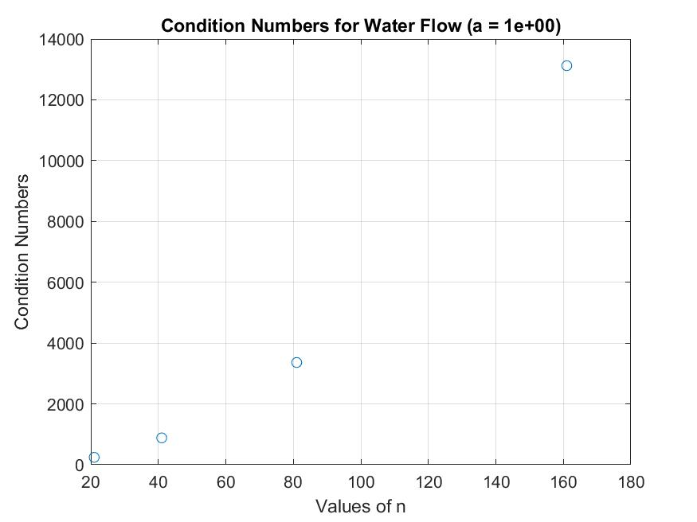

**Figure 2:** Condition Numbers for Water Flow (a = 1e-5)

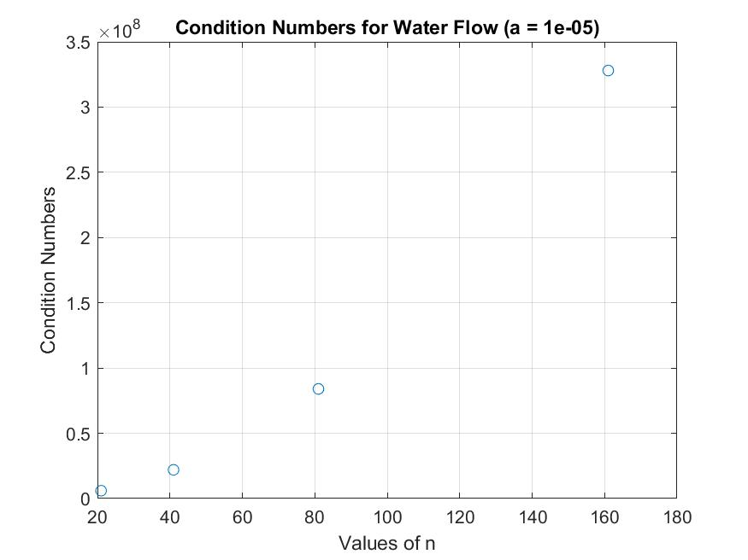

**Figure 3:** Condition Numbers for Water Flow (a = 1e-9)

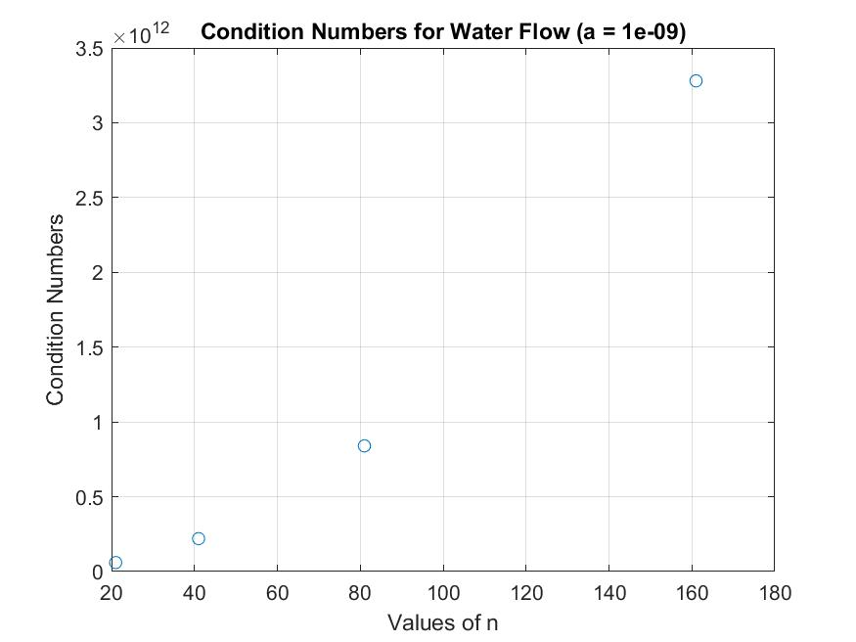

**Figure 4:** Condition Numbers for Water Flow (a = 1e-13)

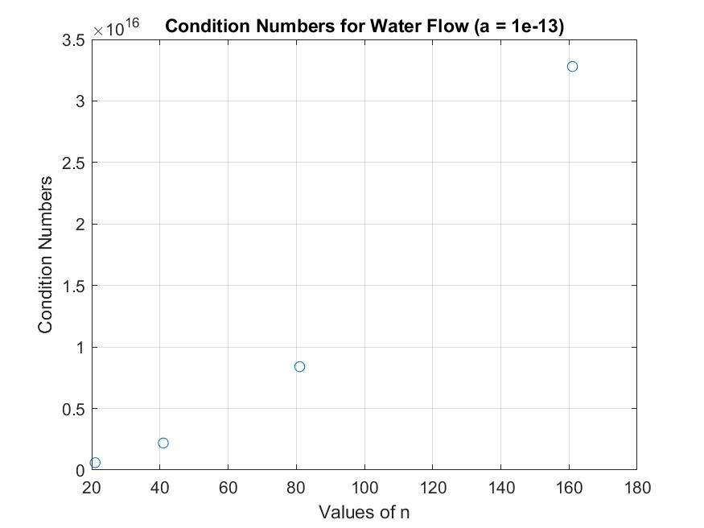

**Figure 5:** Condition Numbers for Water Flow (a = 1e-15)

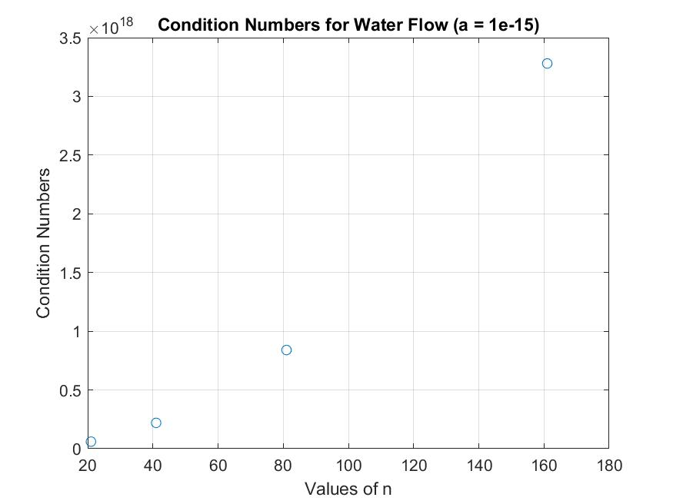

All the graphs look quite similar, with the difference being the scale. As the value of a diminishes, the scale for the condition number increases drastically.

To solve the system of equations for n=161 and the 3 designated a-values, a for-loop iterated over a vector containing the a-values. For each a-value, a matrix, h, was used to hold the solution produced by each iterative refinement. A, x, and b values were generated/calculated.

A nested loop was set up to replicate the iterative refinement process: calculating the residual, solving the system involving the residual for the correction, then adding the correction to the solution. After 200 refinements, the solution of the system were as follows, with various values of a:

**Figure 6:** Solution for the Ill-Condition Matrix (200 refinements, a = 1)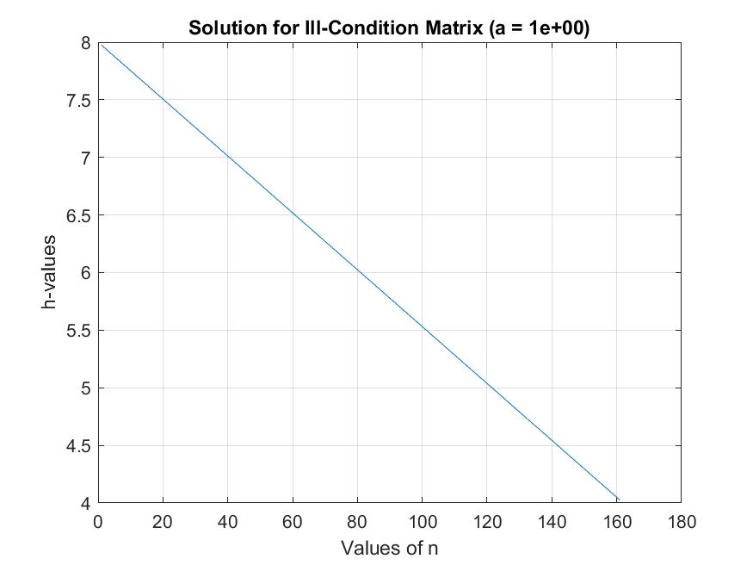

**Figure 7:** Solution for the Ill-Condition Matrix (200 refinements, a = 1e-5)

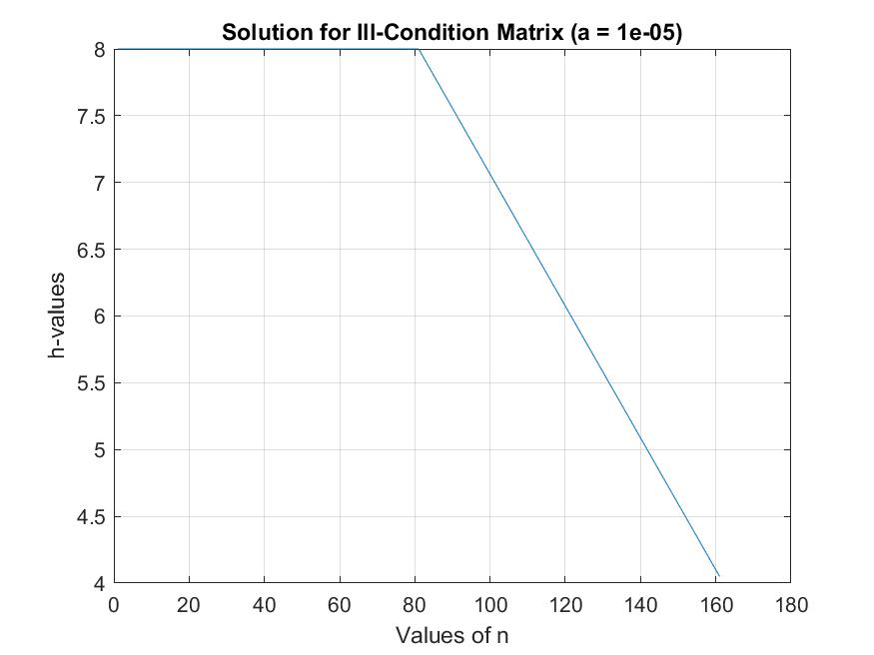

**Figure 8:** Solution for the Ill-Condition Matrix (200 refinements, a = 1e-15)

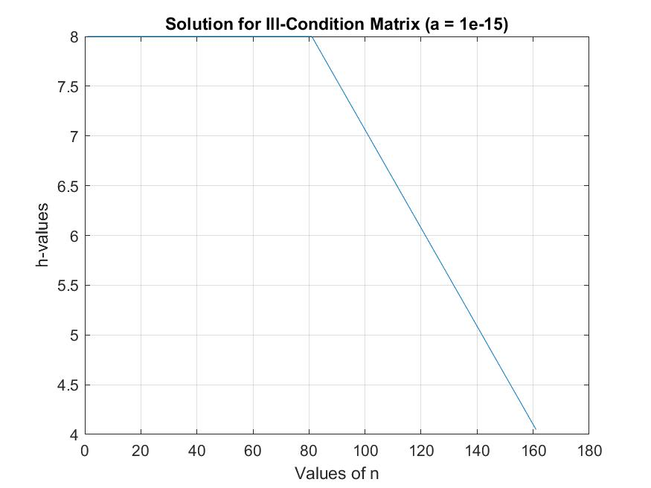

**Sources of Information:**

Sources of information include the slides posted on Canvas, as well as MatLab’s documentation on routines such as cond() and diag(). Also, I did browse the Discussion forum on Canvas for tips, including on clarification on how to interpret the monstrosity of a matrix in Question 4.

These two videos on YouTube aided me greatly in figuring out how to complete an LU decomposition:

* [Linear Algebra 13e: The LU Decomposition](https://www.youtube.com/watch?v=HS7RadfcoFk)
* [Solve a System of Linear Equations Using LU Decomposition](https://www.youtube.com/watch?v=m3EojSAgIao)

I did not collaborate with any classmates on this assignment.

As far as source codes went, I implemented all the functions that didn’t already come with MatLab.