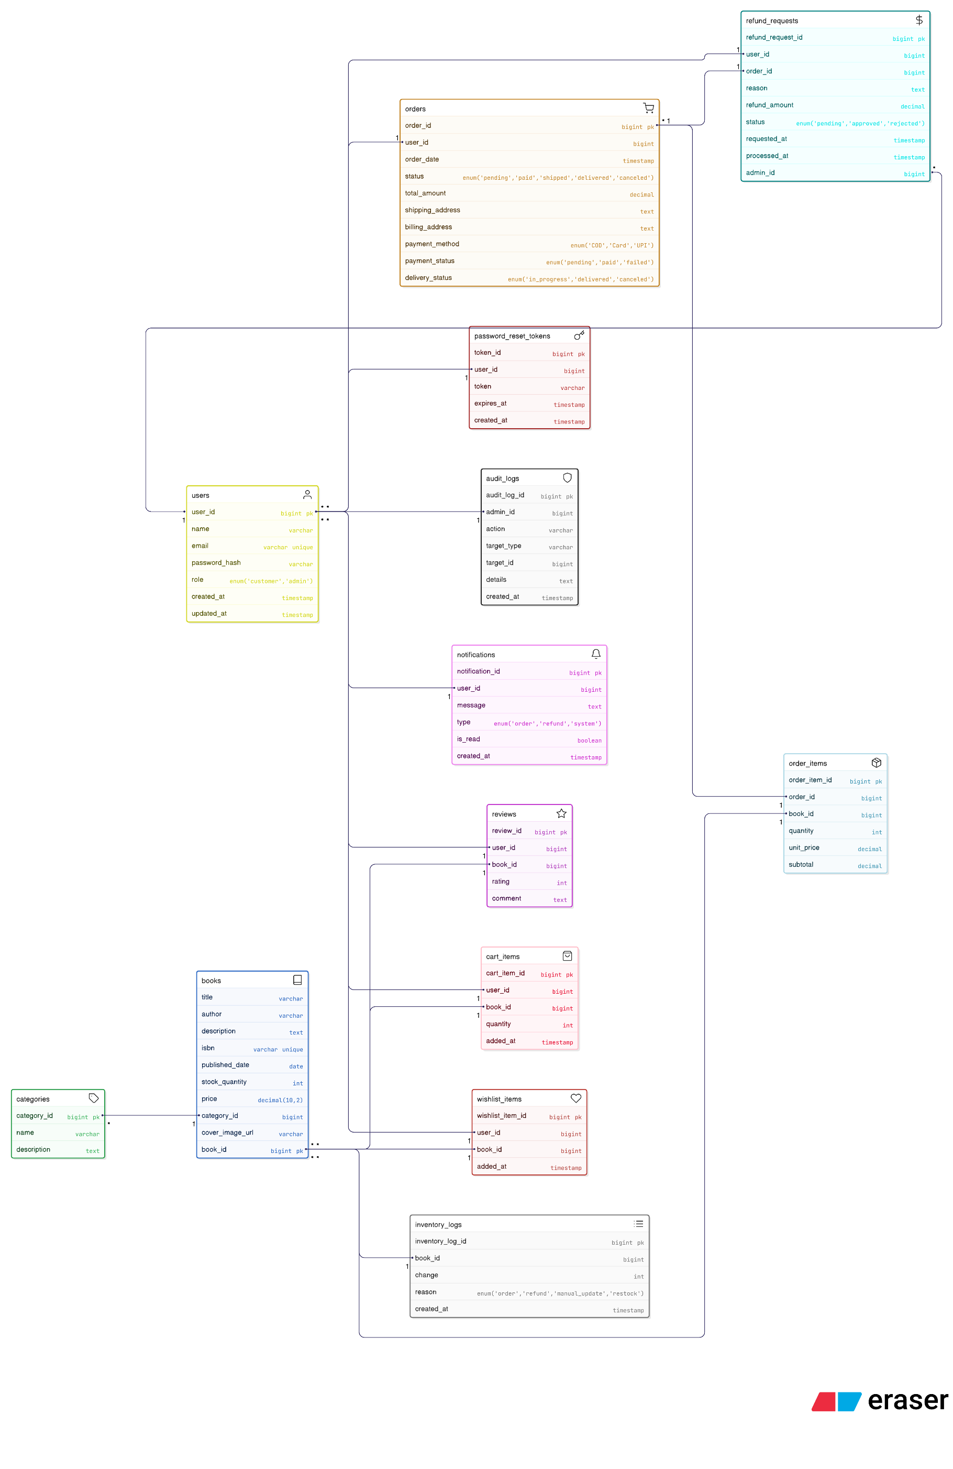
Access Token: bxiiXaXzBs5yiKAxwWSR

