Alibaba

http://connectkeyword.alibaba.com/lenoIframeJson.htm?iframe_delete=true&varname=intelSearchData&keyword=scooter&searchType=product_en&cateId=&cookieId=183.224.156.42.1445046104738.749831.1&buckettest=&callback=jQuery18305847417997301511_1450020260912&_=1450020340406

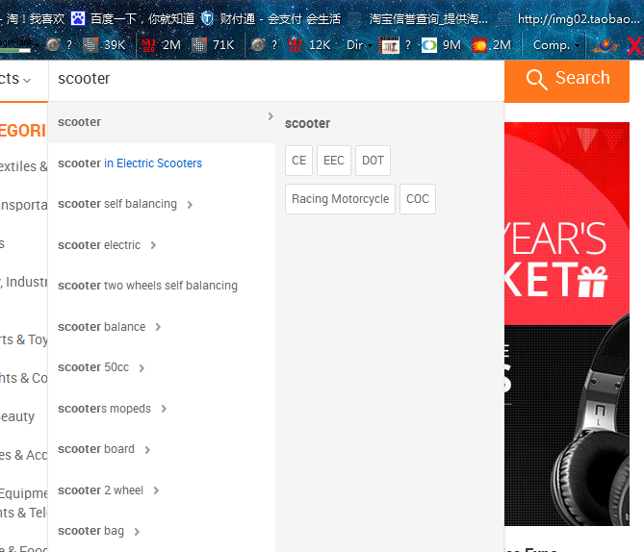

Aliexpress

http://connectkeyword.aliexpress.com/lenoIframeJson.htm?iframe_delete=true&varname=intelSearchData&__number=1&keyword=watch

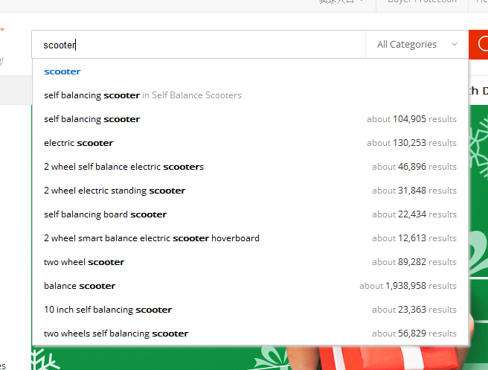

Amazon

http://completion.amazon.com/search/complete?method=completion&mkt=1&client=amazon-search-ui&x=String&search-alias=aps&q=scoo&qs=&cf=1&noCacheIE=1450021966460&fb=1&sc=1&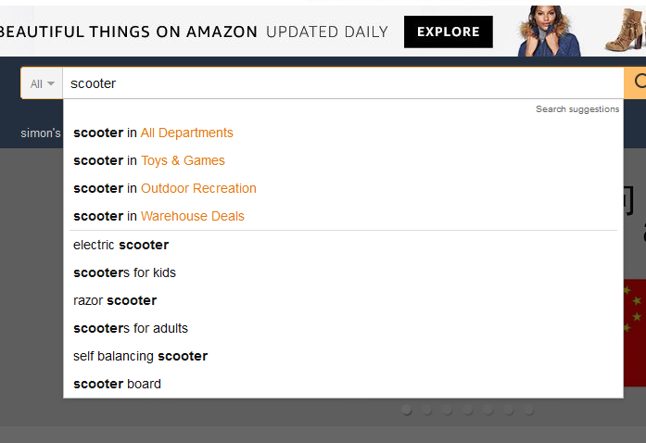

Wish

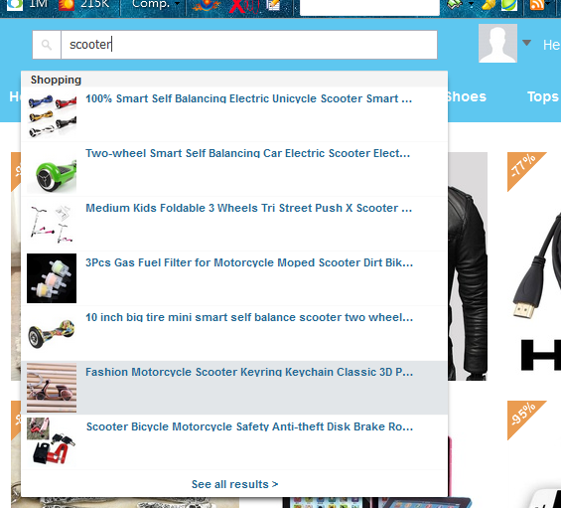

Ebay

http://www.ebay.com/sch/i.html?_from=R40&_trksid=m570.l1313&_nkw=scooter&_sacat=0

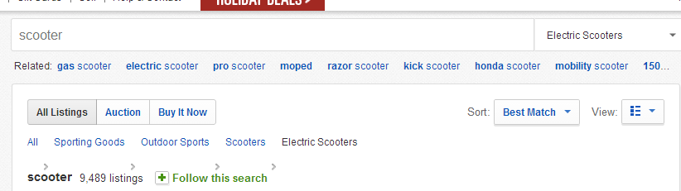

Google

https://www.google.com.hk/complete/search?client=hp&hl=zh-CN&gs_rn=64&gs_ri=hp&tok=xzIOZZnQIDpu6XEDT3j1TA&cp=6&gs_id=22s&q=scoote&xhr=t

