Chapter 1

What is PHP?

- PHP is an acronym for "PHP: Hypertext Preprocessor"

- PHP is a widely-used, open source scripting language

- PHP scripts are executed on the server

- PHP is free to download and use

What is a PHP File?

- PHP files can contain text, HTML, CSS, JavaScript, and PHP code

- PHP code are executed on the server, and the result is returned to the browser as plain HTML

- PHP files have extension ".php"

What Can PHP Do?

- PHP can generate dynamic page content

- PHP can create, open, read, write, delete, and close files on the server

- PHP can collect form data

- PHP can send and receive cookies

- PHP can add, delete, modify data in your database

- PHP can be used to control user-access

- PHP can encrypt data

With PHP you are not limited to output HTML. You can output images, PDF files, and even Flash movies. You can also output any text, such as XHTML and XML.

Why PHP?

- PHP runs on various platforms (Windows, Linux, Unix, Mac OS X, etc.)

- PHP is compatible with almost all servers used today (Apache, IIS, etc.)

- PHP supports a wide range of databases

- PHP is free. Download it from the official PHP resource: www.php.net

- PHP is easy to learn and runs efficiently on the server side

Your First Program

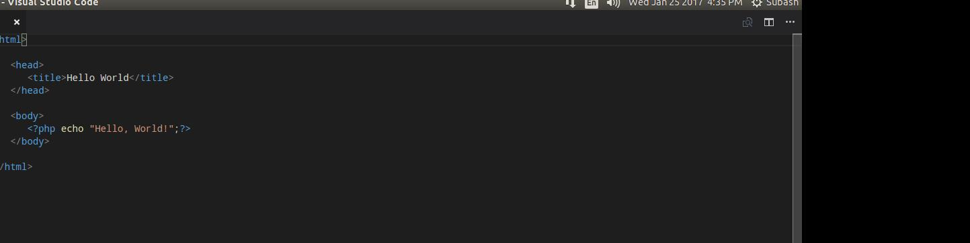

Syntax

The default file extension for PHP files is ".php".
Comments in PHP

A comment in PHP code is a line that is not read/executed as part of the program. Its only purpose is to be read by someone who is looking at the code.

Comments can be used to:

Let others understand what you are doing

Remind yourself of what you did - Most programmers have experienced coming back to their own work a year or two later and having to re-figure out what they did. Comments can remind you of what you were thinking when you wrote the code

<?php
// This is a single-line comment
# This is also a single-line comment – not recomending
/*
This is a multiple-lines comment block
that spans over multiple
lines
*/

