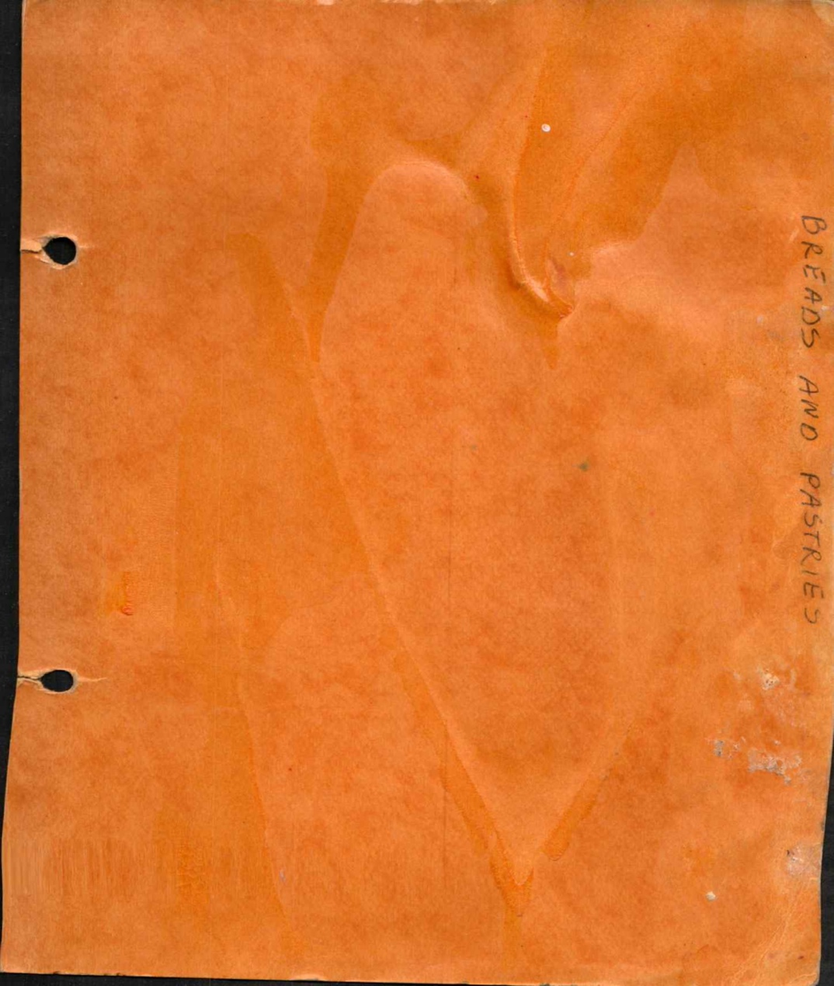

Lefse

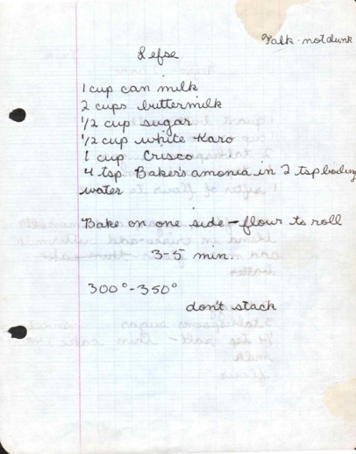
From: Falk

Ingredients
1 cup canned milk
2 cups buttermilk
½ cup sugar
½ cup white Karo syrup
1 cup Crisco
4 tsp. Baker's ammonia in 2 tsp. lukewarm water

Directions
Bake on one side - flour to roll
3-5 min.
300°-350°
Don't stack

Lefse - 2 Bake

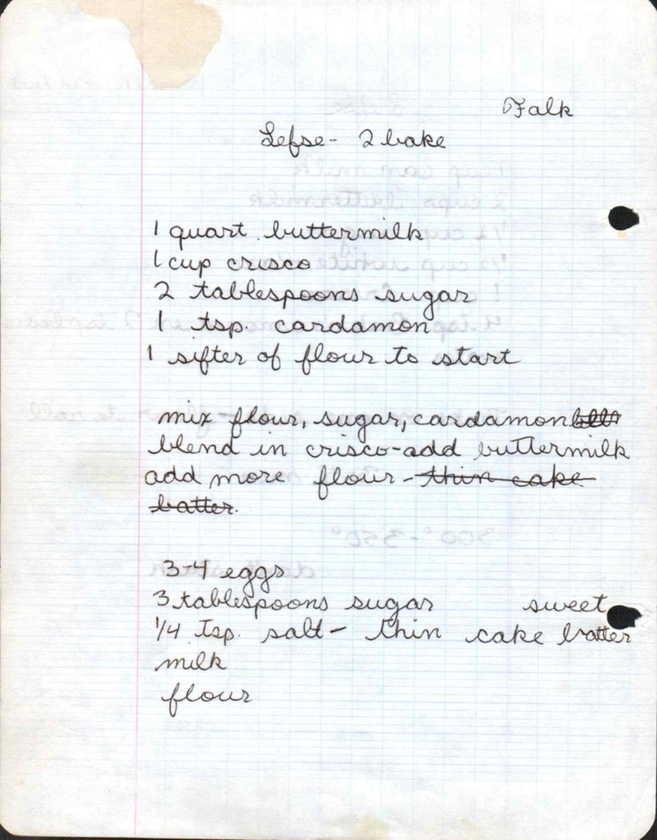
From: Falk

Ingredients
1 quart buttermilk
1 cup Crisco
2 tablespoons sugar
1 tsp. cardamon
1 sifter of flour to start

Directions
Mix flour, sugar, cardamom. Blend in Crisco - add buttermilk, add more flour - thin cake batter.
3-4 eggs
3 tablespoons sugar (sweet)
¼ tsp. salt - thin cake batter
milk
flour

Julekake - Jessie

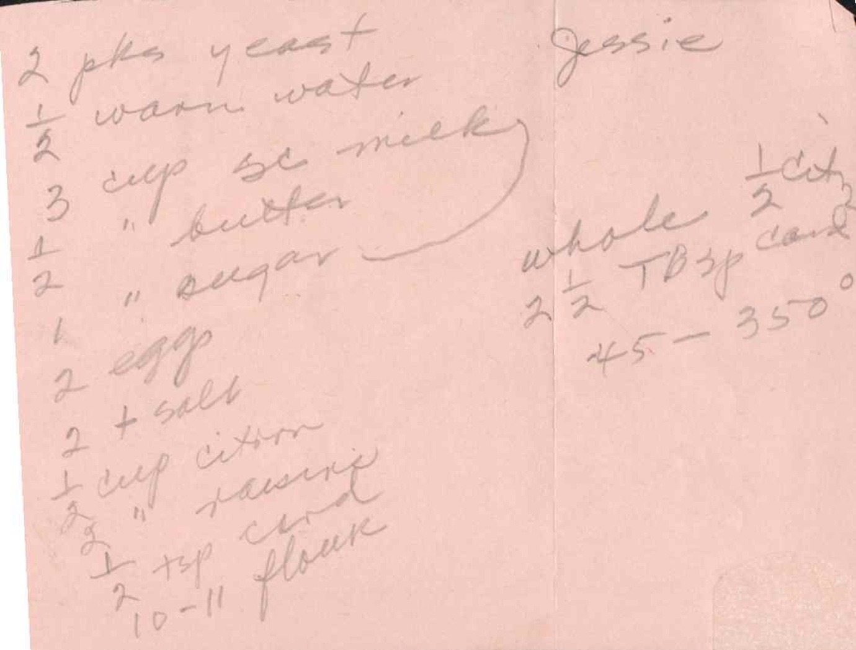

Ingredients
2 pkg. yeast
½ warm water
3 cup sc. (milk?)
4 " butter
2 " sugar
1 egg
2 + salt
½ cup citron
¾ " raisins
7 tsp. flour
10-11 flour
Whole ½ 2-2 Tbsp dark 45-350

Yule Kake 2 - Jessie

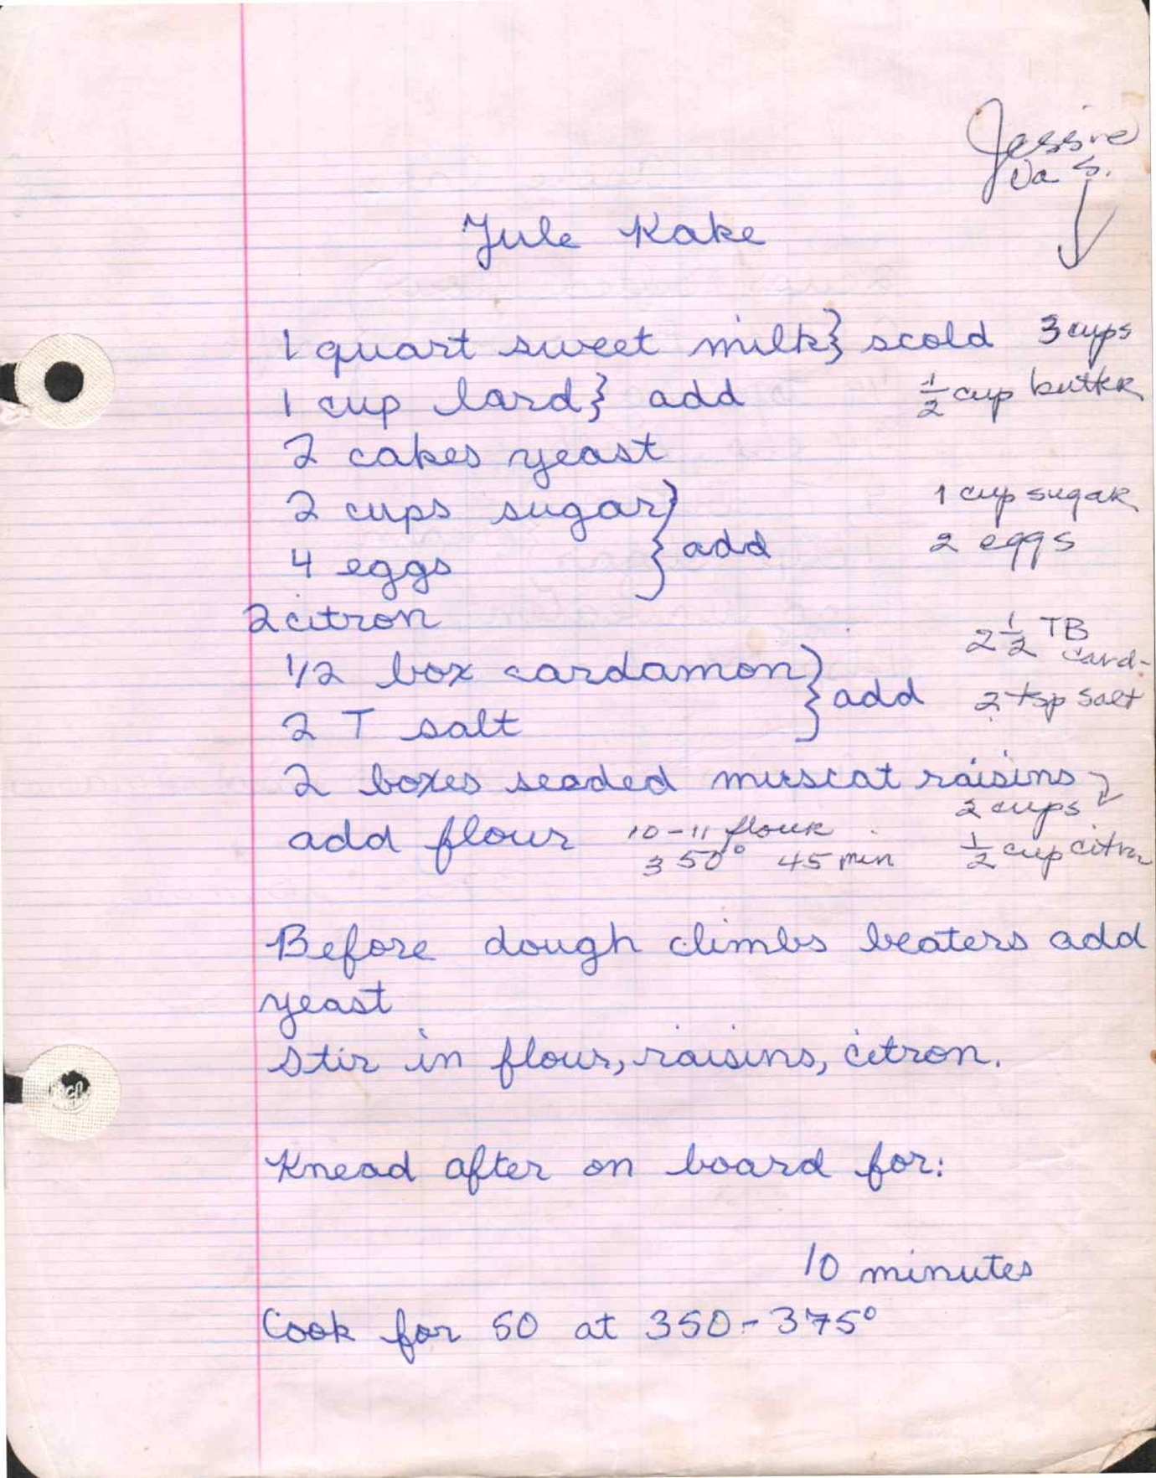
From: Jessie Vas Sister

Ingredients
1 quart sweet milk - scald (3 cups)
1 cup lard, add (½ cup butter)
2 cakes yeast
2 cups sugar, add (1 cup sugar)
4 eggs (2 eggs)
2 citron (2½ TB lard)
½ box cardamon, add (2 tsp salt)
2 T salt
2 boxes seeded muscat raisins (2 cups), add flour 10-11 flour (½ cup citron)

Directions
Before dough climbs, beaters add yeast.
Stir in flour, raisins, citron.
Knead after on board for: 10 minutes
Cook for 60 at 350-375°

Apple Cake

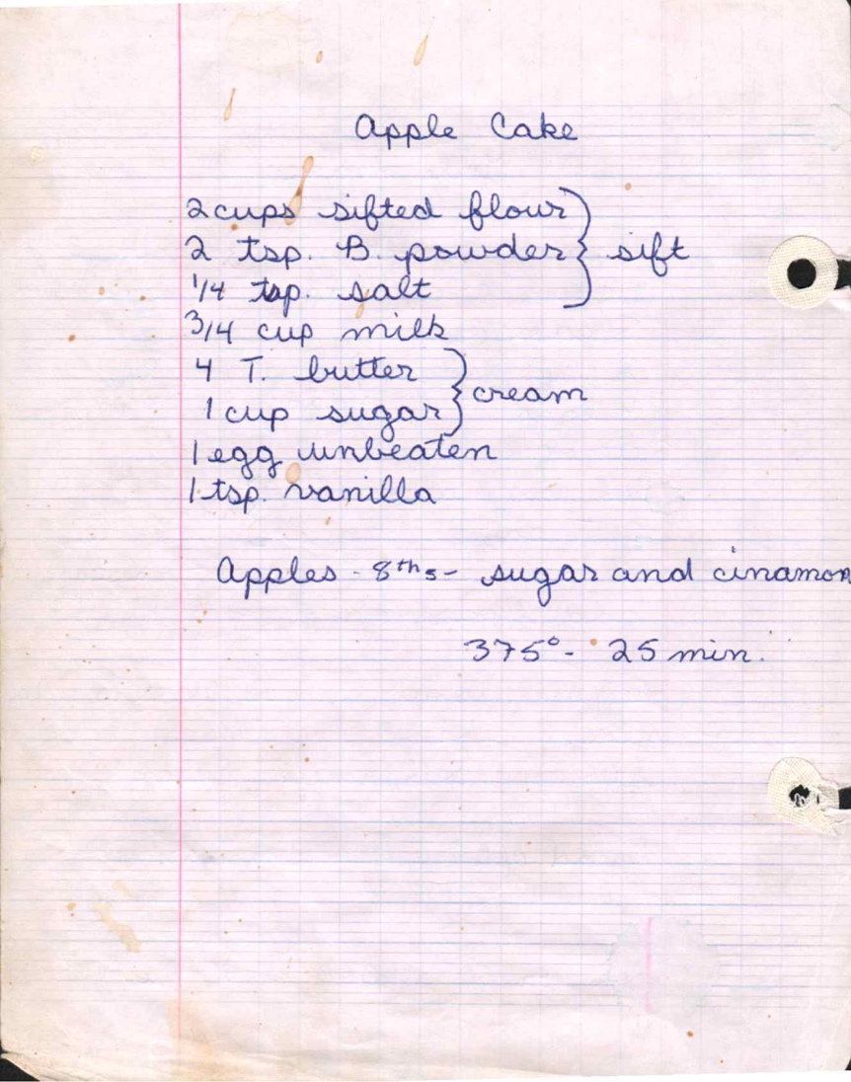

Ingredients
2 cups sifted flour
2 tsp. B. powder, sift
¼ tsp. salt
¾ cup milk
4 T. butter, cream
1 cup sugar
1 egg unbeaten
1 tsp. vanilla

Directions
Apples - 8ths - sugar and cinnamon
375° - 25 min.

Biscuit Cantillais

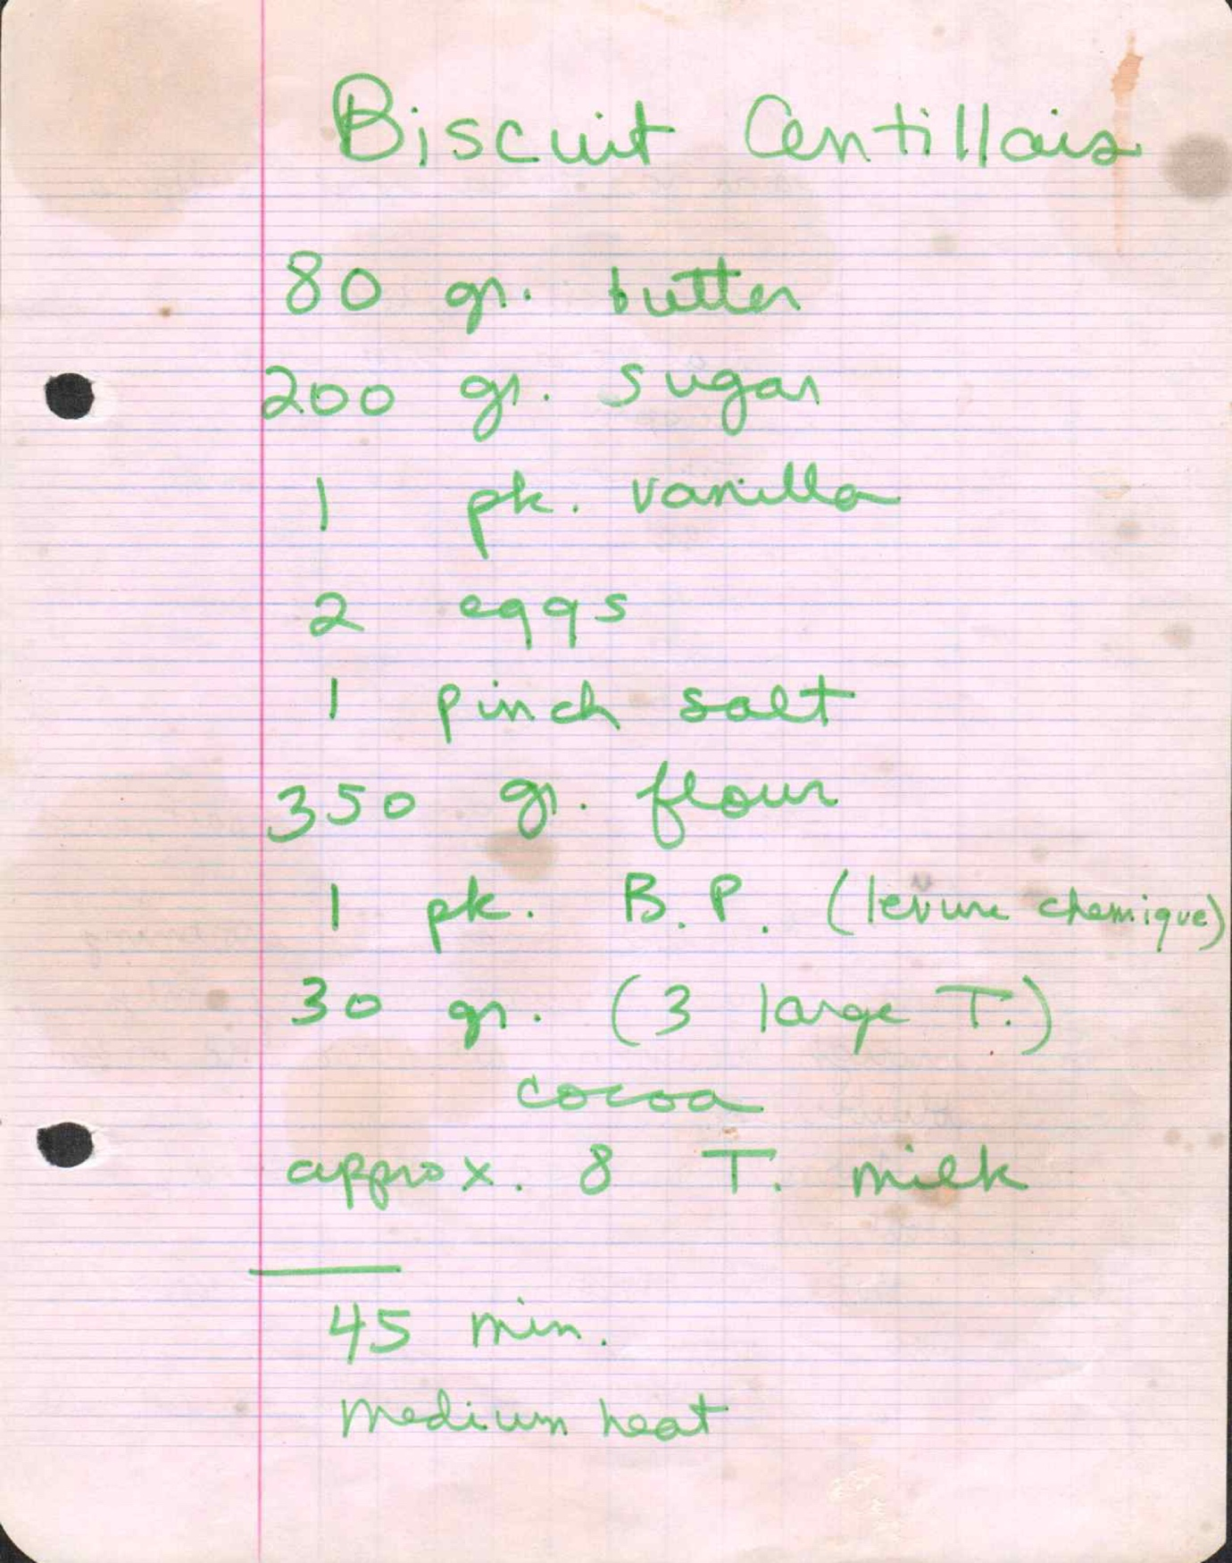

Ingredients
80 g. butter
200 g. sugar
1 pk. vanilla
2 eggs
1 pinch salt
350 g. flour
1 pk. B.P. (levure chimique)
30 g. (3 large T.) cocoa

Directions
Approx. 8 T. milk
45 min. medium heat

Banana, Blueberry Muffins

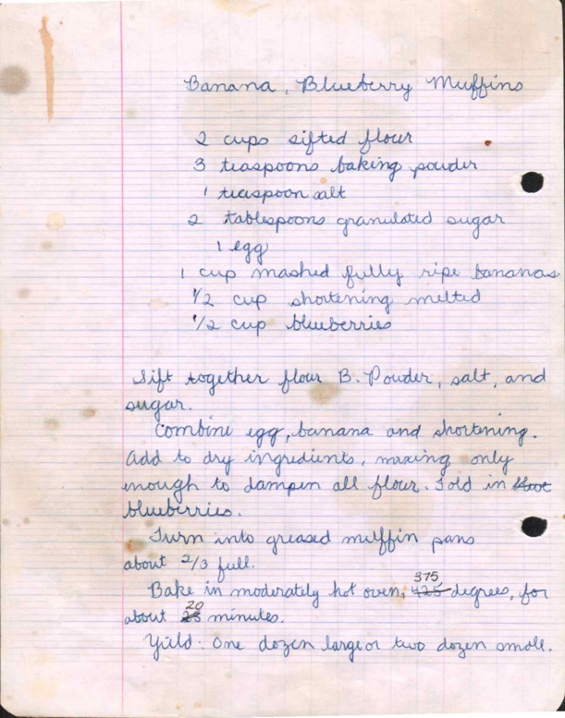

Ingredients
2 cups sifted flour
3 teaspoons baking powder
1 teaspoon salt
2 tablespoons granulated sugar
1 egg
1 cup mashed fully ripe bananas
½ cup shortening melted
½ cup blueberries

Directions
Sift together flour, B. Powder, salt, and sugar.
Combine egg, banana and shortening. Add to dry ingredients, mixing only enough to dampen all flour. Fold in blueberries.
Turn into greased muffin pans about ⅔ full.
Bake in moderately hot oven, 375 degrees, for about 25 minutes.
Yield: One dozen large or two dozen small.

Rolls

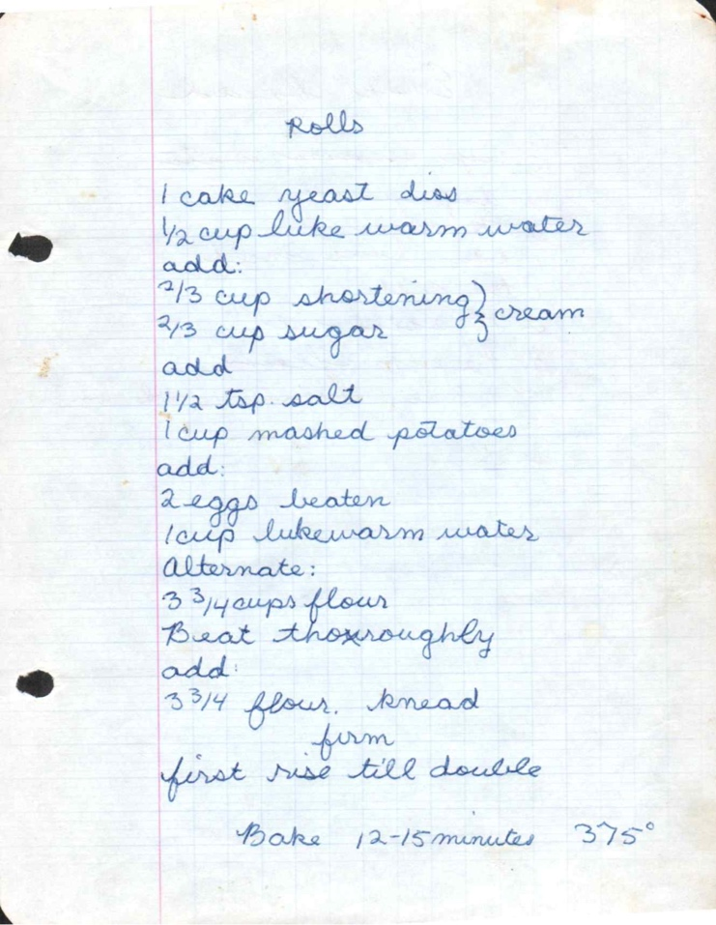

Ingredients
1 cake yeast dissolved
½ cup lukewarm water
add:
⅔ cup shortening, cream
⅔ cup sugar
add
1½ tsp. salt
1 cup mashed potatoes
add:
2 eggs beaten
1 cup lukewarm water
Alternate:
3¾ cups flour
Beat thoroughly. Add: 3¾ flour, knead, form

Directions
First rise till double
Bake 12-15 minutes 375°

Evap Bread

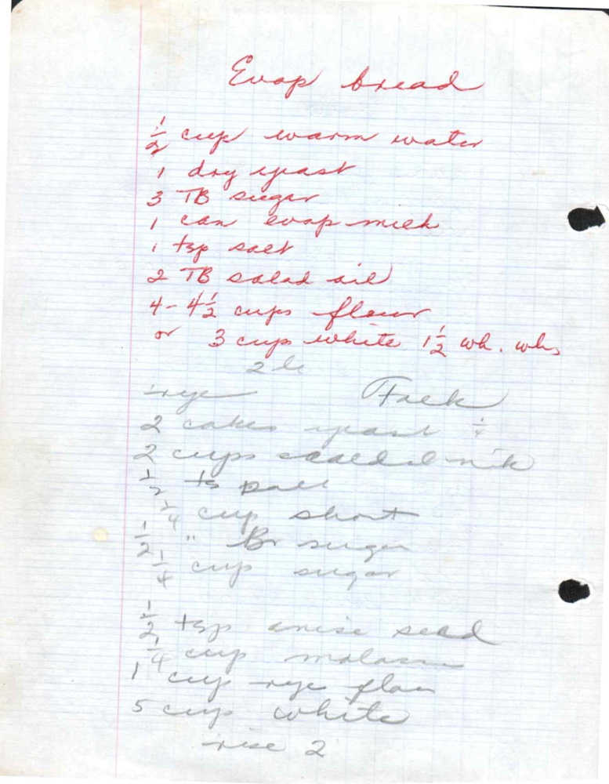

Ingredients
½ cup warm water
1 dry yeast
3 TB sugar
1 can Evap milk
1 tsp salt
2 TB salad oil
4-4½ cups flour
or 3 cups white 1½ wh. wh. (Z.L.)

Directions - Fresh
2 cakes yeast
2 cups salad milk
½ TB purr
1 cup short
¼ cup brown sugar
½ cup sugar
½ tsp anise seed
¼ cup molasses
1 cup rye flour
5 cup white rye 2

Coffee Bread

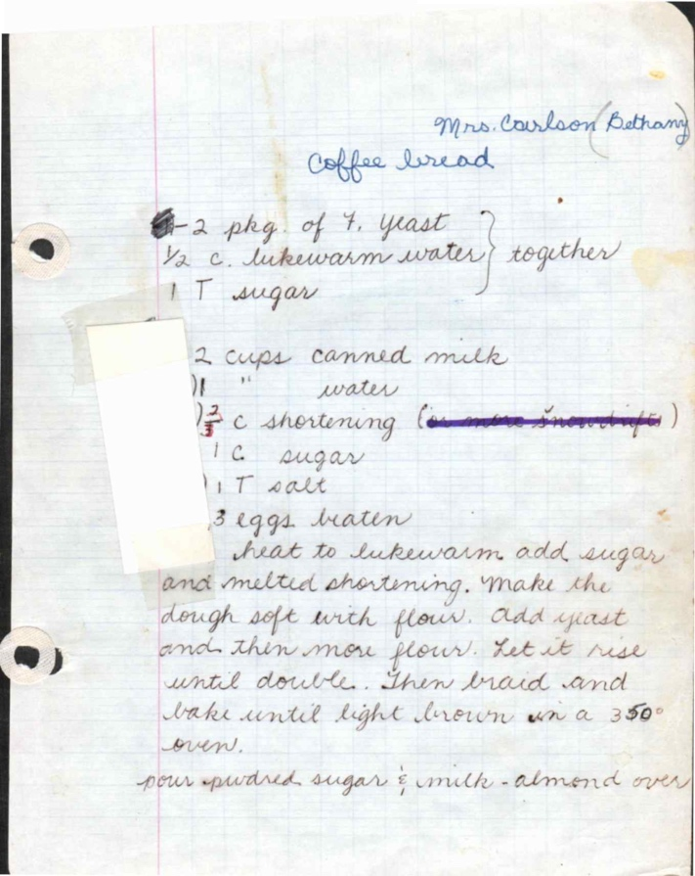
From: Mrs. Carlson Bethany

Ingredients
2 pkg. of ½ yeast
½ c. lukewarm water, together
1 T sugar
2 cups canned milk
II " water
⅔ c shortening (supposedly shortening)
1 c. sugar
1, T salt
3 eggs beaten

Directions
heat to lukewarm, add sugar and melted shortening. Make the dough soft with flour. Add yeast and then more flour. Let it rise until double. Then braid and bake until light brown on a 350° oven.
pour powdered sugar & milk - almost over

Flat Brod

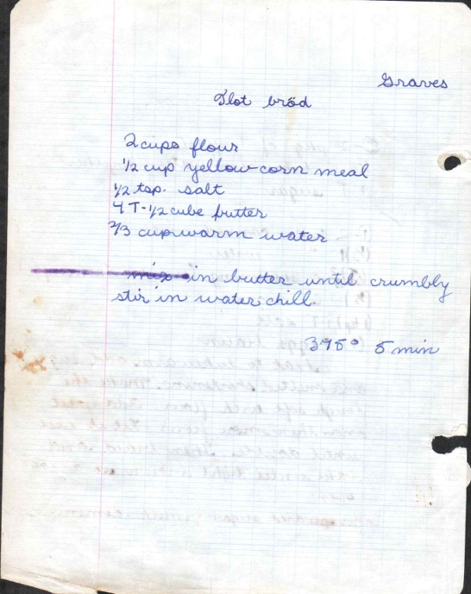
From: Graves

Ingredients
2 cups flour
½ cup yellow corn meal
½ tsp. salt
4 T - ½ cube butter
⅔ cup warm water

Directions
mix in butter until crumbly, stir in water, chill.
375° - 5 min.

Lefse 3

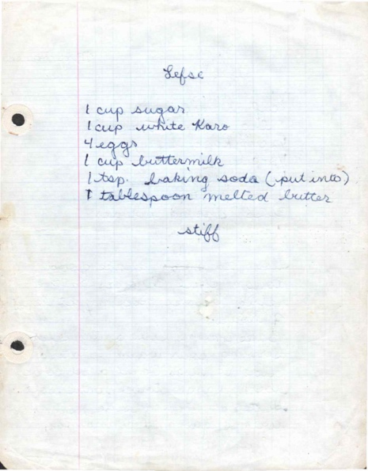

Ingredients
1 cup sugar
1 cup white Karo
4 eggs
1 cup buttermilk
1 tsp. baking soda (put into)
1 tablespoon melted butter

Directions
stiff

Lefse 4

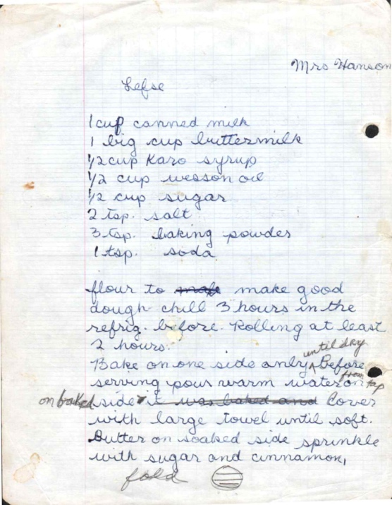
From: Mrs. Hanson

Ingredients
1 cup canned milk
1 big cup buttermilk
½ cup Karo syrup
½ cup wesson oil
½ cup sugar
2 tsp. salt
3 tsp. baking powder
1 tsp. soda

Directions
flour to make good dough chill 3 hours in the refrig. before. Rolling at least 2 hours.
Bake on one side and butter on baked side & it was aired and cover with large towel until soft. Butter on baked side sprinkle with sugar and cinnamon, fold

Doughnuts

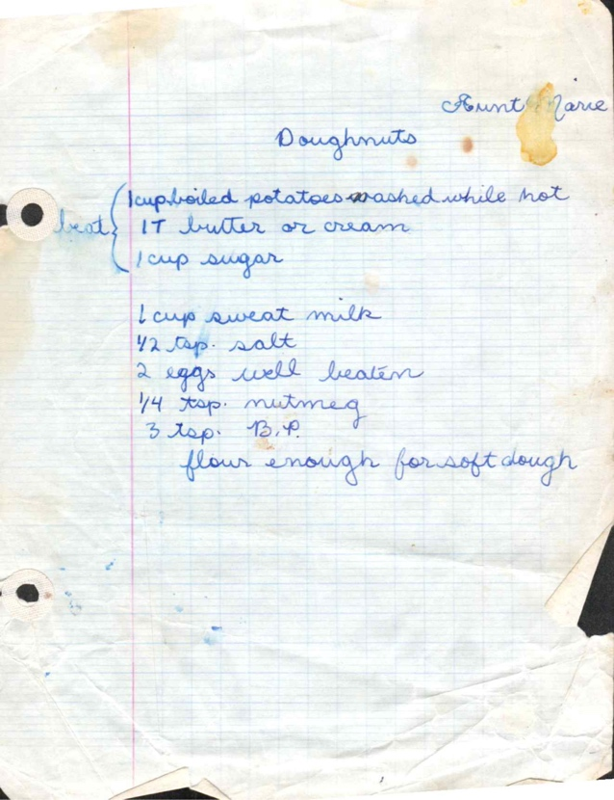
From: Aunt Jane

Ingredients
1 cup boiled potatoes washed while hot
1 T butter or cream
1 cup sugar
1 cup sweet milk
½ tsp. salt
2 eggs well beaten
¼ tsp. nutmeg
3 tsp. B.P.

Directions
flour enough for soft dough

