Crumb Muffins

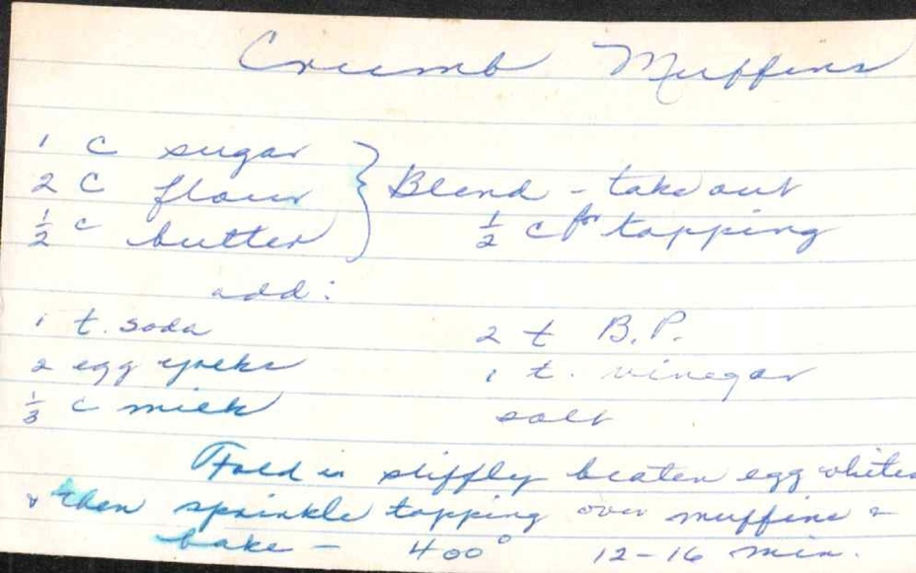

Ingredients
1 c. sugar
2 c. flour - Beene - take out ½ c for topping
½ c. butter
add:
1 t. soda (2 t. B.P.)
2 egg yolks (1 t. vinegar)
⅔ c. milk (salt)

Directions
Fold in stiffly beaten egg whites, then sprinkle topping over muffins & bake - 400° - 12-16 min.

Biscuits

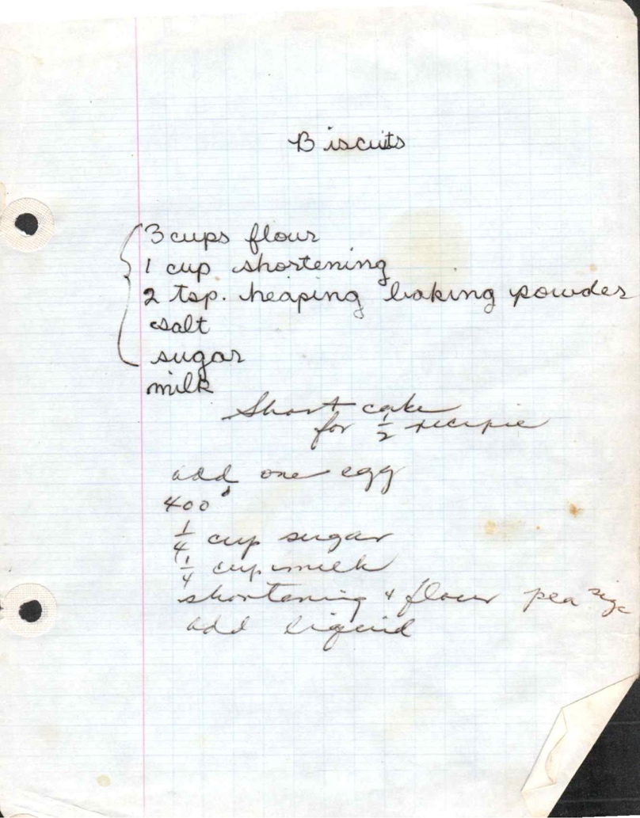

Ingredients
Combine:
- 3 cups flour
- 1 cup shortening
- 2 tsp. heaping baking powder
- salt
- sugar

Add : milk
Short-cake for 1/2 recipe
add one egg
400°
¼ cup sugar
¾ cup milk
shortening & flour per 2½ add liquid

Oatmeal Muffins

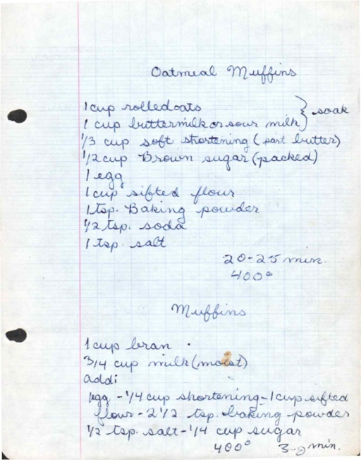

Ingredients
1 cup rolled oats - soak
1 cup buttermilk or sour milk
⅓ cup soft shortening (part butter)
½ cup brown sugar (packed)
1 egg
1 cup sifted flour
1 tsp. baking powder
½ tsp. soda
1 tsp. salt

Directions
20-25 min.
400°

Bran Muffins


Ingredients:
1 cup bran
¾ cup milk (moist)
add:
egg - ¼ cup shortening - 1 cup sifted
flour - 2½ tsp. baking powder
½ tsp. salt - ¼ cup sugar
400° 3-5 min.

Tracy Muffins

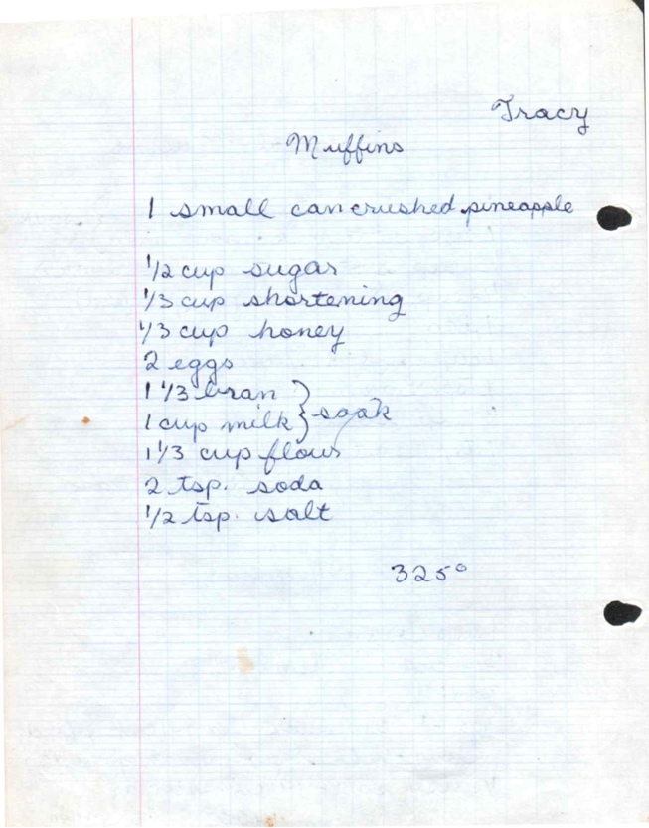
From: Tracy

Ingredients
1 small can crushed pineapple
½ cup sugar
⅓ cup shortening
⅓ cup honey
2 eggs
1⅓ bran - soak
1 cup milk
1⅓ cup flour
2 tsp. soda
½ tsp. salt

Directions
325°

Date Bread

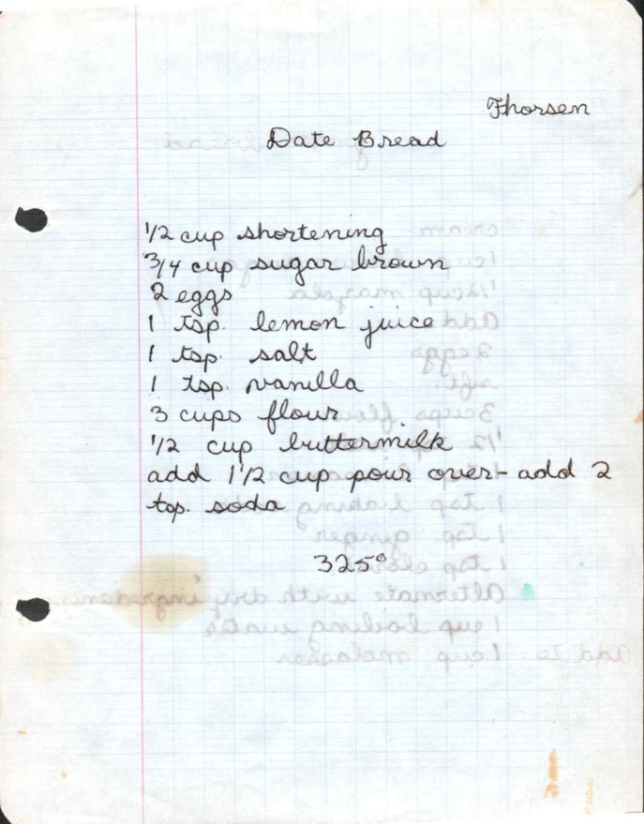
From: Thorsen

Ingredients
½ cup shortening
¾ cup sugar brown
2 eggs
1 tsp. lemon juice
1 tsp. salt
1 tsp. vanilla
3 cups flour
½ cup buttermilk

Directions
add 1½ cup pour over - add 2 tsp. soda
325°

Ginger Bread

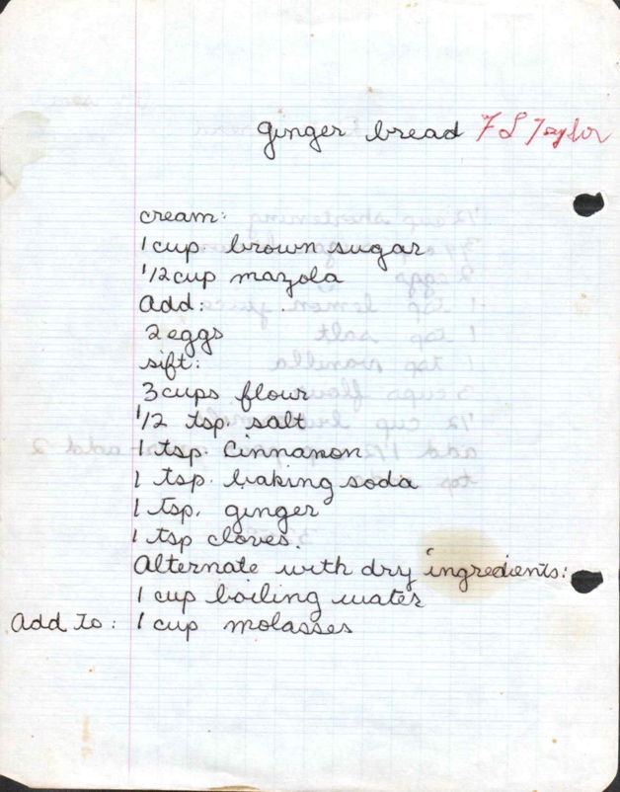
From: F.S./Taylor

Ingredients
cream:
1 cup brown sugar
½ cup margarine
Add:
2 eggs
sift:
3 cups flour
½ tsp. salt
1 tsp. cinnamon
1 tsp. baking soda
1 tsp. ginger
1 tsp. cloves

Directions
Alternate with dry ingredients:
1 cup boiling water
Add to: 1 cup molasses

Waffles (Dad’s)

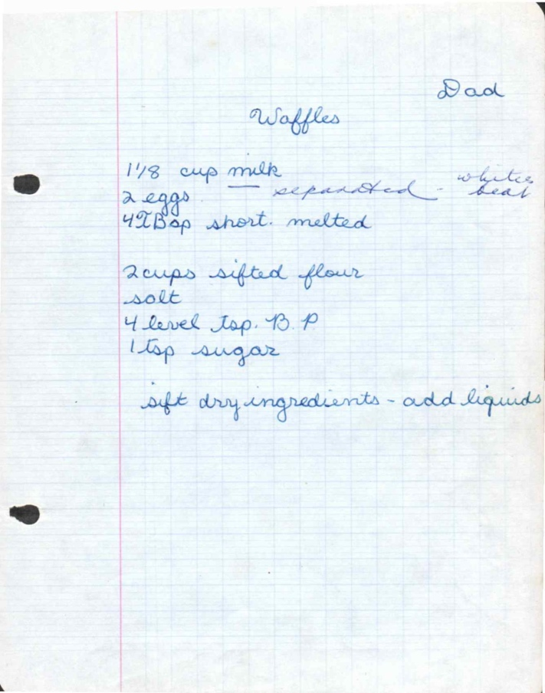
From: Dad (Janice’s Dad?)

Ingredients
1⅛ cup milk (whites)
2 eggs - separated - beat
4 Tbsp short. melted
2 cups sifted flour
salt
4 level tsp. B. P.
1 tsp sugar

Directions
sift dry ingredients - add liquids

Dutch Babies

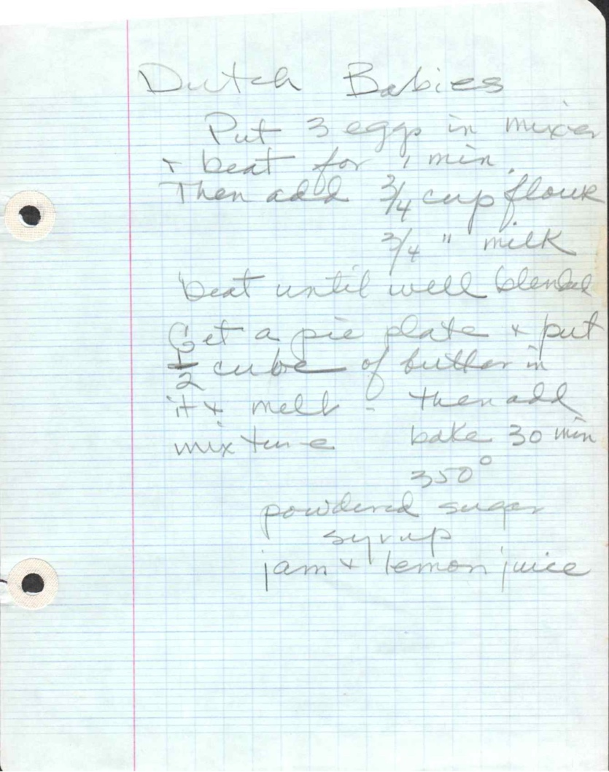

Directions
Put 3 eggs in mixer & beat for 4 min.
Then add ¾ cup flour
¾ " milk
beat until well blended
Get a pie plate & put ½ cube of butter in
it - melt - then add mixture - bake 30 min
350°
powdered sugar
syrup
jam & lemon juice

Whole Wheat Bread

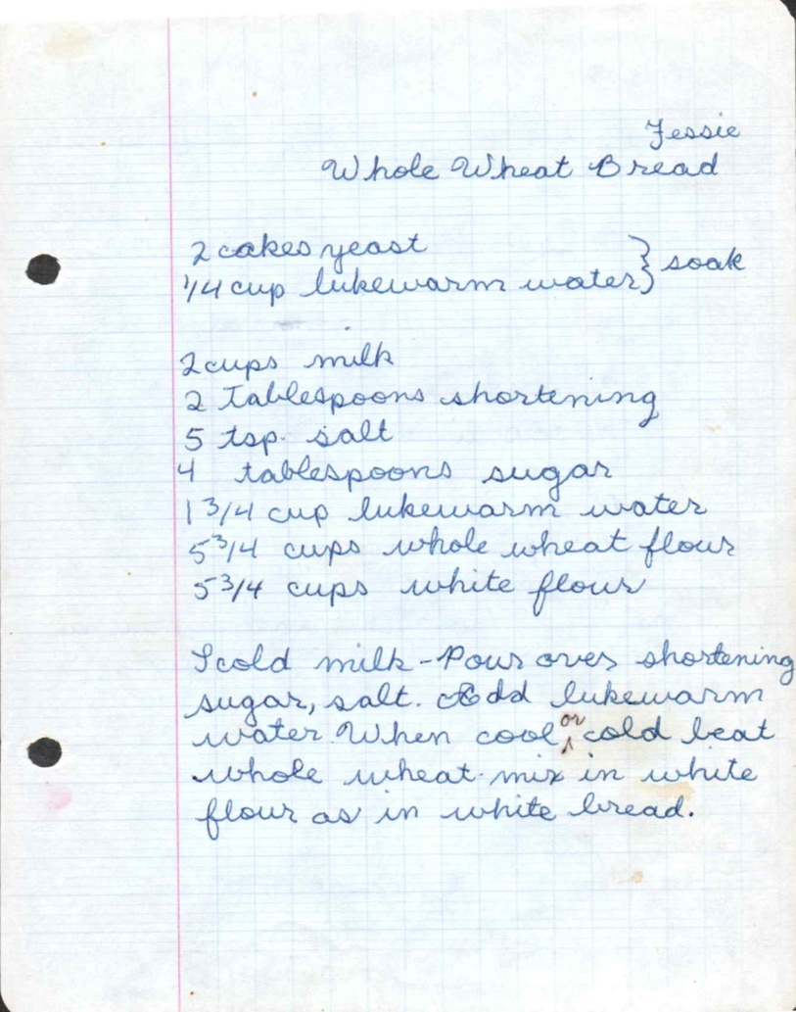
From: Jessie

Ingredients
2 cakes yeast - soak
¼ cup lukewarm water
2 cups milk
2 tablespoons shortening
5 tsp. salt
4 tablespoons sugar
1¾ cup lukewarm water
5¾ cups whole wheat flour
5¾ cups white flour

Directions
Scald milk - Pour over shortening, sugar, salt. Add lukewarm water When cool, add beat whole wheat-mix in white flour as in white bread.

Bread (Aunt Virginia)

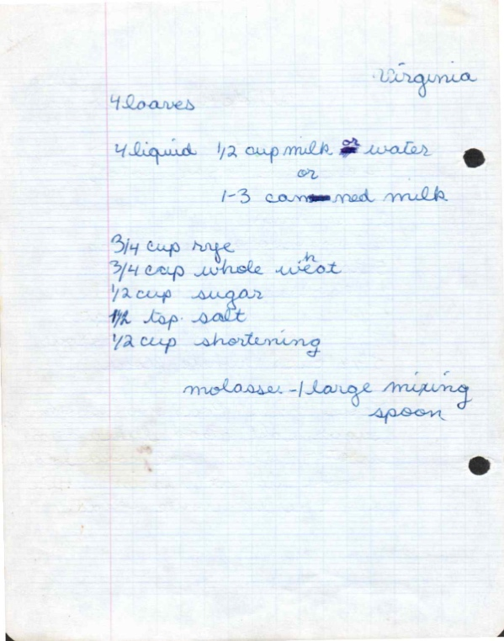
From: Virginia

Ingredients
4 liquid ½ cup milk & water
or
1-3 canned milk
¾ cup rye
¾ cup whole wheat
½ cup sugar
1½ tsp. salt
½ cup shortening

Directions
molasses - 1 large mixing spoon

Pancakes

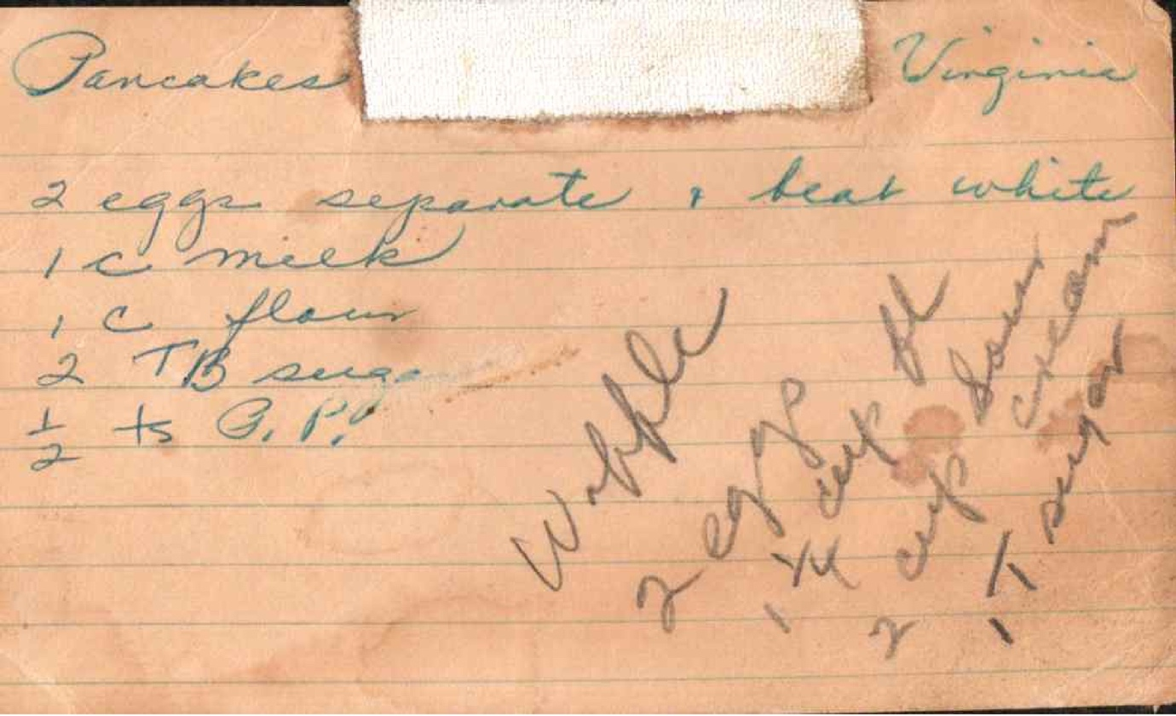
From: Virginia

Ingredients
2 eggs separate & beat white
1 c. milk
1 c. flour
2 Tb sug.
½ ts. G.P.

Directions
With [text unclear]

Waffles 2

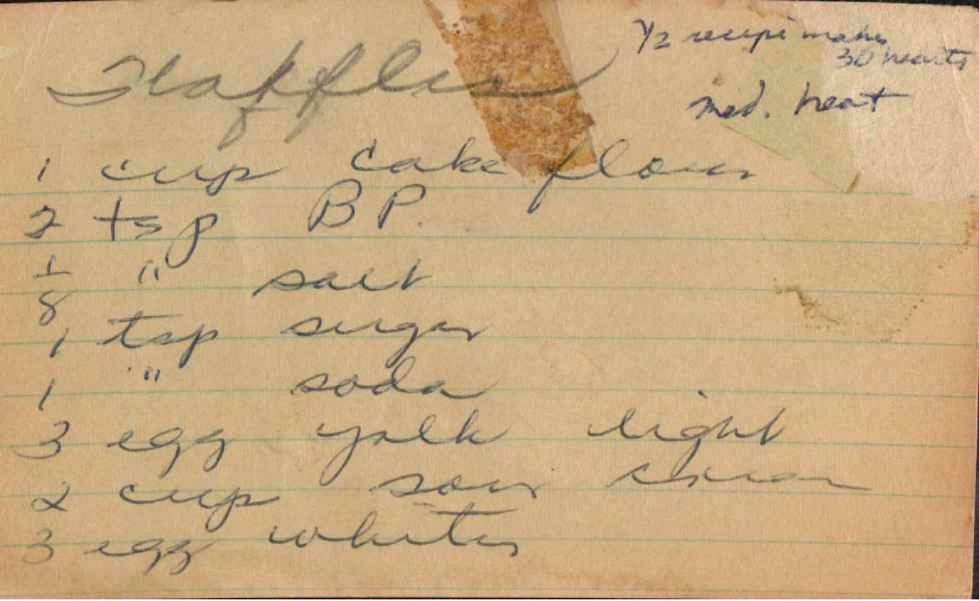

Ingredients
1 cup cake flour
3 tsp. B.P.
½ " salt
1 tsp. sugar
1 " soda
3 egg yolk light
2 cup sour churn
3 egg whites

Directions
½ cup melts
30 melts
red. heat

Velvet Waffles

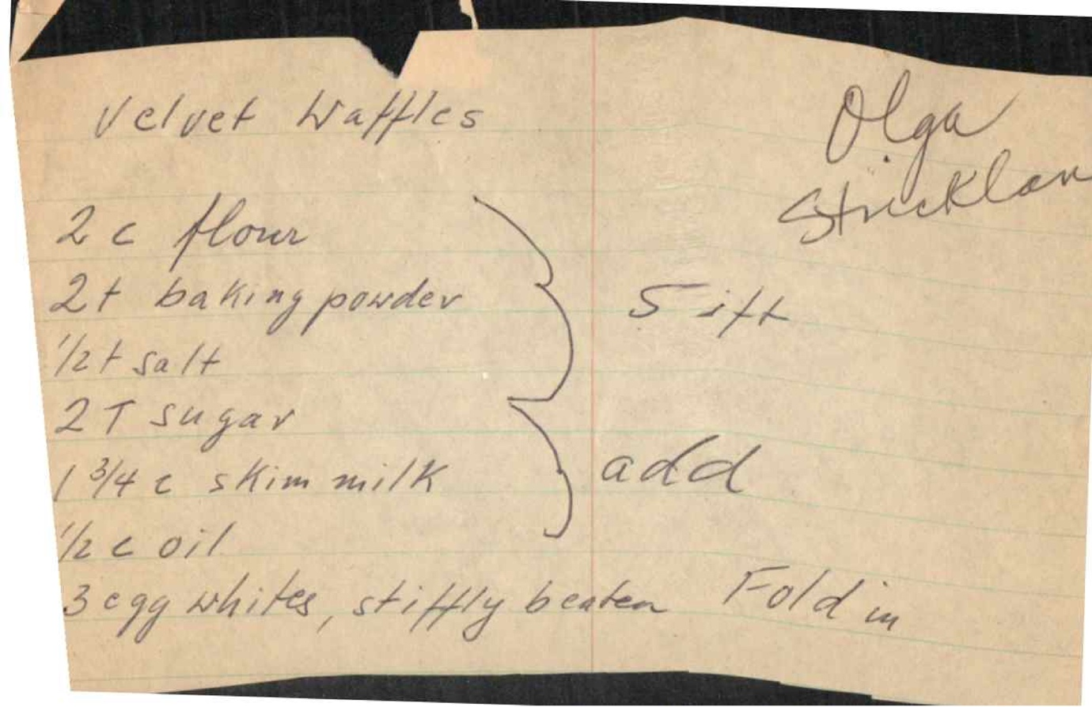
From: Olga Strickland

Ingredients
2 c. flour
2 t. baking powder
½ t. salt
2 T. sugar
1¾ c. skim milk
½ c. oil

Directions
3 egg whites, stiffly beaten - Fold in
Sift
add

Dutch Babies

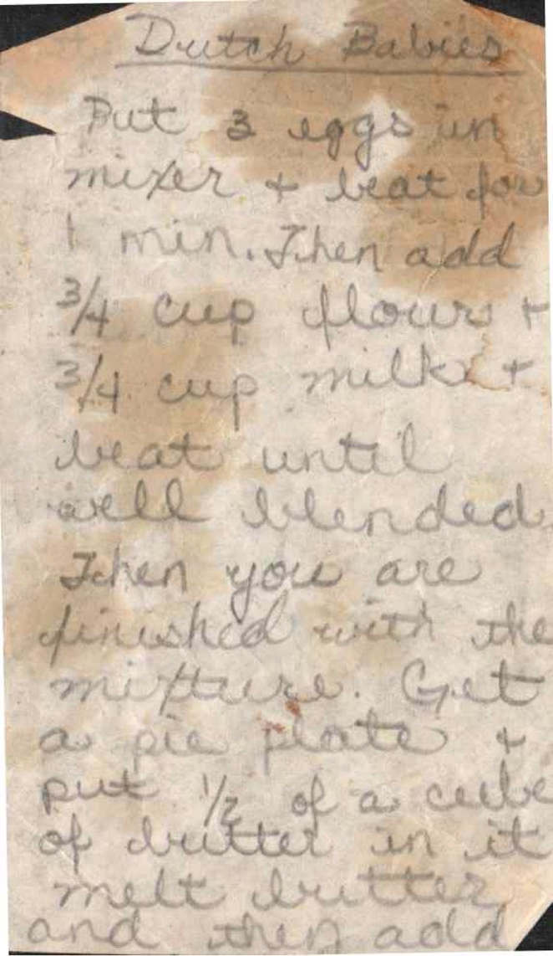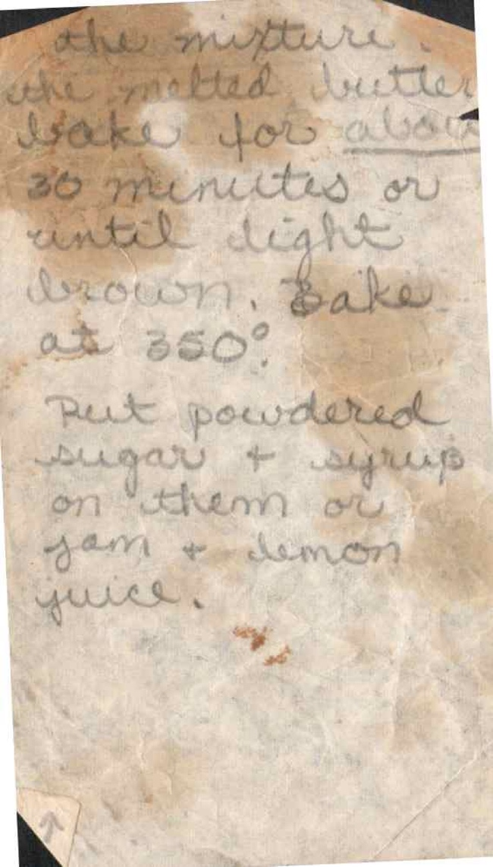

Directions
Put 3 eggs in mixer & beat for 4 min. Then add ¾ cup flour & ¾ cup milk & beat until well blended. Then you are finished with the mixture! Get a pie plate & put ¼ of a cube of butter in it, melt butter and then add
the mixture. the melted butter bakes for about 26 minutes or until light brown. Bake at 350°.
Put powdered sugar & syrup on them or jam & lemon juice.

