Kellogg's Bran Muffins

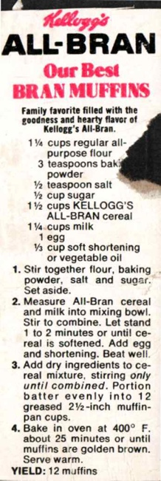

Ingredients
1¼ cups regular all-purpose flour
3 teaspoons baking powder
½ teaspoon salt
½ cup sugar
1½ cups KELLOGG'S ALL-BRAN cereal
1¼ cups milk
1 egg
⅓ cup soft shortening or vegetable oil

Directions
1. Stir together flour, baking powder, salt and sugar. Set aside.
2. Measure All-Bran cereal and milk into mixing bowl. Stir to combine. Let stand 1 to 2 minutes or until cereal is softened. Add egg and shortening. Beat well.
3. Add dry ingredients to cereal mixture, stirring only until combined. Portion batter evenly into 12 greased 2½-inch muffin-pan cups.
4. Bake in oven at 400° F. about 25 minutes or until muffins are golden brown. Serve warm.
YIELD: 12 muffins

Apple Banana Coffee Cake

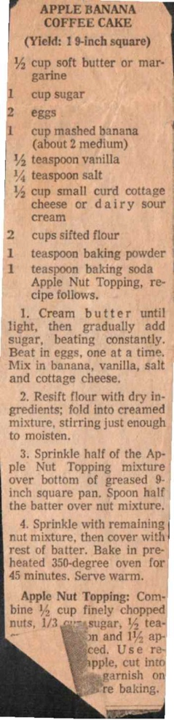

Ingredients
½ cup soft butter or margarine
1 cup sugar
2 eggs
1 cup mashed banana (about 2 medium)
½ teaspoon vanilla
¼ teaspoon salt
½ cup small curd cottage cheese or dairy sour cream
2 cups sifted flour
1 teaspoon baking powder
1 teaspoon baking soda
Apple Nut Topping, recipe follows.

Directions
1. Cream butter until light, then gradually add sugar, beating constantly. Beat in eggs, one at a time. Mix in banana, vanilla, salt and cottage cheese.
2. Resift flour with dry ingredients; fold into creamed mixture, stirring just enough to moisten.
3. Sprinkle half of the Apple Nut Topping mixture over bottom of greased 9-inch square pan. Spoon half the batter over nut mixture.
4. Sprinkle with remaining nut mixture, then cover with rest of batter. Bake in pre-heated 350-degree oven for 45 minutes. Serve warm. Yield: 1 9-inch square

Apple Nut Topping:
Combine ½ cup finely chopped nuts, ⅓ cup sugar, ½ teaspoon cinnamon and 1½ apples, diced. Use reserved apple, cut into thin slices, to garnish on top before baking.

Applesauce or Banana Doughnuts

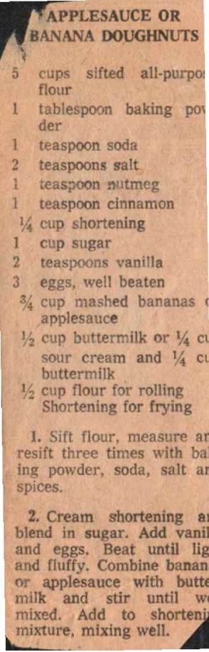

Ingredients
5 cups sifted all-purpose flour
1 tablespoon baking powder
1 teaspoon soda
2 teaspoons salt
1 teaspoon nutmeg
1 teaspoon cinnamon
¼ cup shortening Shortening for frying
1 cup sugar
2 teaspoons vanilla
3 eggs, well beaten
¾ cup mashed bananas or applesauce
½ cup buttermilk or ¼ cup sour cream and ¼ cup buttermilk
½ cup flour for rolling

Directions
1. Sift flour, measure and resift three times with baking powder, soda, salt and spices.
2. Cream shortening and blend in sugar. Add vanilla and eggs. Beat until light and fluffy. Combine bananas or applesauce with buttermilk and stir until well mixed. Add to shortening mixture, mixing well.

Norwegian Pancakes

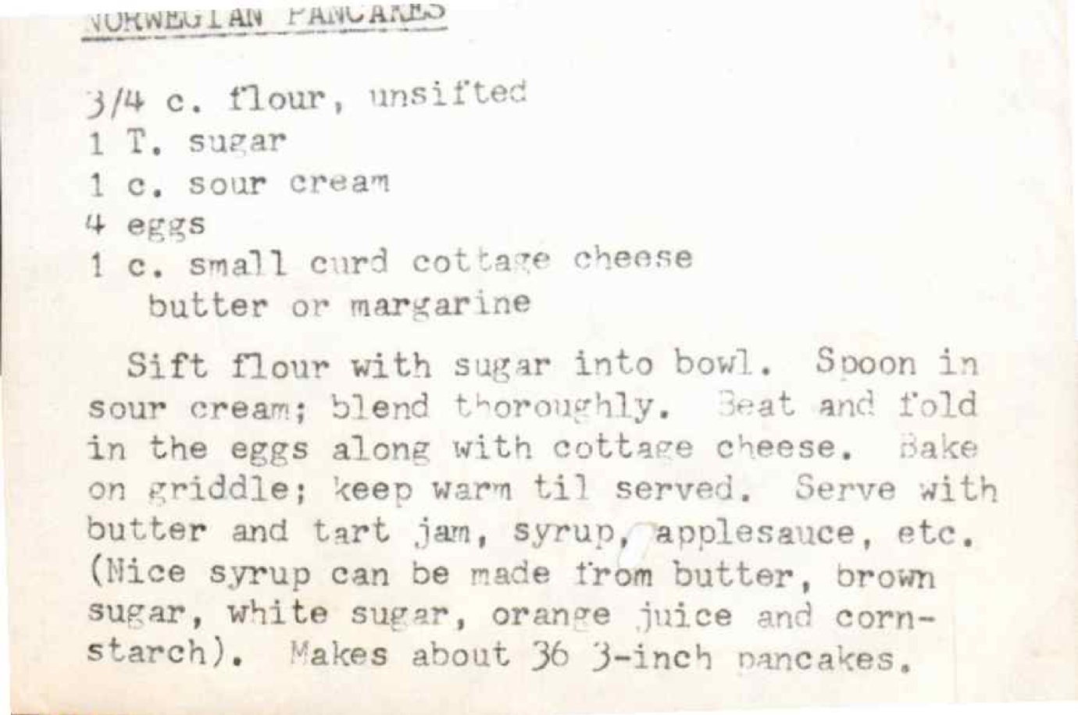

Ingredients
¾ c. flour, unsifted
1 T. sugar
1 c. sour cream
4 eggs
1 c. small curd cottage cheese butter or margarine

Directions
Sift flour with sugar into bowl. Spoon in sour cream; blend thoroughly. Beat and fold in the eggs along with cottage cheese. Bake on griddle; keep warm til served. Serve with butter and tart jam, syrup, applesauce, etc. (Nice syrup can be made from butter, brown sugar, white sugar, orange juice and cornstarch). Makes about 36 3-inch pancakes.

Cracked Wheat & Graham Bread

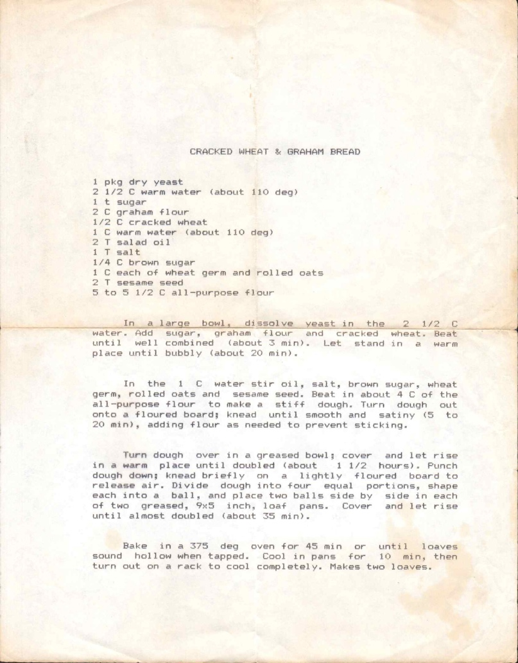

Ingredients
1 pkg dry yeast
2½ C warm water (about 110 deg)
1 t sugar
2 C graham flour
½ C cracked wheat
1 C warm water (about 110 deg)
2 T salad oil
1 T salt
¼ C brown sugar
1 C each of wheat germ and rolled oats
2 T sesame seed
5 to 5½ C all-purpose flour

Directions
In a large bowl, dissolve yeast in the 2½ C water. Add sugar, graham flour and cracked wheat. Beat until well combined (about 3 min). Let stand in a warm place until bubbly (about 20 min).
In the 1 C water stir oil, salt, brown sugar, wheat germ, rolled oats and sesame seed. Beat in about 4 C of the all-purpose flour to make a stiff dough. Turn dough out onto a floured board; knead until smooth and satiny (5 to 20 min), adding flour as needed to prevent sticking.
Turn dough over in a greased bowl; cover and let rise in a warm place until doubled (about 1½ hours). Punch dough down; knead briefly on a lightly floured board to release air. Divide dough into four equal portions, shape each into a ball, and place two balls side by side in each of two greased, 9x5 inch, loaf pans. Cover and let rise until almost doubled (about 35 min).
Bake in a 375 deg oven for 45 min or until loaves sound hollow when tapped. Cool in pans for 10 min, then turn out on a rack to cool completely. Makes two loaves.

Sourdough Starter & Pancakes

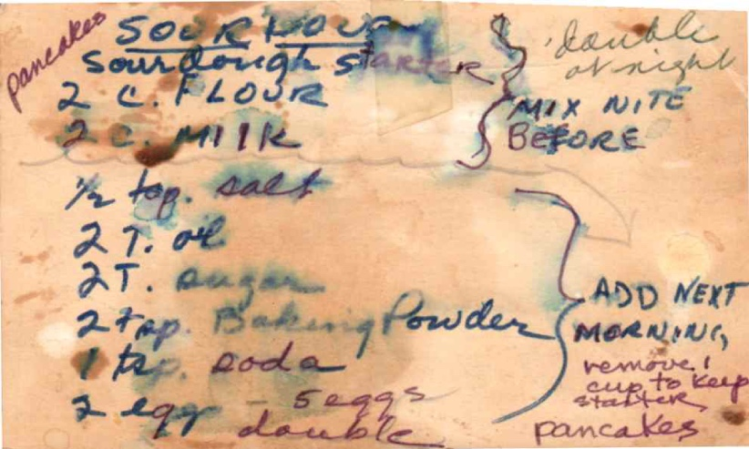

Sourdough Starter

Ingredients
Starter
2 c. flour
2 c. milk
½ tsp. salt
2 T. oil
2 T. sugar
Pancakes:
2 tsp. Baking Powder
1 tsp. soda
& egg - double

Directions
½ handle it right
mix nite before. Add next morning, remove 1 cup to keep starter

Apple Muffins

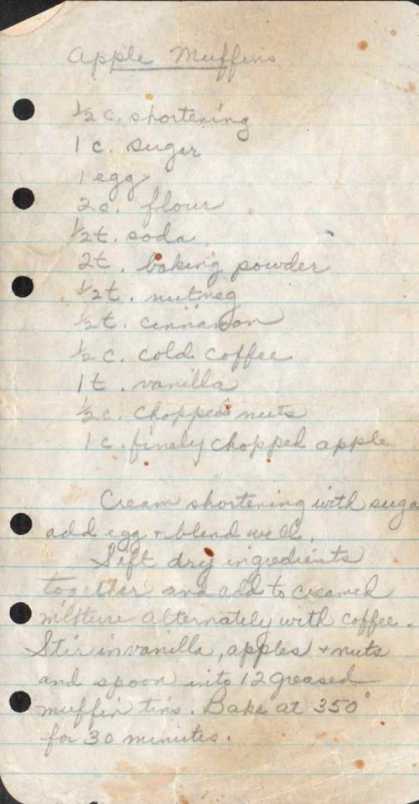

Ingredients
½ c. shortening
1 c. sugar
1 egg
2 c. flour
½ t. soda
2 t. baking powder
½ t. nutmeg
½ t. cinnamon
½ c. cold coffee
1 t. vanilla
½ c. chopped nuts
1 c. finely chopped apple

Directions
Cream shortening with sugar add egg + blend well. Sift dry ingredients together and add to creamed mixture alternately with coffee. Stir in vanilla, apples & nuts and spoon into 12 greased muffin tins. Bake at 350° for 30 minutes.

Crumb Muffins

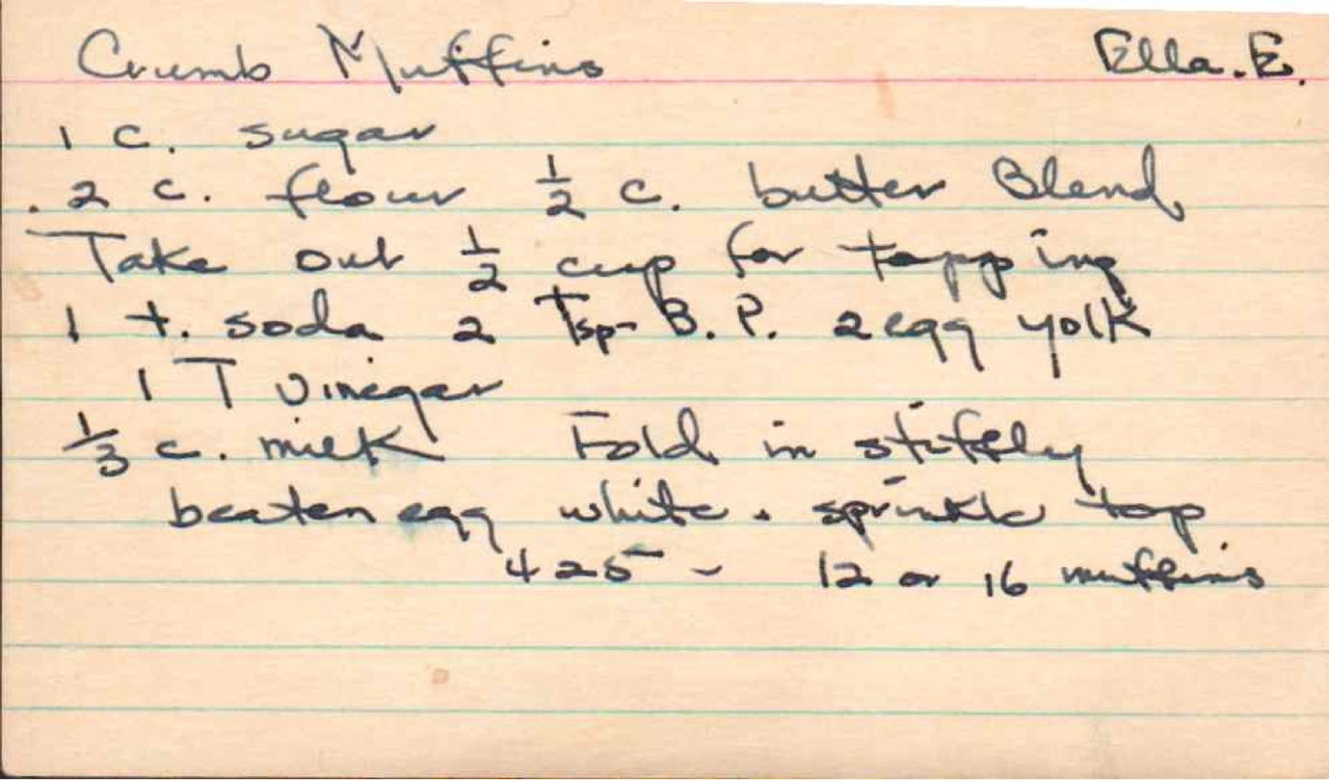
From: Ella B.

Ingredients
1 c. sugar
2 c. flour ½ c. butter blend
Take out ½ cup for topping
1 t. soda 2 tsp B.P. 2 egg yolk
1 T vinegar
⅔ c. milk! Fold in stiffly beaten egg white + sprinkle topping

Directions
425° - 12 or 16 muffins

Sour Cream Waffles

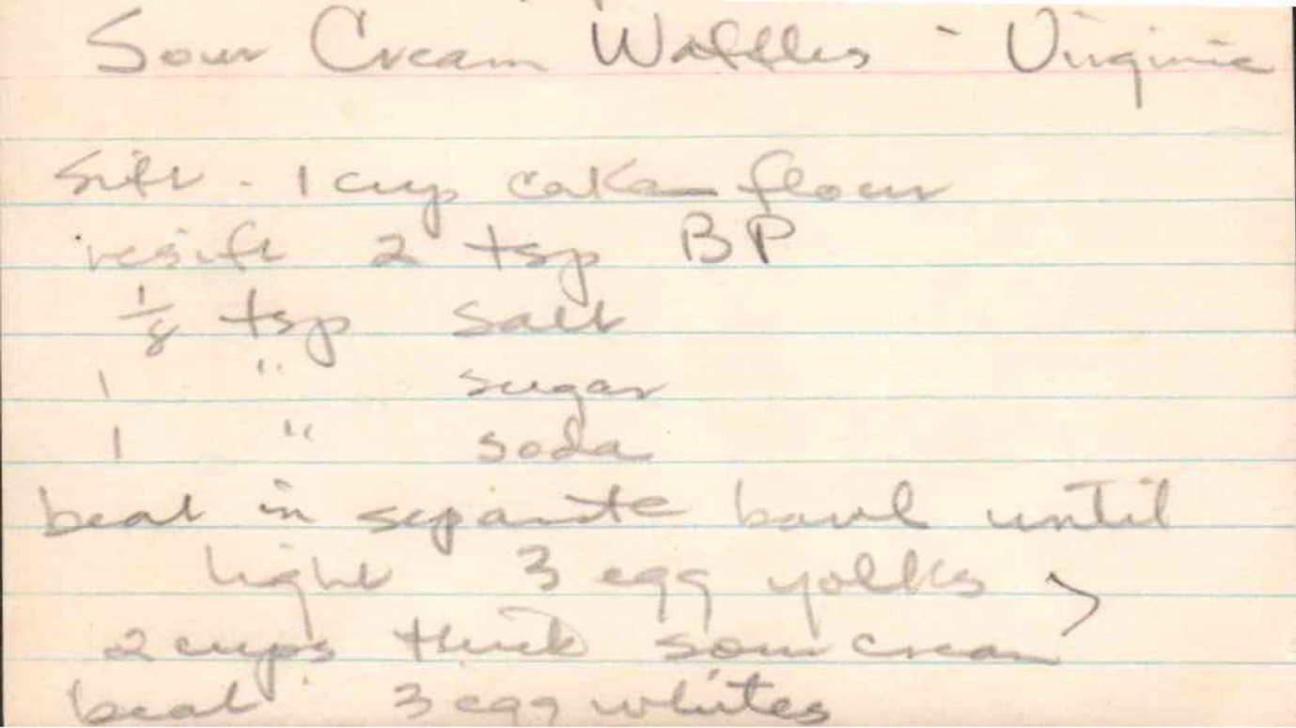
From: Virginia

Ingredients
Sift - 1 cup cake flour
inside 2 tsp B P
½ tsp salt
1 " sugar
1 " soda

Directions
beat in separate bowl until light 3 egg yolks
2 cups thick sour cream
beat! 3 egg whites

Buttermilk Pancakes

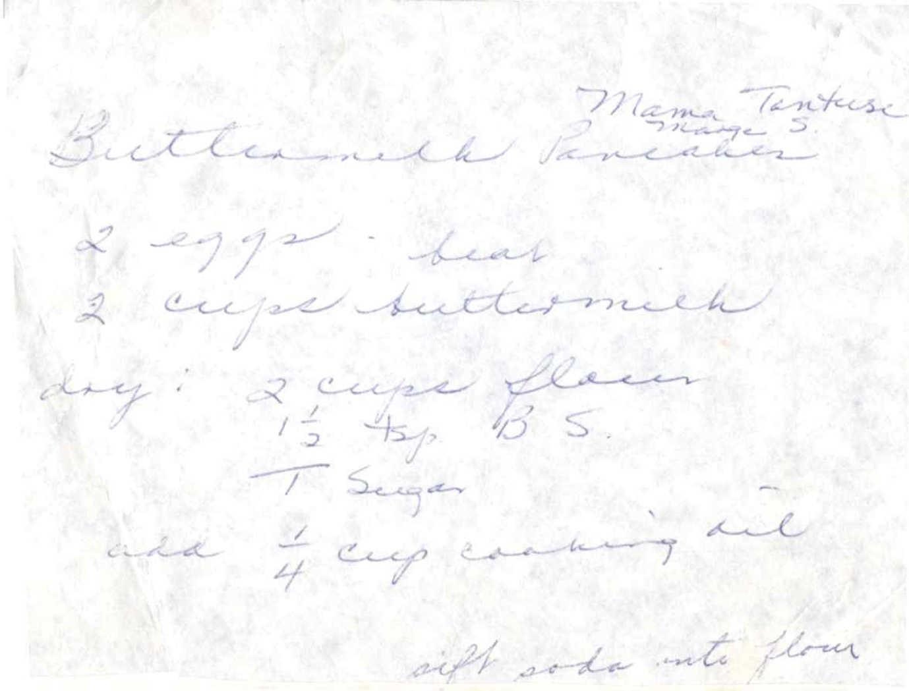
From: Mama Tentese Marge Stensrud’s Mom

Ingredients
2 eggs - beat
2 cups butter milk
dry: 2 cups flour
1½ tsp. B. S.
1 T sugar
add ¼ cup cooking oil

Directions
sift soda into flour

Vafler (Waffles)

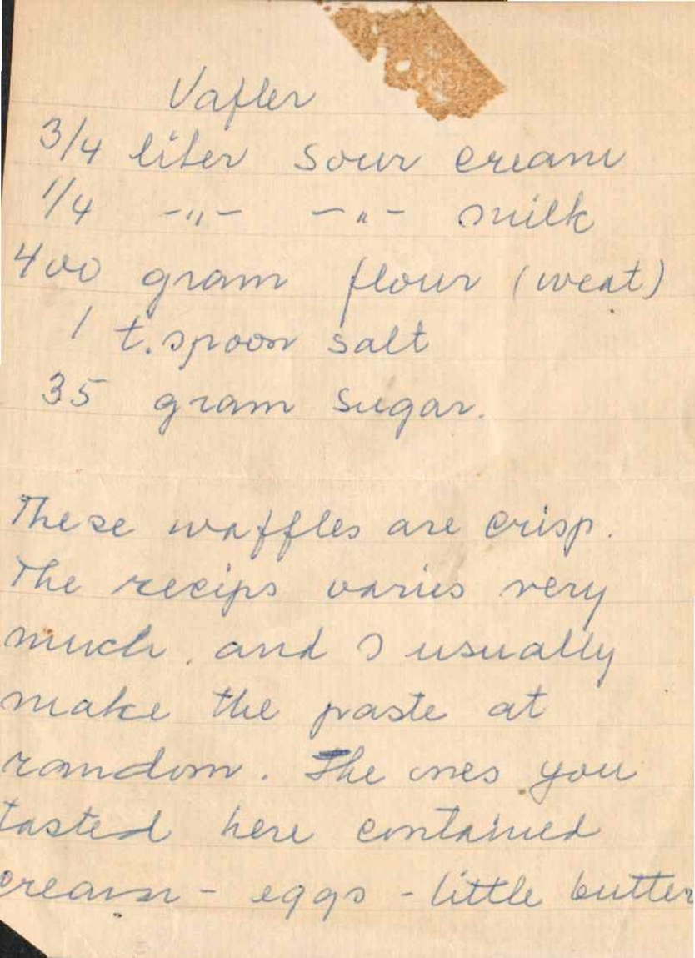

Ingredients
¾ liter sour cream
¼ " " milk
4 w gram flour (weat)
1 t. spoon salt
35 gram sugar

Directions
These waffles are crisp. The recipe varies very much, and I usually make the paste at random. The ones you tasted here continued cream - eggs - little butter

Herb Sour Cream Casserole Bread

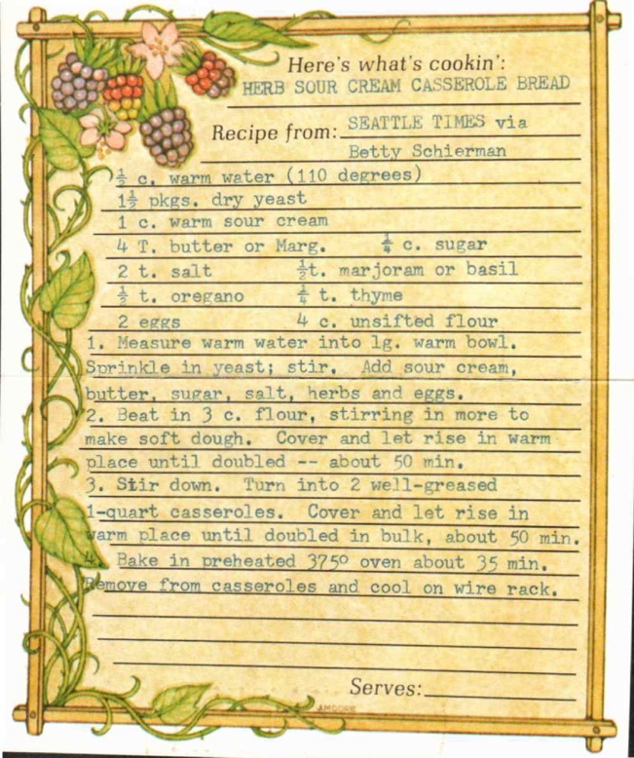
From: Seattle Times via Betty Schierman

Ingredients
½ c. warm water (110 degrees)
1½ pkgs. dry yeast
1 c. warm sour cream
4 T. butter or Marg.
⅓ c. sugar
2 t. salt
½ t. marjoram or basil
½ t. oregano
¼ t. thyme
2 eggs
4 c. unsifted flour

Directions
1. Measure warm water into lg. warm bowl. Sprinkle in yeast; stir. Add sour cream, butter, sugar, salt, herbs and eggs.
2. Beat in 3 c. flour, stirring in more to make soft dough. Cover and let rise in warm place until doubled -- about 50 min.
3. Stir down. Turn into 2 well-greased 1-quart casseroles. Cover and let rise in warm place until doubled in bulk, about 50 min.
4. Bake in preheated 375° oven about 35 min. Remove from casseroles and cool on wire rack.

Orange Bread / Cake

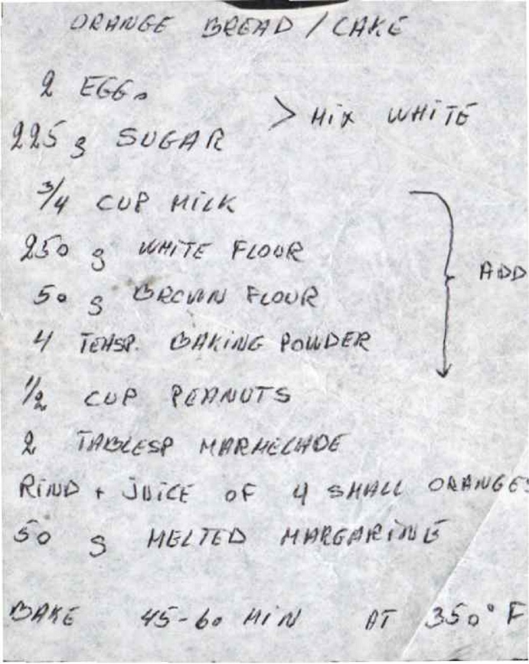

Ingredients
2 Eggs - Mix White
225 g Sugar
¾ cup Milk
250 g White Flour
50 g Brown Flour
4 Teaspoon Baking Powder
½ cup Peanuts
2 Tablespoon Marmalade
Rind + Juice of 4 Small Oranges
50 g Melted Margarine

Directions
Bake 45-60 min at 350° F

Anise Bread

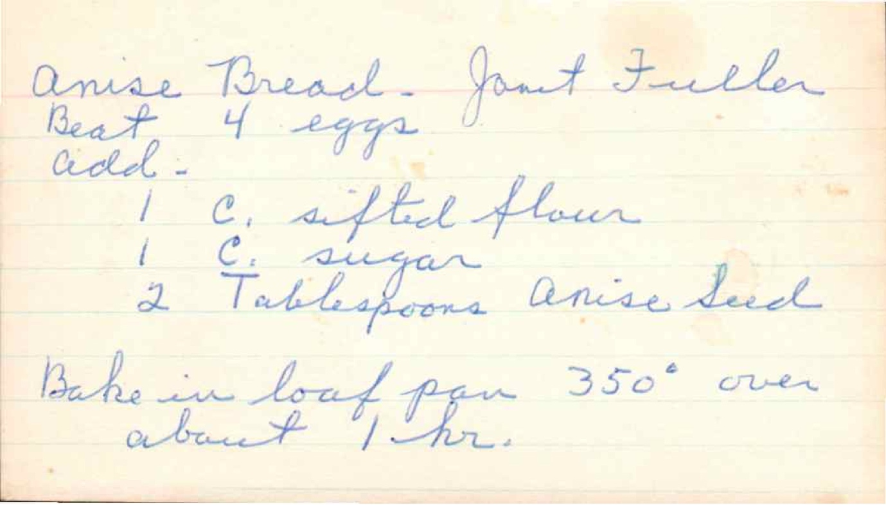
From: Janet Fuller

Ingredients
Beat 4 eggs
Add:
1 c. sifted flour
1 c. sugar
2 Tablespoons anise seed

Directions
Bake in loaf pan 350° over about 1 hr.

Almond Lemon Muffins

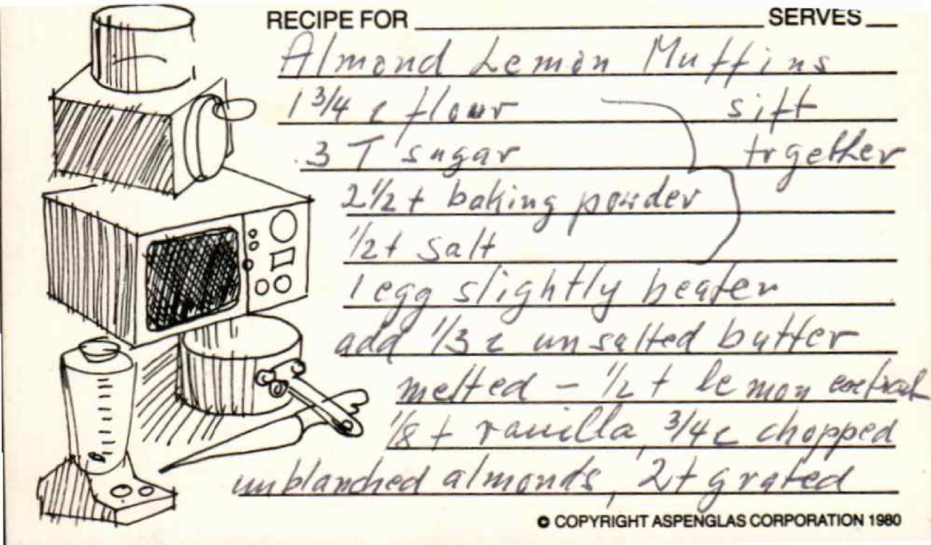

Ingredients
1¾ c flour - sift together
3 T sugar
2½ t baking powder
½ t salt
1 egg slightly beaten
add ⅔ c unsalted butter
melted - ½ t lemon extract
⅛ t vanilla ¾ c chopped
unblanched almonds 2 t grated

