Mrs. Hanson's Lefsa

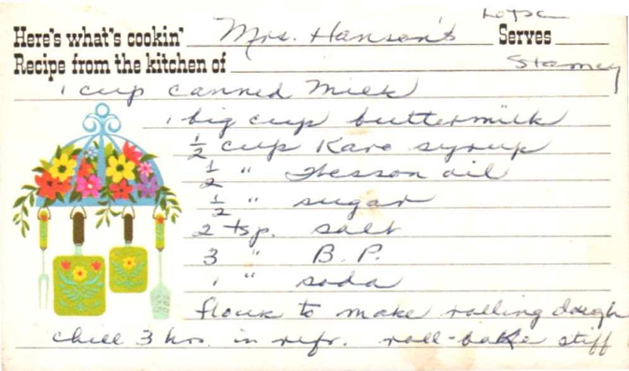
From: Stamey

Ingredients
1 cup canned milk
1 tsp cup buttermilk
½ cup Karo syrup
½ " Wesson oil
½ " sugar
2 tsp. salt
3 " B.P.
1 " soda
flour to make rolling dough

Directions
chill 3 hrs. in refr. roll-bake stiff

Brown Oatmeal Rolls (Bread)

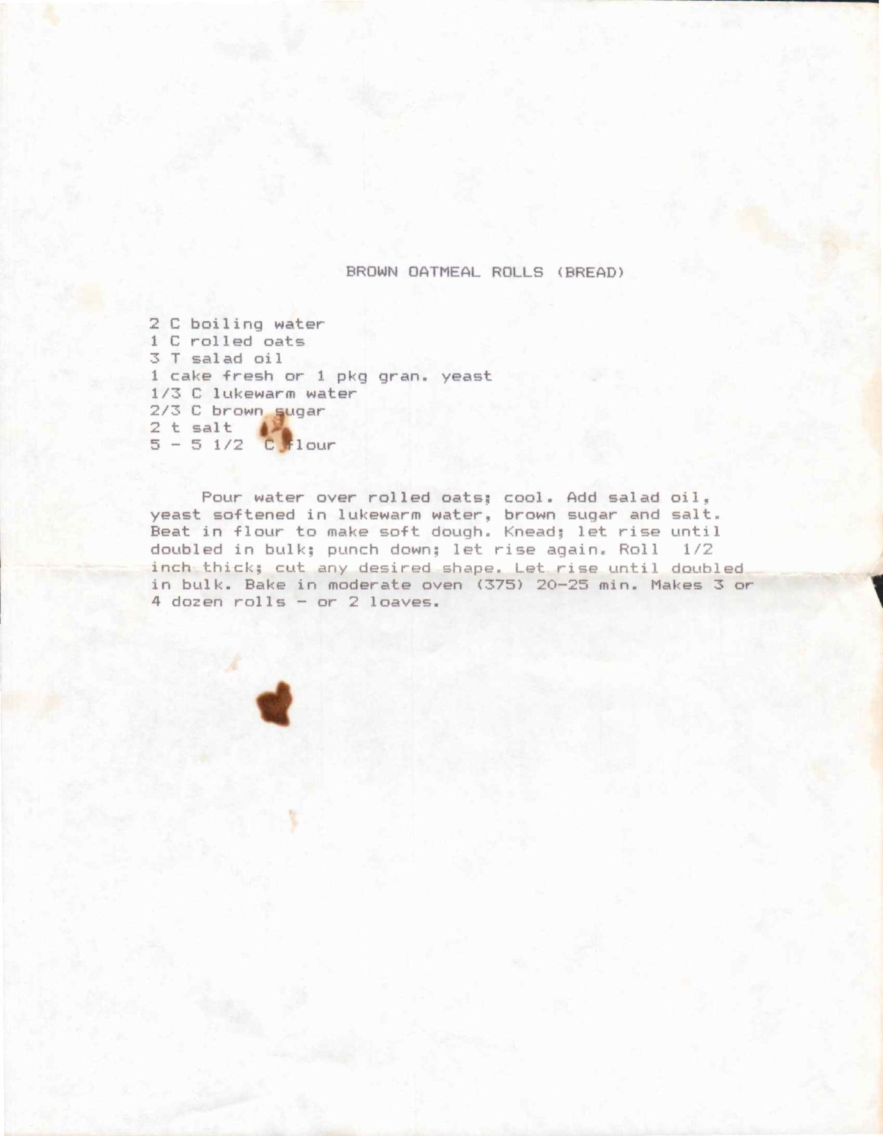

Ingredients
2 C boiling water
1 C rolled oats
3 T salad oil
1 cake fresh or 1 pkg gran. yeast
⅓ C lukewarm water
⅔ C brown sugar
2 t salt
5 - 5½ C flour

Directions
Pour water over rolled oats; cool. Add salad oil, yeast softened in lukewarm water, brown sugar and salt. Beat in flour to make soft dough. Knead; let rise until doubled in bulk; punch down; let rise again. Roll ½ inch thick; cut any desired shape. Let rise until doubled in bulk. Bake in moderate oven (375) 20-25 min. Makes 3 or 4 dozen rolls - or 2 loaves.

Portuguese Sweet Bread (Pão Doce)

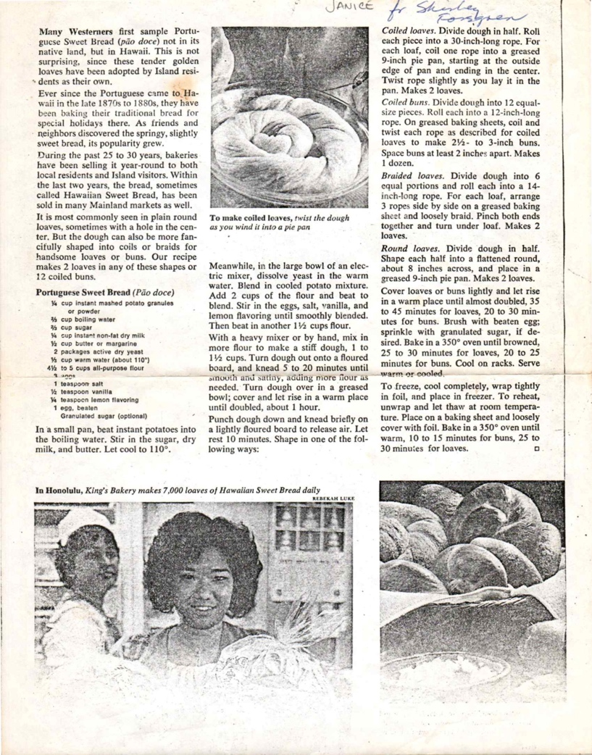
From: Janice & Shirley

Ingredients
¾ cup instant mashed potato granules or powder
⅔ cup boiling water
⅔ cup sugar
½ cup instant non-fat dry milk
½ cup butter or margarine
2 teaspoons salt
½ teaspoon lemon flavoring
1 egg, beaten
Granulated sugar (optional)

Directions
In a small pan, beat instant potatoes into the boiling water. Stir in the ⅔ cup sugar, dry milk, and butter. Let cool to 110°.
Meanwhile, in the large bowl of an electric mixer, dissolve yeast in the warm water. Blend in cooled potato mixture.
Add 2 cups of the flour and beat to blend. Stir in eggs, salt, and lemon flavoring until smoothly blended.
Then beat in another 1½ cups flour.
With a heavy mixer or by hand, mix in more flour to make a stiff dough, 1 to 1½ cups. Turn dough out onto a floured board; knead until smooth and satiny (5 to 20 minutes until smooth and satiny (5 to 20 minutes), adding flour as needed to prevent sticking.
Turn dough over in a greased bowl; cover and let rise in a warm place until doubled, about 1 hour.
Punch dough down and knead briefly on a lightly floured board to release air. Let rest 10 minutes. Shape in one of the following ways:
Coiled loaves:
Divide dough in half. Roll each piece into a 30-inch-long rope. For each loaf, coil one rope into a greased 9-inch pie pan, starting at the outside edge of pan and ending in the center. Twist rope slightly as you lay it in the pan. Makes 2 loaves.
Coiled buns:
Divide dough into 12 equal-size pieces. Roll each into a 12-inch-long rope. On greased baking sheets, coil and twist each rope as directed for coiled loaves to make 2½- to 3-inch buns. Space buns at least 2 inches apart. Makes 1 dozen.
Braided loaves:
Divide dough into 6 equal portions and roll each into a 14-inch-long rope. For each loaf, arrange 3 ropes side by side on a greased baking sheet and loosely braid. Pinch both ends together and turn under loaf. Makes 2 loaves.
Round loaves:
Divide dough in half. Shape each half into a flattened round, about 8 inches across, and place in a greased 9-inch pie pan. Makes 2 loaves.
Cover loaves or buns lightly and let rise in a warm place until almost doubled, 40 to 45 minutes for loaves, 20 to 30 minutes for buns. Brush with beaten egg; sprinkle with granulated sugar, if desired. Bake in a 350° oven until browned, 25 to 30 minutes for loaves, 20 to 25 minutes for buns. Cool on racks. Serve warm or cooled.
To freeze, cool completely, wrap tightly in foil, and place in freezer. To reheat, unwrap and let thaw at room temperature. Place on a baking sheet and loosely cover with foil. Bake in a 350° oven until warm, 10 to 15 minutes for buns, 25 to 30 minutes for loaves.

Lavender Almond Tree Cookies

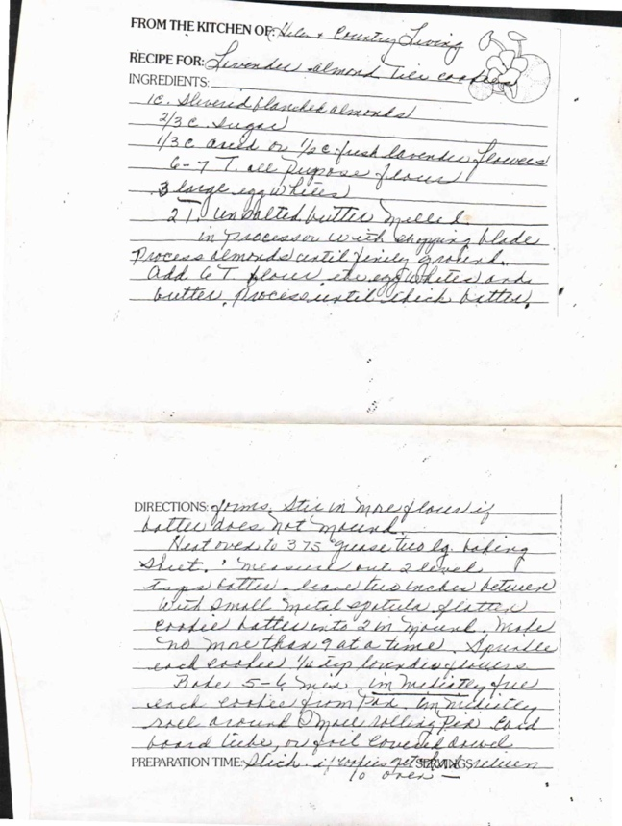
From: Helen & Everett Livesay

Ingredients
1 c. sliced/blanched almonds
⅔ c. sugar
⅓ c. milk or ¼ c. fresh lavender flowers
6-7 T. ice pops - as pressed
3 large egg whites
2½ unsalted butter, melted & well chilled

Directions
In processor with chopping blade:
Process almonds until finely grated. Add to 1 flour, stir in softened soda butter, process until check buttery.
Heat oven to 375° proceed by baking sheet. 1 numerous oven 2 droves. Tape: better - assume two snakes between which small metal spatula glitter evokes batter into 2 m spaced, makes 'no more than 9 at a time.' Sprinkle each cookies ¼ tsp lavender flowers. Bake 5-6 new. (in multitasking five reach cookies from etch. by millimeter, roll around a pencil, release bar left hand liches, or feel come the bread.
PREPARATION TIME: slice + espresso beets serves 10 doves

SW. Pancakes for 5

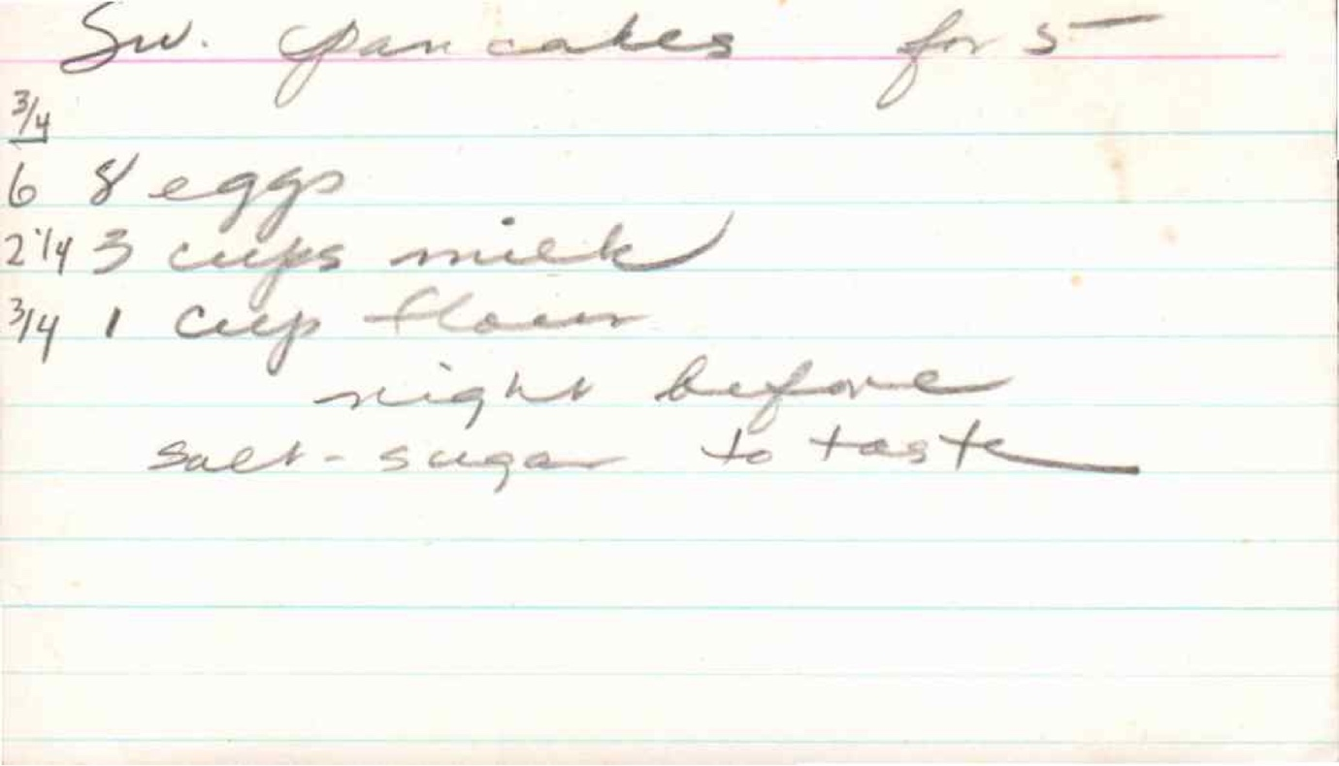

Ingredients
¾
6 & eggs
2¼ 3 cups milk
¾ 1 cup flour

Directions
night before
svet-sugar to taste

Marshmallow Sauce

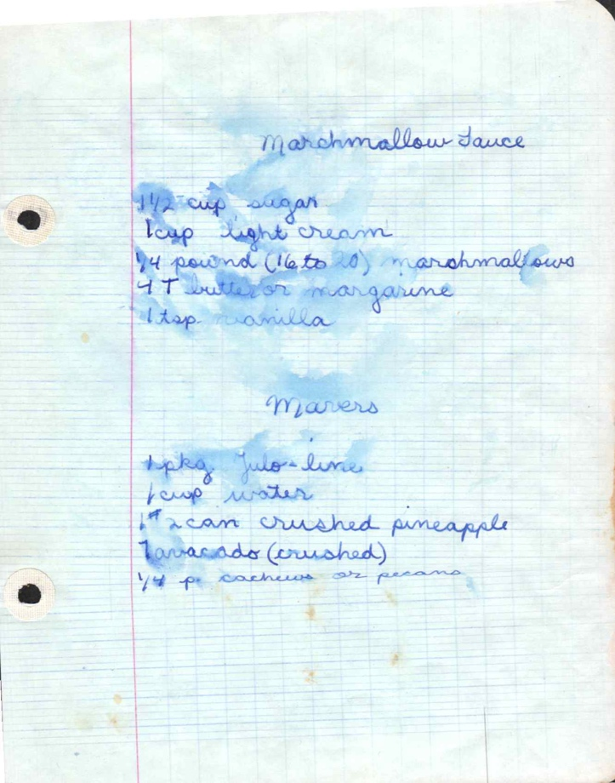

Ingredients
1½ cup sugar
½ cup light cream
¼ pound (16 to 20) marshmallows
4 T butter or margarine
1 tsp. vanilla

Directions
4 pkg. jello-lime
½ cup water
1# 2 can crushed pineapple
1 avacado (crushed)
¼ # cashews or pecans

Fruit Dressing

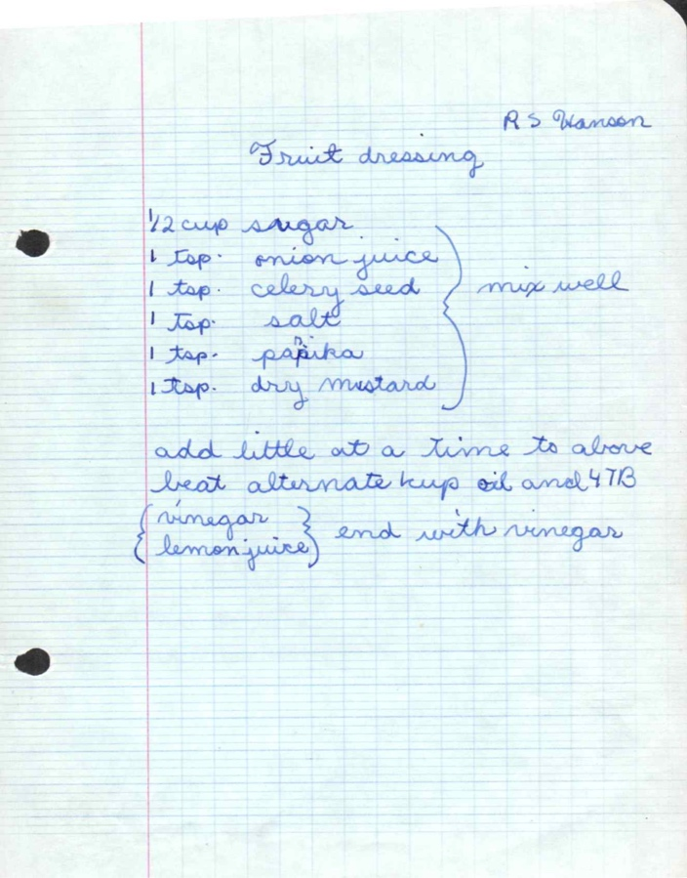
From: R S Hanson

Ingredients
½ cup sugar
1 tsp. onion juice
1 tsp. celery seed
1 tsp. salt
1 tsp. paprika
1 tsp. dry mustard

Directions
add little at a time to above
beat alternate 1 cup oil and 4 TB
(vinegar
lemon juice) end with vinegar

