Devil's Food
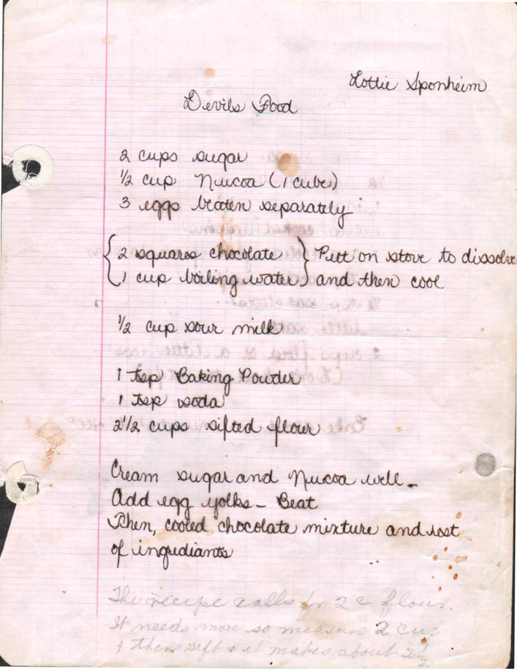
From: Lotte Sponheim

Ingredients
2 cups sugar
½ cup Nucoa (1 cube)
3 eggs beaten separately
2 squares chocolate (put on stove to dissolve)
1 cup boiling water (and then cool)
½ cup sour milk
1 teaspoon baking powder
1 teaspoon soda
2½ cups sifted flour

Directions
Cream sugar and Nucoa well. Add egg yolks - Beat. Then cooled chocolate mixture and rest of ingredients.
The recipe calls for 2 cups flour. It needs more so I make it 2½ cups. Then sift or I make more. 3 cups.

Raisin Cup Cakes
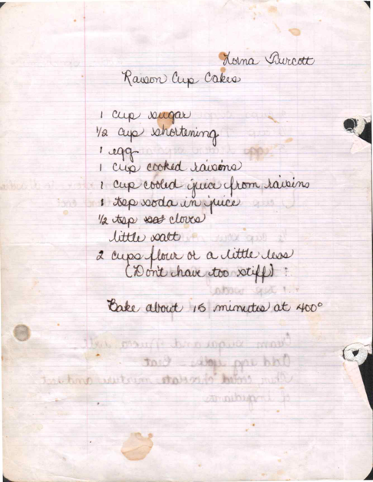
From: Lorna Turcott

Ingredients
1 cup sugar
½ cup shortening
1 egg
1 cup cooked raisins
1 cup cooled juice from raisins
1 teaspoon soda in juice
½ teaspoon salt cloves
Little salt
2 cups flour or a little less
(Don't have too stiff)

Directions
Bake about 15 minutes at 400°

