Program Specification

For Macro

CRV_CHECK

In Version 2.3

Check for discrepancies in CSR tables and listing reports.



Document Approvals

|  |  |  |  |  |
| --- | --- | --- | --- | --- |
| Iraj Mohebalian |  | Signature will be provided in QDoc by a document approval workflow. |  |  |
| Author (print or type) |  | Signature |  | Date |
| Phanikumar Tata |  | Signature will be provided in QDoc by a document approval workflow. |  |  |
| Validation Lead (print or type) |  | Signature |  | Date |
| Sascha Ahrweiler |  | Signature will be provided in QDoc by a document approval workflow. |  |  |
| Process Owner (print or type) |  | Signature (for Approval) |  | Date |

Revision History

|  |  |  |  |
| --- | --- | --- | --- |
| **Revision** | **Date** | **Author** | **Description of change** |
| 1.1 | 19Dec2018 | Iraj Mohebalian | Adapted to work with Swan. |
| 2.0 | 20Mar2020 | Iraj Mohebalian | Added check#10 and check#11 |
| 2.2 | 24Jan2023 | Iraj Mohebalian | Added check#12 |

Table of Contents

Document Approvals 1

Revision History 2

1. Purpose / Short Description of CRV_CHECK 5

2. User Requirements 5

2.1 Program / Tool / Macro Parameters 5

2.1.1 LIB 8

2.1.2 METADATA 8

2.1.3 CHECK1: Check for reports with undefined titles 8

2.1.4 CHECK2: Check for missing footnote references 9

2.1.5 CHECK3: Check for duplicate records in reports 9

2.1.6 CHECK4: Check report creation dates 9

2.1.7 CHECK5: Compare program file names against NAME parameter in %iniprog call 10

2.1.8 CHECK6: Check for empty reports 10

2.1.9 CHECK7: Check for missing %iniprog and/or %endprog calls 11

2.1.10 CHECK8: Check SAS log files 11

2.1.11 CHECK9: Check AE reports for discrepancies 12

2.1.12 CHECK10: Check Big N within each population group 12

2.1.13 CHECK11: Check for hardcoded libnames and formats 13

2.1.14 CHECK12: Check for reports with invalid values 13

2.1.15 CHECKX: Run study specific checks 14

2.1.16 RepORt_TYPE 14

2.1.17 fileFilter 14

2.1.18 COLORS 14

2.1.19 KEYWORD 15

2.1.20 FIRSTOBS 15

2.1.21 OBS 15

2.1.22 Search_column_header 15

2.1.23 TIMING_WinDOW 15

2.1.24 HELP 15

2.1.25 verbose 15

2.2 Checks and Error Handling 15

2.3 Processing Steps 17

2.4 Output Generation 17

2.5 Status 18

2.6 Constraints 19

3. %DocumentFinish 19

4. Appendix A: overall report structure 21

5. Appendix B: examples of footnote reference issues 22

6. APPENDIX C: example of a report with duplicate records 24

# Purpose / Short Description of CRV_CHECK

Check for discrepancies in CSR tables and listing reports.

# User Requirements

|  |  |
| --- | --- |
| Req. No. | Specification |
| 1 | Check for reports with undefined titles |
| 2 | Check for missing footnote references |
| 3 | Check for duplicate records in reports |
| 4 | Check report creation dates |
| 5 | Compare program file names against NAME parameter in %iniprog call |
| 6 | Check for empty reports |
| 7 | Check for missing %iniprog and/or %endprog calls |
| 8 | Check SAS log files |
| 9 | Check AE reports for discrepancies |
| 10 | Check Big N within each population group |
| 11 | Check for hardcoded libnames and formats |
| 12 | Check for reports with invalid values |
| 13 | Run study specific checks |

## Program / Tool / Macro Parameters

The options for CRV_CHECK are provided to the macro through parameters. For a specification of the possible parameters and values for the options, refer to the following table. The effect and possible values of the options are described in the respective specifications below. Note that if any of the required parameters is not used appropriately, the macro will terminate with an error message.

| Parameter | Default | Description |
| --- | --- | --- |
| LIB | TLFMETA | Library reference pointing to %datalist metadata |
| METADATA | META: | Metadata dataset(s) for stored %datalist metadata |
| CHECK1 | Y | Check for reports with undefined titles |
| CHECK2 | Y | Check for missing footnote references |
| CHECK3 | Y | Check for duplicate records in reports |
| CHECK4 | Y | Check report creation dates |
| CHECK5 | Y | Compare program file names against NAME parameter in %iniprog call |
| CHECK6 | Y | Check for empty reports |
| CHECK7 | Y | Check for missing %iniprog and/or %endprog calls |
| CHECK8 | Y | Check SAS log files |
| CHECK9 | Y | Check AE reports for discrepancies |
| CHECK10 | Y | Check Big N within each population group |
| CHECK11 | Y | Check for hardcoded libnames and formats |
| CHECK12 | Y | Check for reprots with invalid values |
| CHECKX | N | Run study specific check(s) |
| REPORT_TYPE | HTML | Store the result files in RTF or HTML (default) format, or ALL to produce both files |
| COLORS | #ff4d4d|#dbb43d | Color to use for flagged records in reports  1st color in the list is used for the failed checks.  2nd color in the list is used for the TBD checks. |
| KEYWORD | UNIDENTIFIED | Optional text string to identify missing titles |
| FIRSTOBS | 1 | Used to limit the number of reports to check. It specifies first observation to process. |
| OBS | MAX | Specifies the last observation to process. |
| SEARCH_COLUMN_HEADER | Total | Select a column header to search |
| TIMING_WINDOW | 21600 | Allowed time interval between report creation dates, in seconds; the default is 6 hours |
| FILEFILTER | .* | Filter for file names to include in validation report; must be a valid regular expression |
| HELP | N | Display the CRV help messages |
| VERBOSE | N | Print additional information into SAS log |

### LIB

This is the SAS library reference points to the location of %datalist metadata directory. Refer to %startMostoMetadata documentation for instruction on how to create one. Following diagram is an overview of how metadata is created:

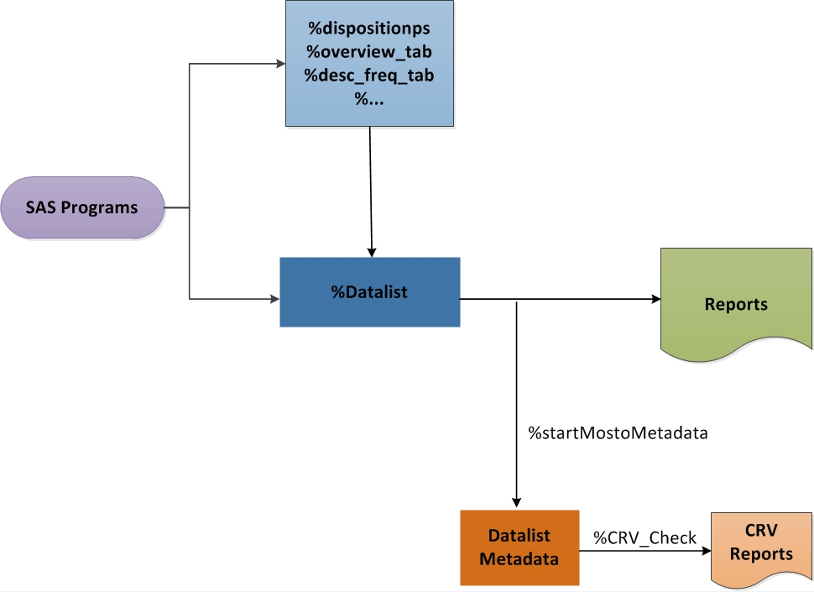

### METADATA

This is the SAS dataset, or list of SAS datasets, in LIB library that contain the list of reports with the associated %datalist parameters used to create them. The default value of “META:”, for example, includes all dataset names beginning with “META”.

### CHECK1: Check for reports with undefined titles

A report is considered having an undefined title if TITLE1 is missing or contains &KEYWORD. The default for the parameter KEYWORD is “UNIDENTIFIED”.

Sample Detail check for reports with undefined titles:



### CHECK2: Check for missing footnote references

The search for possible footnote related issues includes the following:

* Column references without a matching footnote
* Row references without a matching footnote
* Row header reference without a matching footnote
* Value reference without a matching footnote
* Footnote without the corresponding reference

Refer to appendix B for detail.

### CHECK3: Check for duplicate records in reports

This is about identifying duplicate rows in the reports.

Refer to Appendix C for detail.

### CHECK4: Check report creation dates

If the gap between report creation date and that of the most recent report is greater than &TIMING_WINDOW seconds, the report is flagged.

Sample report:

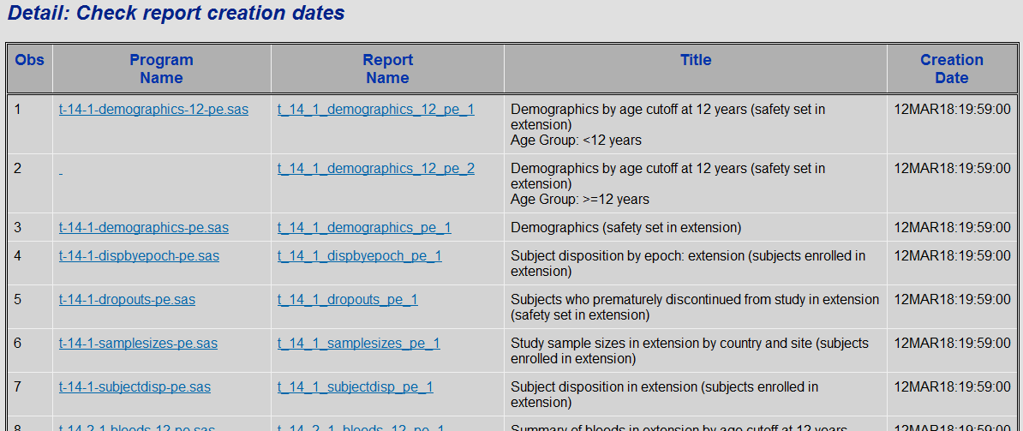

### CHECK5: Compare program file names against NAME parameter in %iniprog call

The report is flagged if NAME parameter in %iniprog call does not match the file name.

Sample report:

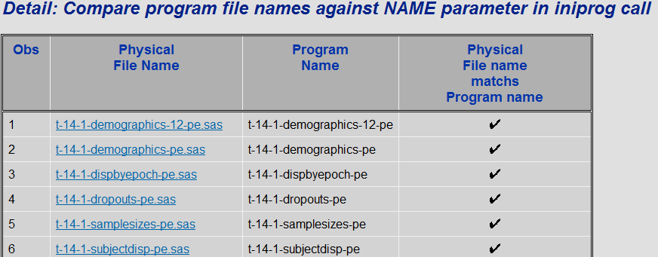

### CHECK6: Check for empty reports

All reports that contain no data are flagged.

Sample report:

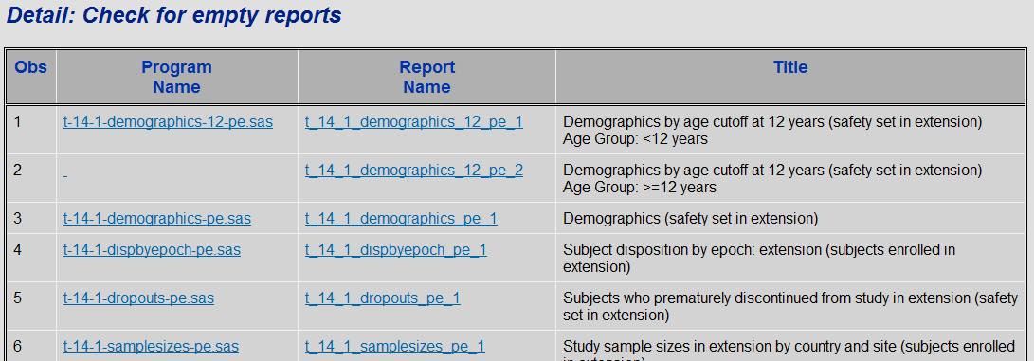

### CHECK7: Check for missing %iniprog and/or %endprog calls

SAS programs are scanned for presence of %iniprog and %endprog calls. Reports that do not contain either of them are flagged.

For Example:

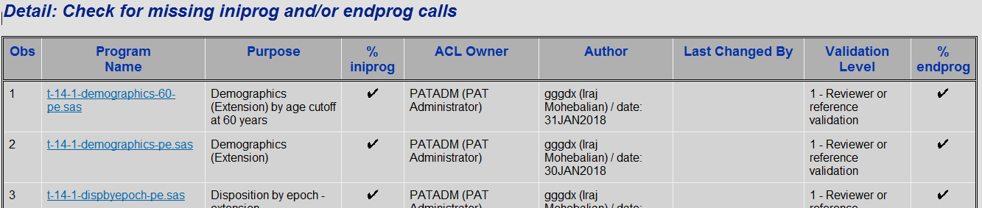

Note: ACL Owner column indicates the Unix ownership of the file. It is the output of the “ls –la” command.

Columns Purpose, Author, Last Changed By, and Validation Level are the text retrieved from the program’s header.

### CHECK8: Check SAS log files

SAS log files are scanned for presence of ERRORs, WARNINGs and critical NOTEs. Reports are flagged if any such lines are detected.

Sample Report:

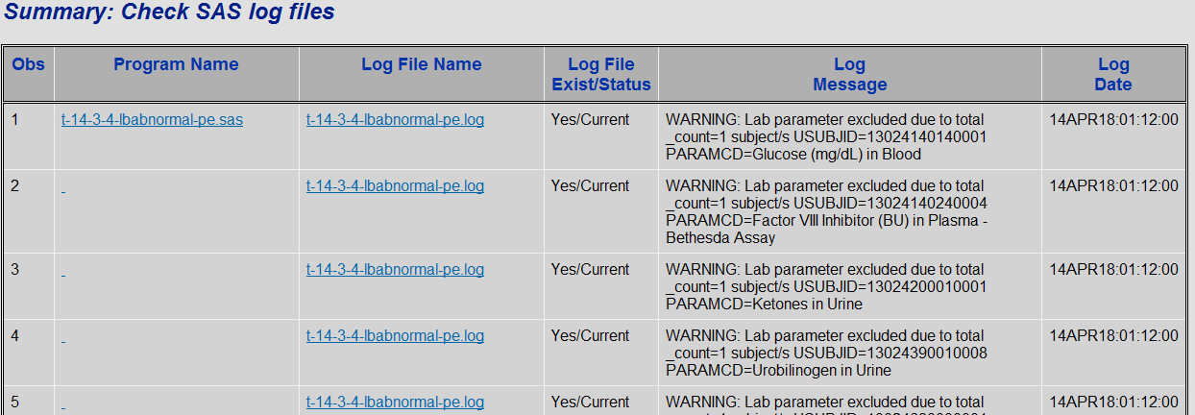

### CHECK9: Check AE reports for discrepancies

Check numbers among AE Summary, Overall and Listing reports.

AE reports are grouped to the following categories:

**Population Set**: safety analysis set, full analysis set, intent-to-treat, per-protocol,….

**Timing Method:** _all_, Treatment Emergent, Cutoff, After, Before, Between, Phase, Pre/Post treatment, Page Title

**Scope:** Any AE, SAE, Severe, Related, SAE, Discontinuation, non-Serious

**Dictionary:** MedDRA, CTCAE, MedDRA/CTCAE, not specific is default to MedDRA

Reported numbers between each group has to match.

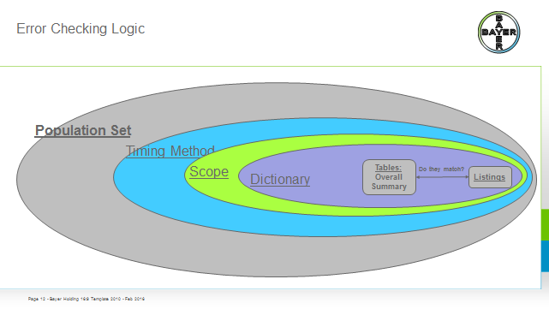



### CHECK10: Check Big N within each population group

Check reports for discrepancies in reporting Big N for various populations. Reports that their Big N do not match within a population are flagged.

Sample HTML detail report using SAS 9.4:

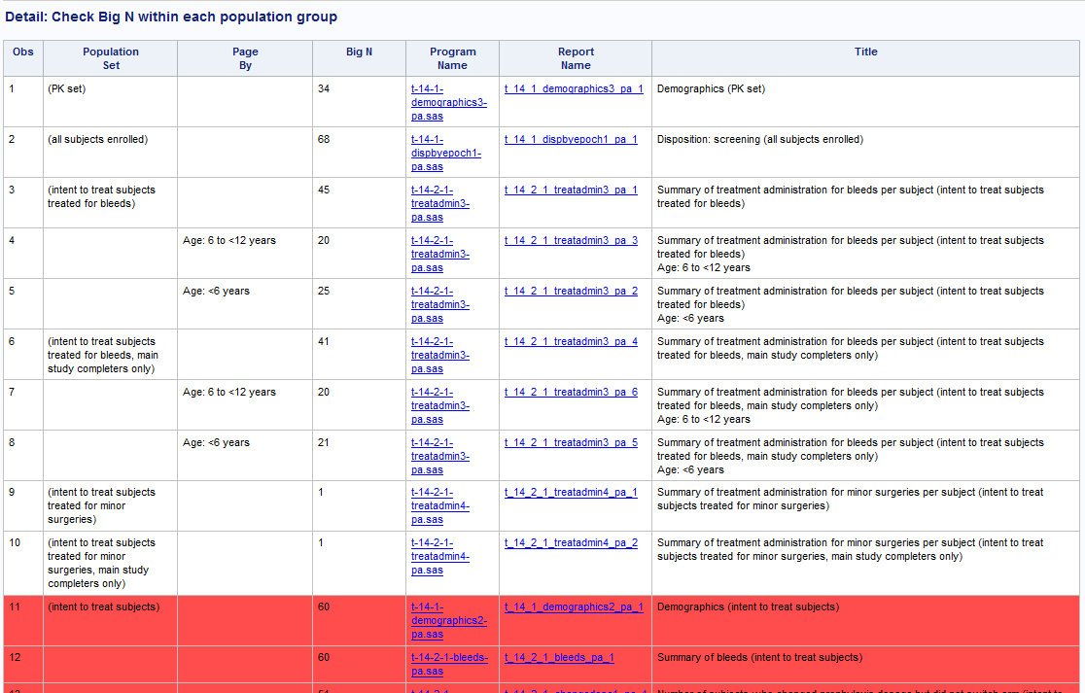

### CHECK11: Check for hardcoded libnames and formats

Check for hardcoded libnames and formats. SAS programs are scanned for presence of LIBNAME and PROC FORMAT words. Reports that contain either of them are flagged.

Sample HTML detail report using SAS 9.4:



### CHECK12: Check for reports with invalid values

Check for reports with invalid values.

For example:

1. Check for UNCODED! fields.

2. in case Taiwan is used in a Table, the following two checks are applied:  
 1.) If Country is used, it should always be "Country / Region". This is also required for all titles and footnotes.  
 2.) In no case the term "Province of China" should be used in combination with Taiwan  
 Both checks are required to ensure we apply to all requirements for submissions in China and Taiwan.

3. Check for reports with invalid value of “&”.

Sample HTML summary report using SAS 9.4:

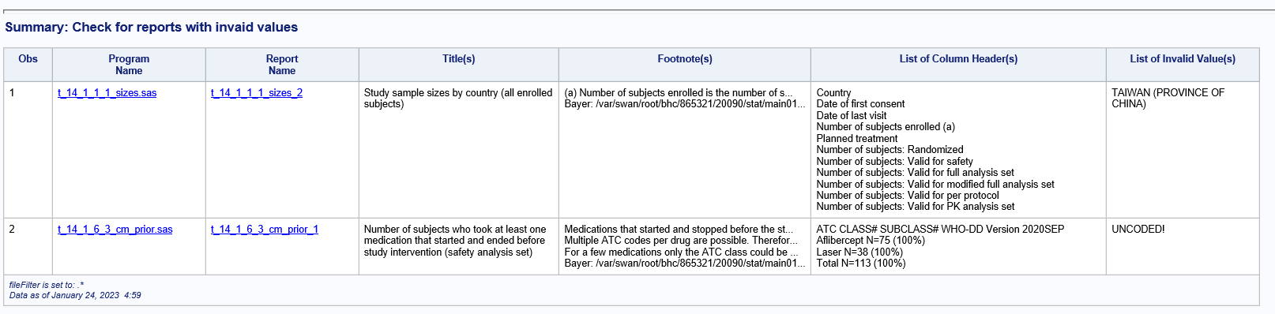

### CHECKX: Run study specific checks

The default for this parameter is NO. When it is changed to YES, macro %CRV_CheckX0 is executed if it is defined. The macro is expected to contain study-specific checks.

### RepORt_TYPE

This parameter determines whether the output is stored in HTML or RTF formats, or both if it is set to ALL (default).

### fileFilter

This parameter defines a regular expression to subset specific reports. The default is “.*”, which selects every existing report.

### COLORS

This parameter defines the colors used for flagged records in the reports. The default is set to Orange|Yellow.

1st color in the list used for the failed checks. 2nd color in the list is used for the TBD checks.

### KEYWORD

Optional text string to identify missing titles. A report is considered having an undefined title if TITLE1 is missing or contains &KEYWORD. The default for the parameter KEYWORD is “UNIDENTIFIED”.

### FIRSTOBS

It is used to limit the number of reports to check. Because of memory issue, we may need to limit the number of reports to check. It specifies the first observation to process.

### OBS

It specifies the last observation to process. When FIRSTOBS is not also used, this corresponds to the number of observations that will be read. The default value is set to Max.

Following is an example of selecting only the 5000 reports:

*%crv_check(obs=5000)*

### Search_column_header

This parameter defines a column header to search. The default is “Total”, which select columns with the header of “Total”.

### TIMING_WinDOW

This parameter sets maximal time span, in seconds, allowed between individual reports. The default value is 21600, which is an equivalent of 6 hours.

### HELP

The default for this parameter is NO. When it is changed to YES, help text is printed to the SAS log.

### verbose

The default for this parameter is NO. When it is changed to YES, general messages (including starting and finishing information) are printed to the SAS log. With the default setting, only ERROR and WARNING messages are printed.

## Checks and Error Handling

The following checks and error handlings are performed.

| Type of check | Object | Descriptions | Message / Reaction |
| --- | --- | --- | --- |
| FORMAL | LIB | Must be a valid existing library | Abort with an error message |
| FORMAL | METADATA | Must be existing dataset(s) (also in combination with INLIB if provided) | Abort with an error message |
| FORMAL | LIB METADATA | LIB and METADATA must not be both missing | Abort with an error message |
| FORMAL | REPORT_TYPE | Must use HTM, RTF or ALL | Abort with an error message |
| FORMAL | CHECK1-CHECK12 | Must either be N(O) or Y(ES) | Abort with an error message |
| FORMAL | CHECKX | Must either be N(O) or Y(ES) | Abort with an error message |
| FORMAL | FIRSTOBS | Must be a valid integer number. Cannot be empty. | Abort with an error message |
| FORMAL | OBS | Must be a valid integer number. Cannot be empty. | Abort with an error message |
| FORMAL | TIMING_FLAG | Must be a NUMERIC | Abort with an error message |
| FORMAL | HELP | Must either be N(O) or Y(ES) | Abort with an error message |
| FORMAL | VERBOSE | Must either be N(O) or Y(ES) | Abort with an error message |

## Processing Steps

CRV_check macro relies on the datalist metadata to identify discrepancies in the tables and reports. To create datalist metadata for a study, add the following lines to your run_all.sas program:

%initsystems(initstudy=5)

%initstudy(.......)

%startMostoMetadata()

## Output Generation

Based on the REPORT_TYPE parameter, CRV_Check macro generates an .HTM and/or a .RTF file(s) that includes the results from all the checks.

Example:

Clicking of the “Obs” number, detail report of the selected check will be displayed. Clicking on the “Status” column, summary report of the selected check will be displayed. 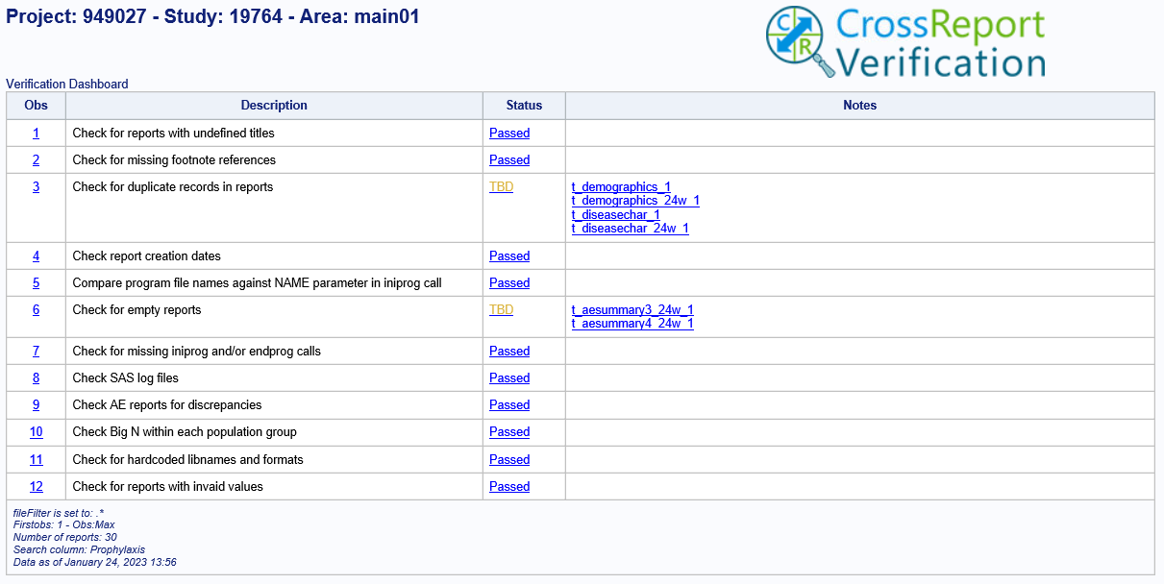

To generate the above report, run the %crv_check macro at the end of your run_all.sas program.

Or, you may also want to create a separate run_crv file to generate the report.

For example:

%initsystems(initstudy=5, spro=3, crv=2)

%initstudy()

%crv_check;

## Status

Status field has the following options: Passed, Failed and TBD (To-Be-Determined).

* **Passed:** I know the values are correct.
* **Failed**: I know the values are incorrect.
* **TBD**: I don’t know if the values are correct.

For some checks, by checking, I know that the values are correct or not. Passed or Failed. Checks like looking for missing titles. Titles are there or not? Yes or No

Some checks like check#3, find duplicate records, it totally depends on the report. You can easily find duplicate records in the demography report. But in the death report, you don’t want to find duplicates.

TBD is for those cases where the program cannot figure whether something is correct or not, so they need to be checked visually.

Following is a list of valid status values for each check:

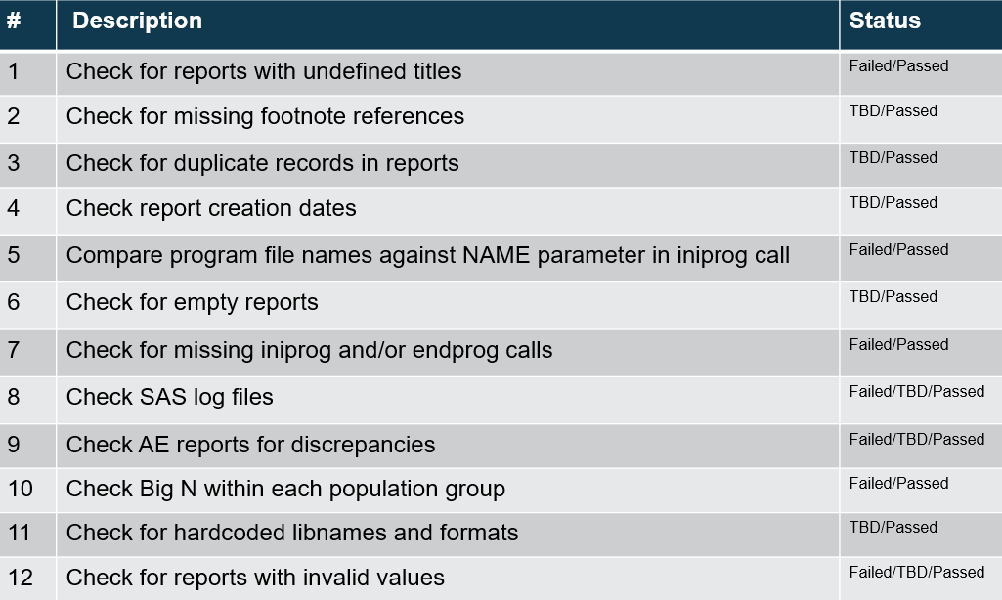

Default colors associated with status values are:

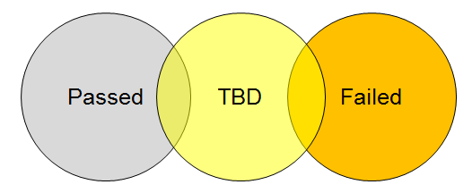

Within the CRV reports, there are default colors associated with these values: Yellow for “TBD”, Orange for “Failed”, default SAS background color for “Passed”. When running CRV in SAS 9.2, default background color is “Gray”. Running it with SAS 9.4, default background color is “White”.

You can change these default colors with the use of CRV macro parameter.

## Constraints

If your study has multiple runall programs, and you want to run them all at the same time, you need to specify a unique metadat parameter for the %startMostoMetadata macro.

For Example:

%startmostometadata(metadat=tlfmeta.META_Section14);

%startmostometadata(metadat=tlfmeta.META_Section16);

# %DocumentFinish

Following are the steps for storing the crv_check findings to a MS-Word document:

1. Copy the \\by-sas2p.bayer-ag.com\patdb\std_sg\stat\systems\crv\doc\crv2\template_crv_check.doc file to your study .pgm directory.
2. Update the template_crv.doc header information.
3. Add the following line to your runall program:

%DocumentFinish(template=template_CRV_check.doc, tmpldir=&prgdir, _outdir=&outdir, ResultPrefix= )

Sample CRV_Check.doc file:

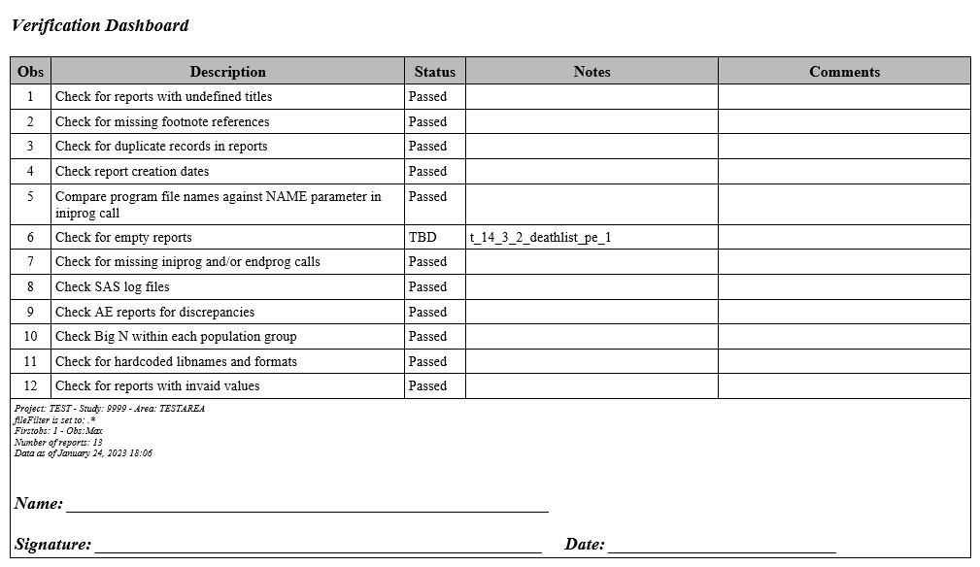

# Appendix A: overall report structure

Following is the overall structure of the html file generated by the CRV_CHECK:

Table of C



Check Specific Section

Detail Section

Summary Section

Table of Contents

Following is the overall structure of the rtf file generated by the CRV_CHECK:

Table of Contents

Summary Section

# Appendix B: examples of footnote reference issues

Following are examples of various missing footnote references:

Column reference missing footnote:

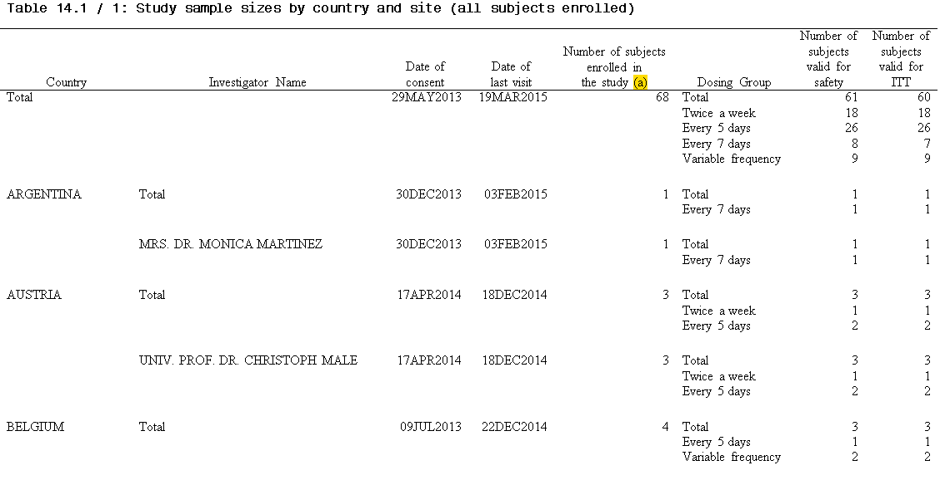

Row reference missing footnote

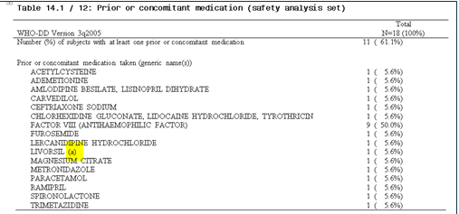

Footnote without any reference



Summary check report for the above report:



# APPENDIX C: example of a report with duplicate records

Following is a sample summary report that shows reports with a number of duplicate records.

For example, in the first row, it shows we have three duplicate AE records.

Clicking on the number 3 in the duplicate records column will display the duplicate records.

Example of checking for duplicate records in a report:

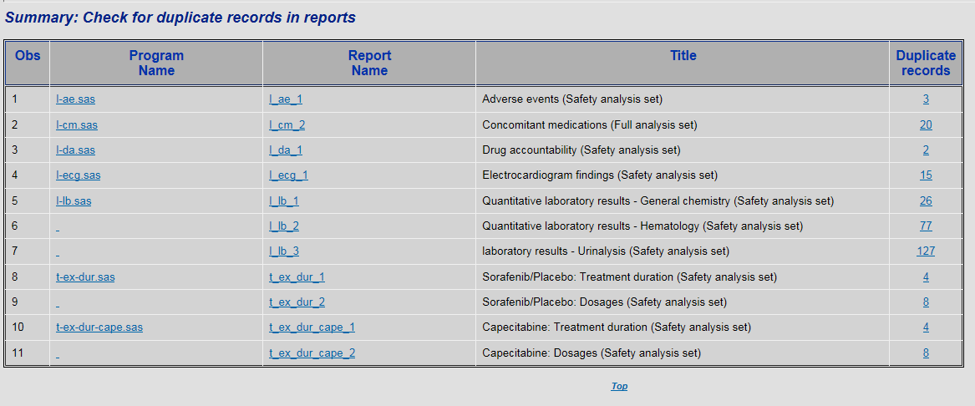

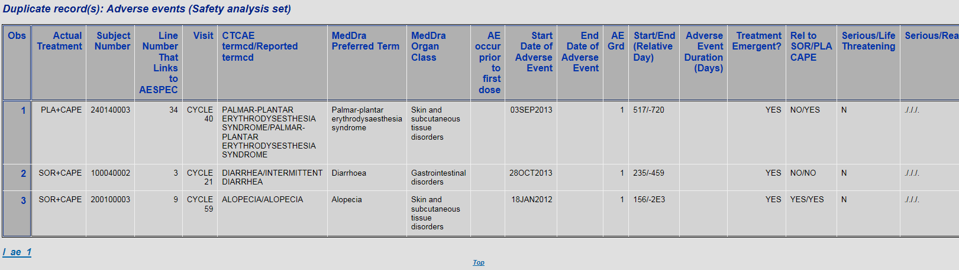

By clicking on the report name on the last line, it will take you to the report.

Following is the snapshot of the actual report, with its duplicate records.

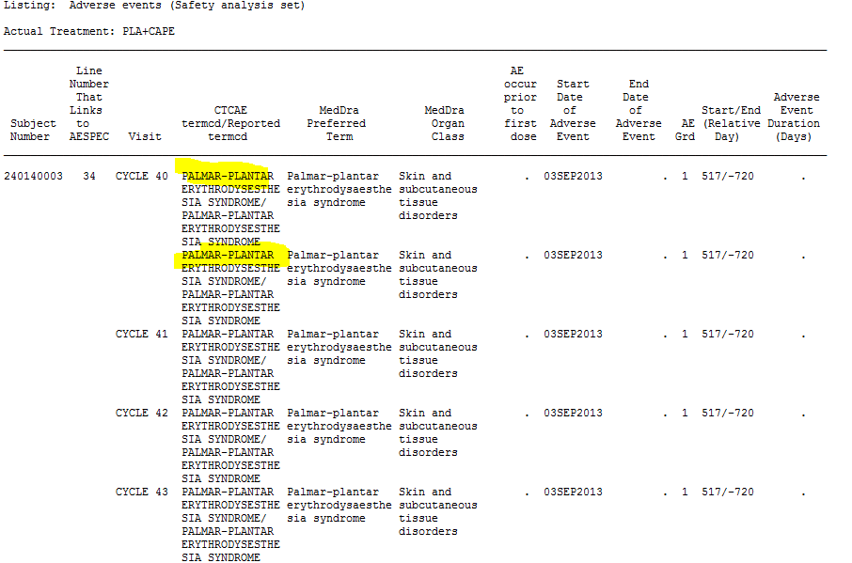

When running a check against a study that includes the above report, this discrepancy will be identified.

First row in the following summary report shows there are three duplicate AE records.

Clicking on the number “3” in the duplicate records column will display the three duplicate records.



Following report indicates three separate duplicate records in the AE listing.

Clicking on the report name on the last line will display the actual report.

