# Escaping the IT Trap:

# How Cloud Computing and Innovative Technologies Can Cut IT Costs by Two-Thirds

# (A prototype for Federal agencies)

Patrick Stingley

Chief Technical Officer

Bureau of Land Management

Originally Written: August 6, 2014

Copyright 2015

Ver2, edited June 9, 2015

**Introduction**

Implementing Cloud Computing is like solving a multivariable equation. Even the best cloud computing infrastructure is of no use if the bandwidth isn’t available to deliver the services to the users. T-1 lines which used to serve an entire office are insufficient when the servers are now a continent away. As these circuits are upgraded to T-3 services, costs jump from $800/mo. to $3,000/mo. completely eclipsing any savings brought about by the less expensive hosting that cloud offers. Applications that were designed to run on a Local Area Network (LAN) can be prohibitively expensive in terms of bandwidth, which equates to cost, when moved away from the user and into a cloud computing data center. Simply encapsulating an application in a virtual machine (VM) doesn’t necessarily reduce costs. In reality it increases complexity and extends the supply chain between the users and the services the applications provide. In some organizations, licensing costs for software can run a million dollars a year, but re-writing the applications to migrate off of them while re-working the application to operate more efficiently over a Wide Area Network can cost well over a million dollars for each of the applications sharing that licensed software. As if this wasn’t bad enough, the operations and maintenance costs of the existing systems don’t leave any extra money for upgrading services to use the cloud more effectively. This is the IT Trap. In order to escape the trap, all four prongs of this dilemma must be solved in parallel.

The first two prongs of this solution, telecommunications and end user computing result in lower costs. With these measures in place, the budget can be re-programmed to improve the other two prongs, natively hosting enterprise applications/services in the cloud and cloud based automation.

The numbers in this document come from my work at the Bureau of Land Management (BLM) and though approximate, represent the best that could be found at the time. The initial estimates (shown) were based on the OMB A-11/Exhibit 53 information submitted to Congress. These numbers were averaged with the actuals as well as to the planned spending for FY14 and 15 where available. The estimates in 3 of 4 areas varied less than 10%. The Desktop computing estimate was within parameters for an initial estimate, though much of the data was fuzzy due to a re-organization across the Bureau, affecting estimates of personnel costs. Because of the scope of the changes suggested and the ripple effects that would ensue, further precision is unnecessary, in all cases, the outcomes consistently point to significant savings that would be achievable through the measures described herein. If the estimated savings in this document are added up, the total comes to $116M, but conversion costs and other factors may reduce these savings. It is impossible to guess the actual savings until cloud hosting becomes a reality and conversion strategies (along with their costs) are developed, but it appears at this point that the initial estimate of $80M is a very good one.

Those measures that are successful could then serve as a proof of concept for other Bureaus and Agencies across the government and potentially lead to enormous government wide savings and efficiencies.

The numbers in this document and the cost models represent annual, recurring, savings.

**1. Telecommunications**

In 2008 the Bureau of Land Management set an ambitious goal of consolidating over 95% of its data centers. Over the last four years, we have been successful in closing 75% and are working on achieving the goal of 95%+ by the end of 2016. We developed a cost model to show the costs and savings of each site as we closed them. Based on the first 30 sites, the projected total effect was a cost increase of $1.7M. However, when Telecommunications is removed from these figures, the net effect of the project was a $4.5M savings. This demonstrates that telecommunications alone has the ability to determine whether migrating servers out of the offices is a winning proposition or a total loser. Further analysis about traffic patterns was done and it was determined that the increase in telecomm costs were not due to data center consolidation, but was actually resulted from a general increased demand for bandwidth across the board.

Up until about four years ago, a typical BLM field office was served by a T-1 line with another T-1 for a backup, bringing the total monthly cost from $800.00 to $1,600. As these became inadequate to meet user demands, they were upgraded to fractional T-3s commonly costing $3,000/mo each. The fractional T-3s in these offices brought the bandwidth up from 1.544Mbps, to about 12Mbps (For those readers who are not network engineers, 12Mbps is a little less than most people get on an iPhone) we had an entire field office served this way. Imagine yourself and 22- 200 people sharing that iPhone and you’ll begin to understand the problem. Multiply $3,000/mo ($36,000/yr.) for nearly 200 offices and it begins to add up.

At the same time, these users who were staying late were able to bring 20Mbps into their homes for $60.00/mo. Others who had Government-issued cellphones were able to get 12Mbps for $60.00/mo.

The Cisco 550 is a FIPS compliant wireless router that can connect to a Cable TV or DSL (Digital Subscriber Line) circuit, establish a Virtual Private Network (VPN) back to the Bureau’s central data center in Denver. These devices cost less than $500.00 and since most people already have a similar device in their own house, they can be installed in the field without having to dispatch a network engineer to do so.

The second part of this setup was a CradlePoint router, which uses cellular service instead of a terrestrial line. CradlePoints can bond with these Ciscos to provide cumulative bandwidth plus automatic fail over in case the terrestrial circuit suddenly develops backhoe fade.

$120.00 for 45Mbps is much more reasonable for an office full of workers, especially once their servers have been relocated elsewhere. Our pilot efforts with these devices have been very successful. The Bureau is using the Ciscos 550 s over the Internet in 155 locations across the West. The primary obstacles have turned out to be the IT community who sees their budgets decreasing (even though the money was being passed to the telcos and despite more bandwidth for the users.)

The diagram below shows the cost savings from adopting this telecommunications infrastructure. That cost model also shows the savings found by eliminating the desk phones entirely and migrating to cellphones. Currently everyone in the organization has a desk phone and 60% of the employees have a cellphone as well. This model recognizes that this is a duplication, completes the deployment of the cellphones to the remaining 40% and drops the desk phones.

It can be seen in the model that the cost for the Cisco 550s is less than the maintenance cost of the existing routers, so there is little reason to delay full implementation. Subsequent analysis of replacing the existing router infrastructure with these 550s, if phased in over a 3 year period would conservatively result in $10M for the Bureau. If each 550 had a 10 year lifespan, then simply replacing the routers in this fashion would save almost an entire year’s IT budget by the end of the decade.

Use of these devices makes traffic shapers, such as the Steelhead devices the Bureau has purchased unnecessary.

The simpler network eliminates the need for most of the 11 network analysis and monitoring tools currently in use and their associated licensing fees. Only the NetIQ software is shown in this model. 36 network and monitoring personnel are no longer needed, though 2 are retained to troubleshoot problems and mail new routers to sites that experience a failure. (Since they have redundant, divergent paths, one of the routers can fail and the office continues to function until a new router arrives.)

Another telecomm cost that is dropped is the VTC system. The Bureau has invested in a combination of ISDN and IP based VTC systems. While these systems could be considered sunk costs, removal of them makes sense for the following three reasons: The ISDN costs are in the hundreds of thousand per year. The devices are so complex that most of the time they are not used. Third, Skype, Google+ and a number of other desktop VTC are easy enough and ubiquitous enough that they have made these older devices unnecessary. One potential platform for VTC may well be the Google VTC box, which can run an articulating camera and two large screen TVs with intuitive controls, plus they interoperate with the desktop VTC technologies. This hasn’t been figured into the model but at $1000/box outfitting the entire Bureau with one in each office would cost $200,000, which is less than the annual ISDN costs for the existing systems.

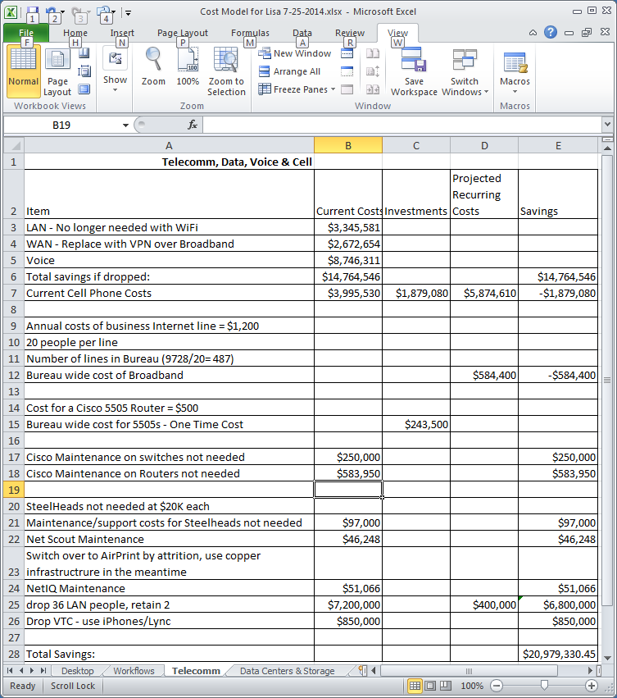

**2. End User Computing**

The high cost of maintaining desktop computers (around $2K/unit/Yr.) is driven primarily by the amount of touch labor necessary to keep the software working, whether installing it, fixing it, patching it, uninstalling it, etc. In comparison, it is notable how little maintenance is required by mobile devices.

As the applications are relocated from the user’s computer to the cloud, they will either be delivered by web browser interfaces, or by virtual desktop integration (VDI) software such as Citrix. These kinds of user interfaces can be used on a wide variety of platforms without having to write unique applications for each platform.

In recent years we have learned much from the mobile devices we have been using. In many ways mobile devices are superior computing platforms to the laptops and desktops we have been using. They require little or no maintenance. Since they display web pages and Citrix, they are effectively thin clients or zero clients, with less maintenance demand than thin clients or zero clients. They have the same CPU power as top of the line laptop or desktop computers did just a few years ago, and with their WiFi and Cell based networking capabilities they are actually more functional. These devices have much less internal, storage than conventional computers, which induces users to adopt better data management practices; storing their files to file servers, or better yet, cloud storage instead of on the devices themselves. Most mobile devices include GPS, which makes them more suitable to land management than either laptops or desktops. With their blue tooth capability, not common on laptops, desktops, thin or zero clients, these devices can link them up to even more accurate GPS units. Of course smart phones are also telephones, which fulfills a need, plus most often they can be used as a hotspot to deliver much needed bandwidth into the offices.

The image on the left below shows a smartphone with a Bluetooth keyboard attached to a full sized monitor, with the assistance of a $39.00 VGA adapter. In this case, it is editing documents using Google Docs. The image on the right shows a map from the Bureau’s eGIS application that was created using this smartphone. This setup shows how a tablet can be used in a dual display configuration while a smartphone is used both as the hot spot for the tablet and as a track pad.

|  |  |
| --- | --- |
|  |  |
| Although smartphones and tablets could replace conventional computers in a pinch, this is not the use- | |

Case foreseen for the desktop.

Devices with more conventional form factors such as Dell’s Android based Venue 10 7000 (left) or the Asus Flip Chromebook (below right) offer the same robustness. The chromebook on the right has an is essentially the same as the Apple Air, with its aluminum skin, but at less than $250.00, would be ideal for workers to have at home and at work. The Dell Venue has a removable keyboard, allowing it to be used as a tablet.

|  |  |
| --- | --- |
|  |  |

Google has deployed thousands of Chromebooks to schools across the country and has used the knowledge from these experiences to develop enterprise level management of Android and Chrome devices, in a package called ChromeManage. The product suite includes a ~$1000 Chrome based VTC system that is easy to use, interfaces with Google Hangouts, Skype and other desktop VTC systems and most importantly, is user friendly. They have also developed Chrome based signage and kiosks, all of which can be managed by ChromeManage both of which have been a perennial source of headaches for the Bureau using other platforms.

Ideally, each person would be issued a cellphone which would allow them to take their office with them in their pocket, then the cellphone would be used as the hotspot for them to use these kinds of office automation, while teleworking or in the field (as well as other kinds of tablets for data collection). In the office, these devices would use the building WiFi described above under Telecommunications. The cost model below shows the cost savings by migrating to this kind of a robust platform.

Today, 60% of Bureau employees have a government furnished mobile device. To provide the remainder of the Bureau with wireless devices would require an increase of $1.8M, which will be more than offset by the reduction in support costs.

These kinds of user devices are much less labor intensive to support, thus reducing the need for much of the support staff. Since they primarily store data on servers and the cloud, the requirements (and costs of the Data At Rest software is eliminated. Chrome Manage eliminates the need for the Belarc Software the Bureau pays unknown amounts of money for each year. It eliminates the need for the DS-1 servers, which are primarily in the offices to provide SCCM service. Other DS-1 functions, such as file services could be shifted to the cloud and print services really are unnecessary anymore since printers are fully capable of spooling print jobs with their own internal memory. Printers with air print capability will replace the existing, Ethernet bound devices, though this can be done gracefully, as both the Cisco 550 and the CradlePoint routers have a few Ethernet ports available for devices such as printers.

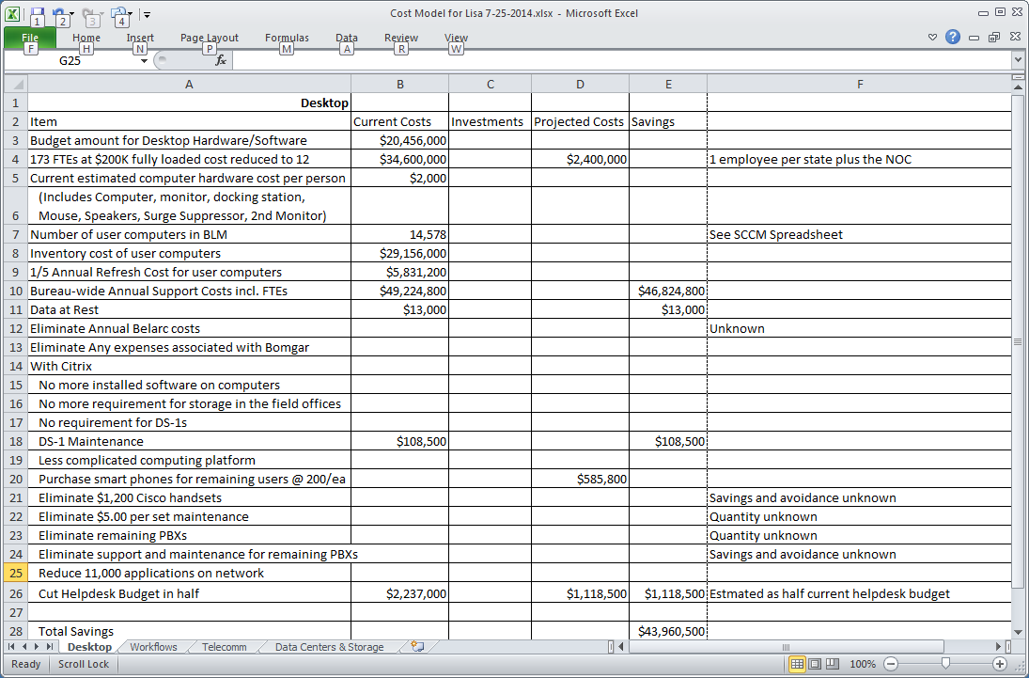

A significant amount of savings is also anticipated from eliminating the desktop telephones, VOIP systems and their maintenance and replacements. Prices for the Cisco VOIP handsets have been as high as $1200.00. The figures for these items are unknown, but would only serve to further the case that this approach would result in significant savings.

**3. Natively Hosting Enterprise Applications/Services in the Cloud**

In any organization, there is a technology or set of technologies that are core to its mission. In BLM, that technology is the Geographic Information System (GIS). Other enterprise services such as data storage is addressed in this section because if the GIS moves to the cloud, the GIS data, land documents and other material that could be referred to in the GIS should be as close to the GIS as possible to reduce load time delays.

Currently the Bureau has six distinct GIS architectures, each with disparate data and technologies. These different systems are a source of innumerable issues with data quality, due to inconsistencies between them. In some regard, Data Center Consolidation has been a valuable influence in that it has caused the many of the servers to be migrated into the same building, but as yet little has been done to resolve the discrepancies between them. If this consolidation is seen as a staging phase, after which the data will be ported into a single, coherent GIS in the cloud, then this step could be quite helpful. Migrating the data from these disparate systems into a single, coherent, GIS in the cloud would be highly beneficial to the Bureau because doing so would encourage (force) the organization to resolve the inconsistencies in the data.

Migrating the data to the cloud will also result in significant lowering of IT costs. Estimates are that the Bureau has upwards of 430 terabytes of data, for which it currently pays $11,000 per TeraByte (TB). 30% of that data is duplicate copies ($5,000 for the storage, and $6,000/TB for the backup software licensing). Cloud storage is much less expensive than that, as shown in the cost model below. The figures for cloud hosted data storage were created using Amazon’s on-line costing tool. The figures were created based on the total amount of data filling the OC-12 that is installed in the Denver Data Center. This is intended to under estimate the savings, in an effort to offset unforeseen cost increases that might occur.

For fiduciary reasons, it is necessary that the government maintain a repository copy of its data within a federal data center. Just in case something happens to the cloud provider. But this is merely as a repository archive.

The Earth Resources Observation and Science center (EROS), run by the United States Geological Survey (USGS) holds massive amounts of data in a highly secure facility because of the Landsat satellite system they operate, so they would be a good choice to provide storage to meet this need. While we do not have an actual agreement for storage costs at EROS, estimates are approximately $1,386/TB for the first year build out and $176/TB for the remaining four years, for an average annual cost of just under $500/TB. For the purposes of this model, the average annual figure of $500/TB will be used.

Even though cost would have been sufficient enough to warrant migrating data storage to EROS, the primary reason was mission driven. EROS contains all of the LandSat and other satellite data for the United States as well as LIDAR and other forms of telemetry. The Bureau of Land Management should begin using these forms of data in managing its land. Since the slowest part of running a GIS is loading data into it, it makes sense for BLM to collocate its internal GIS in EROS next to all of the data they hold.

Migrating the GIS to the cloud eliminates many of the servers and licensing fees the Bureau pays perennially. It also significantly reduces the amount of storage the Bureau needs. Currently data is stored in a field office in a RAID 5 DS-1 server, which means that there are about 2 ½ copies of the data on-site, then this data is backed up into RAID 5 Servers in Denver (another 2 ½ copies). Then this data is spooled off onto tape and driven off site. When the data is hosted in the cloud, it’s already off site, so that tape layer of storage can be eliminated immediately. All the Bureau needs to keep is an archival copy as a repository. EROS is very capable of retaining data long term, as it has the satellite data for the last 50 years. It makes sense for the Bureau to outsource this storage to them because of their technical competence as well as lower cost.

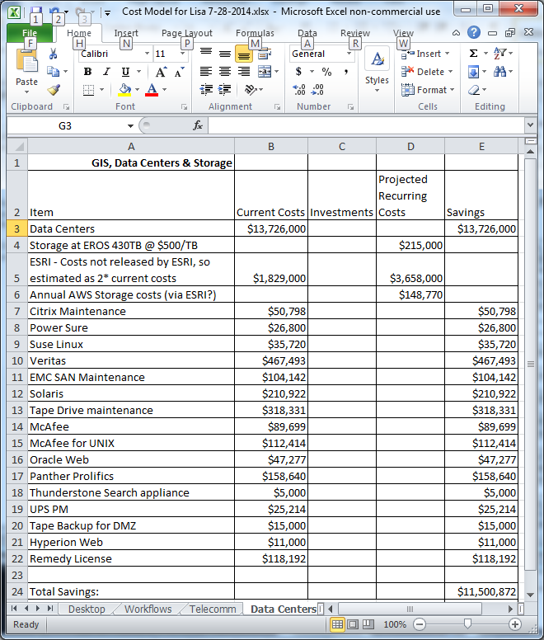 Note, ESRI was asked to provide some idea about what hosting ArcMap via VDI would cost but was not able to get the figures cleared by their management in time for this document, so the estimate in this spreadsheet was arrived at by doubling the current ESRI contract.

**4. Cloud Based Automation**

Start with workflows - Every computer sciences student is taught how to make a flow chart when they are first learning to program. A flow chart graphically describes the processes that a program (an application) is supposed to do. Eventually, people began using flow charts to document business processes; these are called workflows. In recent years, it has been realized that such workflow flow charts could be converted into code to automate entire segments of an organization. The Bureau has recently begun using Business Process Management tools, servers on which these workflows are loaded and which automatically execute them. This approach holds significant advantages because it doesn’t create the silos that a systems centric approach tended to do. More importantly workflow automation is 10 – 100 times less expensive to implement than application systems built from scratch. Since as migrating to a cloud environment often requires substantial re-development of applications, generally the better solution is to abandon the legacy applications and replace them wholesale with workflows. Once these workflows are created, they can be run internally, or migrated to a BPM infrastructure in the cloud.

Having these workflows does a couple of very good things for the organization. First, it documents the organization’s business processes, which allows it to normalize them and improve them. Second, it presents the organization with the option of being able to outsourcing its information technology entirely, an option that would have been much more difficult, if not untenable, without those business processes being documented as workflows..

There are companies that specialize in running workflows on behalf of government agencies. One of them runs permitting workflows for 30 state level organizations across the country. In many cases, these states have been able to approach zero-dollar IT budgets, by using a shared revenue model. In this model, the company displays a web page front end for a state organization’s workflow that allows a person to apply for a permit, for example, a hunting license. This is routed to the appropriate government official to review the application. The company processes the payment, taking a portion of the fee for itself and sending the balance to the bank account specified by the State. The government official reviews and either approves or disapproves the application and the company either sends back the approval/disproval document or it e-mails an electronic document back to the applicant for them to print for themselves. .

With this approach, instead of spending millions of dollars and risking multi-million dollar cost overruns (or failures) developing applications internally, the agency simply outsources the system to a company that specializes in this kind of business. The fact that there is at least one company providing these services for 30 states across the country, attests to the viability of this kind of software as a service.

Detailed below are representative costs and savings from employing the outsourcing model, based primarily on costs taken from BLM’s 2016 Exhibit 53. This approach eliminates most of the operations and development staffs. Since the servers are in the cloud and monitoring is no longer the organization’s issue, IT Security’s role and costs can be reduced significantly and many of the tools would no longer be necessary.

IT Asset management is significantly reduced as are licensing costs for relational databases. All that is needed is the database for repository purposes.

SharePoint would be replaced by Google Drive.

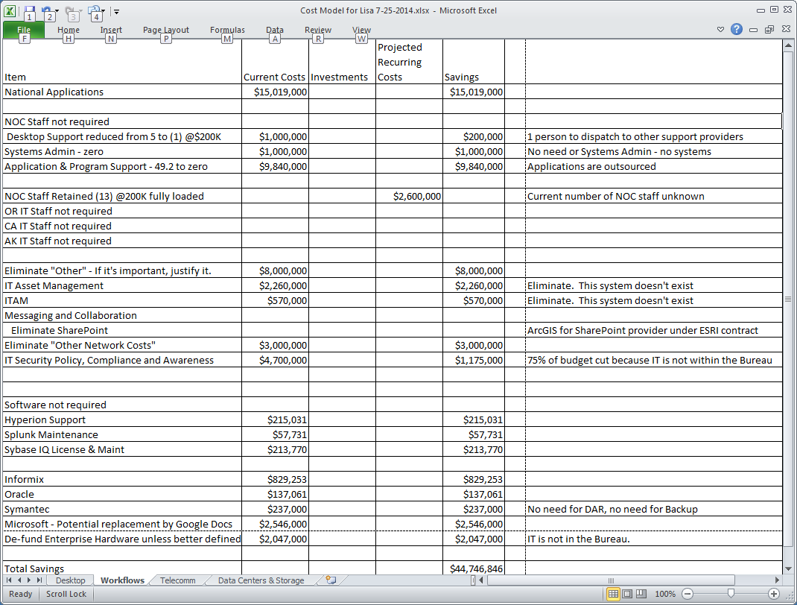

**Summary**

Although significant additional planning and preparatory work needs to be done, the goal was to create a cost model to gather a ball-park estimate of the amount of savings an organization, like BLM could potentially save if it embraced innovative technologies including cloud computing. Based on this, it appears certain that savings of well over $80M could be achieved by outsourcing IT, while providing better service and more effectively supporting a highly mobile workforce.