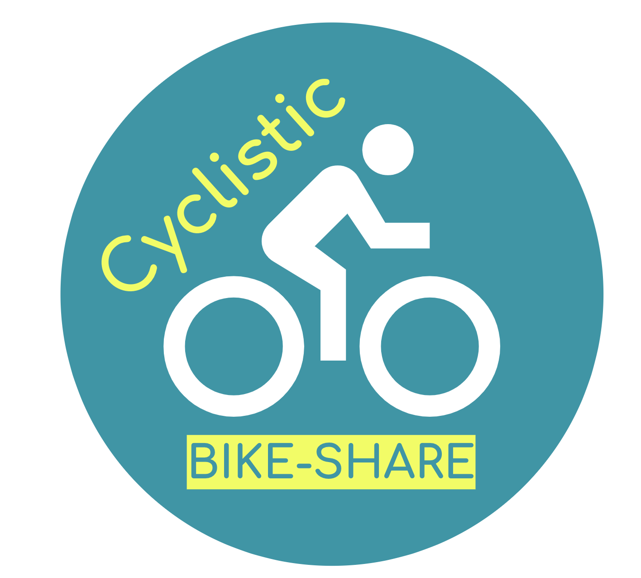

Case Study: How can we Navigate Speedy Success?

Business Task:

How can we design a marketing campaign to convert casual users into subscribers?

In order to answer the question, we should find out how members and subscribers use our service differently.

