https://github.com/bdring/FluidNC
http://wiki.fluidnc.com/en/installation
https://github.com/bdring/6-Pack_CNC_Controller (no board schematics)
https://github.com/simon-jouet/ESP32Controller/blob/master/pdf/esp32controller.pdf (schematics esp32, I2S, to HC595)

https://randomnerdtutorials.com/esp32-pinout-reference-gpios/
GPIO | Input | Output | Notes
0 | pulled up | OK | outputs PWM signal at boot  LOLIN button?  Joystick PB (Mode)
1 | TX pin | OK | debug output at boot  Serial Comm Tx
2 | OK | OK | connected to on-board LED?  UNUSED
3 | OK | RX pin | HIGH at boot  Serial Comm Rx
4 | OK | OK | TFT_RST
5 | OK | OK | outputs PWM signal at boot  X_LIMIT
6 | x | x | connected to the integrated SPI flash
7 | x | x | connected to the integrated SPI flash
8 | x | x | connected to the integrated SPI flash
9 | x | x | connected to the integrated SPI flash
10 | x | x | connected to the integrated SPI flash
11 | x | x | connected to the integrated SPI flash
12 | OK | OK | boot fail if pulled high  SPINDLE_STEP (A_STEP_PIN)
13 | OK | OK | SD_CS
14 | OK | OK | outputs PWM signal at boot  SDI (I2S SR)
15 | OK | OK | outputs PWM signal at boot  WCLK (I2S SR)
16 | OK | OK | BCLK (I2S SR)
17 | OK | OK | TFT_CS
18 | OK | OK | TFT_SCK
19 | OK | OK | TFT_MISO
21 | OK | OK | TFT_DC
22 | OK | OK | SPINDLE_OUTPUT_PIN (PWM)
23 | OK | OK | TFT_MOSI
25 | OK | OK | X_STEP
26 | OK | OK | Z_STEP
27 | OK | OK | Y_STEP
32 | OK | OK | ADC1, ch4 T_CS
33 | OK | OK | ADC1, ch5 Y_ANALOG (joystick)
34 | OK |  | input only  Z_LIMIT ADC1, ch6
35 | OK |  | input only  PROBE ADC1, ch7
36 | OK |  | input only  X_ANALOG (joystick) ADC1, ch0
37 | OK |  | input only  ENC1_Q1 ADC1, ch1 (Not on WROOM or NodeMCU)
38 | OK |  | input only  ENC1_Q2 ADC1, ch2 (Not on WROOM or NodeMCU)
39 | OK |  | input only  Y_LIMIT ADC1, ch3

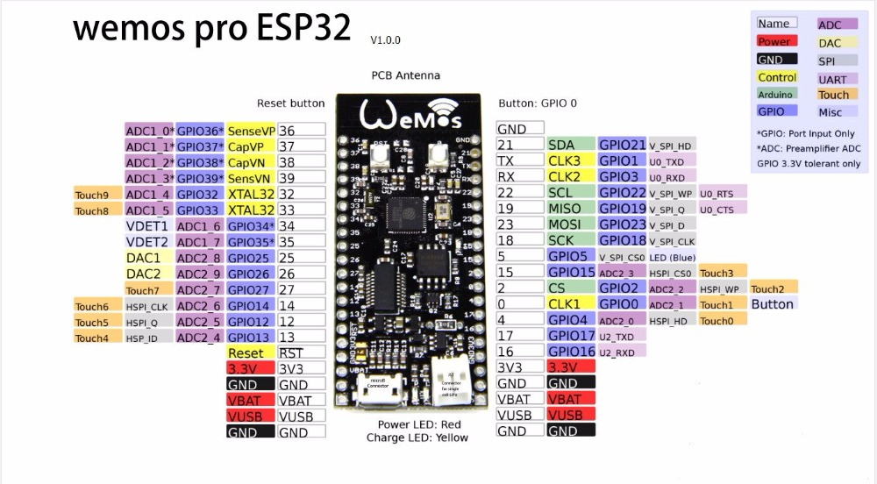
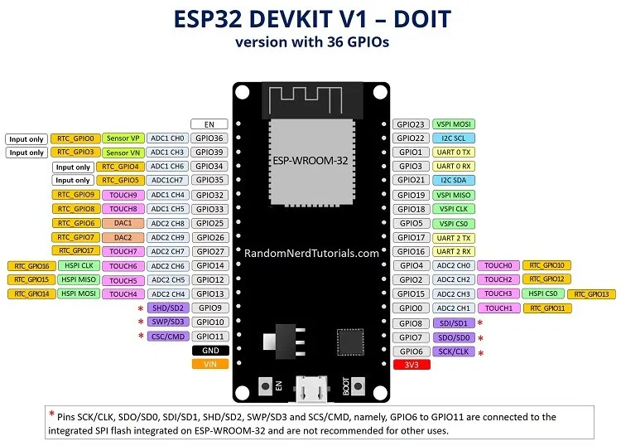
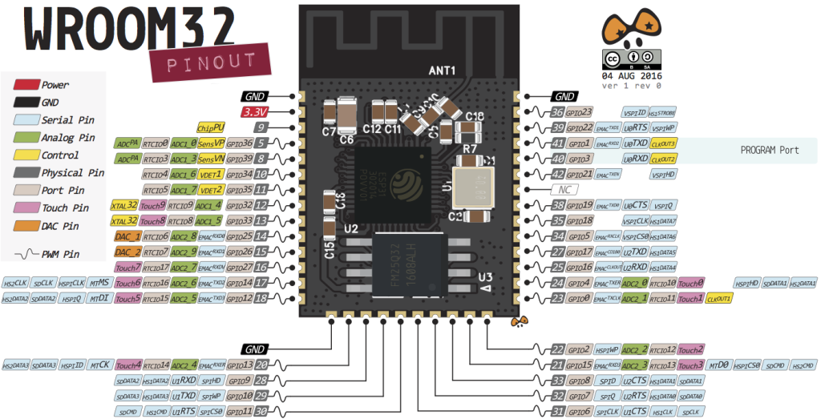

NOTE THAT THE NODEMCU Needs a 2.2 uF capacitor between the RST/EN pin and ground in order to be able to flash from the IDE without pressing the BOOT button.
