NOTE THAT THE NODEMCU Needs a 2.2 uF capacitor between the RST/EN pin and ground in order to be able to flash from the IDE without pressing the PGRM button.
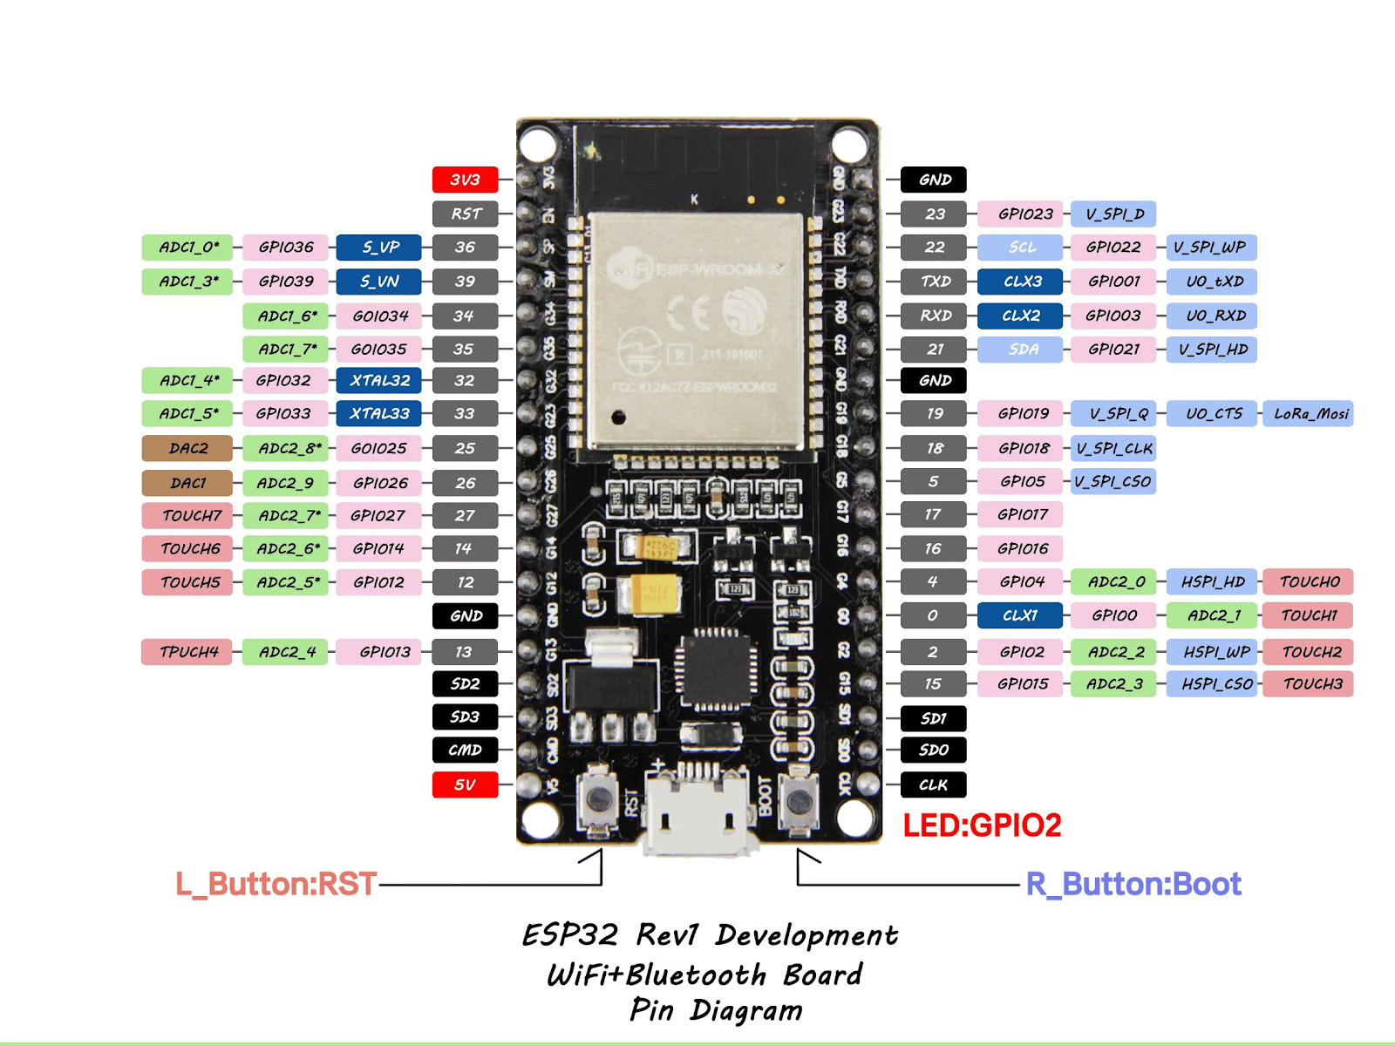

GPIO | Input | Output | Notes
0 | pulled up | OK | outputs PWM signal at boot  UNUSED
1 | TX pin | OK | debug output at boot  UNUSED
2 | OK | OK | connected to on-board LED?  UNUSED
3 | OK | RX pin | HIGH at boot  UNUSED
4 | OK | OK | TFT_RST
5 | OK | OK | outputs PWM signal at boot
6 | x | x | connected to the integrated SPI flash
7 | x | x | connected to the integrated SPI flash
8 | x | x | connected to the integrated SPI flash
9 | x | x | connected to the integrated SPI flash
10 | x | x | connected to the integrated SPI flash
11 | x | x | connected to the integrated SPI flash
12 | OK | OK | boot fail if pulled high  UNUSED
13 | OK | OK | UNUSED
14 | OK | OK | outputs PWM signal at boot  UNUSED
15 | OK | OK | outputs PWM signal at boot  TFT_CS
16 | OK | OK | UNUSED
17 | OK | OK | UNUSED
18 | OK | OK | TFT_SCLK
19 | OK | OK | TFT_MISO
21 | OK | OK | TFT_DC
22 | OK | OK | TOUCH_CS
23 | OK | OK | TFT_MOSI
25 | OK | OK | Encoder Q1, INPUT_PULLUP (set by library)
26 | OK | OK | Encoder Q2, INPUT_PULLUP (set by library)
27 | OK | OK | Encoder Button, INPUT_PULLUP
32 | OK | OK | PIR Sensor
33 | OK | OK | DHT22 Data INPUT_PULLUP
34 | OK |  | input only  UNUSED
35 | OK |  | input only  UNUSED
36 | OK |  | input only  ADC1_0 Light Level
37 | OK |  | NOT PRESENT
38 | OK |  | NOT PRESENT
39 | OK |  | input only  UNUSED

https://www.youtube.com/watch?v=c0tMGlJVmkw&list=PLnwT_Zd4ZKYjpOVA3Mo5TGBYnDJL-yC3C&ab_channel=TheHookUp

pinMode(pin#, INPUT_PULLUP) incompatible pins: GPIO6-11, 34, 35, 36, 39
pinMode(pin#, INPUT_PULLDOWN) incompatible pins: GPIO0-3
Don’t use the following for outputs:
GPIO0, 1, 3, 5-11, 13-15, 34-39 Or, first check that ‘odd’ output during boot won’t cause problems in circuit.

