Walmart Product Wheel

Introduction
I created this app recently as part of my application to Walmart.
The Walmart Product Wheel app was written in Kotlin and displays a list of their products and product details.

This document describes:

Table of Contents
Introduction 1
Why Kotlin? 2
Requirements 3
Take-Home Assignment 3
Screen 1: 3
Screen 2: 3
Submission: 3
WalmartLabs Test Instructions 4
URL for these instructions and to make rest calls to is: 4
Get Products List Rest Request Call 4
Input Parameters 4
Return Parameters 4
Product Object 4
Sample JSON Rest Response 5
Get Image URL 6
Sample Response 6
Design 7
Structure 8

Why Kotlin?
Kotlin is rapidly replacing Java as the language of choice for Android Development is easy to learn and has several improvements over Java such as:

- A more concise clean look due to being able to specify constants (val) and variables (var) by name only
- Apps run faster than java apps
- Leverages the language design expertise built into Java
- Completely interoperable with Java
- And more!

Requirements

Take-Home Assignment
The next step is a take-home assignment, which consists of developing an Android app. Create an app that uses WalmartLabs take-home assignment API.
The application should have two screens:

Screen 1:
First screen should contain a List of all the products returned by the service call.
The list should support Lazy Loading. When scrolled to the bottom of the list, start lazy loading next page of products and append it to the list.
When a product is clicked, it should go to the second screen.

Screen 2:
Second screen should display details of the product.
We should be able to swipe to next/previous items on this screen.
API Endpoint: https://mobile-tha-server.
We'll be looking at your coding style, use of data structures, Collections, and overall Android SDK knowledge.
Handling orientation changes efficiently will be a plus.
It's up to you to impress us with this assignment. The list of products and the details screen can be a simple or as "fancy" as you'd like it to be. Include product image for each product. Add some animations. Try to have some fun!

Submission:
Please send your recruiter a zip/tgz of your finished project, and don't hesitate to reach out if you have any questions.
Good luck!

WalmartLabs Test Instructions

URL for these instructions and to make rest calls to is:
https://mobile-tha-server.firebaseapp.com

Get Products List Rest Request Call
/walmartproducts/{pageNumber}/{pageSize}

Input Parameters
pageNumber - (Required) Page Number of the list of products - Starts from 1
pageSize - (Required) Number of products to be returned in a page - Maximum is 30

Return Parameters
products : List of Product Objects
totalProducts : Total number of products available
pageNumber : Current page number
pageSize : Number of items per page
statusCode : HTTP Status

Product Object
productId : Unique Id of the product
productName : Product Name
shortDescription : Short Description of the product
longDescription : Long Description of the product
price : Product price
productImage : Image url for the product
reviewRating : Average review rating for the product
reviewCount : Number of reviews
inStock : Returns true if item in stock

Sample JSON Rest Response

Example : https://mobile-tha-server.firebaseapp.com/walmartproducts/1/1
{
"products":[
{
"productId":"003e3e6a-3f84-43ac-8ef3-a5ae2db0f80e",
"productName":"Ellerton TV Console",
"shortDescription":"<p><span style=\"color:#FF0000;\"><b>White Glove Delivery Included</b></span></p>\n\n<ul>\n\t<li>Excellent for the gamer, movie enthusiest, or interior decorator in your home</li>\n\t<li>Built-in power strip for electronics</li>\n\t<li>Hardwood solids and cherry veneers</li>\n</ul>\n",
"longDescription":"<p>The Ellerton media console is well-suited for today&rsquo;s casual lifestyle. Its elegant style and expert construction will make it a centerpiece in any home. Soundly constructed, the Ellerton uses hardwood solids &amp; cherry veneers elegantly finished in a rich dark cherry finish. &nbsp;With ample storage for electronics &amp; media, it also cleverly allows for customization with three choices of interchangeable door panels.</p>\n",
"price":"$949.00",
"productImage":"/images/image2.jpeg",
"reviewRating":2,
"reviewCount":1,
"inStock":true
}
],
"totalProducts":224,
"pageNumber":1,
"pageSize":1,
"statusCode":200
}

Get Image URL
/images/image*.jpeg

Sample Response
Example : https://mobile-tha-server.firebaseapp.com/images/image1.jpeg
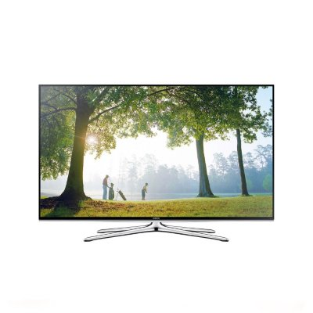

Design
The apps structure grew out of its

The MainActivity use one fragment to display the list of products.
The list lazy loads products as you scroll. The list uses Android's RecyclerView

The other fragment displays product details and if swiped lets you move to prev/next
product detail screens. The product details screen uses Android's ViewPager

Pressing the button takes you back to the product list.

Structure

Improvements Needed

