Course Project Proposal

1. Project Category & Title
Category: Core Domain Projects
Project Title: Campus Rental (Housing)
Git Repositor: https://github.com/psu-edu/sweng861-capstone-cup130.git

2. Problem & Users

Problem Statement
University housing requires coordination between students selecting housing and housing personnel managing a limited inventory of rooms and beds. Availability must remain accurate while students make selections, and the process of securing a room involves multiple steps, including reserving inventory, generating lease documents, and obtaining signatures. Campus Rental will provide a centralized application for managing this workflow while reducing the possibility of conflicting room selections and providing students and housing officers with a consistent view of the housing process.

Target Users
Students will use the application to view available campus housing, select a room or bed, manage their housing application, complete lease documents, and potentially participate in roommate matching.
Housing Officers will use the application to manage housing inventory and availability, oversee student housing applications, and manage the leasing process.

3. Core Features

Must-Have Features
1. User Authentication and Role-Based Access: Students and Housing Officers.
2. Housing Inventory and Room Selection: Housing Officers will manage available rooms and beds. Students will be able to browse available housing and select an available unit.
3. Housing Application and Secure Room Workflow: Students will be able to submit a housing application and secure an available room. The workflow will lock the selected bed inventory to prevent conflicting selections and initiate the leasing process.
4. Lease Management and Electronic Signature: The system will generate a lease document for the selected housing assignment and support electronic signature through the DocuSign API.

Nice-to-Have Features
1. Roommate Matching: Students could provide roommate preferences or request another student as a roommate.

4. Architecture & Tech Stack

Architecture Diagram
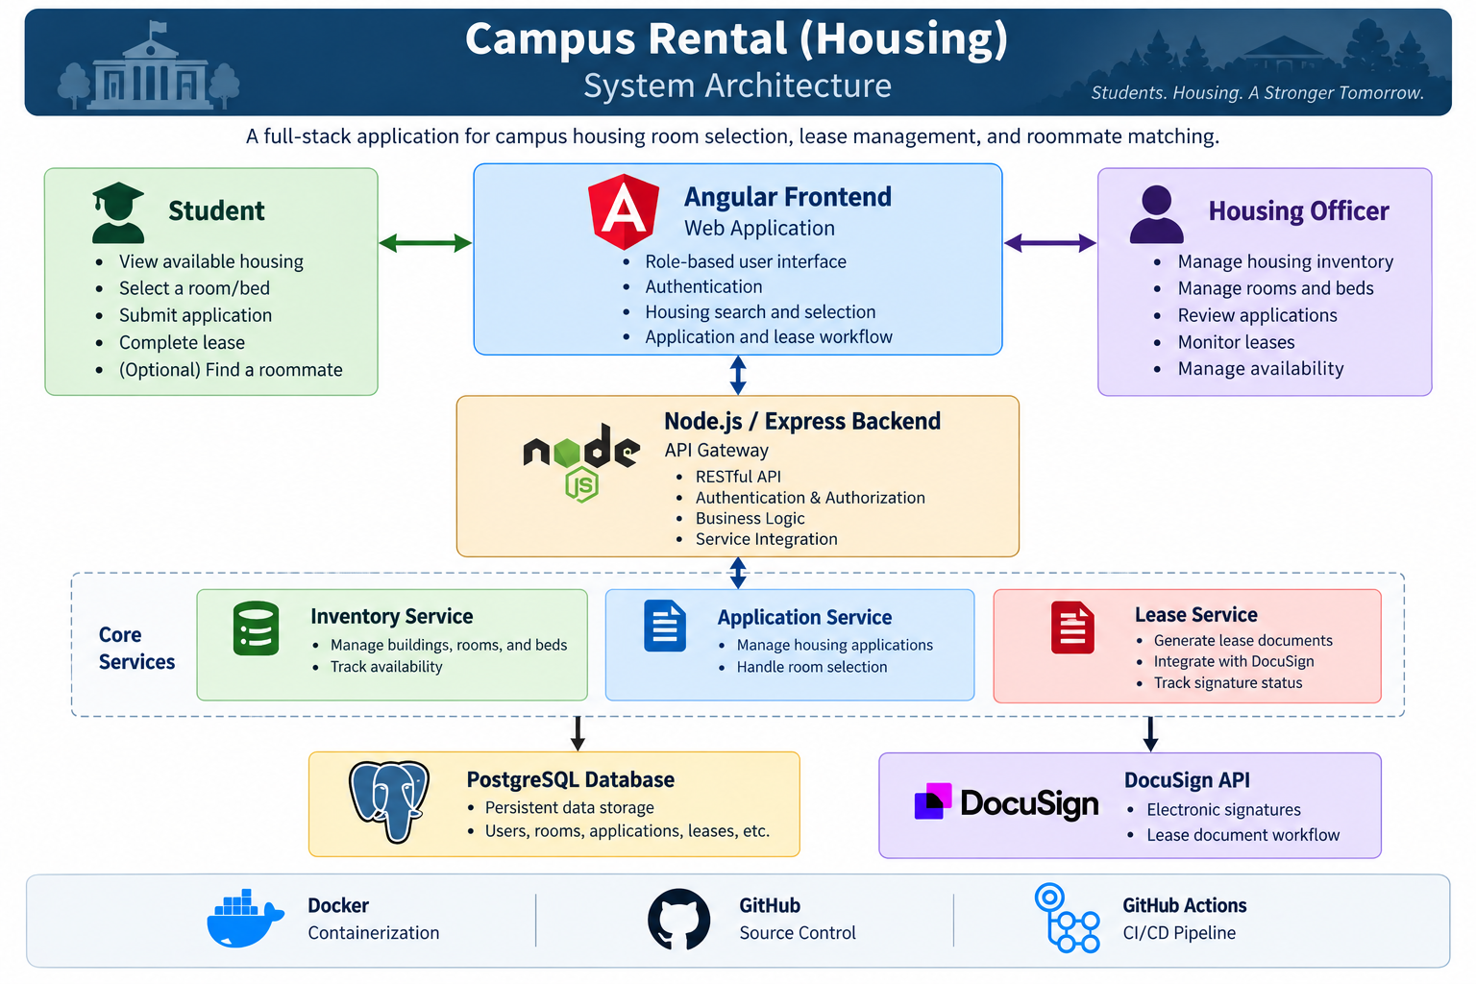

Planned Technology Stack
Frontend: Angular
Backend: Node.js with Express
Database: PostgreSQL
External Integration: DocuSign API
Containerization: Docker and Docker Compose
Source Control: Git and GitHub
CI/CD: GitHub Actions

