USER MANUAL

Preface
Thank you for buying products from Shenhui laser. Our machine is a professional and high-technology equipment combined with the optical, mechanical and electrical, here especially edit this manual for your good operating and maintenance.
We also take many real object photographs in the manual, it helpfully introduces installation & adjustment, maintenance, safty attention etc. in details.
The user should read this manual in details before using, because it will help you have a good grasp of operating and maintenance.
Welcome to provide your valuable comments or suggestions, will highly appreciate it !

Catalogue
USER MANUAL 1
Preface 2
Catalogue 3
Statement 6
Chapter 1 Machine Appearance and Accessories 7
1.1 Machine Appearance (Different model will have different appearance, according to the real object) 7
1.2 Accessories set(according to the real object) 8
Chapter 2 Installation and Commissioning of The Machine 10
2.1 Installation and Adjusting Steps 10
Chapter 3 Operation of laser machine 12
3.1 Introduction of buttons 12
3.2 Operating 13
Chapter 4 Daily Maintenance and Common Faults 15
4.1 Daily maintenance 15
4.2 Common Faults Analysis 17
Chapter 5 Warranty Regulations 19
5.1 Warranty Period 19
5.2 Warranty Clause 19
Postscript 20
AppendixⅠOptical path adjustment 21
Appendix ⅡI nstruction of Laser stamp machine 28

Safety Note
★The users should read the related operating manual carefully before operating. Must obey the operating regulations strictly.
Non-trained people are forbidden to operate machine.
★The machine uses IV LASER (strong laser radiate),this kind laser radiation might make following accidents:
①Easy to burn around combustible materials；②Different working materials might produce other radiations and toxic or harmful gases during laser processing；③Laser radiation's direct sunlight will cause body harm;
The machine location must equip fire-fighting equipments, so forbidden something combustible and explosive around the machine, keep drafty. Non-trained people are forbidden to operate the machine.
★Processing material and emission should conform to local laws and regulations
★The user should consider carefully whether processing materials are suitable for laser working for risk reason.
★There are high-voltage and other potentially dangerous in the machine, non professionals are forbidden to disassemble machines.
★The operator is forbidden to leave during operating and must cut off switch when work finishing.
★Forbid open any cover during working.
★Make sure the wire connects well with the ground before operating.
★Forbid the things inconnected diffuse reflection around the machine for fear the laser light reflect the person or incendive directly(advise use firehosereel box in location of working).
★The operator must observe carefully during the working of machine, if something is exceptional, should cut off all switchs.
★Keep the machine in the dry place, non-pollution, non-concussing, non-strong electricity, strong magnetism etc. environmental temperature should be 5-40℃,environmental humidity should be 5-95%(no condensed steam).
★The laser machine needs far from sensitive EMI equipment, it will make EMI to this kind equipments.
★The working voltage: AC220V，50Hz, it is forbidden to open machine when the power supply voltage is unsteady or mismatch.
Manufacturer won't take any responsibility and liability because of improper use and user not obey above all regulations.

Statement

1. Any differences are not specially notified in advance for products update etc. reasons.
2. All products according to the real object, manual's photograph maybe different with real object for products update etc. reasons.

Chapter 1 Machine Appearance and Accessories

1.1 Machine Appearance (Different model will have different appearance, according to the real object)
1. Right side is shown in Fig.F1-1
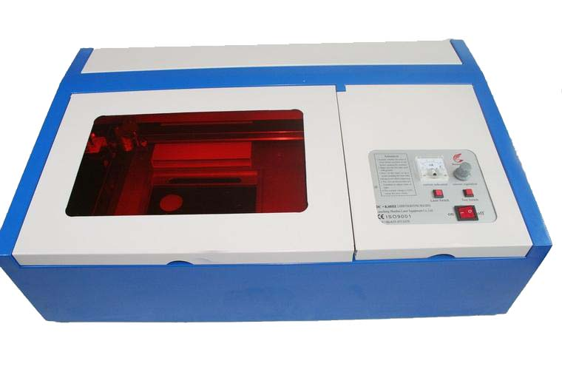
F1-1
2. Back side is shown in Fig. F1-2
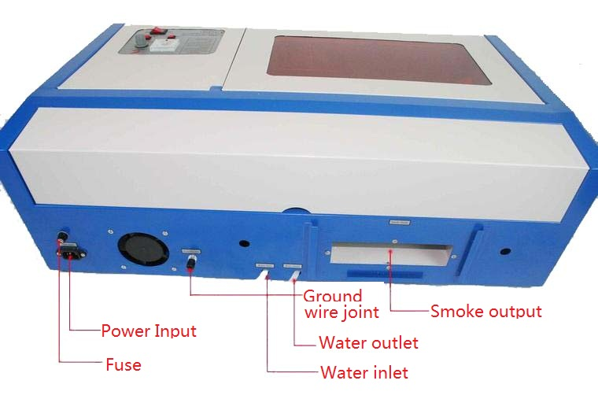
F1-2

1.2 Accessories set(according to the real object)
Your accessories set include following parts except machine(except option spare parts)
1. Water pump,is shown in Fig. F1-3:
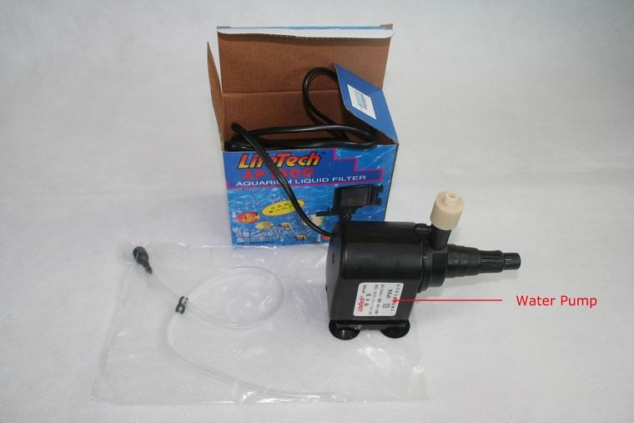
F1-3
2. Exhaust fan,smoke pipe,is shown in Fig. F1-4：
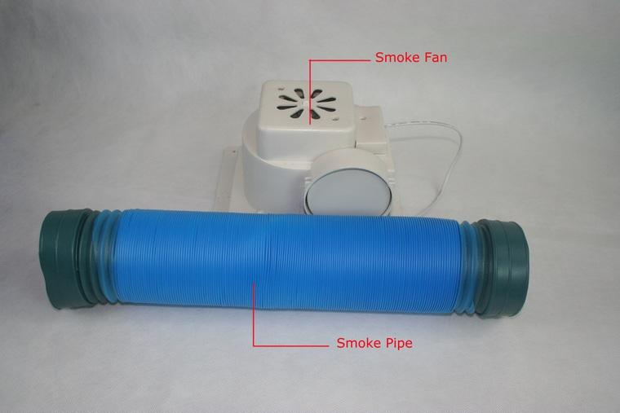
F1-4
- Manual Bag and inside accessories,is shown in Fig. F1-5,F1-6：
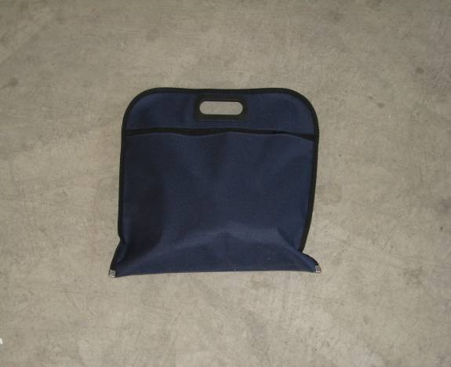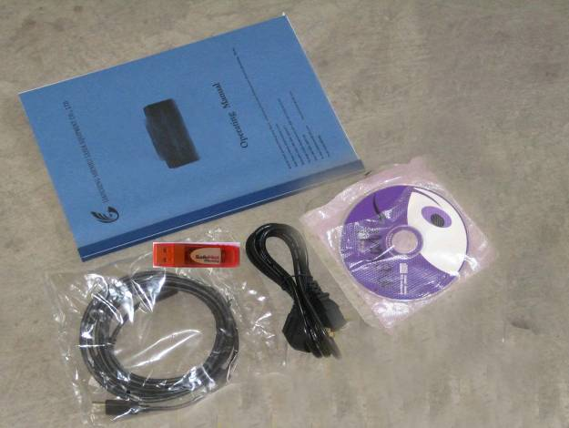
F1-5 F1-6

Chapter 2 Installation and Commissioning of The Machine
A complete working system is composed by laser engraving machine, the exhaust fan, exhaust pipe, water pump, water tank, USB cable and so on. According to the needs, the users can configure the computers, printers, scanners and so on by themselves.

2.1 Installation and Adjusting Steps
1. Water pump connection
Cooling water system is very important to the laser machine, when laser machine works without cooling water, the laser tube will be exploded by heat.
Water inlet pipe on laser machine should connect water pump, put the water outlet pipe in the water tank directly , then fill water in the water tank ,connect power for water pump, the water will start to running .As shown in Fig. F2-1:
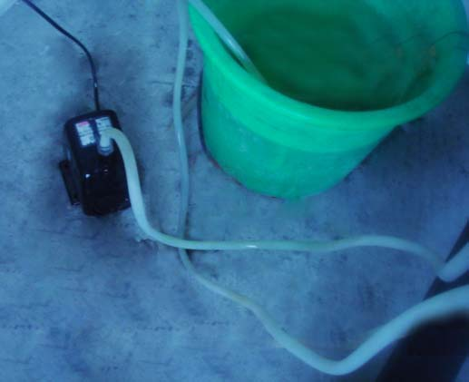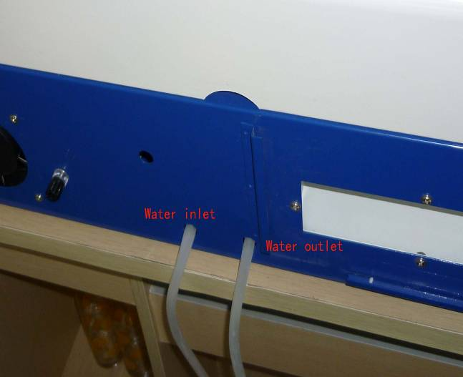
F2-1
Note: Every time before you switch on laser machine ,please make sure the cooling water is running well .When temperature of the water is higher than 35℃,please change cool water ,or put some ice in the water .Please put some antifreeze in the water when temperature is below 0℃.

2. Exhaust fan installation
As shown in Fig. F2-2:
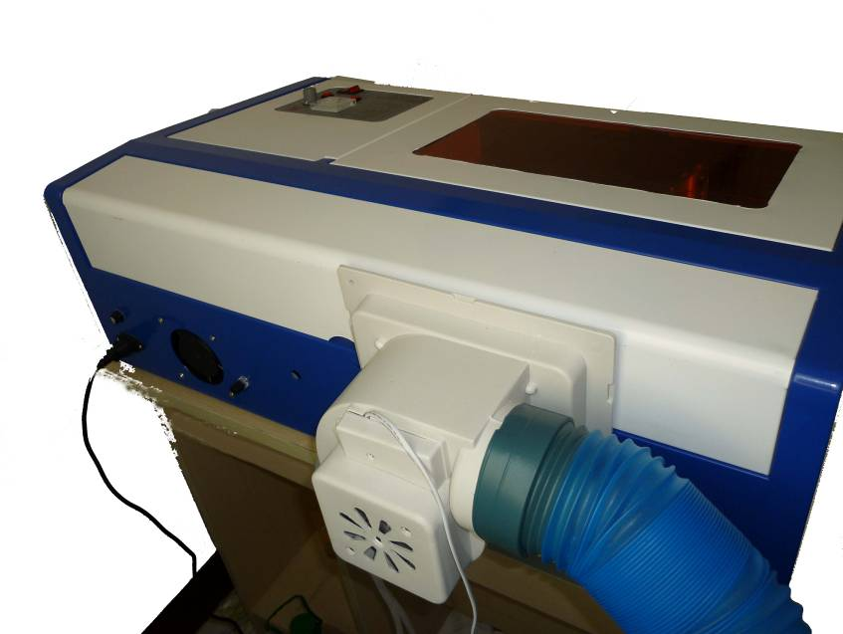
F2-2
3.Safety Grounding
Shenhui laser engraver uses fourth type of laser tube. The type of drive is high-voltage-driven, so during users use the machine, they must comply with the " Safty Note ". On the other hand, it asks stringent requirement about the safety grounding to the users. The safe Line-to-Ground Resistance should be less than 5Ω. Specific connection method are shown in Fig.F2-3, F2-4
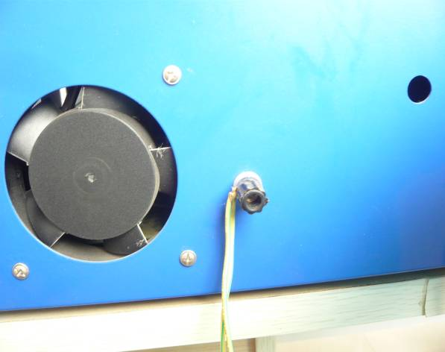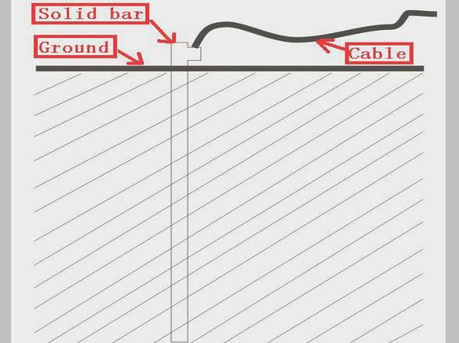
F2-3 F2-4
Attention please, bad grounding can cause high failure rate of equipment and at the same time may cause other safety incidents! ! !
The company won’t assume any responsibility and obligation to the fault and the accident caused by bad grounding!!!

Chapter 3 Operation of laser machine
There has a control panel used to operate the machine . The following is the brief instruction of control panel and main function.
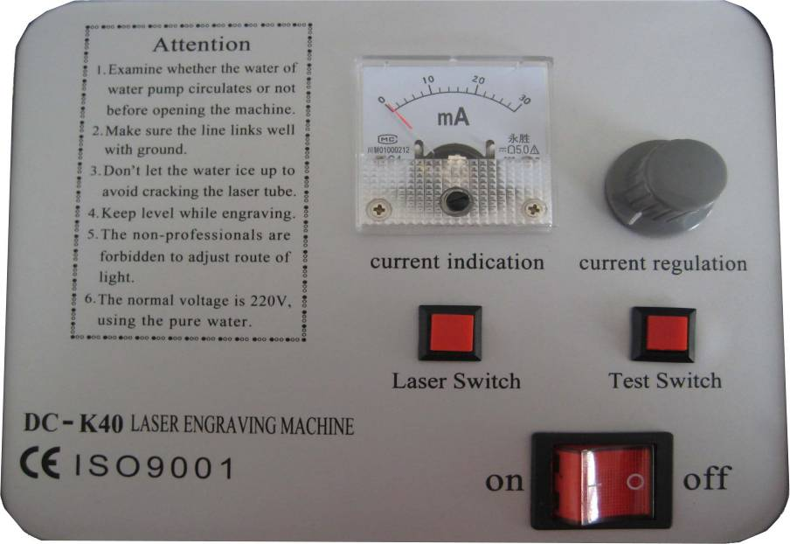

3.1 Introduction of buttons
（1）On/Off swtich

This switch is the main power switch of the laser machine ,laser head will move back to top left corner after you turn on this switch .
（2）Laser Switch

Laser switch is used to control the laser on and off , please make sure you press it down before you test the laser beam or do a job on machine .
（3）Test Switch

When On/Off switch and Laser Swtich are on, if you press this button, the laser will be emitted, meanwhile, you can see the current value on the current amperermeter.
This button will be used when adjusting laser power and laser beam aligning.
（4）Current Regulation

This knob used to adjust the laser power .

（5）Current Indication

This is the current amperemeter. Generally, the current value should be lower than 15mA when machine working. When aligning laser beam, please adjust current lower than 10mA for safety.
Note: There has Attention items on the control panel, please read it carefully before you turn on the machine.

3.2 Operating
Step one:
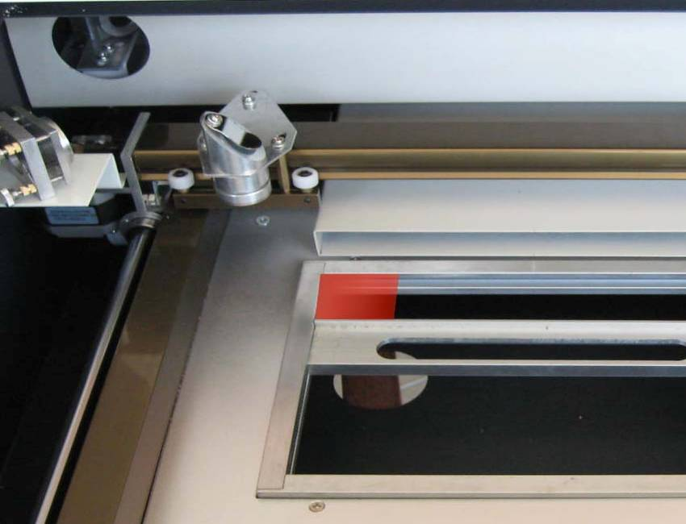
Fix material by the clamp, the top surface of the material should be in same level as the clamp frame to keep the focus distance is correct, this distance is about 5cm. As shown on the picture below:

Note: incorrect distance will lead bad engraving effect.

Step two:
Make design in software ,

Step three:
Move laser head to set working origin by drag the design on output interface.
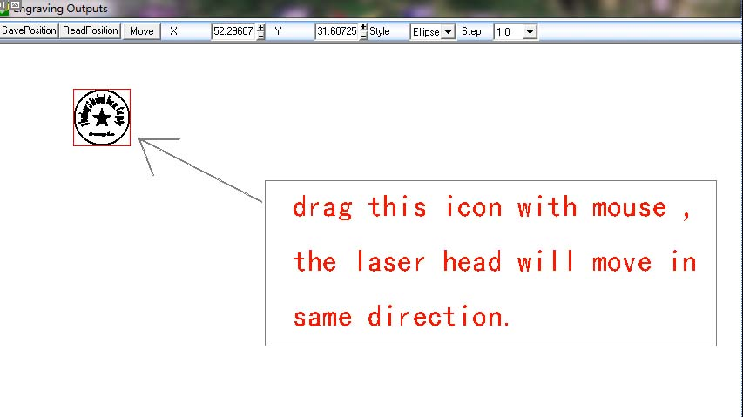
As shown on picture below:

Step four:
Set suitable laser power on machine according to which kind of material you want to process. For rubber stamp, we suggest the current value 12mA—15mA.

Step five:
Set Carving speed in software, then output the job to machine.
Chapter 4 Daily Maintenance and Common Faults
The stable working of the machine is inseparable with normal daily operation and maintenance. Here are some common daily maintenance and common faults analysis:

4.1 Daily maintenance
1. Replacement of the cooling water(clean water tank and replace recycled water once a week are recommended):
Quality and temperature of the cooling water can affect the lifetime of laser tube directly, suggest use purified water or distilled water, and water temperature should be below than 35 ℃.When higher than 35 ℃,please replace cooling water, or add ice cubes to lower the water temperature,(cooling device is recommended, or use two water tanks).
Note: To ensure that the laser tube full filled with cooling water before machine working.
2. Cleaning of Water Tank
First of all, turn off power, disconnect the water inlet pipe, let the inside water of the laser tube flow into the water tank automatically, open water tank, take out the water pump, clean water pump and water tank, put the pump back to water tank, insert the water pipe which connect water pump to water inlet mouth of the machine, finish all joints, then replace cooling water. Turn on the water pump power supply isolately, let the pump run 2-3 minutes (make laser tube full filled with water).
3. Cleaning of Exhaust Fan
After long time using, inside of fan will accumulate much solid dust, so the exhaust fan will make a great noise, and it is not conducive to the exhaust .When the exhaust effect become poor, we have to clean the fan and smoke pipe .Firstly, turn off the power supply, remove the two pipes from the fan, clean dust inside of the pipes, and then clean the dust inside of the fan.
4. Cleaning of Lens (daily cleaning is recommended before work, equipment must be in shutdown state)
Engraving machine has three reflector mirrors and one focus lens(1# reflector mirror is near the light outlet mouth of laser tube, the upper left corner of the machine,2# reflector mirror is at left side of the beam,3# reflector mirror is on the top of laser head, the focus lens is located in the bottom part of the laser head). Mirror is easy to be dirty, resulting in laser loss and mirror damage, you needn’t remove 1#,2# and 3# mirror when cleaning them, Just using a cotton bar to dip some cleaning solution (acetone or alcohol) , swab carefully by rotating from central to edge of the lens.
Take out the focus lens from the laser head, using the same method clean it, after cleaning, put it back.
Note: ① you should wipe the lens carefully, can not damage the surface coating; ② you should do that lightly, to prevent falling; ③keep concave side downward when install the focus lens.
5. Cleaning of Guide rail (suggest cleaning every two weeks, equipment must be in shutdown state)
First of all, move the laser head to the far right (or left), wipe with a dry cloth until shiny clean. Then, clean and lubricate the Y axis guide rail, together with a little oil (sewing machine oil is recommended),push the beam several times slowly along the Y guide, so that lubricant can be evenly distributed..
Note: Please prepare for cleaning Guide - dry cotton cloth, lubricating oil.
6. Optical path inspection
Optical path system of the laser engraving machine is completed by the mirror reflection and focus lens focusing, and there is optical path bias with the focus lens, but the three mirrors is fixed by the mechanical part, optical path offset is very possible ,although there is no optical bias normally, we still suggest you check optical path before working.
Please get detailed explanation from Appendix I "Alignment Standards of Optical Path "

4.2 Common Faults Analysis
No. | Phenomena of Malfunction | Analysis method | Solution
1 | Open the machine but no movement | Check power supply of machine connects well or not | Make all power supply electrify again
2 | Working with nonstop laser | Connect ground wire or not for the machine | Connect ground wire for machine.
3 | Desultory light when working | Check water circulation is swimmingly or not | Clean water tank,water pump and water pipe
3 | Desultory light when working | Voltage is stable or not | Add regulator for the laser machine
4 | Self-test abnormal when starting | Check whether the metal can touch the limit correct or not | Adjust the metal sheet position to touch the limit switch well
5 | After output data ,machine no action | Check whether the data cable is corrected or not. | Connect data cable
5 | After output data ,machine no action | Check whether turn on the machine | Turn on the machine
5 | After output data ,machine no action | Check whether connected ground wire for the machine | Connect ground wire
5 | After output data ,machine no action | check whether installed the USB driver | install the USB driver
6 | No laser when working | Check whether optical path is bias | Adjust the optical path
6 | No laser when working | Check whether the cooling water is running | Ensure the water is running
7 | When engraving ,the laser head moves disorderly | cCheck whether the speed is too fast | Reduce engraving speed
7 | When engraving ,the laser head moves disorderly | Check whether connect ground wire | Connect ground wire well

Chapter 5 Warranty Regulations

5.1 Warranty Period
From the date of purchase, whole year warranty(except consumables). Optical lenses and the laser tube are consumables, three months warranty.

5.2 Warranty Clause
This warranty is for products of Shandong Shenhui Laser Science and Technology R&D Co., Ltd.
During the warranty period and under the correct use, malfunction can be based on this warranty terms, show the warranty card or invoice, enjoy our free maintenance service.
The following cases, can’t enjoy the free service, a fee will be charged according to the concrete condition.
1) Maintenance services not caused by the machine quality;
2) Overstep the warranty period;
3) Can’t show or alter warranty card;
4) Didn’t fulfill the contractual obligation;
5) Without the company agrees, privately to tear open outfit, modification, maintenance of product;
6) Equipment failure due to human or force majeure factors.
The company only assume the legal obligation for the product itself, but don't assume other responsibilities which caused by the using of the products

AppendixⅠOptical path adjustment
Ⅰ.Preview of parts

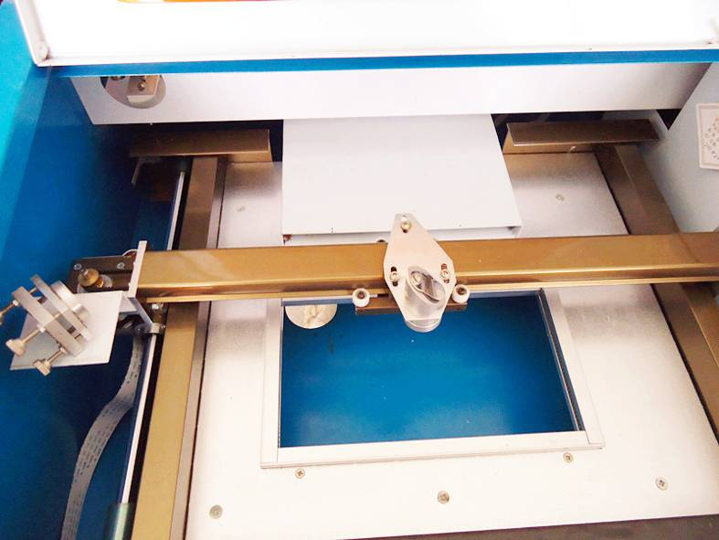
Figure 1

Figure 1 is showing you the area of the optical path adjustment.
There have three reflecting mirrors and one focus lens .We appoint them as 1#, 2#,3# and 4# , here 1#, 2# and 3# are reflecting mirrors, 4# is the focus lens ,as is showing on Figure 2 and Figure 3 below:

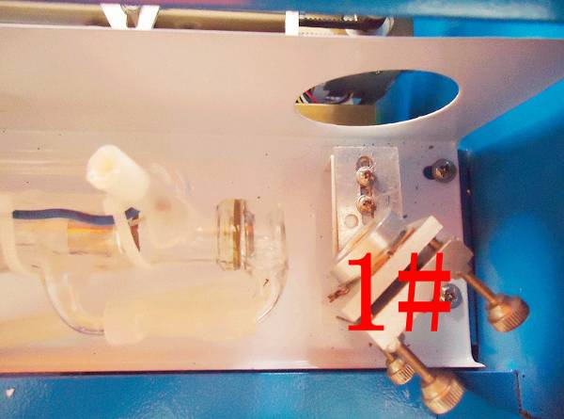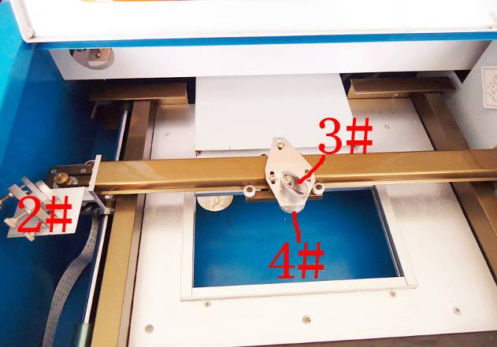
Figure 2 Figure 3

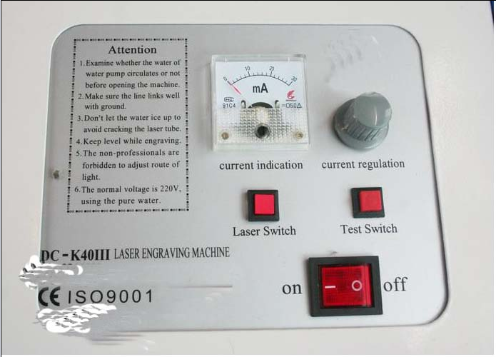
Figure 4
It is Control panel on above picture Figure 4 ,There have Control Switch ,Laser Switch ,Test Switch ,Current Regulation and Current indication.
Ⅱ.Operating steps
1,Turn on laser machine.
2, Turn on laser switch ,there will be no laser when this switch is off.
3,Test swtich, laser will be enable when this switch is pushed down , at the same time you can get the current value on the ampere meter. This switch used to adjust current ,show the laser position before engraving and optical path adjustment.
4,Current Regulation: we can adjust the current value by turning this button when Test switch is pushed down,the current value will be higher when we turn it clockwise,
Ⅲ Adjusting steps

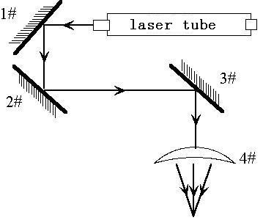
Step 1.
Adjust the current value to 6mA
Step 2 .
Put 4 layers double side adhesive tape on the 1# mirror, then push Test switch to get a laser spot on the tape ,make sure it is near the center position of the mirror, otherwise ,please adjust the laser tube's position to get that ,generally, here no need to adjust.
Step 3,
Put double side adhesive tape on 2# mirror, then move the X axis beam to the position A where near the laser tube ,push Test switch to get a laser spot on the tape ,to avoid burnt by laser,please put a carton board at front of 2# mirror to get the general position of the laser spot ,the laser spot also should be near center of the mirror.As is showing on the picture below:
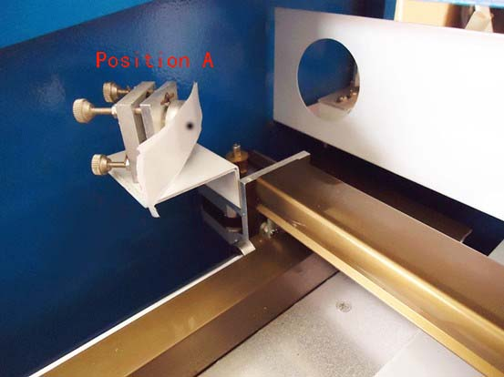
Figure 6
Step 4 Move the X axis beam to position B slowly where far from the laser tube ,then push Test switch to get another laser spot on the tape.
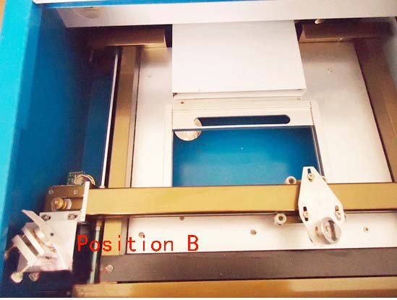
Figure 7
Step 5, if the second spot is not at the same position as the first one ,please adjust the screws at back of the 1# mirror (please loose the screws which are used to fix the adjusting screws firstly),until the second spot overlap with the firstly.
There are three adjusting screws ,the top two are used to adjust the spot move left and right, the bottom on is used to move the spot up and down.As is shown on below picture:
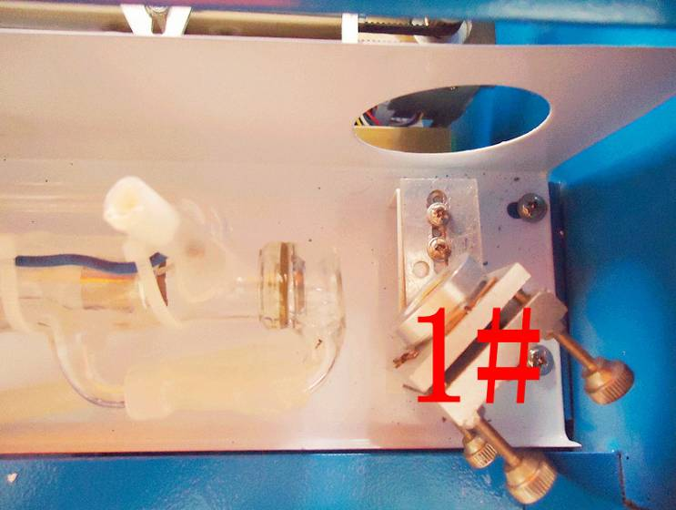
Figure 8
Step 6, repeat step 3,4,5 until the two spots are at same position.
Step 7, Put tape on the third mirror, move the laser head near 2# mirror,then push Test switch to get a laser spot on tape,as is shown on picture below:
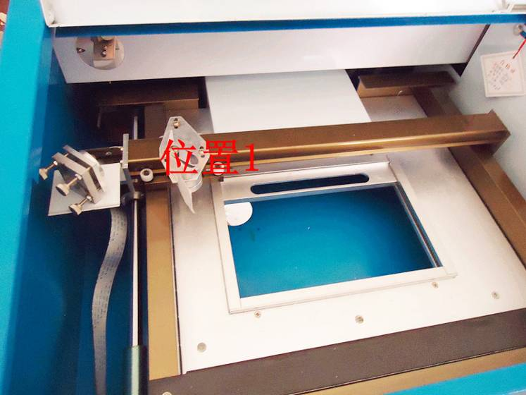
Figure 9
Step 8,move the laser head slowly to the side far from 2# mirror ,push Test switch to get a laser spot ,to avoid burnt by laser ,please put a carton board at front of 3# mirror to get the general position of the laser spot ,
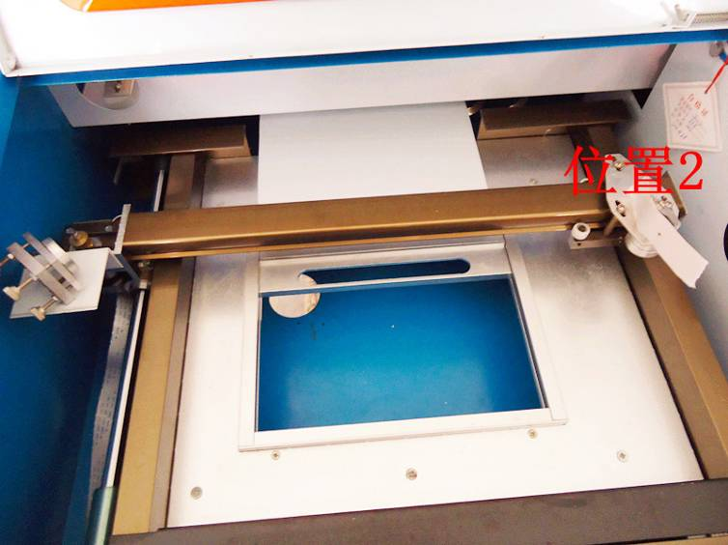
Figure 10
Step 9,if these two spots doesn't overlap, please adjust the three screws at back of 2# mirror.As is shown on picture below:
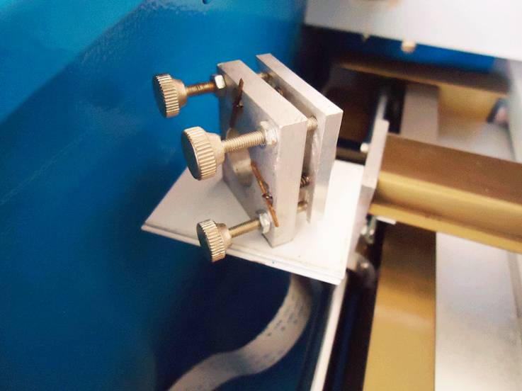
Figure 10
Step 10, repeat step 7,8,9 ,until the two spots overlap.
Step 11,put tape on the hole at top of the laser head, push Test switch to get a laser spot ,the spot should be near center of the hole.
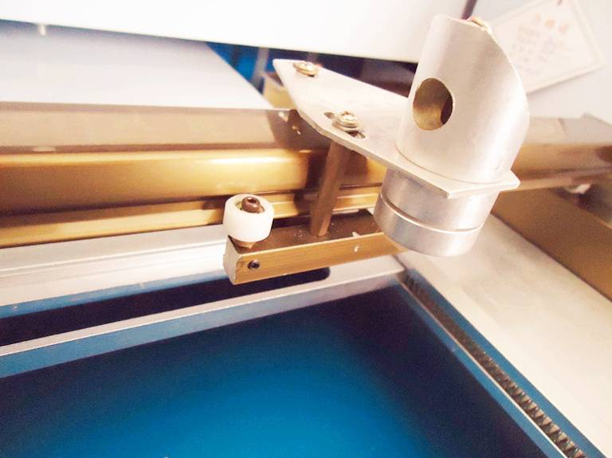
Figure 12
Step 12,if the spot is not at center of the hole ,we take the situation as is shown on picture below ,
It is upper on right ,


We should move the laser tube up or down to adjust the spot moving up and down,
Move the lase tube front or back to adjust the spot moving left and right.
For this situation above on the picture, we should adjust the laser tube lower and a little bit front ,as is shown on pictures below:
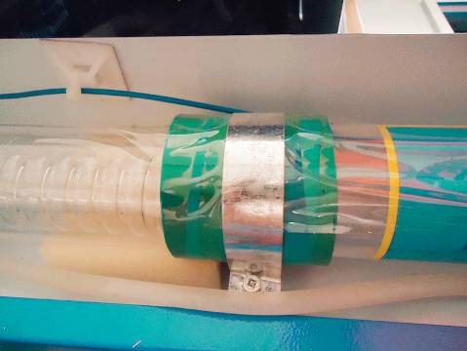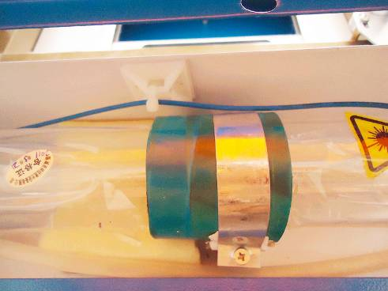
Figure 13
Appendix ⅡI nstruction of Laser stamp machine parts
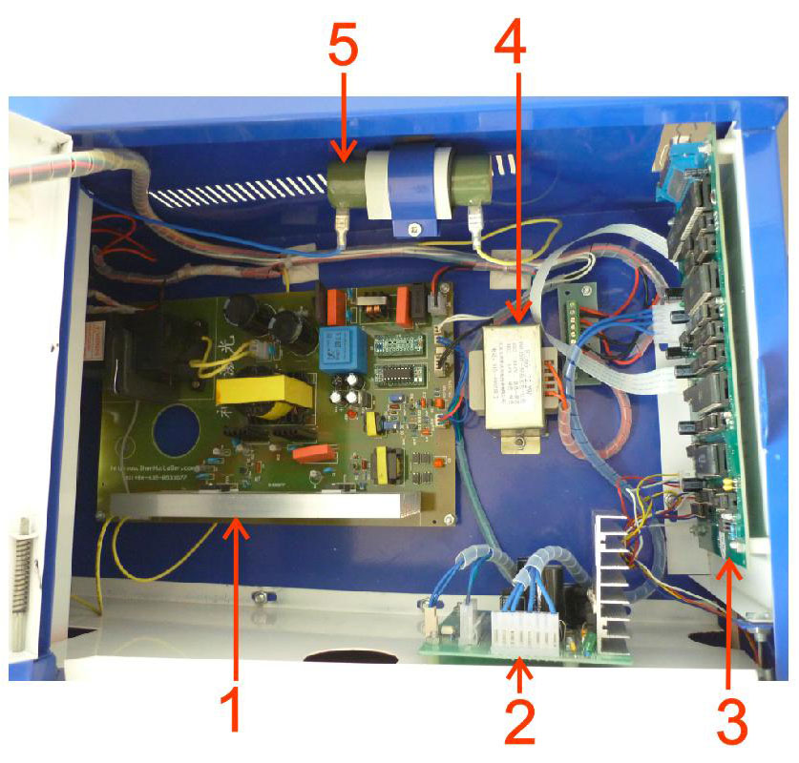
- Laser power supply
- Mainboard power supply
- Mainboard
- Transformer
- 50KΩ Electrical resistance
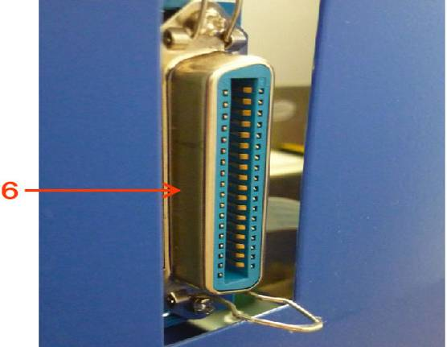
6. Output port
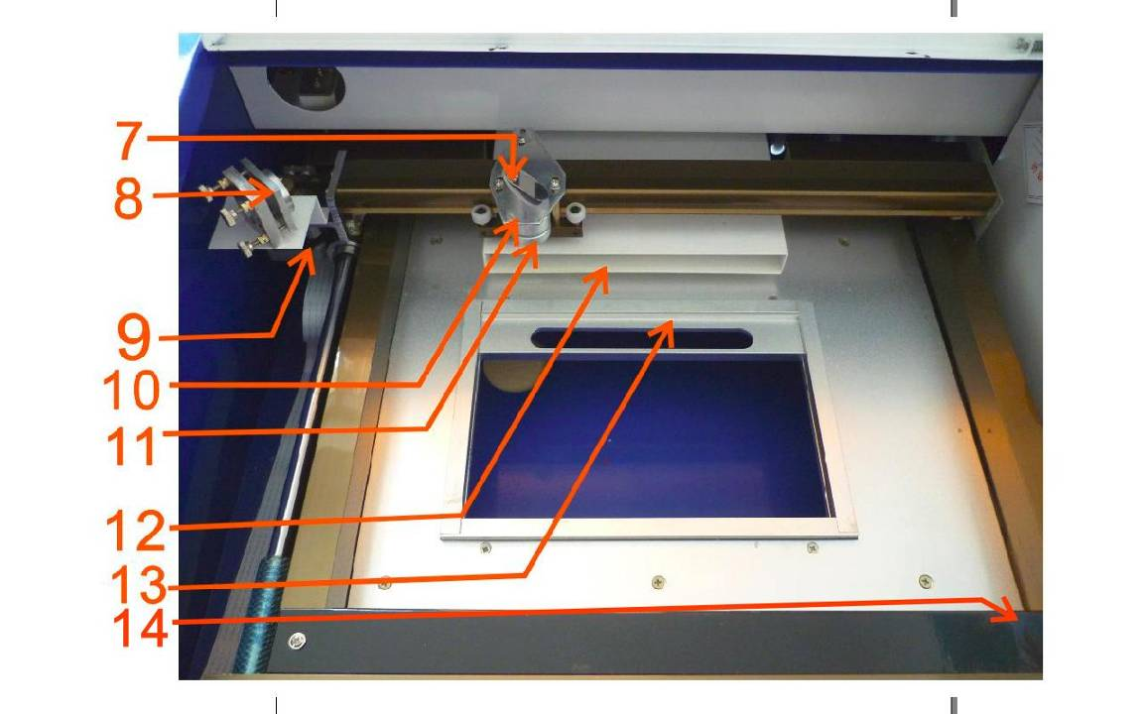
7. 3# reflector mirror
8. 2# reflector mirror
9. X axis motor
10. Laser head
11. Lens
12. Relief opening
13. Tongs
14. Y axis motor
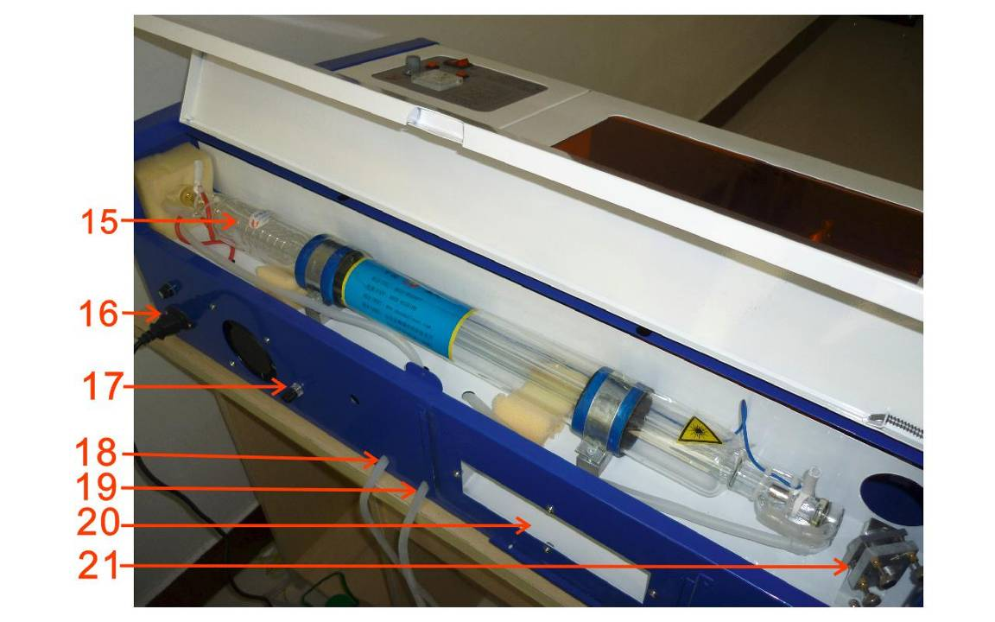
15. Laser tube
16. 220V power input
17. Ground post
18. Water inlet pipe
19. Water outlet pipe
20. Smoke exhaust
21. 1# reflector mirror
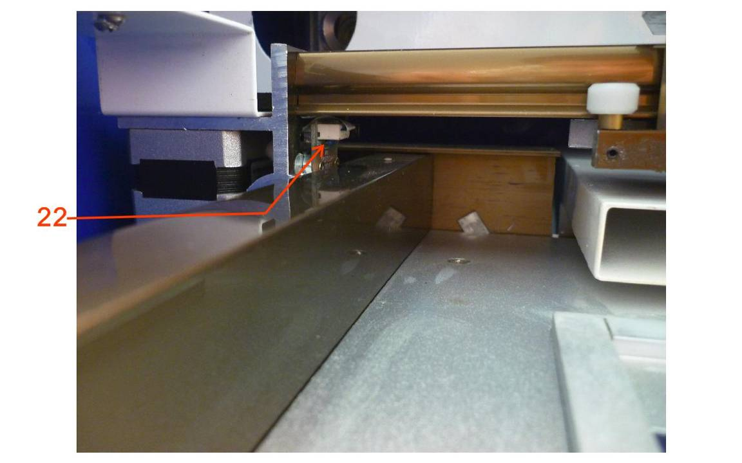
22. Small light-operated switch
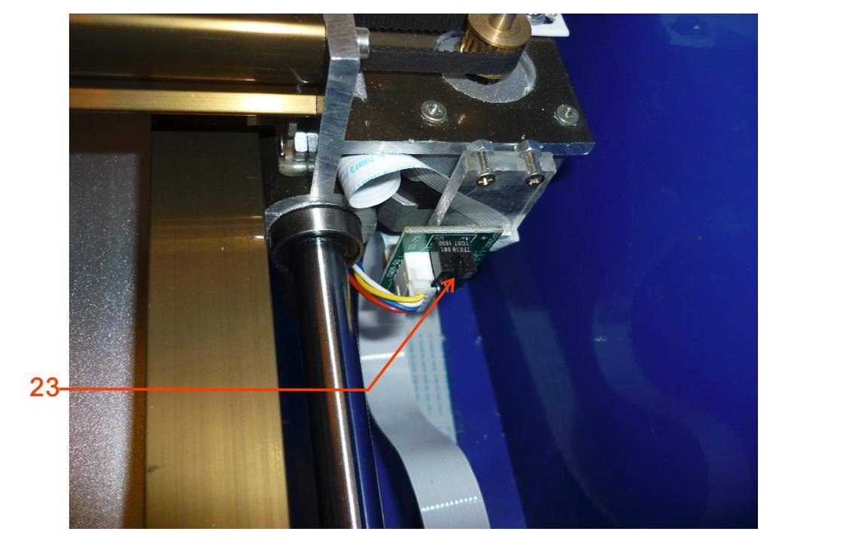
23. Big light-operated switch

